Sts. Peter & Paul
Evangelical Lutheran Church
Lutheran Church-Missouri Synod
Founded-1917

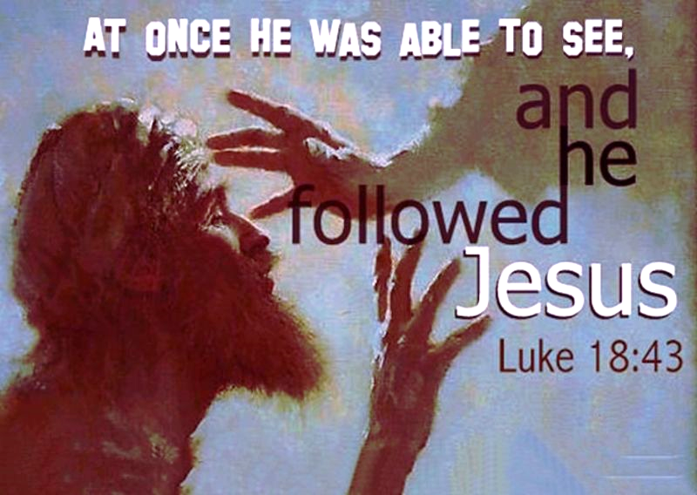

February 11, 2024

699 Stambaugh Ave.
Sharon, Pennsylvania 16146

“I was glad when they said to me,
Let us go to the house of the LORD!”
Psalm 122:1
Sts. Peter & Paul Evangelical Lutheran Church, LC-MS
QUINQUAGESIMA
February 11, 2024

A special welcome to our guests this day! If you would like more information about The Lutheran Church - Missouri Synod, or this congregation, please speak with Pastor Deal or an Elder after the service.
Members & Guests: Don’t be embarrassed if your children make noise during the worship service, all children do. We encourage families to worship together but, if you feel the need, there are pews in the rear of the Church which are reserved for young families on both sides of the sanctuary. There is also a quiet room available to you, located next to the sanctuary (formerly the Pastor’s office), where you would be able to follow along with the service.

Today’s service includes the Sacrament of Holy Communion. If during this past year, you have not worshipped with us and been communed, we respectfully ask that you do not partake of this sacrament this day before first speaking with Pastor Deal.
If visiting from a sister congregation of the LC-MS and are in good standing, please inform Pastor Deal of your desire to commune prior to the service.
If wishing to receive a blessing during communion, please approach with your arms crossed.

CONTACT INFORMATION
Pastor Deal: pastordeal@saintspeterandpaul.net or 724-347-3620 (opt. 2)
Church Office: church@saintspeterandpaul.net or 724-347-3620 (opt. 3)
Secretary’s Office: The office will be open Tuesday and Thursday (8:30 am – 4:30 pm).

Silent prayer before worship: Heavenly Father, You sent Your only Son Jesus to wash away my sins and to give me eternal life. Open my heart this day, so that I can receive Your Word and Sacrament and be assured of Your gracious love. In Jesus’ name. Amen.
Confession and Absolution

Opening Hymn: LSB #688 “’Come, Follow Me,’ the Savior Spake”

Stand

The sign of the cross may be made by all in remembrance of their Baptism.

Invocation
P In the name of the Father and of the T Son and of the Holy Spirit.
C Amen.

Exhortation Hebrews 10:22; Psalm 124:8; Psalm 32:5
P Beloved in the Lord! Let us draw near with a true heart and confess our sins unto God our Father, beseeching Him in the name of our Lord Jesus Christ to grant us forgiveness.

P Our help is in the name of the Lord,
C who made heaven and earth.
P I said, I will confess my transgressions unto the Lord,
C and You forgave the iniquity of my sin.

Silence for reflection on God’s Word and for self-examination.

Confession of Sins
P O almighty God, merciful Father,
C I, a poor, miserable sinner, confess unto You all my sins and iniquities with which I have ever offended You and justly deserved Your temporal and eternal punishment. But I am heartily sorry for them and sincerely repent of them, and I pray You of Your boundless mercy and for the sake of the holy, innocent, bitter sufferings and death of Your beloved Son, Jesus Christ, to be gracious and merciful to me, a poor, sinful being.

Absolution [John 20:19–23]
P Upon this your confession, I, by virtue of my office, as a called and ordained servant of the Word, announce the grace of God unto all of you, and in the stead and by the command of my Lord Jesus Christ I forgive you all your sins in the name of the Father and of the T Son and of the Holy Spirit.
C Amen.

Service of the Word

Introit Psalm 31:1, 5, 9, 16; antiphon: vv. 2b–3
Be a rock of ref- | uge for me,*
a strong fortress to | save me!
For you are my rock and my | fortress;*
and for your name’s sake you lead me and | guide me.
In you, O Lord, do I take refuge; let me never be | put to shame;*
in your righteousness de- | liver me!
Into your hand I commit my | spirit;*
you have redeemed me, O Lord, | faithful God.
Be gracious to me, O Lord, for I am | in distress;*
my eye is wasted from grief; my soul and my body | also.
Make your face shine on your | servant;*
save me in your | steadfast love!
Glory be to the Father and | to the Son*
and to the Holy | Spirit;
as it was in the be- | ginning,*
is now, and will be forever. | Amen.

Kyrie Mark 10:47
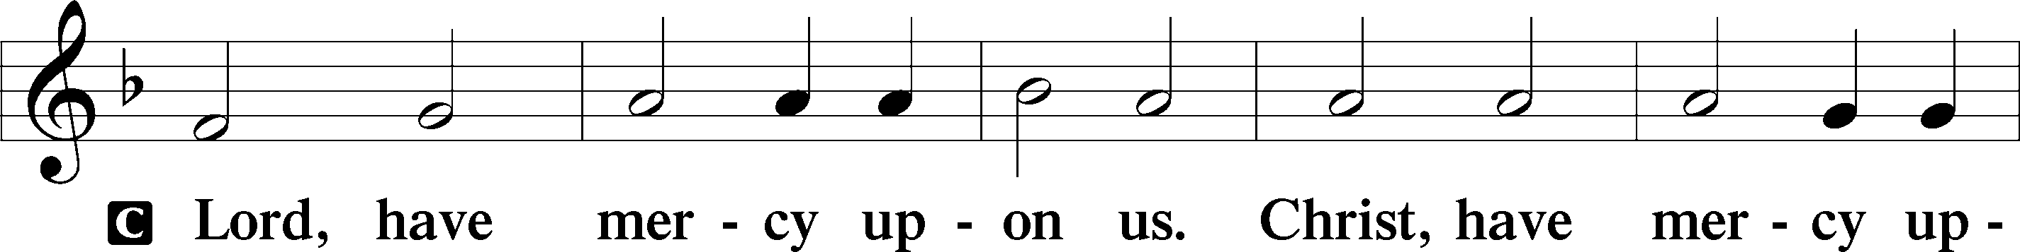
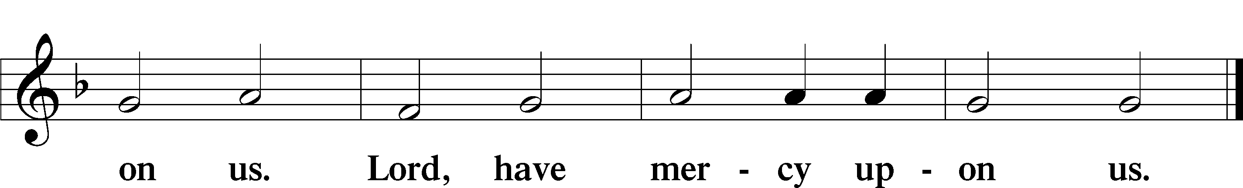

Salutation and Collect of the Day: Quinquagesima
P The Lord be with you.
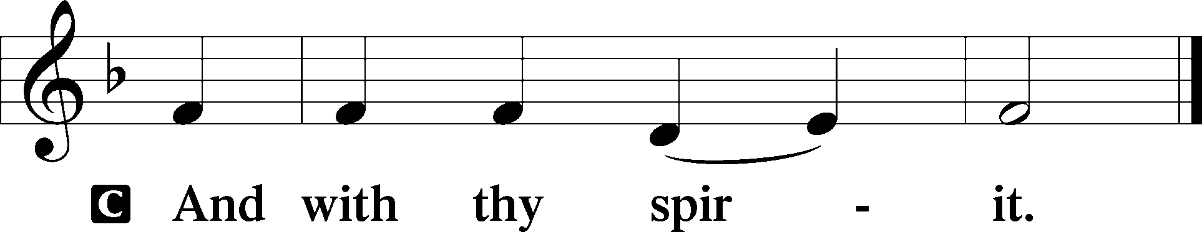

P Let us pray.
O Lord, mercifully hear our prayers and having set us free from the bonds of our sins deliver us from every evil; through Jesus Christ, Your Son, our Lord, who lives and reigns with You and the Holy Spirit, one God, now and forever.
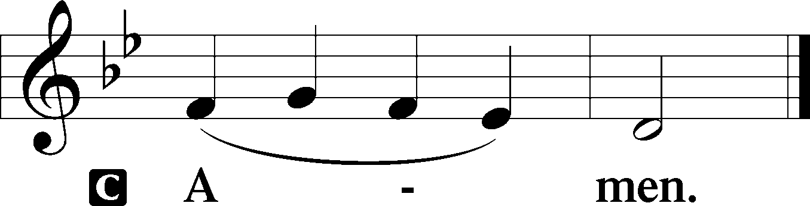
Sit

Prophecy: 1 Samuel 16:1–13 (NKJV)
In those days: The Lord said to Samuel, “How long will you mourn for Saul, seeing I have rejected him from reigning over Israel? Fill your horn with oil, and go; I am sending you to Jesse the Bethlehemite. For I have provided Myself a king among his sons.” And Samuel said, “How can I go? If Saul hears it, he will kill me.” But the Lord said, “Take a heifer with you, and say, ‘I have come to sacrifice to the Lord.’ Then invite Jesse to the sacrifice, and I will show you what you shall do; you shall anoint for Me the one I name to you.” So Samuel did what the Lord said, and went to Bethlehem. And the elders of the town trembled at his coming, and said, “Do you come peaceably?” And he said, “Peaceably; I have come to sacrifice to the Lord. Sanctify yourselves, and come with me to the sacrifice.” Then he consecrated Jesse and his sons, and invited them to the sacrifice. So it was, when they came, that he looked at Eliab and said, “Surely the Lord’s anointed is before Him!” But the Lord said to Samuel, “Do not look at his appearance or at his physical stature, because I have refused him. For the Lord does not see as man sees; for man looks at the outward appearance, but the Lord looks at the heart.” So Jesse called Abinadab, and made him pass before Samuel. And he said, “Neither has the Lord chosen this one.” Then Jesse made Shammah pass by. And he said, “Neither has the Lord chosen this one.” Thus Jesse made seven of his sons pass before Samuel. And Samuel said to Jesse, “The Lord has not chosen these.” And Samuel said to Jesse, “Are all the young men here?” Then he said, “There remains yet the youngest, and there he is, keeping the sheep.” And Samuel said to Jesse, “Send and bring him. For we will not sit down till he comes here.” So he sent and brought him in. Now he was ruddy, with bright eyes, and good-looking. And the Lord said, “Arise, anoint him; for this is the one!” Then Samuel took the horn of oil and anointed him in the midst of his brothers; and the Spirit of the Lord came upon David from that day forward. So Samuel arose and went to Ramah.

P This is the Word of the Lord.
C Thanks be to God.

Gradual Psalm 77:14–15
You are the God who works | wonders;*
you have made known your might among the | peoples.
You with your arm redeemed your | people,*
the children of Jacob and | Joseph.

Epistle: 1 Corinthians 13:1–13 (NKJV)
Brethren: Though I speak with the tongues of men and of angels, but have not love, I have become sounding brass or a clanging cymbal. And though I have the gift of prophecy, and understand all mysteries and all knowledge, and though I have all faith, so that I could remove mountains, but have not love, I am nothing. And though I bestow all my goods to feed the poor, and though I give my body to be burned, but have not love, it profits me nothing. Love suffers long and is kind; love does not envy; love does not parade itself, is not puffed up; does not behave rudely, does not seek its own, is not provoked, thinks no evil; does not rejoice in iniquity, but rejoices in the truth; bears all things, believes all things, hopes all things, endures all things. Love never fails. But whether there are prophecies, they will fail; whether there are tongues, they will cease; whether there is knowledge, it will vanish away. For we know in part and we prophesy in part. But when that which is perfect has come, then that which is in part will be done away. When I was a child, I spoke as a child, I understood as a child, I thought as a child; but when I became a man, I put away childish things. For now we see in a mirror, dimly, but then face to face. Now I know in part, but then I shall know just as I also am known. And now abide faith, hope, love, these three; but the greatest of these is love.

P This is the Word of the Lord.
C Thanks be to God.

Stand

Tract Psalm 100:1–3
Make a joyful noise to the Lord, | all the earth!*
Serve the Lord with gladness! Come into his presence with | singing!
Know that the Lord, | he is God!*
It is he who made us, and we are his; we are his people, and the sheep of his | pasture.

Holy Gospel: Luke 18:31–43 (NKJV)
P The Holy Gospel according to St. Luke, the eighteenth chapter.
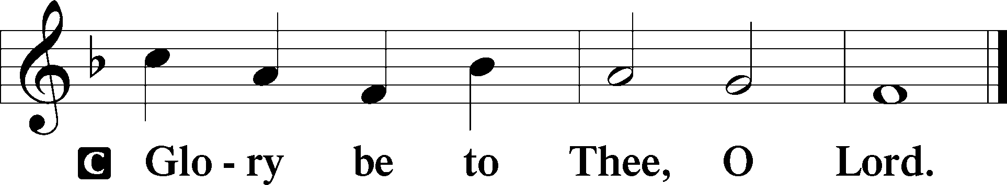

At that time: Jesus took the twelve aside and said to them, “Behold, we are going up to Jerusalem, and all things that are written by the prophets concerning the Son of Man will be accomplished. For He will be delivered to the Gentiles and will be mocked and insulted and spit upon. They will scourge Him and kill Him. And the third day He will rise again.” But they understood none of these things; this saying was hidden from them, and they did not know the things which were spoken. Then it happened, as He was coming near Jericho, that a certain blind man sat by the road begging. And hearing a multitude passing by, he asked what it meant. So they told him that Jesus of Nazareth was passing by. And he cried out, saying, “Jesus, Son of David, have mercy on me!” Then those who went before warned him that he should be quiet; but he cried out all the more, “Son of David, have mercy on me!” So Jesus stood still and commanded him to be brought to Him. And when he had come near, He asked him, saying, “What do you want Me to do for you?” He said, “Lord, that I may receive my sight.” Then Jesus said to him, “Receive your sight; your faith has saved you.” And immediately he received his sight, and followed Him, glorifying God. And all the people, when they saw it, gave praise to God.

P This is the Gospel of the Lord.
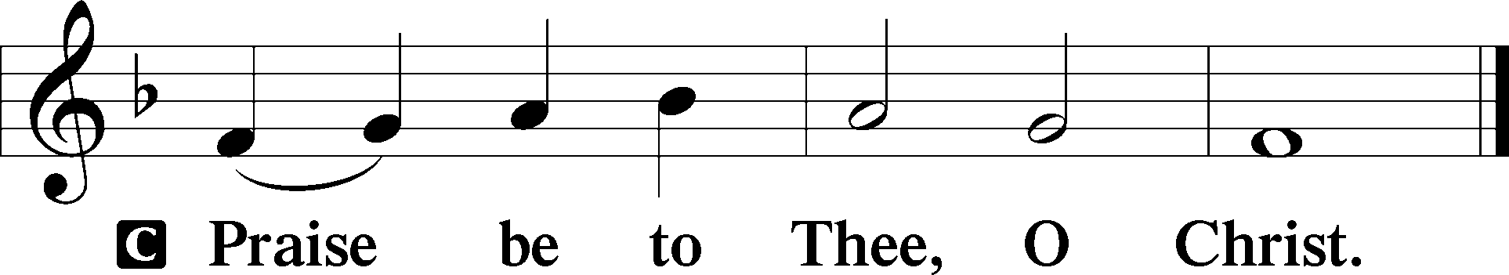

Nicene Creed
C I believe in one God,
the Father Almighty,
maker of heaven and earth
and of all things visible and invisible.

And in one Lord Jesus Christ,
the only-begotten Son of God,
begotten of His Father before all worlds,
God of God, Light of Light,
very God of very God,
begotten, not made,
being of one substance with the Father,
by whom all things were made;
who for us men and for our salvation came down from heaven
and was incarnate by the Holy Spirit of the virgin Mary
and was made man;
and was crucified also for us under Pontius Pilate.
He suffered and was buried.
And the third day He rose again according to the Scriptures
and ascended into heaven
and sits at the right hand of the Father.
And He will come again with glory to judge both the living and the dead,
whose kingdom will have no end.

And I believe in the Holy Spirit,
the Lord and giver of life,
who proceeds from the Father and the Son,
who with the Father and the Son together is worshiped and glorified,
who spoke by the prophets.
And I believe in one holy Christian and apostolic Church,
I acknowledge one Baptism for the remission of sins,
and I look for the resurrection of the dead
and the life T of the world to come. Amen.
Sit

Hymn of the Day: LSB #353 “Jesus Came, the Heavens Adoring”

Sermon

Stand
Offertory Psalm 51:10–12
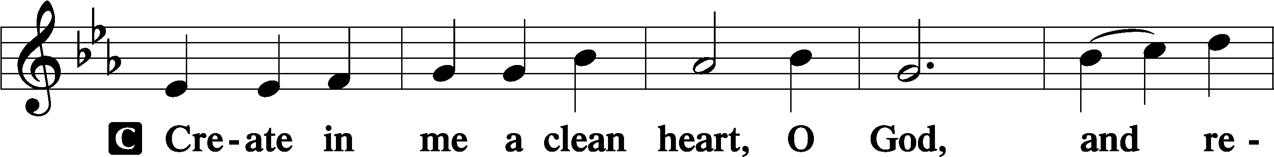
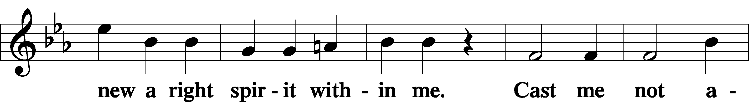
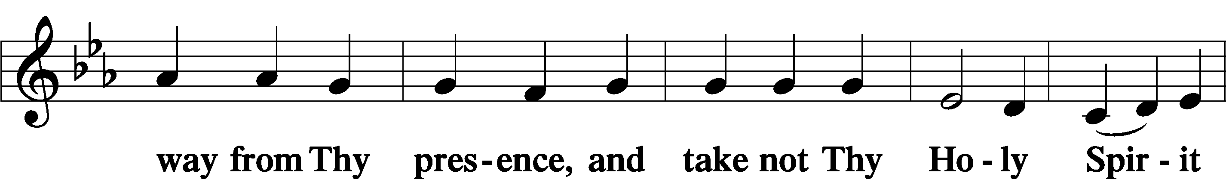
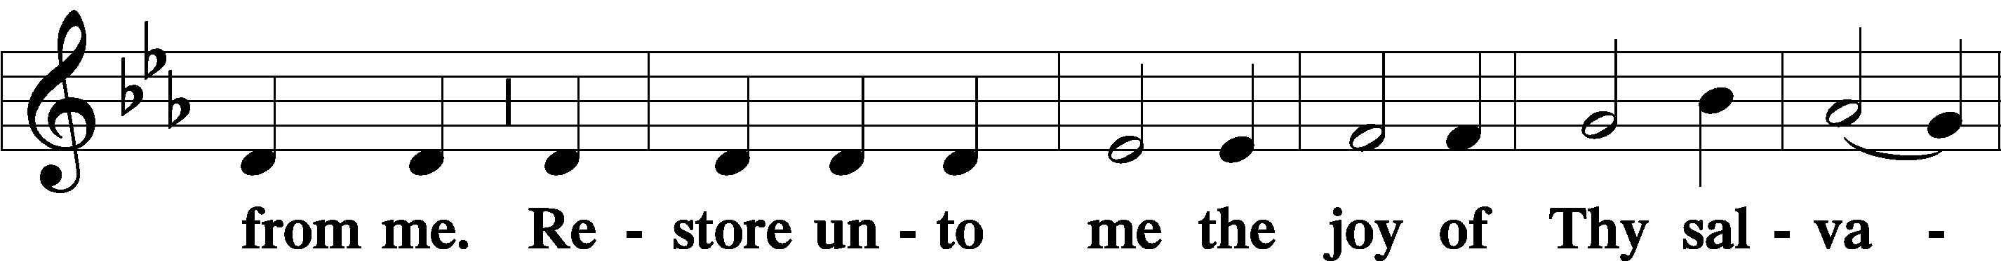
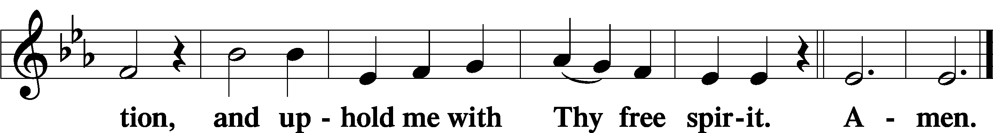

Prayer of the Church

Sit

Preparatory Hymn: LSB #627 “Jesus Christ, Our Blessed Savior”

Stand
Service of the Sacrament

Preface 2 Timothy 4:22; Colossians 3:1 Psalm 136
P The Lord be with you.

P Lift up your hearts.
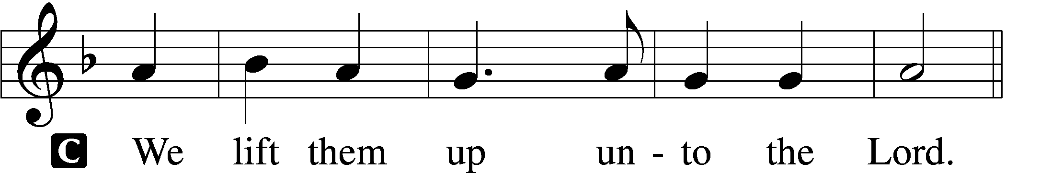
P Let us give thanks unto the Lord, our God.
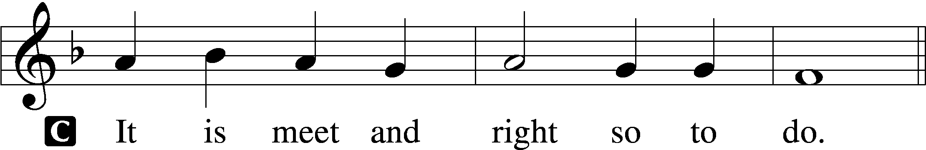

Proper Preface (Abbreviated) LSB 194
P It is truly meet, right, and salutary . . . evermore praising You and saying:

Sanctus Isaiah 6:3; Matthew 21:9
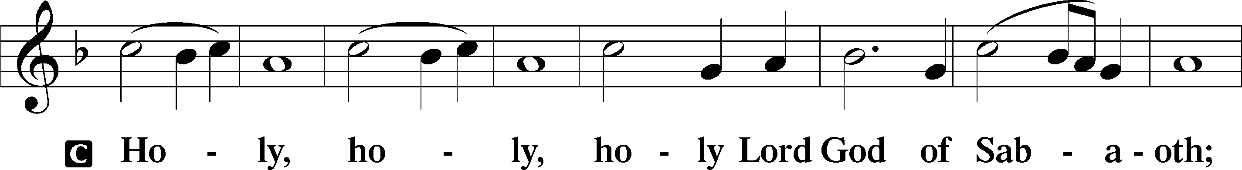
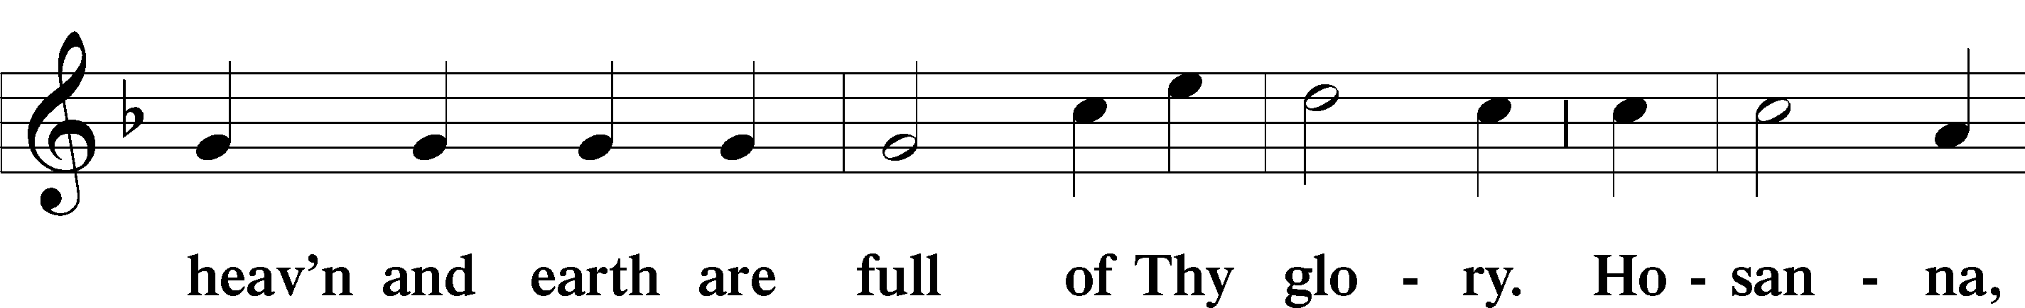
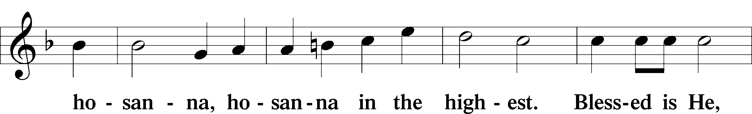
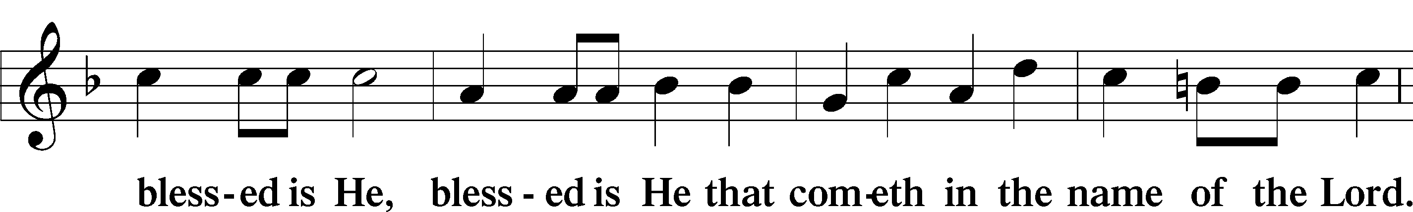
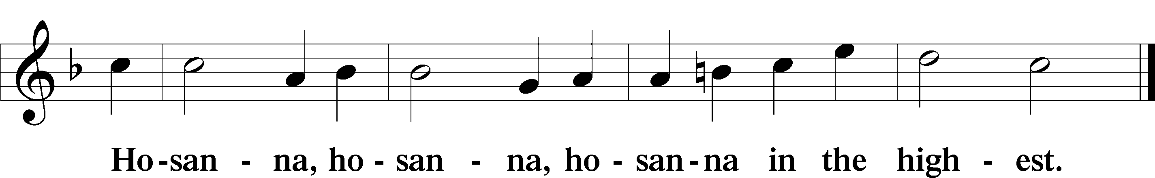

Lord’s Prayer The congregation is encouraged to silently pray the Lord’s Prayer as it is chanted. Matthew 6:9–13
P Our Father who art in heaven,
hallowed be Thy name,
Thy kingdom come,
Thy will be done on earth as it is in heaven;
give us this day our daily bread;
and forgive us our trespasses as we forgive those who trespass against us;
and lead us not into temptation,
but deliver us from evil.
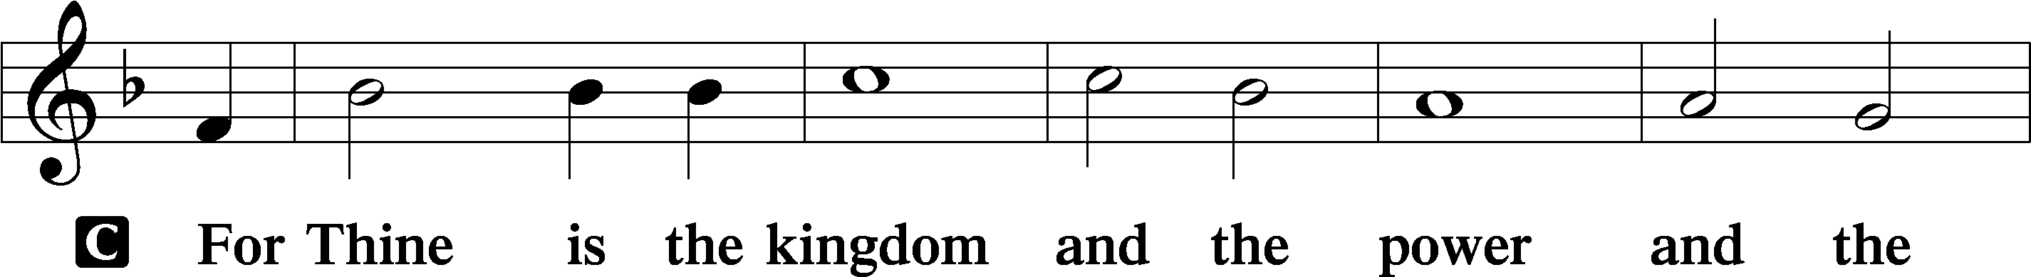
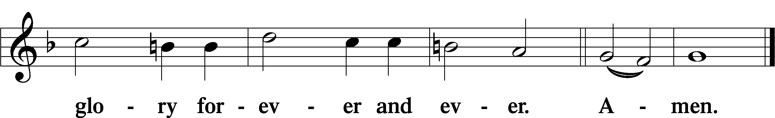

The Words of Our Lord Matthew 26:26–28; Mark 14:22–24; Luke 22:19–20; 1 Corinthians 11:23–25
P Our Lord Jesus Christ, on the night when He was betrayed, took bread, and when He had given thanks, He broke it and gave it to the disciples and said: “Take, eat; this is My T body, which is given for you. This do in remembrance of Me.”

In the same way also He took the cup after supper, and when He had given thanks, He gave it to them, saying: “Drink of it, all of you; this cup is the new testament in My T blood, which is shed for you for the forgiveness of sins. This do, as often as you drink it, in remembrance of Me.”

Pax Domini John 20:19
P The peace of the Lord be with you always.
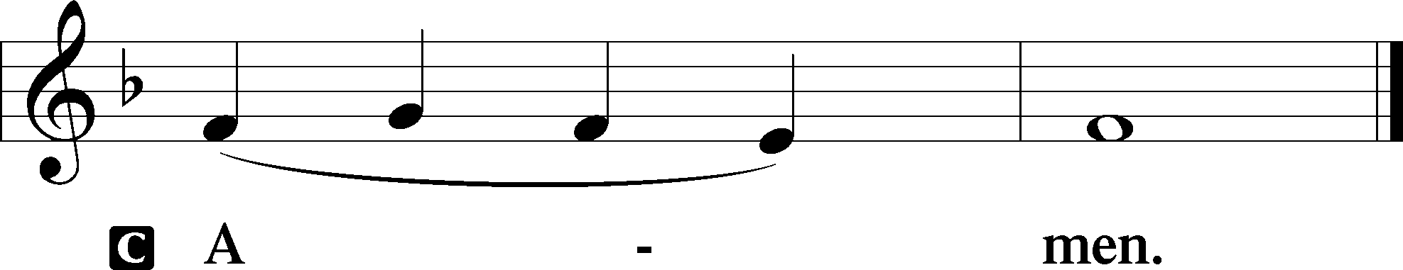

Agnus Dei John 1:29
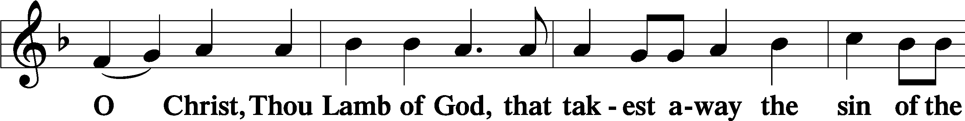
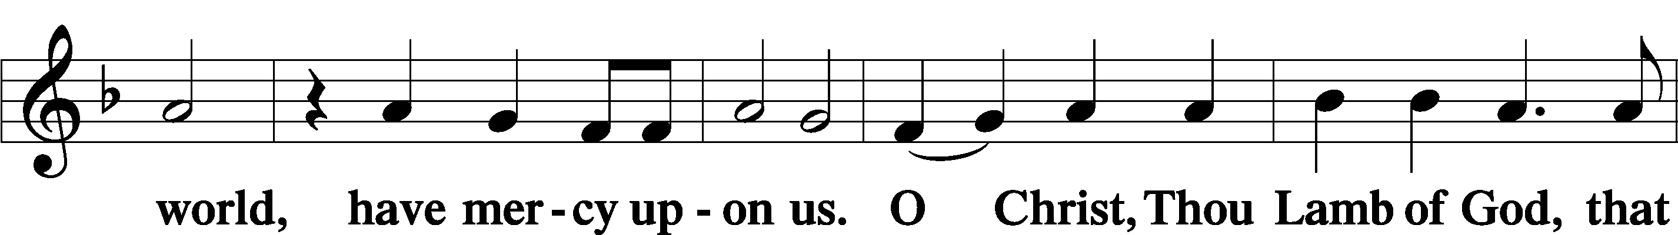
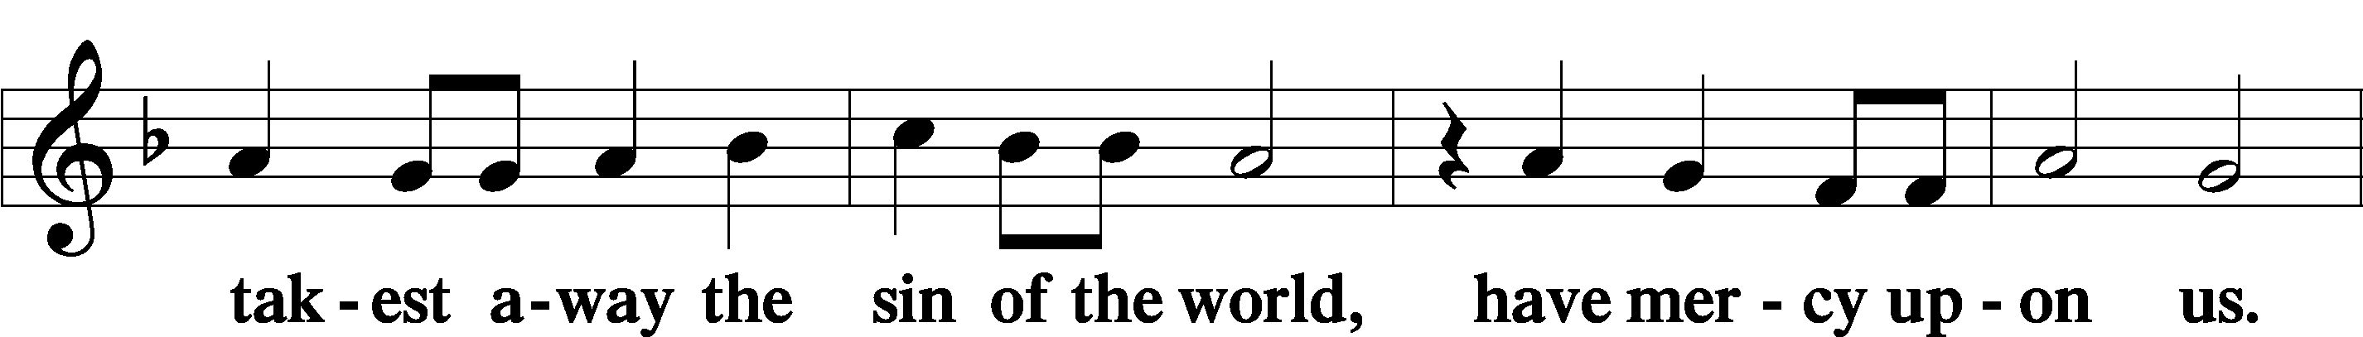
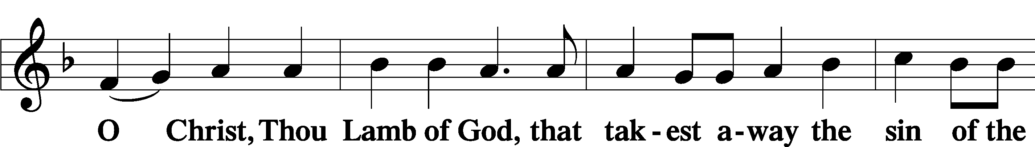
Sit

Distribution
The pastor and those who assist him receive the body and blood of Christ first and then distribute them to those who come to receive, saying:
Take, eat; this is the true body of our Lord and Savior Jesus Christ, given into death for your sins.
Amen.

Take, drink; this is the true blood of our Lord and Savior Jesus Christ, shed for the forgiveness of your sins.
Amen.

In dismissing the communicants, the following is said:
The Dismissal
P The body and blood of our Lord Jesus Christ strengthen and preserve you in body and soul to life everlasting. Depart T in peace.
C Amen.

Distribution Hymn: LSB #618 “I Come, O Savior, to Thy Table”

Distribution Hymn: TLH #165 “Behold the Lamb of God!”
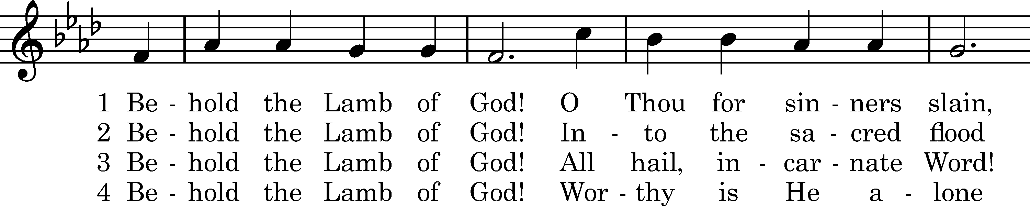
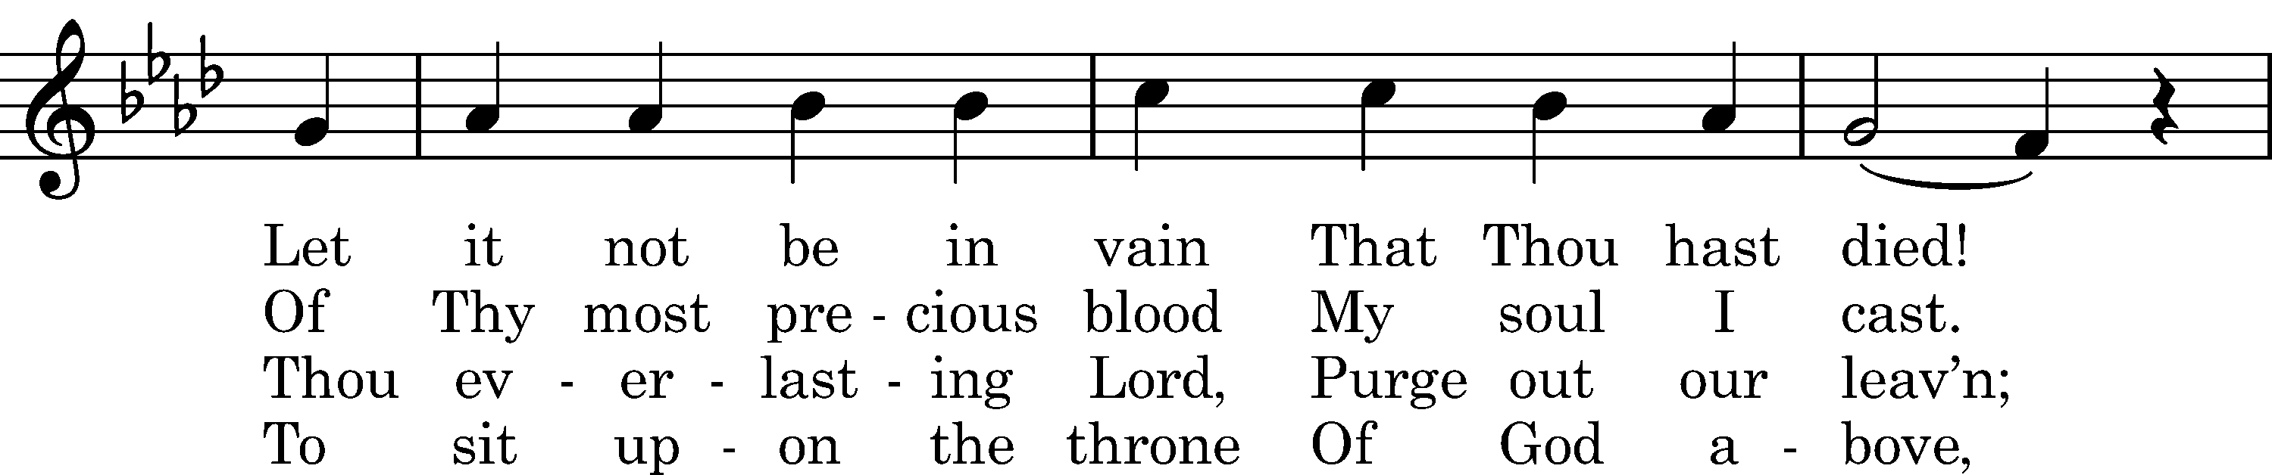
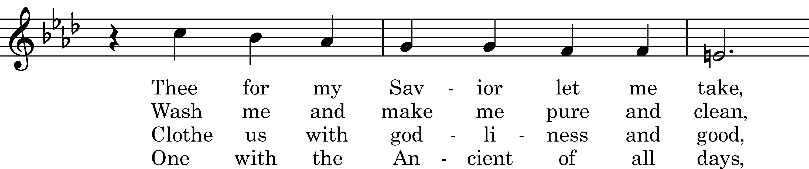
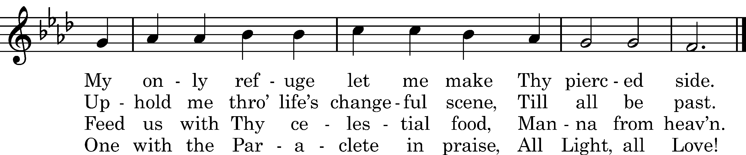

Text: Matthew Bridges, 1848, alt. Tune: Neues Gesangbuch, Dresden, 1593 Text and tune: Public domain

Distribution Hymn: LSB #630 “Now, My Tongue, the Mystery Telling”

Nunc Dimittis Luke 2:29–32
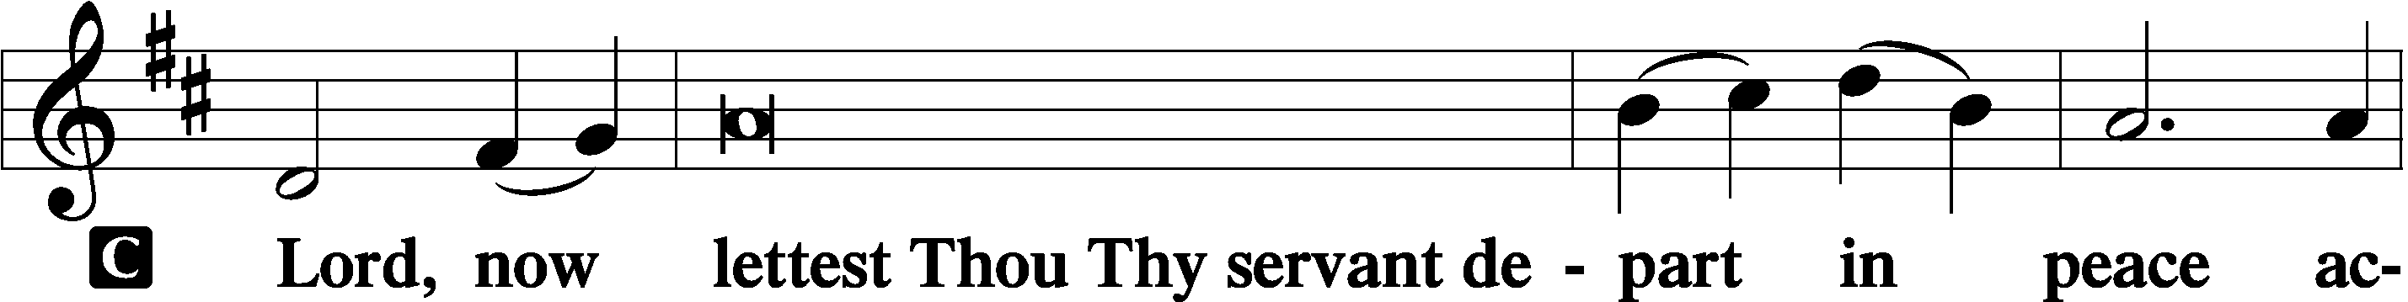
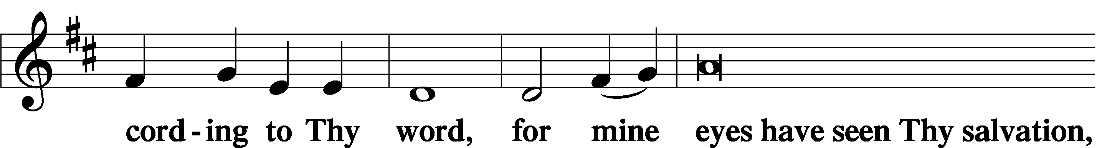
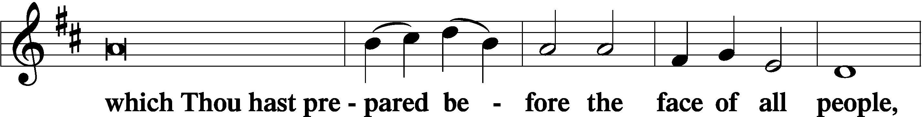
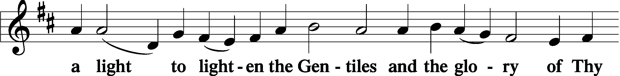
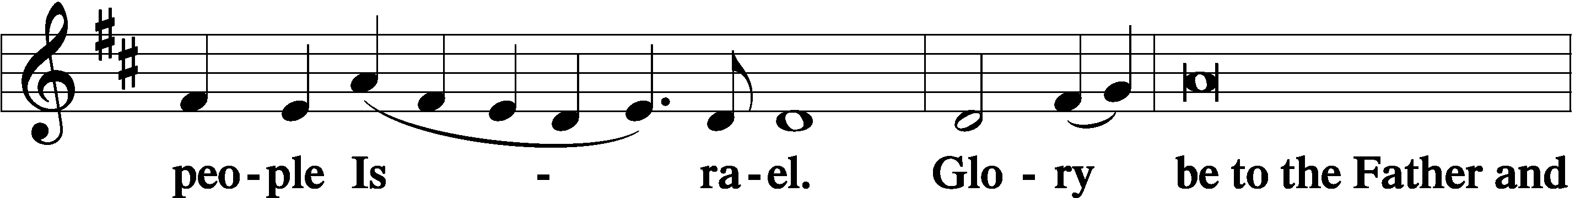
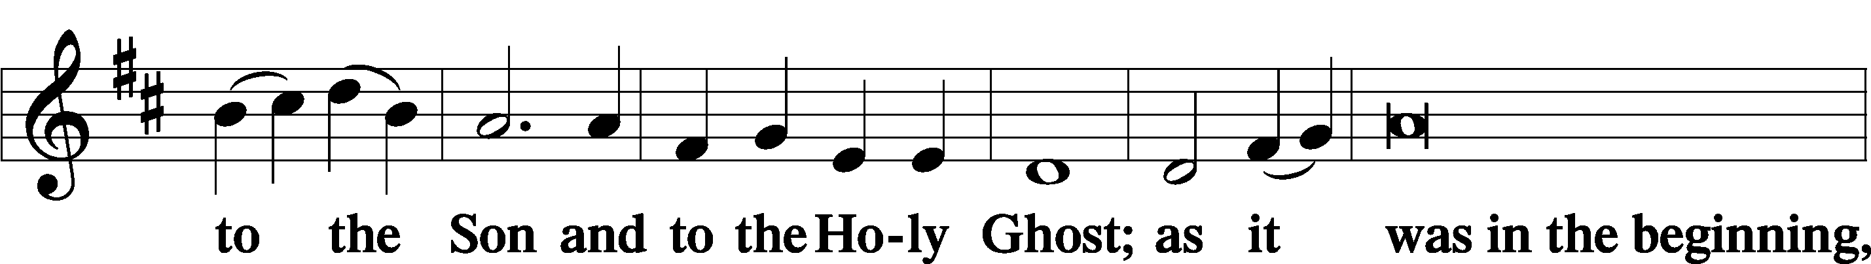
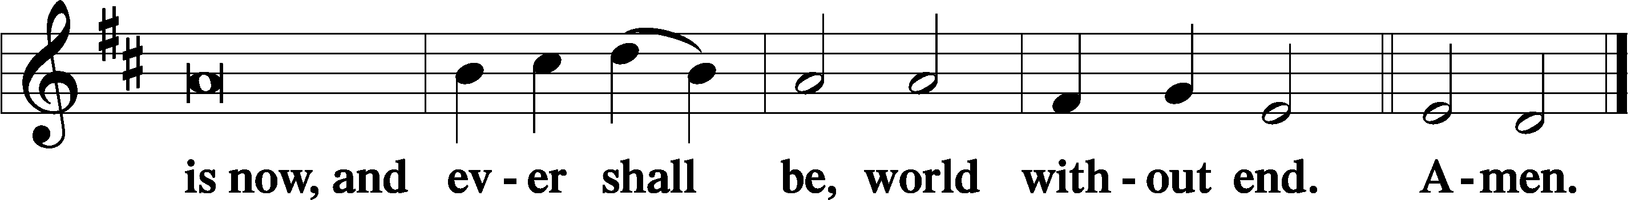

Thanksgiving Psalm 107:1
P O give thanks unto the Lord, for He is good,
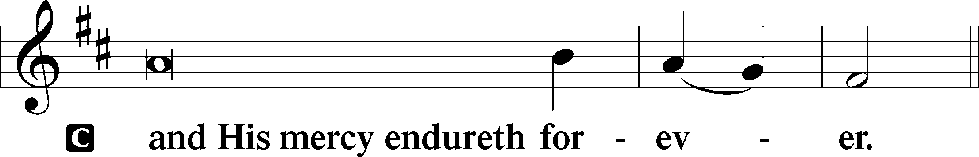

Post-Communion Collect
P Let us pray.
We give thanks to You, almighty God, that You have refreshed us through this salutary gift, and we implore You that of Your mercy You would strengthen us through the same in faith toward You and in fervent love toward one another; through Jesus Christ, Your Son, our Lord, who lives and reigns with You and the Holy Spirit, one God, now and forever.
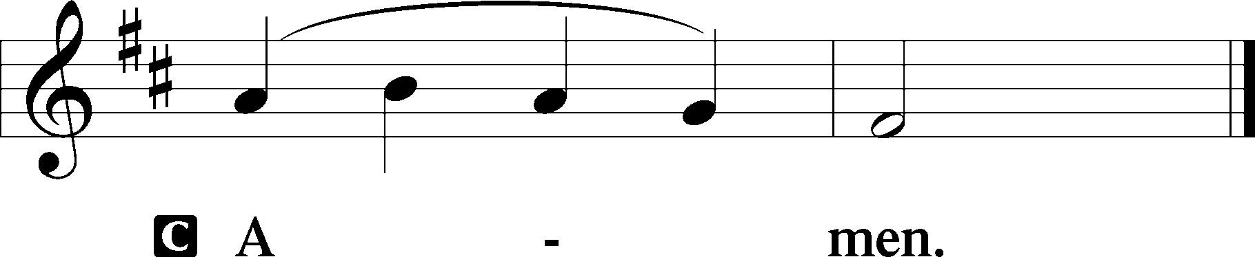

Salutation 2 Timothy 4:22
P The Lord be with you.
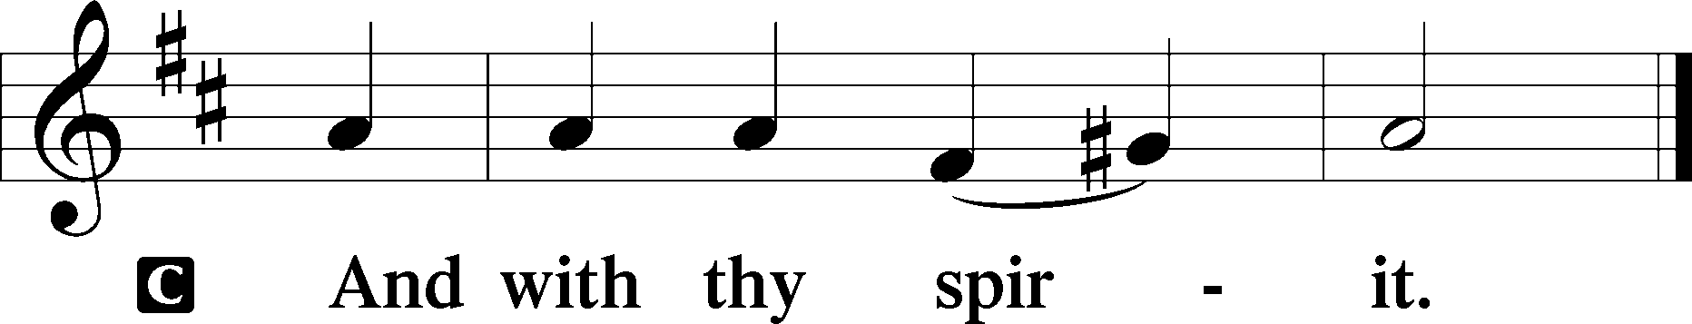

Benedicamus Psalm 103:1
P Bless we the Lord.
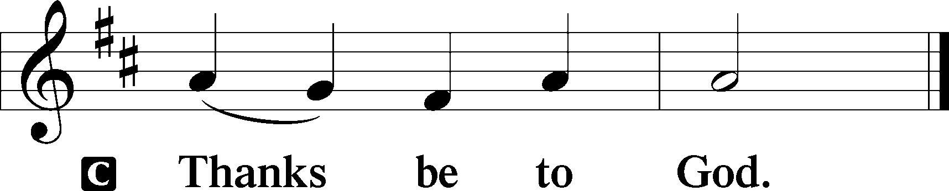

Benediction Numbers 6:24–26
P The Lord bless you and keep you.
The Lord make His face shine upon you and be gracious unto you.
The Lord lift up His countenance upon you and T give you peace.
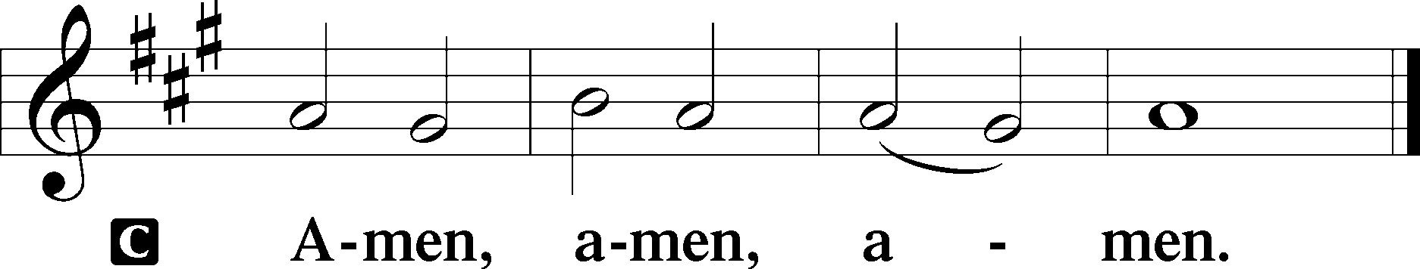

Closing Hymn: LSB #423 “Jesus, Refuge of the Weary”

Silent prayer after worship: Lord Jesus, as I go forth from this worship service, cause me to remember Your great love for me and all people. Give me boldness and faith to share Your love with others through my words and deeds. Amen.

Acknowledgments
Unless otherwise indicated, Scripture quotations are from the ESV® Bible (The Holy Bible, English Standard Version®), copyright © 2001 by Crossway, a publishing ministry of Good News Publishers. Used by permission. All rights reserved.
Created by Lutheran Service Builder © 2024 Concordia Publishing House.

fffffffffffffffffffffffffffffffffff
In Loving Memory of Parents, Eva & Michael Dorfi: Edeltraud Sulek (Capital Campaign).
fffffffffffffffffffffffffffffffffff
Attendance: Friday, February 2, 2024: 6
Sunday, February 4, 2024: 35
fffffffffffffffffffffffffffffffffff
SCHEDULE THROUGH FEBRUARY 18, 2024:

:

Today, following Worship, Fellowship Hall: Coffee Fellowship
7 pm, Fellowship Hall: AA Meeting
7 pm, Deal home: Bible Study
Monday, 9 am – 5 pm, Sanctuary: Individual Confession and Absolution
Tuesday, 7 pm, Library: Trustees’ Meeting
7-9 pm, Fellowship Hall: Penn-Ohio Singers
Wednesday, 7 pm, Sanctuary: Ash Wednesday Divine Service
7 pm, Fellowship Hall: NA Meeting
Next Sunday, 8 am, Fellowship Hall: Bible Study
9 am, Sanctuary: Divine Service
Following, Library: Monthly Audit
7 pm, Fellowship Hall: AA Meeting
fffffffffffffffffffffffffffffffffff
Bible Memory Verses ~ Week of February 11th:
For Adults: You shall love your neighbor as yourself. Mark 12:31

For Children: See, we are going up to Jerusalem, and everything that is written about the Son of Man by the prophets will be accomplished. Luke 18:31
fffffffffffffffffffffffffffffffffff
Minutes from the January 29th Church Council meeting are available on the table in the narthex and outside the secretary’s office.
fffffffffffffffffffffffffffffffffff

Our Stewardship of Treasures for the Lord:
Online Figure for Thursday, February 1, 2024
General Fund: $80.00
Figures for Sunday, February 4, 2024
General Fund: $4,215.00
SELC: $115.00
Food Pantry: $100.00
Quarterly Missions: $50.00
Capital Campaign: $967.00
YTD Giving/Budget (as of January 28, 2024)
General Fund: $8,125.50/$10,850.08
SELC: $262.00/$307.68

For online giving, check out https://www.saintspeterandpaul.net/online-giving.
fffffffffffffffffffffffffffffffffff
THANK YOU FOR SERVING IN FEBRUARY: Elder: Jonathan Baisch; Ushers: Matt Berent, Mark Gabriel, Michael Laird, and Jerome Thomas; Altarware ~ Sundays: (prior) Marie Flaugher (02.11), Diane Riefstahl (02.18 and 02.25); (after) Marie Flaugher; ~Special Divine Service (02.14): (prior) Diane Riefstahl; (after) Marie Flaugher.
fffffffffffffffffffffffffffffffffff
Sunday Morning Bible Study has resumed. Join us at 8 am Sunday mornings as we study the Minor Prophets. This evening at 7 pm is the first Sunday Evening Bible Study at the Deal home. This Bible Study group will meet the second and fourth Sunday evenings of the month and is open to all!
fffffffffffffffffffffffffffffffffff
Join us downstairs this morning following worship for Coffee Fellowship sponsored by Mark & Bess Kleindienst.
fffffffffffffffffffffffffffffffffff
This morning is “Stock the Food Pantry Sunday”! Your financial donations to this important outreach mission will be greatly appreciated.
fffffffffffffffffffffffffffffffffff
Remember the following in Prayer…
~The Hurting and Healing: Amy, Steve, Mary Jane Anderson, Steve Antolovich, Ellen Baron^{CA}, Amy Blomenberg, Lois Bortner^{CA}, Sara Brubaker and her son, Canaan; Dee Bullock, Bev & Joe Chlpka, Susan Davies, Loretta Deal, Tim Dudash, Mike Flaugher, Judith & Eddy Furey, Griffin, Pastor Charles Henrickson, Joan, Keith Jozwiakowski, Darla Krajci, Barbara Kreske, Jess Lavoie, Paul Lucas^{CA}, Sandy Marshall, Lynn Price, Juanita Rentschler, Richard Reuning^{CA}, Nancy Robertson^{CA}, Kriss Svidro^{CA}, Rudy Tomko, Bob Usnarski, Joel & Peggy Wasson, Angela Weser^{CA}, Ruth Wolf, and Michelle Young.
~The Homebound: Anna Mae Daris, Millie Elavsky, Jean Tomko, Betty Wolf, and Ed & Millie Zachar.
~Serving in the Military: Alex (Sasha) Carr, Duncan Vaupel, Curtis Sinewe, and Joshua Solyan.
~Community & World Needs: Those suffering due to the conflicts in the Middle East and between Ukraine and Russia; those suffering from loss and dislocation because weather disasters; those suffering from addiction and their families; Local, State, and National Government Leaders; safety for all Police Officers, Firefighters, & First Responders; the unemployed; our First Quarter Local Mission: Community Outreach. *CA represents cancer.
fffffffffffffffffffffffffffffffffff
A box has been placed on the pew outside the library for donations of diapers, baby clothes, and wipes to Katharina’s Closet, an outreach mission of Trinity Evangelical Lutheran Church in Warren, OH. Sts. Peter & Paul’s will be collecting items here through Sunday, March 3rd. If you would like to make a financial donation to this cause, which will aid area women and families in need, please make your check out to Katharina’s Closet/Trinity Ev. Lutheran Church and give it directly to Matt Berent.
For additional information, see the brochure posted on the bulletin board outside Pastor Deal’s office.
fffffffffffffffffffffffffffffffffff
Attention All Crafters! Our next Craft Fellowship is tentatively scheduled for Friday, February 23rd at 10 am. Bring your favorite craft to work on and come join us! (Current plans are to meet the second and fourth Fridays of each month.)
Individual Confession and Absolution will be offered Monday, February 12, 2024, between 9 am and 5 pm. Prepare yourself for the penitential season of Lent with the unburdening of your soul by meeting with Pastor Deal. Please enter the church building via the Clover St. door and stop by Pastor’s office before entering the sanctuary. If sanctuary doors are closed, please wait and be seated on a pew in the main hallway.
fffffffffffffffffffffffffffffffffff

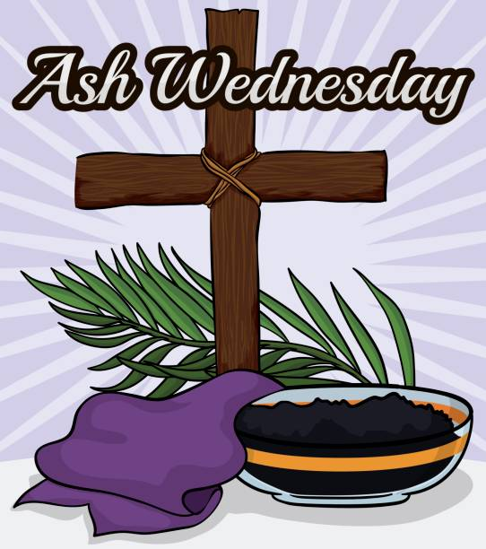
Join us this Wednesday evening, February 14th at 7 pm, for our Ash Wednesday Divine Service.

fffffffffffffffffffffffffffffffffff
There is a sign-up sheet on the table in the narthex for those wishing to provide soup for Lenten soup luncheons/suppers beginning Wednesday, February 21st. Please speak with Pastor Deal if you should have any questions.
fffffffffffffffffffffffffffffffffff
The 2024 Lenten Devotions are available this morning on the tables in the narthex and next to the nursery. Take a copy for a friend!
Help yourself to a tri-fold explanation of “Spiritual Discipline: Almsgiving, Praying, & Fasting”. Copies are available on the table next to the nursery.
fffffffffffffffffffffffffffffffffff
Additional Contact Information:
- Church Website: www.saintspeterandpaul.net
- Food Pantry email: foodpantry@saintspeterandpaul.net
- AA Contact: Steve @ 724-813-2358
- NA Contact: Larry @ 724-977-8733
fffffffffffffffffffffffffffffffffff

