Sts. Peter & Paul
Evangelical Lutheran Church
Lutheran Church-Missouri Synod
Founded-1917

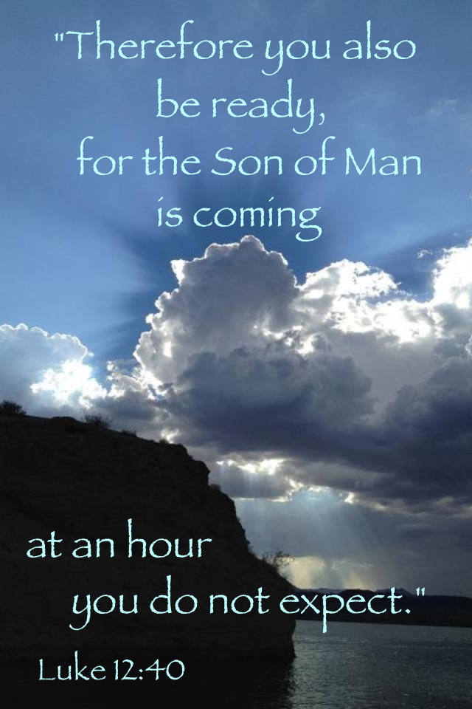

December 31, 2022

699 Stambaugh Avenue
Sharon, Pennsylvania 16146

“I was glad when they said to me,
Let us go to the house of the LORD!”
Psalm 122:1
Sts. Peter & Paul Evangelical Lutheran Church, LC-MS

NEW YEAR’S EVE
December 31, 2022

A special welcome to our guests this day! If you would like more information about The Lutheran Church - Missouri Synod, or this congregation, please speak with Pastor Deal or an Elder after the service.
Members & Guests: Don’t be embarrassed if your children make noise during the worship service, all children do. We encourage families to worship together but, if you feel the need, there are pews in the rear of the Church which are reserved for young families on both sides of the sanctuary. There is also a quiet room available to you during our service which is located down the hallway past the offices on the right side of the church as well as a children’s area in the Fellowship Hall where you are able to follow along with the service.

CONTACT INFORMATION
Pastor Deal: pastordeal@saintspeterandpaul.net or 724-347-3620 (opt. 2)
Church Office: church@saintspeterandpaul.net or 724-347-3620 (opt. 3)

Silent prayer before worship: Dearest Lord Jesus, You have come to me as the Holy Child of Bethlehem. I come to You this hour to receive Your gifts peace, hope, love, joy and life. Help me to value these more than anything else. Amen.

VESPERS SERVICE
Opening Hymn: LSB #760 “What God Ordains Is Always Good”

Stand

Common Versicles LSB 229
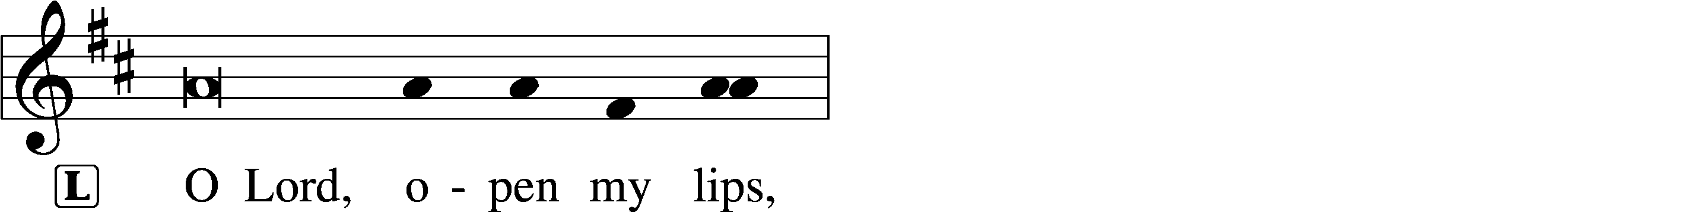
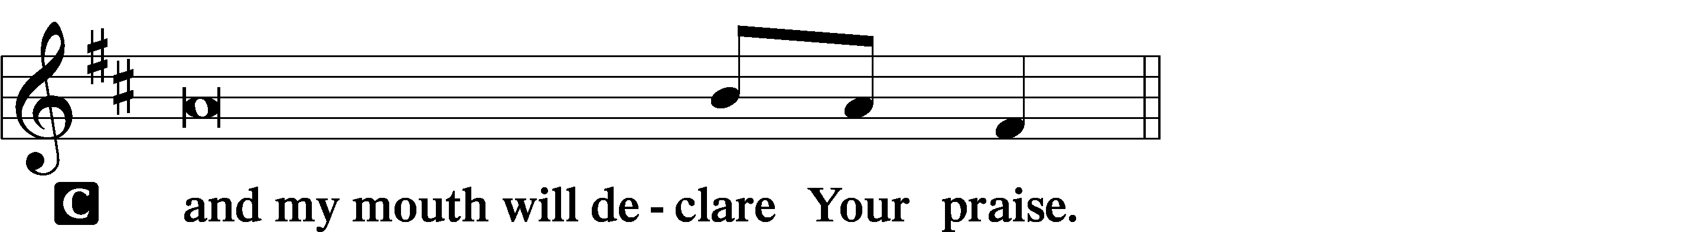

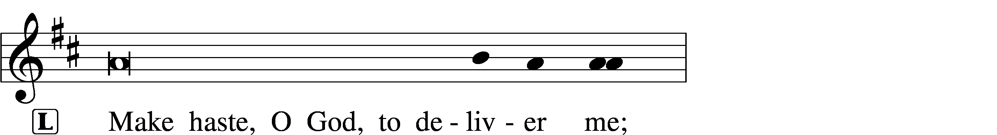
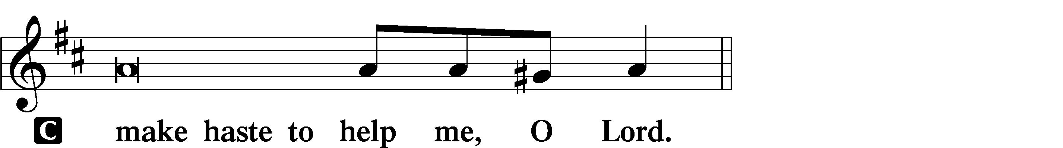

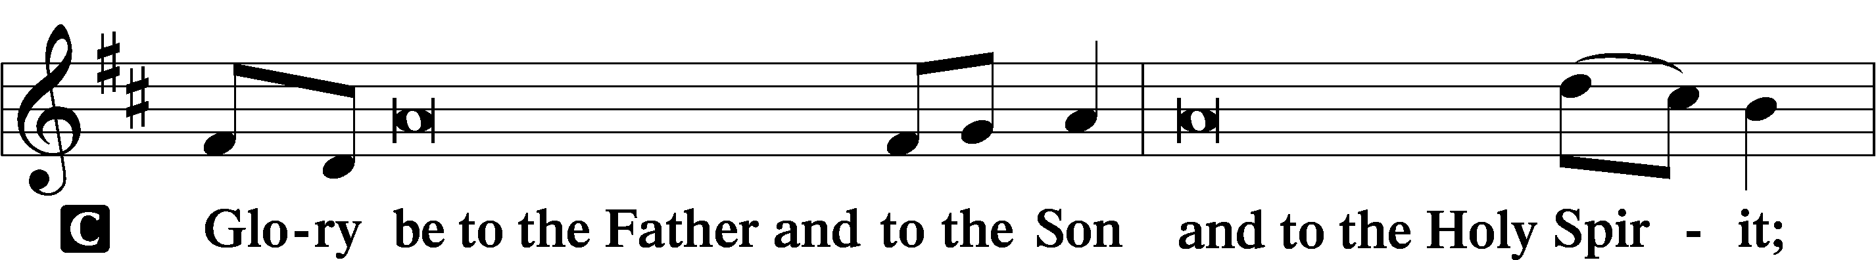
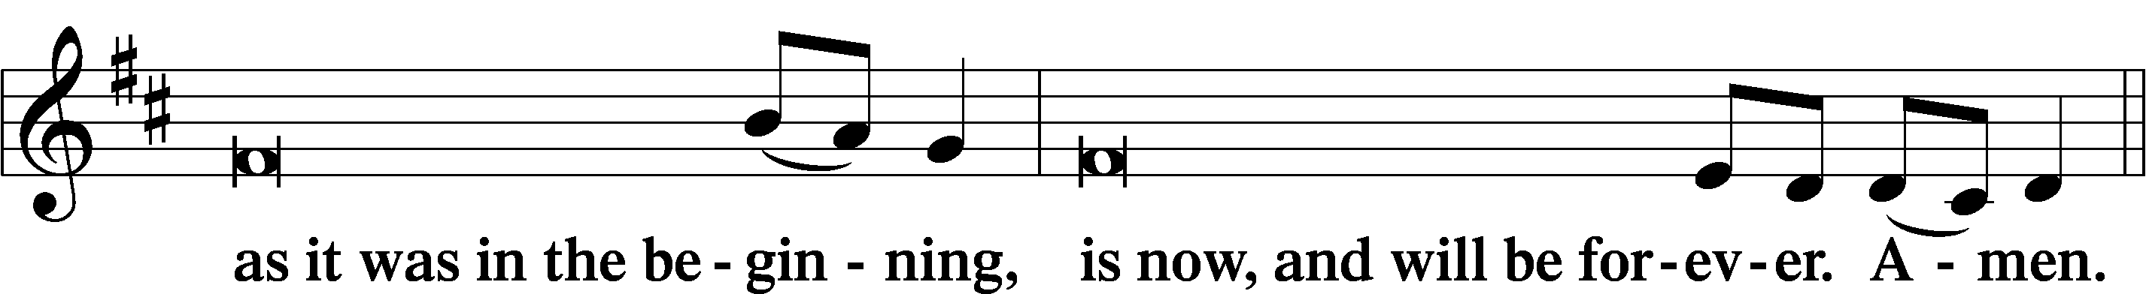
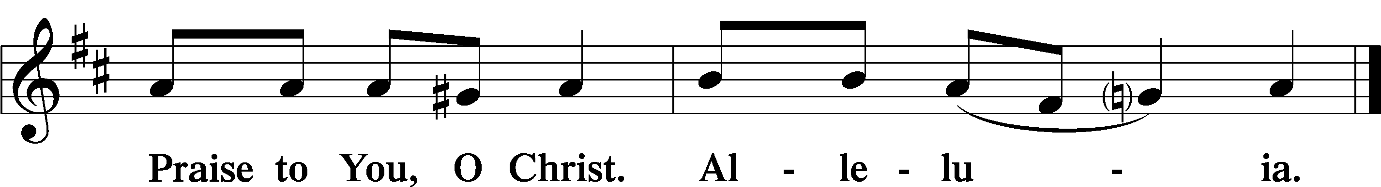

Psalmody

Psalm 90:1–12
Lord, you have been our dwelling place
in all generations.
Before the mountains were brought forth,
or ever you had formed the earth and the world,
from everlasting to everlasting you are God.
You return man to dust
and say, “Return, O children of man!”
For a thousand years in your sight
are but as yesterday when it is past,
or as a watch in the night.
You sweep them away as with a flood;
they are like a dream,
like grass that is renewed in the morning:
in the morning it flourishes and is renewed;
in the evening it fades and withers.
For we are brought to an end by your anger;
by your wrath we are dismayed.
You have set our iniquities before you,
our secret sins in the light of your presence.
For all our days pass away under your wrath;
we bring our years to an end like a sigh.
The years of our life are seventy,
or even by reason of strength eighty;
yet their span is but toil and trouble;
they are soon gone, and we fly away.
Who considers the power of your anger,
and your wrath according to the fear of you?
So teach us to number our days
that we may get a heart of wisdom.
Sit

Hymn of the Day: LSB #899 “Across the Sky the Shades of Night”

Readings

Reading: Isaiah 30:8–17
And now, go, write it before them on a tablet
and inscribe it in a book,
that it may be for the time to come
as a witness forever.
For they are a rebellious people,
lying children,
children unwilling to hear
the instruction of the Lord;
who say to the seers, “Do not see,”
and to the prophets, “Do not prophesy to us what is right;
speak to us smooth things,
prophesy illusions,
leave the way, turn aside from the path,
let us hear no more about the Holy One of Israel.”
Therefore thus says the Holy One of Israel,
“Because you despise this word
and trust in oppression and perverseness
and rely on them,
therefore this iniquity shall be to you
like a breach in a high wall, bulging out, and about to collapse,
whose breaking comes suddenly, in an instant;
and its breaking is like that of a potter’s vessel
that is smashed so ruthlessly
that among its fragments not a shard is found
with which to take fire from the hearth,
or to dip up water out of the cistern.”
For thus said the Lord God, the Holy One of Israel,
“In returning and rest you shall be saved;
in quietness and in trust shall be your strength.”
But you were unwilling, and you said,
“No! We will flee upon horses”;
therefore you shall flee away;
and, “We will ride upon swift steeds”;
therefore your pursuers shall be swift.
A thousand shall flee at the threat of one;
at the threat of five you shall flee,
till you are left
like a flagstaff on the top of a mountain,
like a signal on a hill.
P This is the Word of the Lord.
C Thanks be to God.

Reading: Romans 8:31b–39
If God is for us, who can be against us? He who did not spare his own Son but gave him up for us all, how will he not also with him graciously give us all things? Who shall bring any charge against God’s elect? It is God who justifies. Who is to condemn? Christ Jesus is the one who died—more than that, who was raised—who is at the right hand of God, who indeed is interceding for us. Who shall separate us from the love of Christ? Shall tribulation, or distress, or persecution, or famine, or nakedness, or danger, or sword? As it is written,
“For your sake we are being killed all the day long;
we are regarded as sheep to be slaughtered.”
No, in all these things we are more than conquerors through him who loved us. For I am sure that neither death nor life, nor angels nor rulers, nor things present nor things to come, nor powers, nor height nor depth, nor anything else in all creation, will be able to separate us from the love of God in Christ Jesus our Lord.

P This is the Word of the Lord.
C Thanks be to God.

Reading: Luke 12:35–40
[Jesus said:] “Stay dressed for action and keep your lamps burning, and be like men who are waiting for their master to come home from the wedding feast, so that they may open the door to him at once when he comes and knocks. Blessed are those servants whom the master finds awake when he comes. Truly, I say to you, he will dress himself for service and have them recline at table, and he will come and serve them. If he comes in the second watch, or in the third, and finds them awake, blessed are those servants! But know this, that if the master of the house had known at what hour the thief was coming, he would not have left his house to be broken into. You also must be ready, for the Son of Man is coming at an hour you do not expect.”

P This is the Word of the Lord.
C Thanks be to God.

Sermon
Canticle
Stand

Antiphon (Common) 231
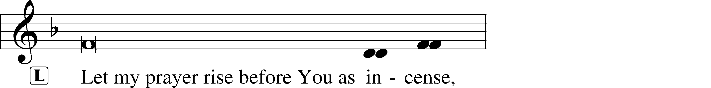
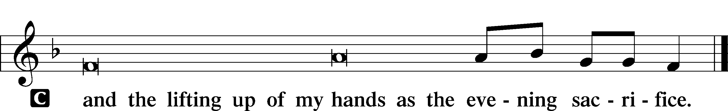

Magnificat 231
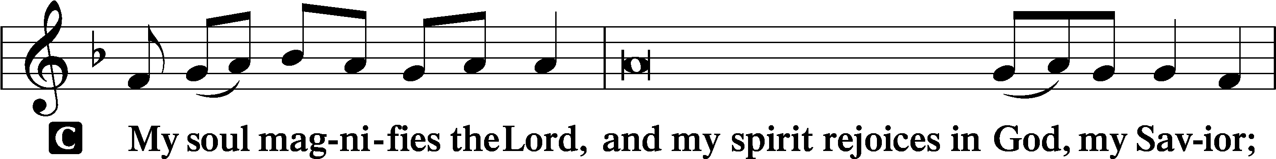
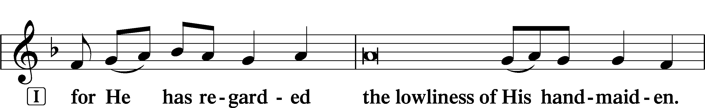
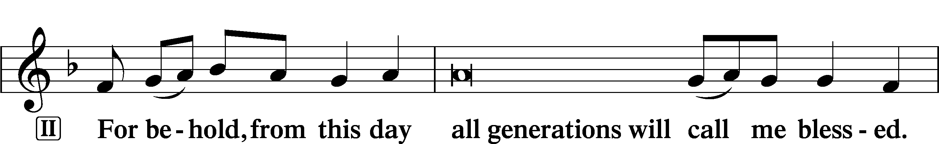
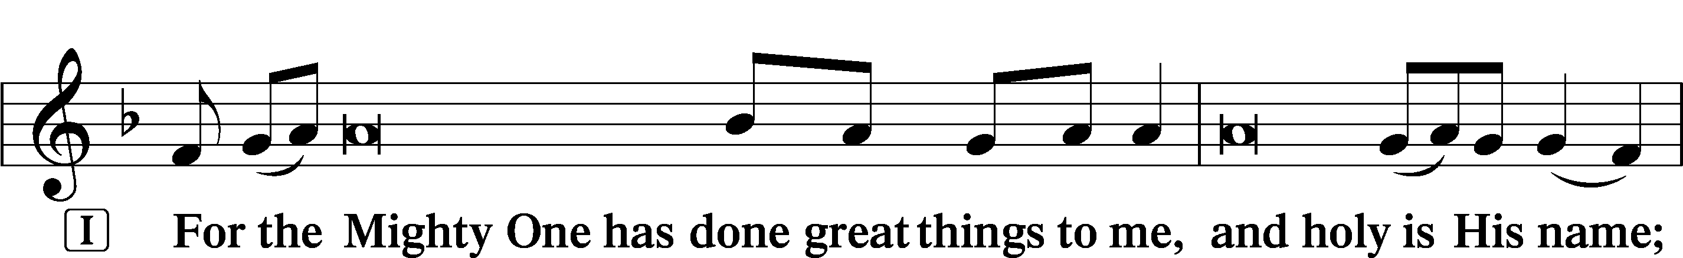
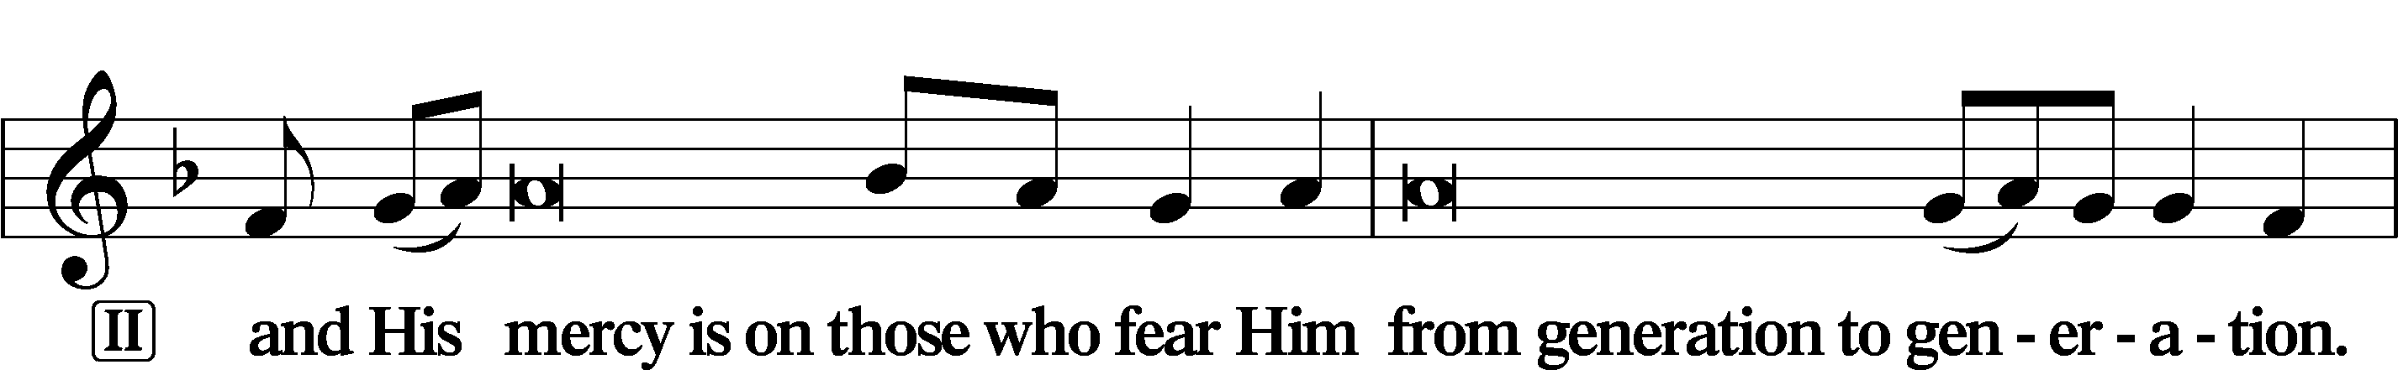
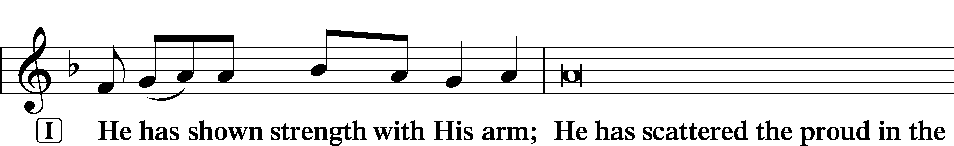
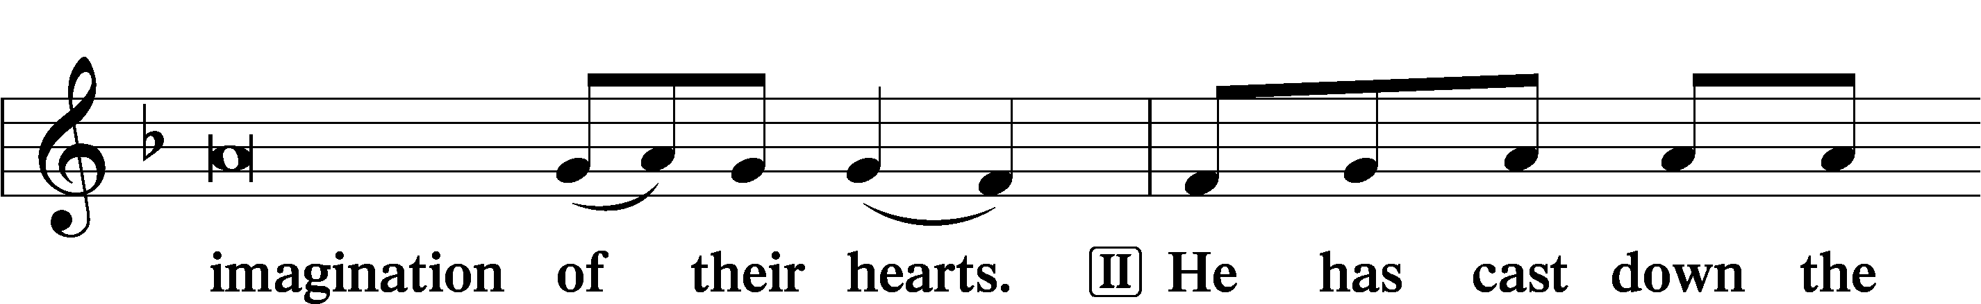
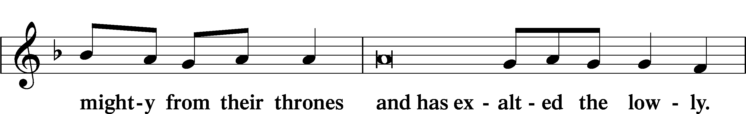
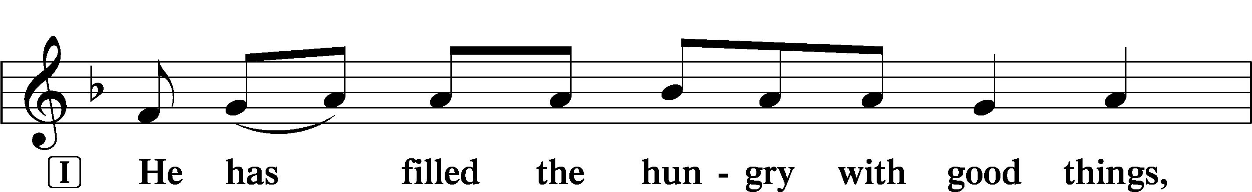
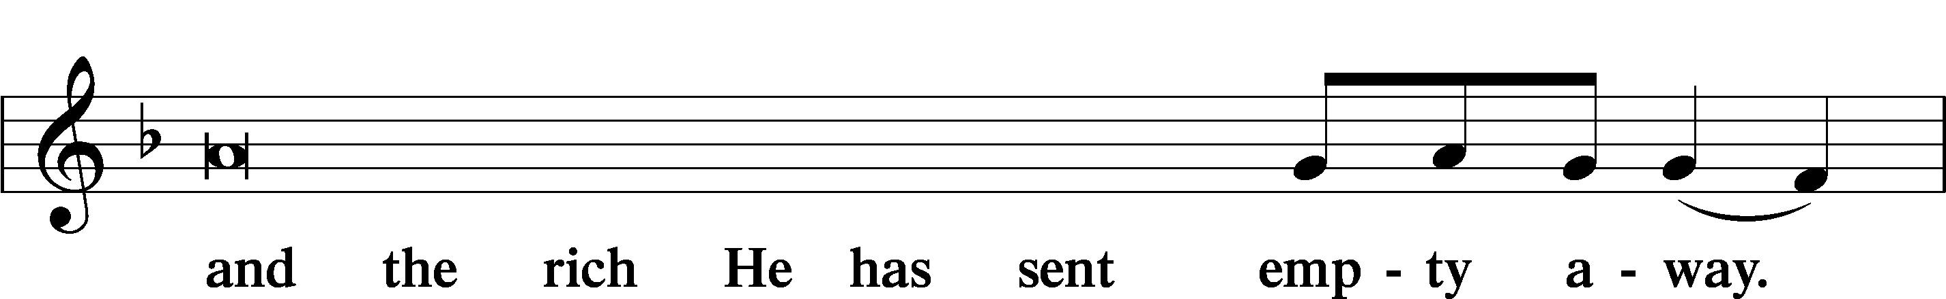
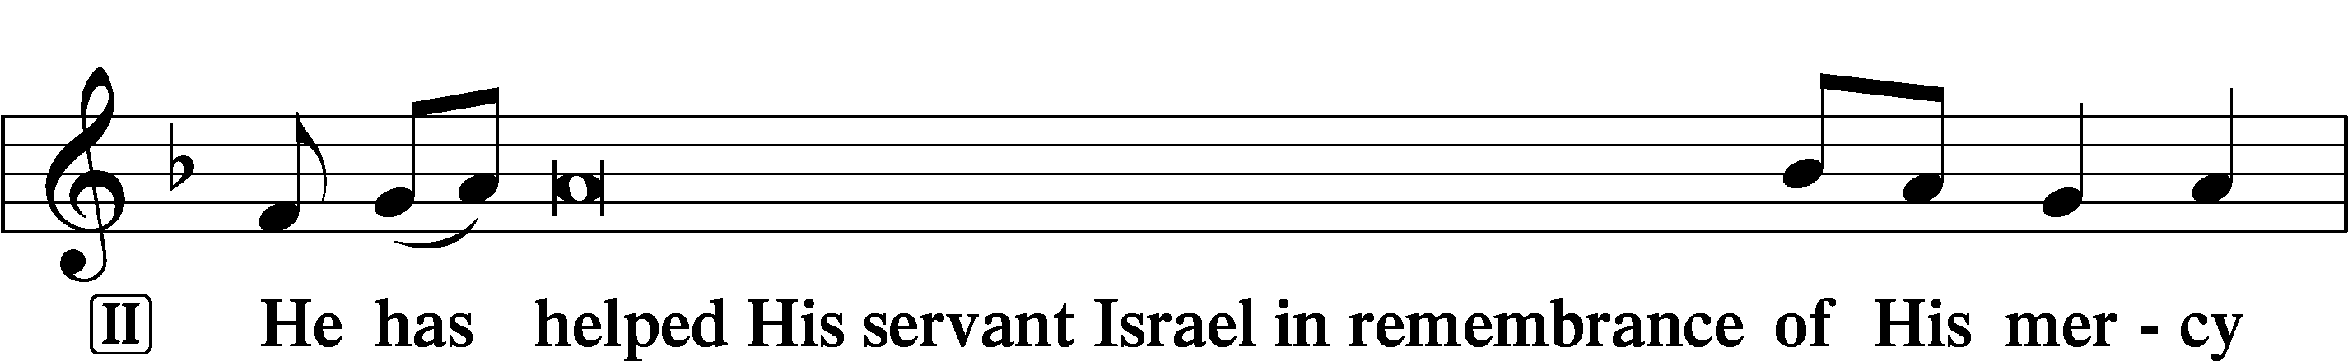
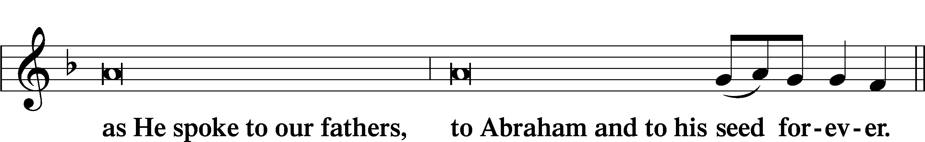
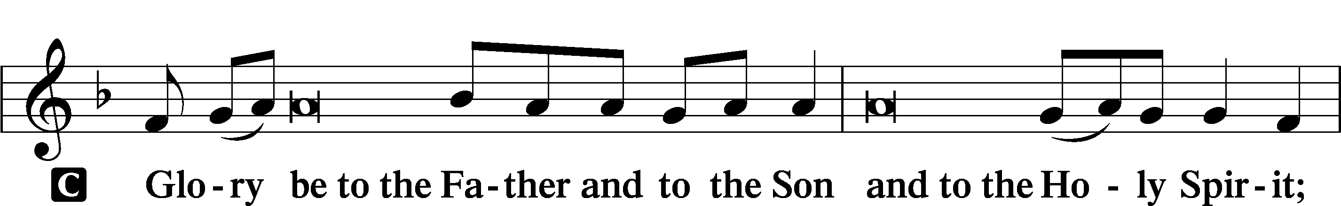
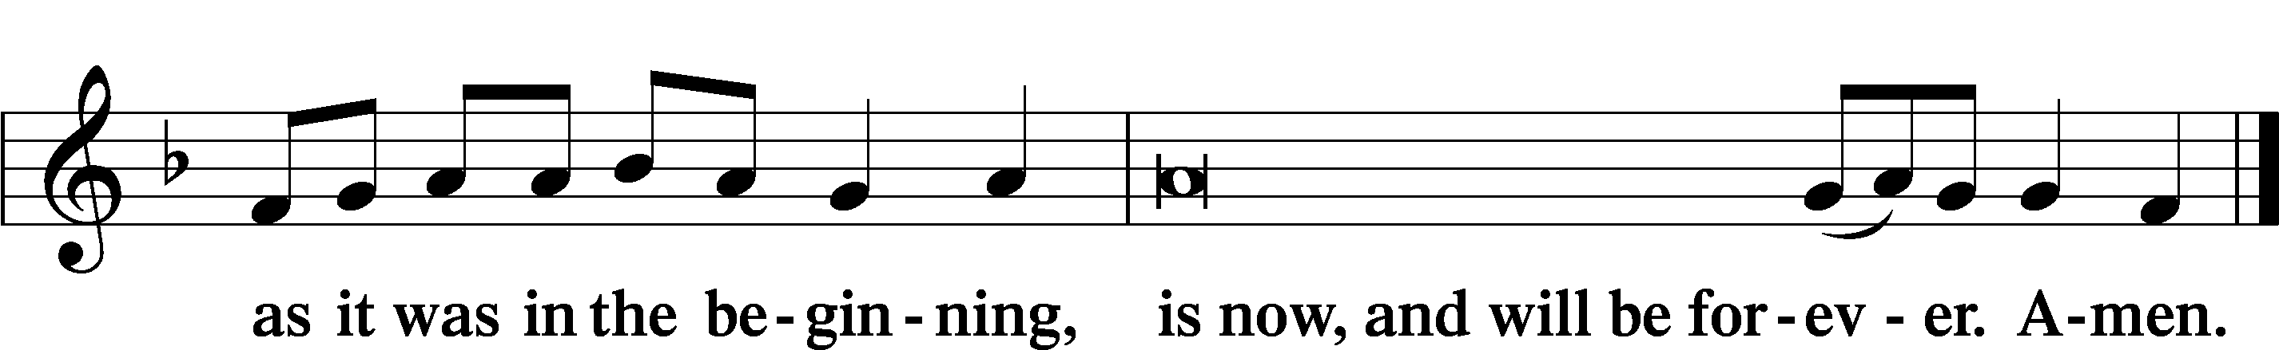

Prayer

Kyrie LSB 233
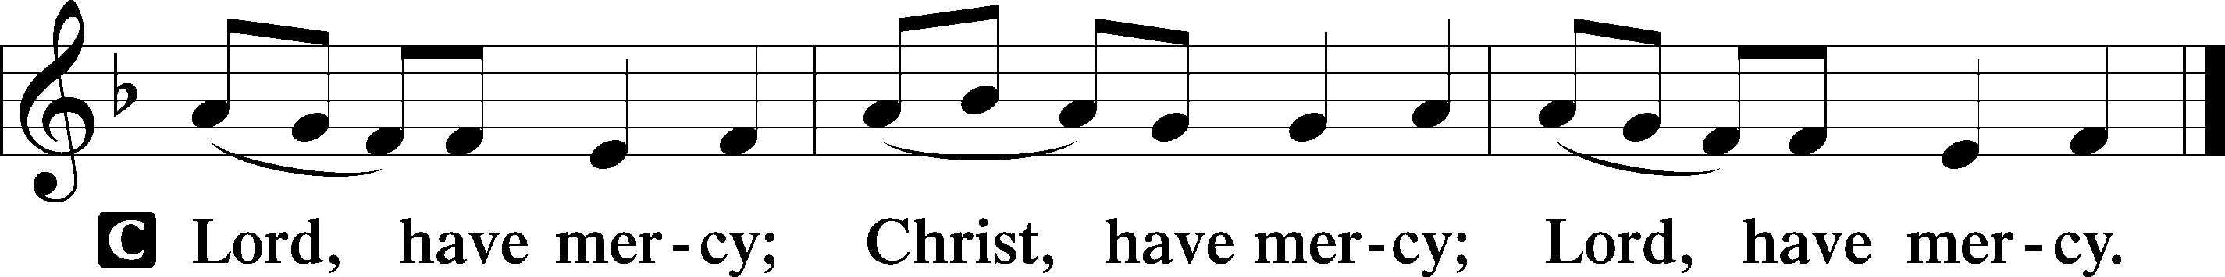

Lord’s Prayer
C Our Father who art in heaven,
hallowed be Thy name,
Thy kingdom come,
Thy will be done on earth
as it is in heaven;
give us this day our daily bread;
and forgive us our trespasses
as we forgive those
who trespass against us;
and lead us not into temptation,
but deliver us from evil.
For Thine is the kingdom
and the power and the glory
forever and ever. Amen.

Collects
Introduction to Collects LSB 233
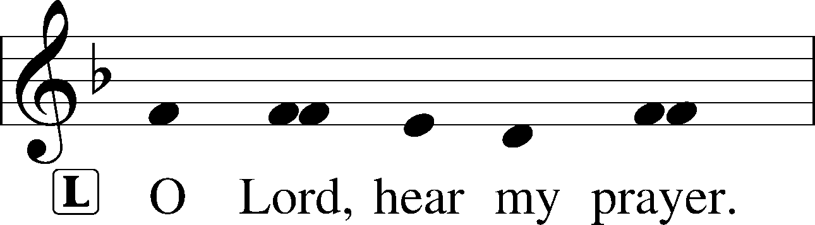
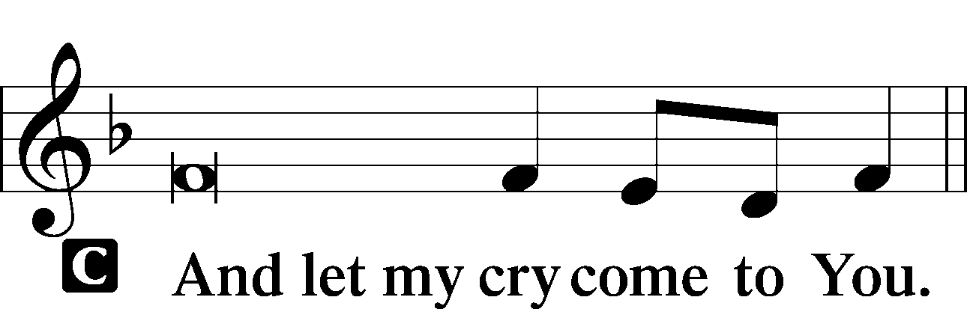

Collect of the Day: New Year’s Eve
P Eternal God, we commit to Your mercy and forgiveness the year now ending and commend to Your blessing and love the times yet to come. In the new year, abide among us with Your Holy Spirit that we may always trust in the saving name of our Lord Jesus Christ, who lives and reigns with You and the Holy Spirit, one God, now and forever.

Collect for Peace
L O God, from whom come all holy desires, all good counsels, and all just works, give to us, Your servants, that peace which the world cannot give, that our hearts may be set to obey Your commandments and also that we, being defended from the fear of our enemies, may live in peace and quietness; through Jesus Christ, Your Son, our Lord, who lives and reigns with You and the Holy Spirit, one God, now and forever.
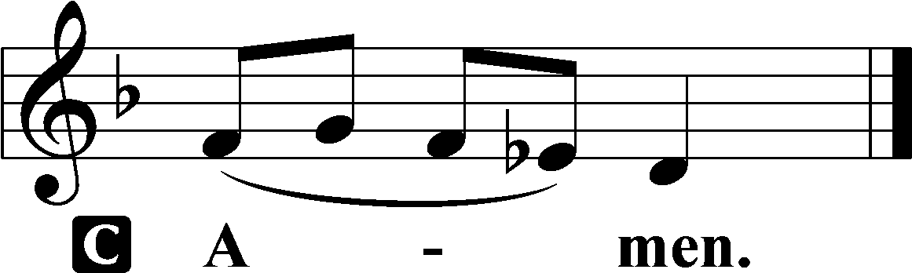

Benedicamus LSB 234
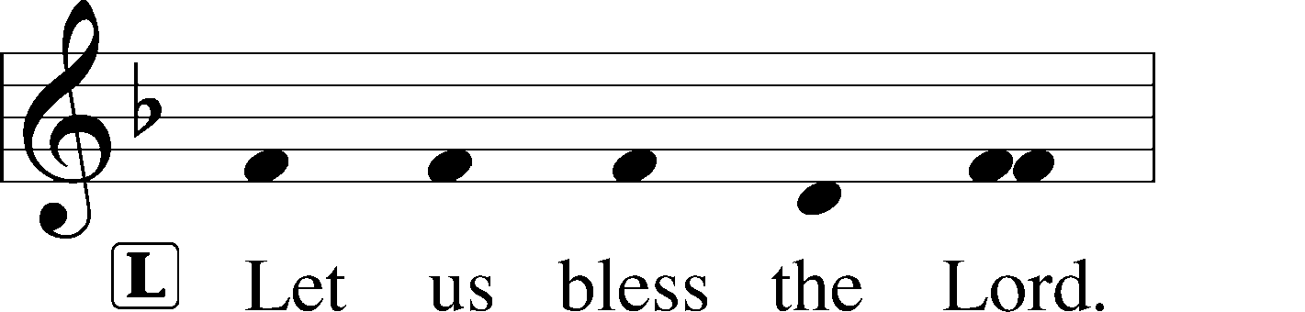
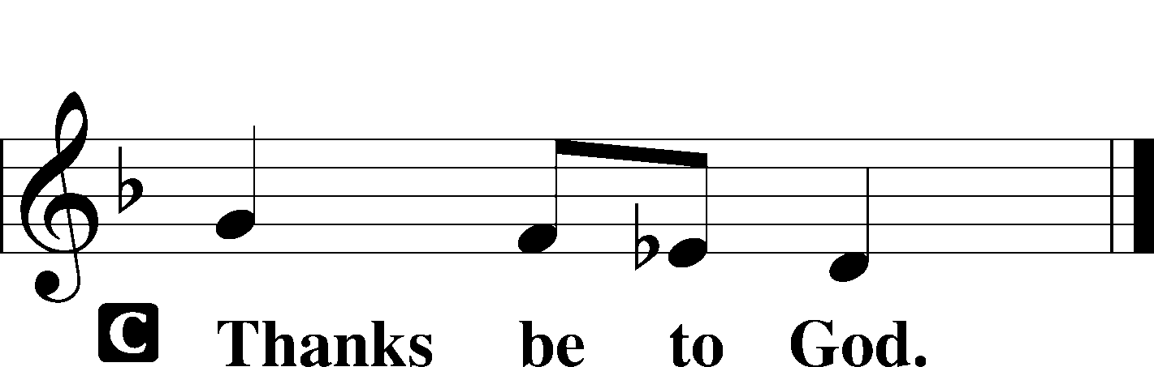

Benediction LSB 234
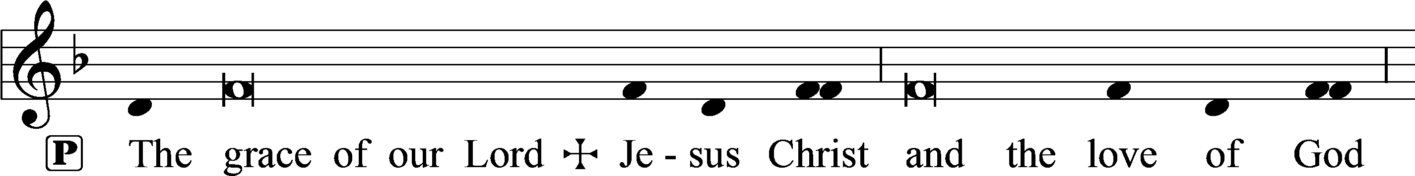
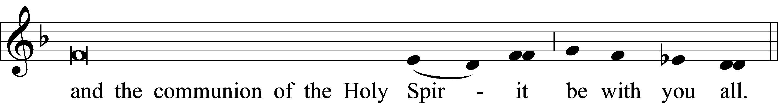

Closing Hymn: LSB #663 “Rise, My Soul, to Watch and Pray”

Silent prayer after worship: Thank You, Lord Jesus, for leaving Your throne in heaven to come and be my Savior. Lead me to daily rejoice and give thanks for Your gift of salvation, and to share with others the good news of Your birth. Amen.
fffffffffffffffffffffffffffffffffff
Acknowledgments
Unless otherwise indicated, Scripture quotations are from the ESV® Bible (The Holy Bible, English Standard Version®), copyright © 2001 by Crossway, a publishing ministry of Good News Publishers. Used by permission. All rights reserved.
Created by Lutheran Service Builder © 2021 Concordia Publishing House.

Note: 2023 Offering envelopes are available in the library.
Here to Serve

Pastor………………………………………………...……………Rev. Jacob Deal
E-mail …………………………….……pastordeal@saintspeterandpaul.net
Phone Number……………………..…………………724-347-3620 (Option 2)
Church Office………………………..…………………724-347-3620 (Option 3)
Website …………………………………………www.saintspeterandpaul.net
Secretary…………………………………………………………Diane Riefstahl
E-mail ………………………………………church@saintspeterandpaul.net
Website …………………………………………www.saintspeterandpaul.net
Food Pantry: Please leave message……………724-347-3620 (Option 3)
AA Contact: Steve………………………………………………..…724-813-2358
NA Contact: Larry………………………………………………..724-977-8733
Choir Director………………………………………………………Chris Nelson
Congregation President……………………………………Jonathan Baisch
Elder Chairman…………………………………………...………Barry Nelson
fffffffffffffffffffffffffffffffffff
REMINDER! If needing to get into the church building during the week, please phone first to make certain someone is here to let you in.

