Sts. Peter & Paul
Evangelical Lutheran Church
Lutheran Church-Missouri Synod
Founded-1917

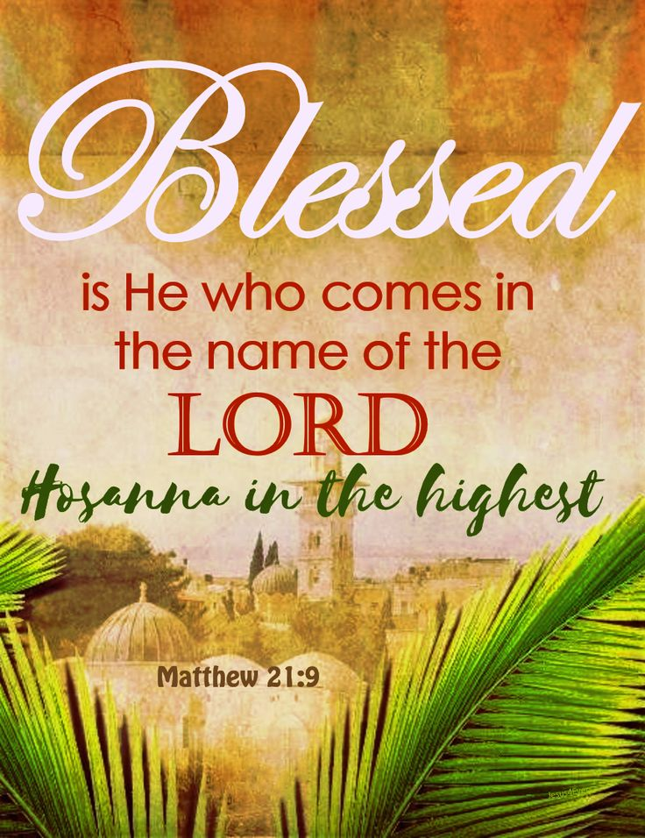

December 3, 2023

699 Stambaugh Ave.
Sharon, Pennsylvania 16146

“I was glad when they said to me,
Let us go to the house of the LORD!”
Psalm 122:1
Sts. Peter & Paul Evangelical Lutheran Church, LC-MS
AD TE LEVAVI
December 3, 2023

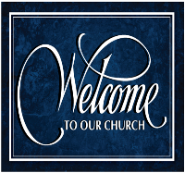
A special welcome to our guests this day! If you would like more information about The Lutheran Church - Missouri Synod, or this congregation, please speak with Pastor Deal or an Elder after the service.
Members & Guests: Don’t be embarrassed if your children make noise during the worship service, all children do. We encourage families to worship together but, if you feel the need, there are pews in the rear of the Church which are reserved for young families on both sides of the sanctuary. There is also a quiet room available to you, located next to the sanctuary (formerly the Pastor’s office), where you would be able to follow along with the service.

Today’s service includes the Sacrament of Holy Communion. If during this past year, you have not worshipped with us and been communed, we respectfully ask that you do not partake of this sacrament this day before first speaking with Pastor Deal.
If visiting from a sister congregation of the LC-MS and are in good standing, please inform Pastor Deal of your desire to commune prior to the service.
If wishing to receive a blessing during communion, please approach with your arms crossed.

CONTACT INFORMATION
Pastor Deal: pastordeal@saintspeterandpaul.net or 724-347-3620 (opt. 2)
Church Office: church@saintspeterandpaul.net or 724-347-3620 (opt. 3)
Secretary’s Office: The office will be open Monday (8:30-5:00). & Wednesday (8:30-10:00; 10:45-5:00).

Silent prayer before worship: Almighty God, You sent Your Son Jesus Christ into this world to give hope and life to all who believe. Lead me to give You thanks and praise for this wonderful gift, and to grow in my love for You. In Jesus’ name. Amen.
Confession and Absolution

Opening Hymn: LSB #334 “O Lord, How Shall I Meet You”

Stand

The sign of the cross may be made by all in remembrance of their Baptism.

Invocation
P In the name of the Father and of the T Son and of the Holy Spirit.
C Amen.

Exhortation Hebrews 10:22; Psalm 124:8; Psalm 32:5
P Beloved in the Lord! Let us draw near with a true heart and confess our sins unto God our Father, beseeching Him in the name of our Lord Jesus Christ to grant us forgiveness.

P Our help is in the name of the Lord,
C who made heaven and earth.
P I said, I will confess my transgressions unto the Lord,
C and You forgave the iniquity of my sin.

Silence for reflection on God’s Word and for self-examination.

Confession of Sins
P O almighty God, merciful Father,
C I, a poor, miserable sinner, confess unto You all my sins and iniquities with which I have ever offended You and justly deserved Your temporal and eternal punishment. But I am heartily sorry for them and sincerely repent of them, and I pray You of Your boundless mercy and for the sake of the holy, innocent, bitter sufferings and death of Your beloved Son, Jesus Christ, to be gracious and merciful to me, a poor, sinful being.

Absolution [John 20:19–23]
P Upon this your confession, I, by virtue of my office, as a called and ordained servant of the Word, announce the grace of God unto all of you, and in the stead and by the command of my Lord Jesus Christ I forgive you all your sins in the name of the Father and of the T Son and of the Holy Spirit.
C Amen.
Service of the Word

Introit Psalm 25:4–5, 21–22; antiphon: vv. 1–3a
To you, O Lord, I lift | up my soul.*
O my God, in you I trust; let me not be | put to shame.
Let not my enemies exult | over me.*
Indeed, none who wait for you shall be | put to shame.
Make me to know your ways, | O Lord;*
teach me | your paths.
Lead me in your truth and teach me, for you are the God of my sal- | vation;*
for you I wait all the | day long.
May integrity and uprightness pre- | serve me,*
for I | wait for you.
Redeem Israel, | O God,*
out of all his | troubles.
To you, O Lord, I lift | up my soul.*
O my God, in you I trust; let me not be | put to shame.
Let not my enemies exult | over me.*
Indeed, none who wait for you shall be | put to shame.

Gloria Patri
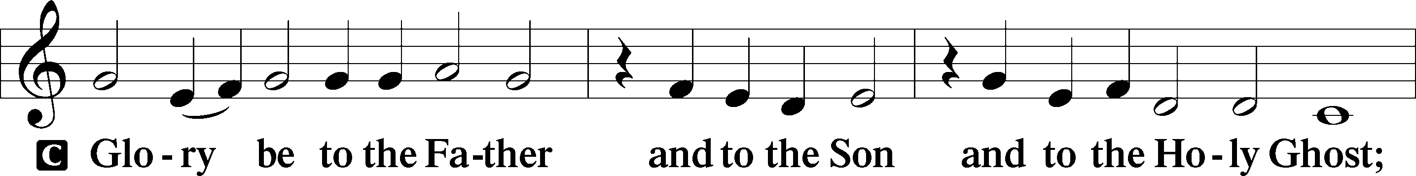
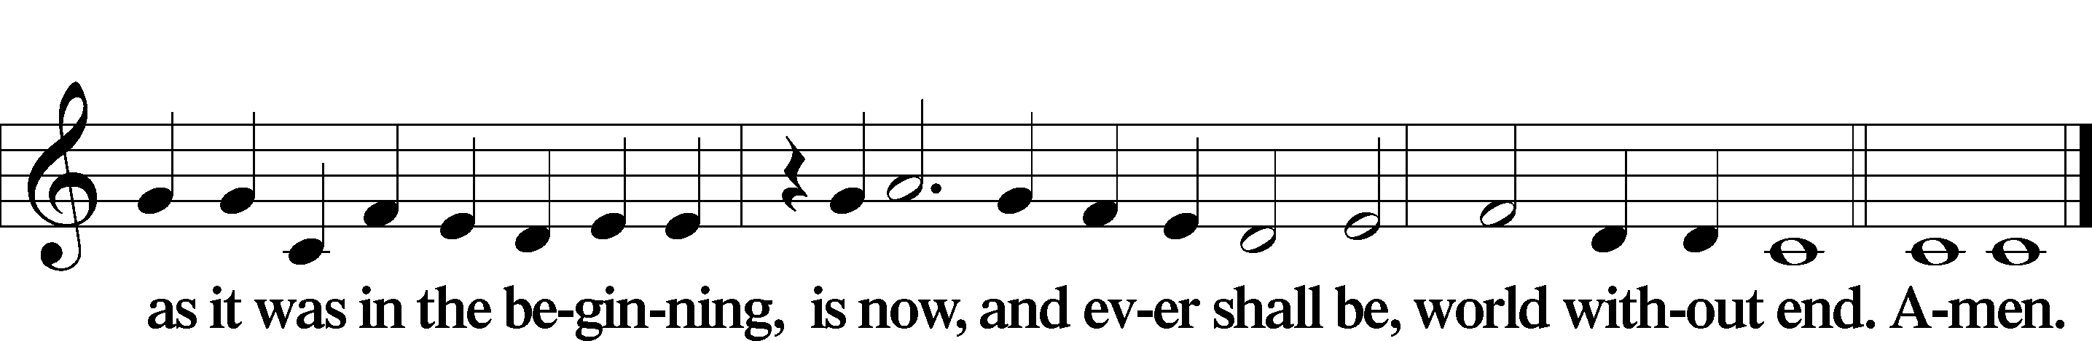

Kyrie Mark 10:47
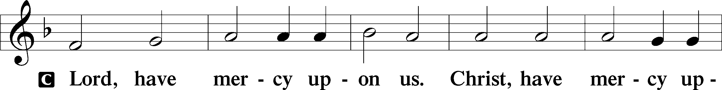
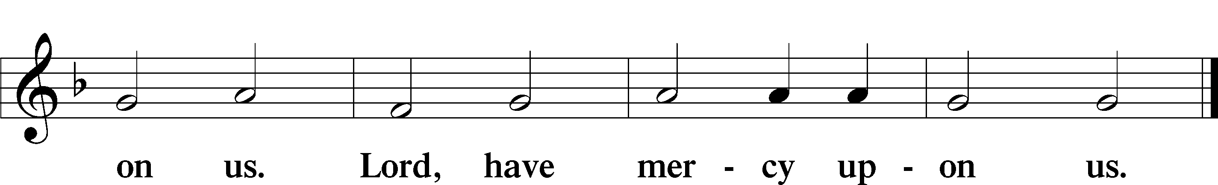

Salutation and Collect of the Day: Ad Te Levavi
P The Lord be with you.
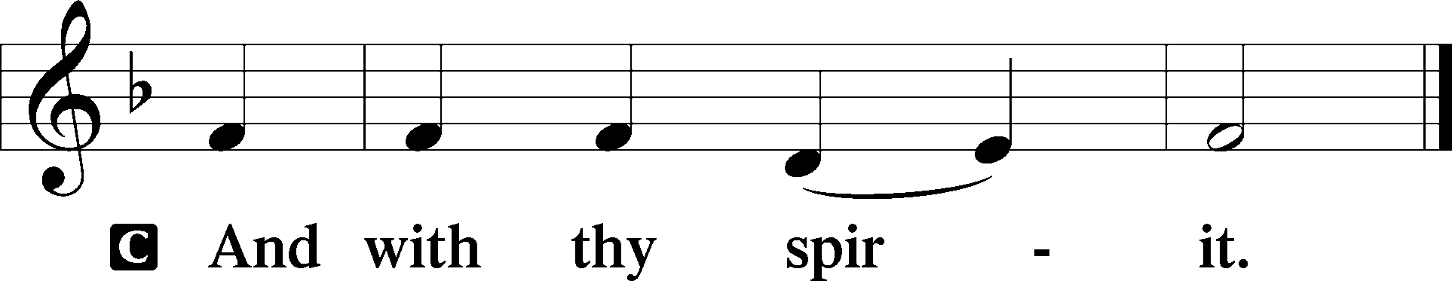

P Let us pray.
Stir up Your power, O Lord, and come, that by Your protection we may be rescued from the threatening perils of our sins and saved by Your mighty deliverance; for You live and reign with the Father and the Holy Spirit, one God, now and forever.
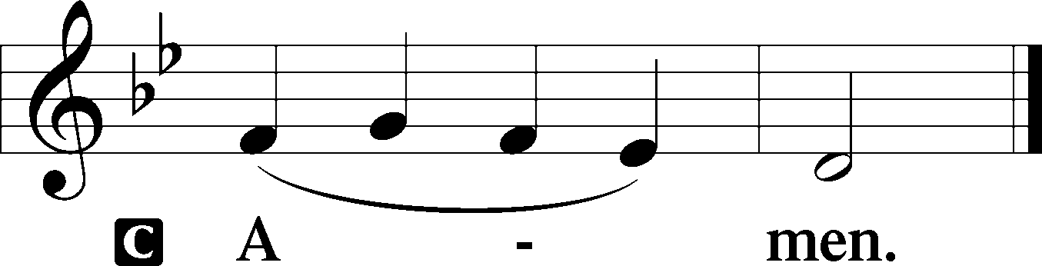
Sit

Prophecy: Jeremiah 23:5–8 (NKJV)
“Behold, the days are coming,” says the Lord, “That I will raise to David a Branch of righteousness; a King shall reign and prosper, and execute judgment and righteousness in the earth. In His days Judah will be saved, and Israel will dwell safely; now this is His name by which He will be called: THE LORD OUR RIGHTEOUSNESS. Therefore, behold, the days are coming,” says the Lord, “that they shall no longer say, ‘As the Lord lives who brought up the children of Israel from the land of Egypt,’ but, ‘As the Lord lives who brought up and led the descendants of the house of Israel from the north country and from all the countries where I had driven them.’ And they shall dwell in their own land,” says the Lord Almighty.

P This is the Word of the Lord.
C Thanks be to God.

Gradual Psalm 25:3–4
None who wait for you shall be | put to shame;*
they shall be ashamed who are wantonly | treacherous.
Make me to know your ways, | O Lord;*
teach me | your paths.

Epistle: Romans 13:11–14 (NKJV)
Brethren: You know the time, that now it is high time to awake out of sleep; for now our salvation is nearer than when we first believed. The night is far spent, the day is at hand. Therefore let us cast off the works of darkness, and let us put on the armor of light. Let us walk properly, as in the day, not in revelry and drunkenness, not in lewdness and lust, not in strife and envy. But put on the Lord Jesus Christ, and make no provision for the flesh, to fulfill its lusts.

P This is the Word of the Lord.
C Thanks be to God.
Stand
Verse Psalm 85:7
Alleluia. Show us your steadfast love, O Lord, and grant us your salvation. Alleluia.

Alleluia
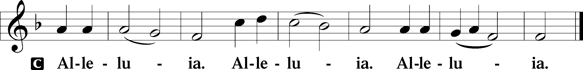

Holy Gospel: Matthew 21:1–9 (NKJV)
P The Holy Gospel according to St. Matthew, the twenty-first chapter.
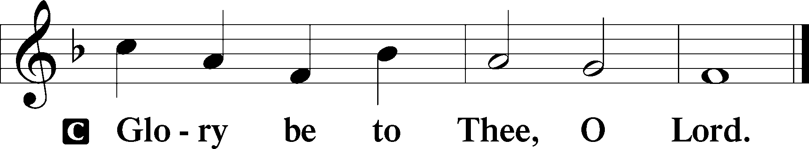

At that time: When they drew near Jerusalem, and came to Bethphage, at the Mount of Olives, then Jesus sent two disciples, saying to them, “Go into the village opposite you, and immediately you will find a donkey tied, and a colt with her. Loose them and bring them to Me. And if anyone says anything to you, you shall say, ‘The Lord has need of them,’ and immediately he will send them.” All this was done that it might be fulfilled which was spoken by the prophet, saying: “Tell the daughter of Zion, ‘Behold, your King is coming to you, lowly, and sitting on a donkey, a colt, the foal of a donkey.’ ” So the disciples went and did as Jesus commanded them. They brought the donkey and the colt, laid their clothes on them, and set Him on them. And a very great multitude spread their clothes on the road; others cut down branches from the trees and spread them on the road. Then the multitudes who went before and those who followed cried out, saying: “Hosanna to the Son of David! ‘Blessed is He who comes in the name of the Lord!’ Hosanna in the highest!”

P This is the Gospel of the Lord.
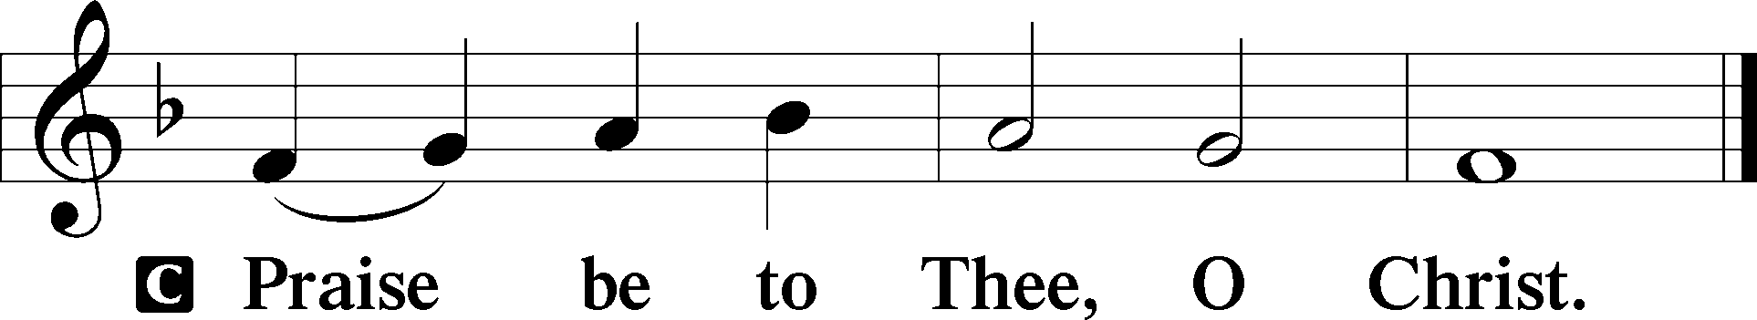
Nicene Creed
C I believe in one God,
the Father Almighty,
maker of heaven and earth
and of all things visible and invisible.

And in one Lord Jesus Christ,
the only-begotten Son of God,
begotten of His Father before all worlds,
God of God, Light of Light,
very God of very God,
begotten, not made,
being of one substance with the Father,
by whom all things were made;
who for us men and for our salvation came down from heaven
and was incarnate by the Holy Spirit of the virgin Mary
and was made man;
and was crucified also for us under Pontius Pilate.
He suffered and was buried.
And the third day He rose again according to the Scriptures
and ascended into heaven
and sits at the right hand of the Father.
And He will come again with glory to judge both the living and the dead,
whose kingdom will have no end.

And I believe in the Holy Spirit,
the Lord and giver of life,
who proceeds from the Father and the Son,
who with the Father and the Son together is worshiped and glorified,
who spoke by the prophets.
And I believe in one holy Christian and apostolic Church,
I acknowledge one Baptism for the remission of sins,
and I look for the resurrection of the dead
and the life T of the world to come. Amen.
Sit

Hymn of the Day: LSB #332 “Savior of the Nations, Come”

Sermon

Stand

Offertory Psalm 51:10–12
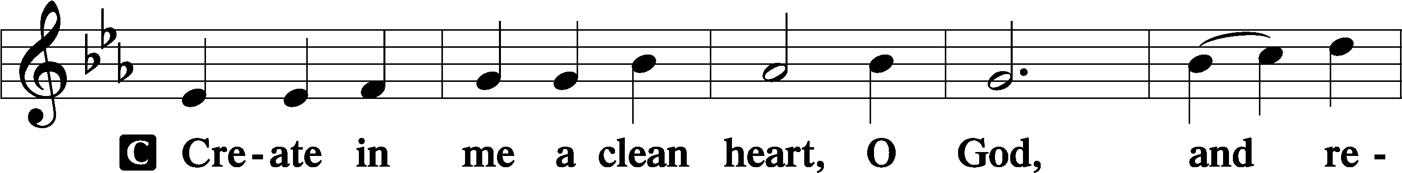
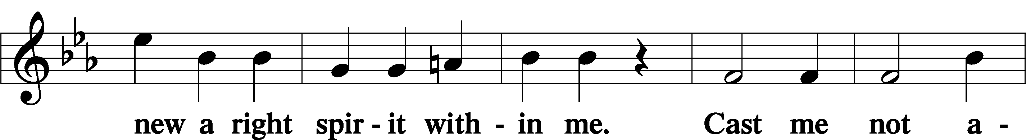
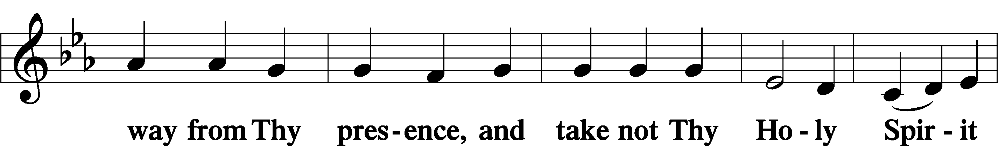
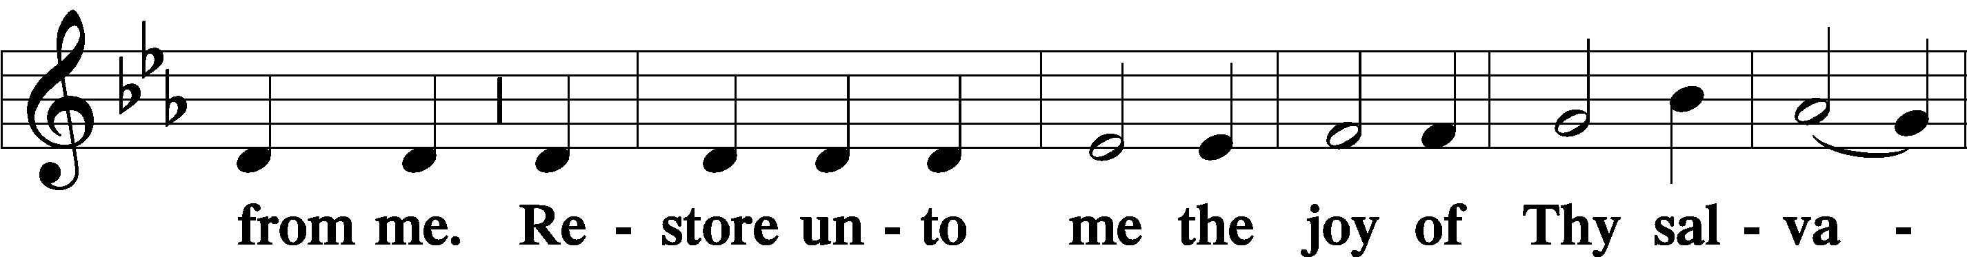
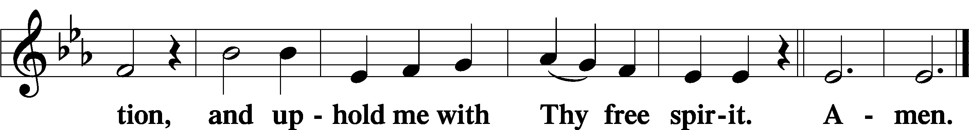

Prayer of the Church

Sit

Preparatory Hymn: LSB #343 “Prepare the Royal Highway”

Stand

Service of the Sacrament

Preface 2 Timothy 4:22; Colossians 3:1 Psalm 136
P The Lord be with you.
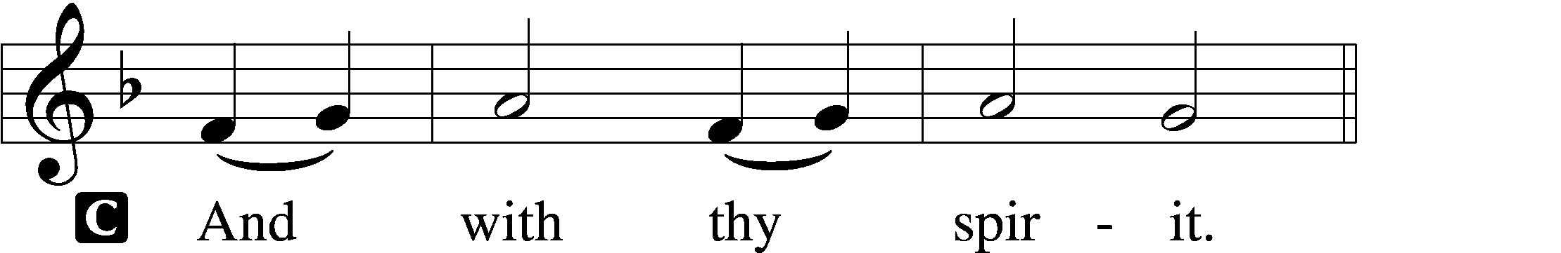

P Lift up your hearts.
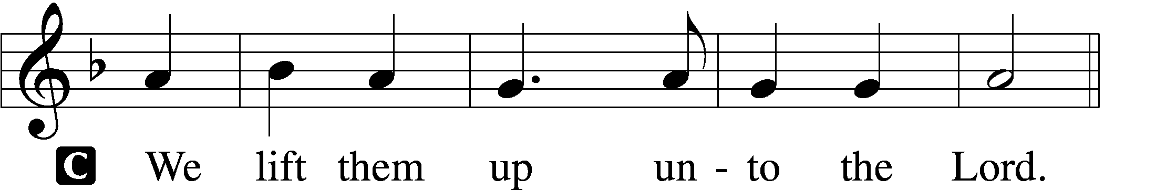

P Let us give thanks unto the Lord, our God.
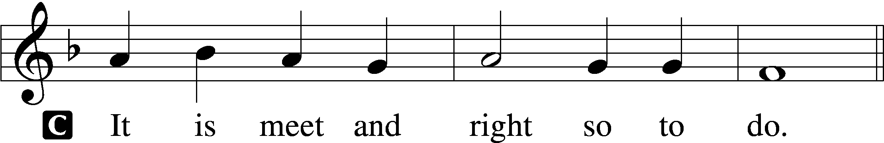

Proper Preface (Abbreviated) LSB 194
P It is truly meet, right, and salutary . . . evermore praising You and saying:

Sanctus Isaiah 6:3; Matthew 21:9
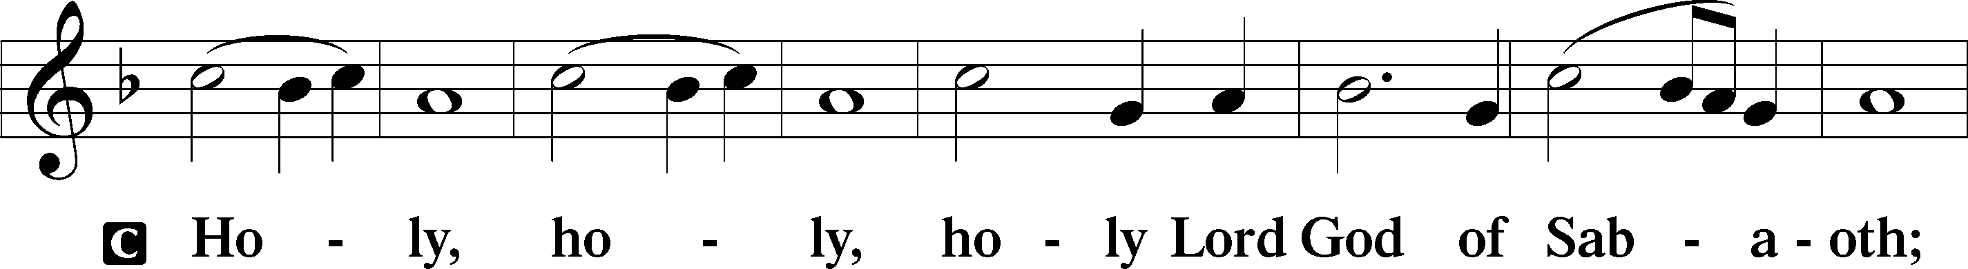
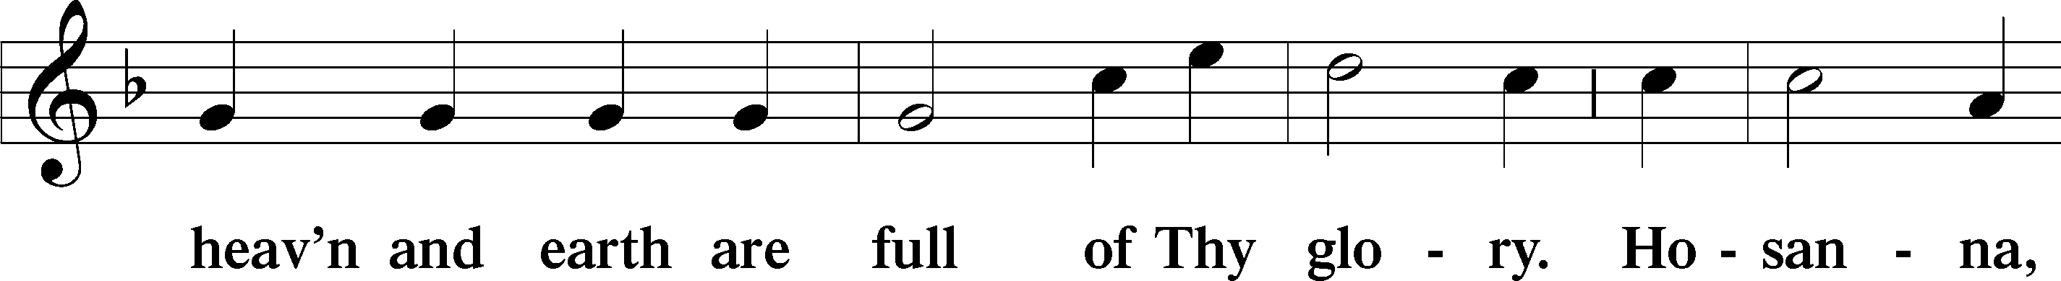
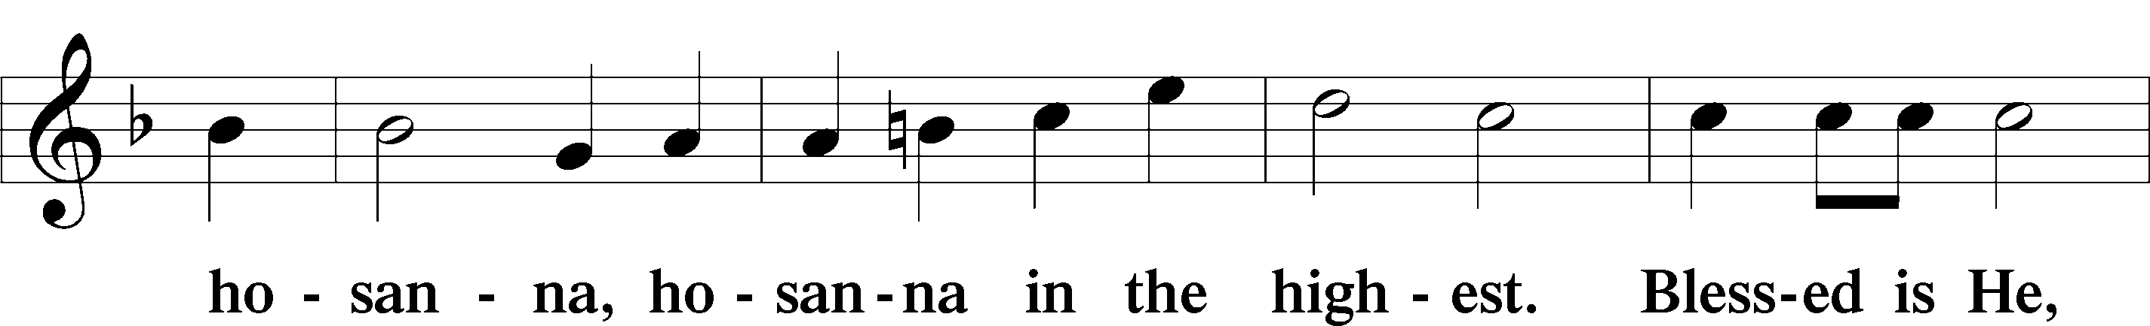
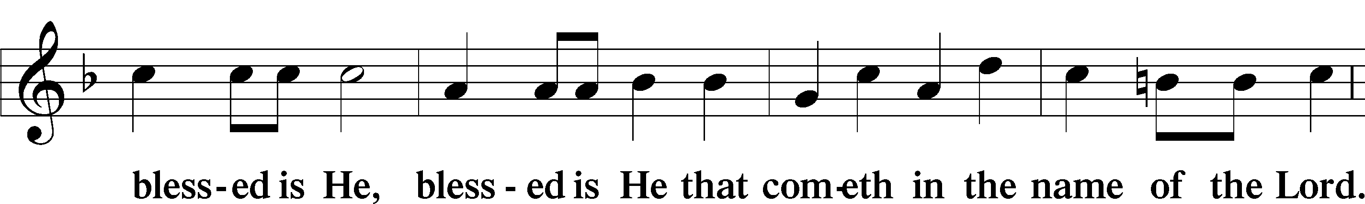
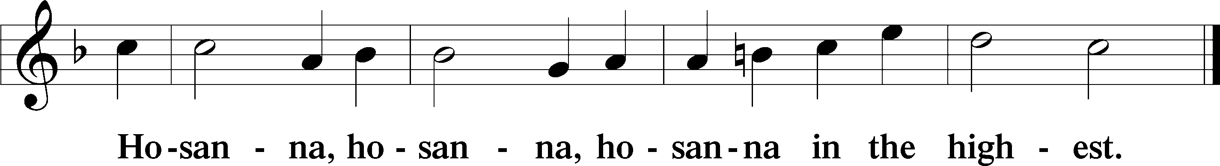

Lord’s Prayer The congregation is encouraged to silently pray the Lord’s Prayer as it is chanted. Matthew 6:9–13
P Our Father who art in heaven,
hallowed be Thy name,
Thy kingdom come,
Thy will be done on earth as it is in heaven;
give us this day our daily bread;
and forgive us our trespasses as we forgive those who trespass against us;
and lead us not into temptation,
but deliver us from evil.
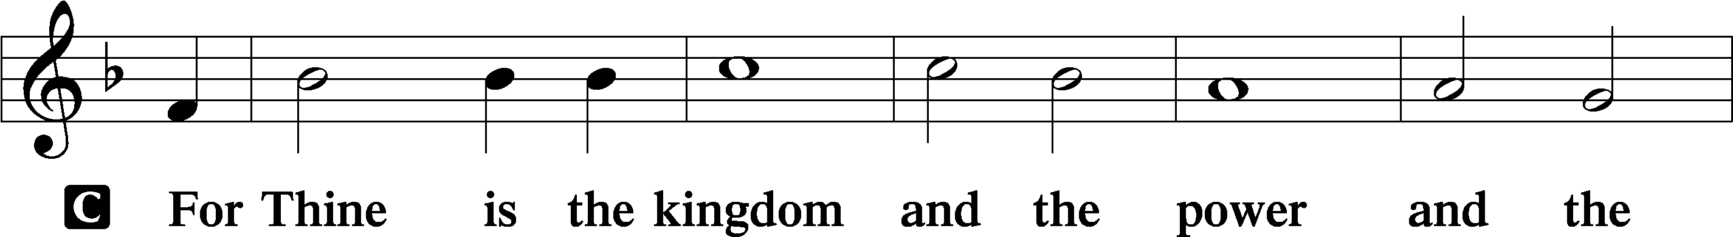
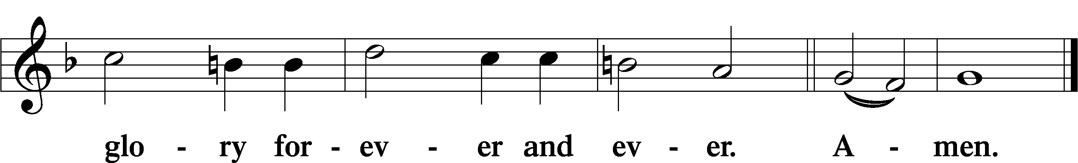

The Words of Our Lord Matthew 26:26–28; Mark 14:22–24; Luke 22:19–20; 1 Corinthians 11:23–25
P Our Lord Jesus Christ, on the night when He was betrayed, took bread, and when He had given thanks, He broke it and gave it to the disciples and said: “Take, eat; this is My T body, which is given for you. This do in remembrance of Me.”

In the same way also He took the cup after supper, and when He had given thanks, He gave it to them, saying: “Drink of it, all of you; this cup is the new testament in My T blood, which is shed for you for the forgiveness of sins. This do, as often as you drink it, in remembrance of Me.”

Pax Domini John 20:19
P The peace of the Lord be with you always.
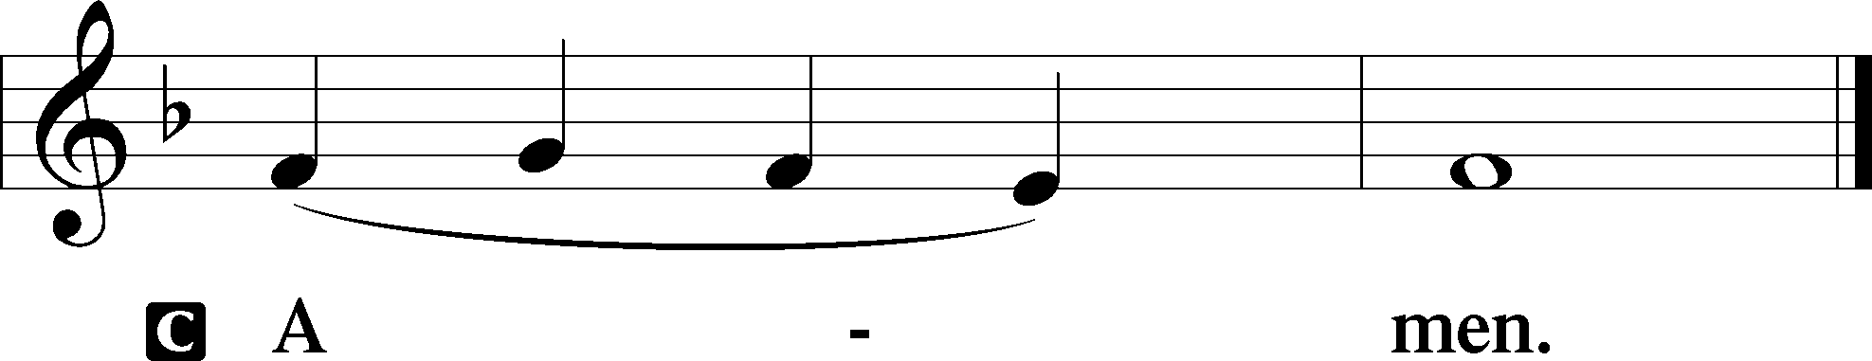

Agnus Dei John 1:29
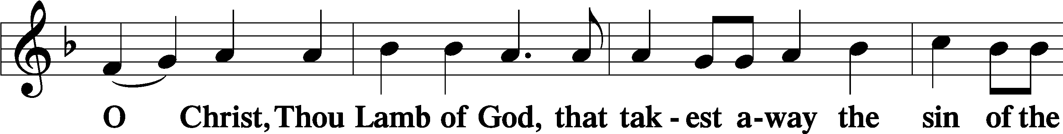
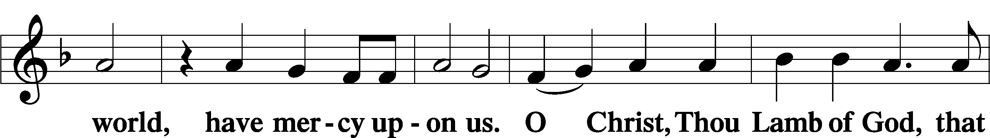
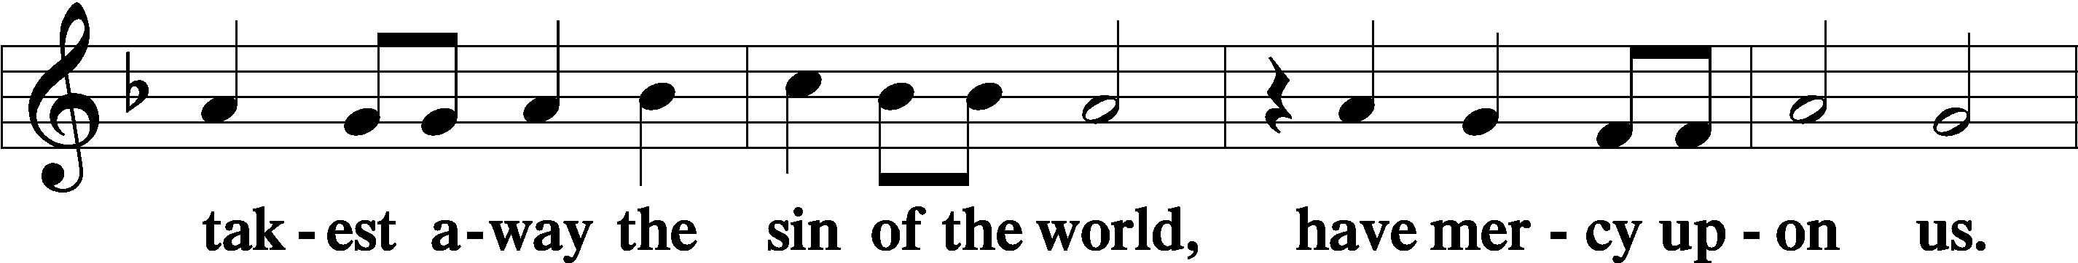
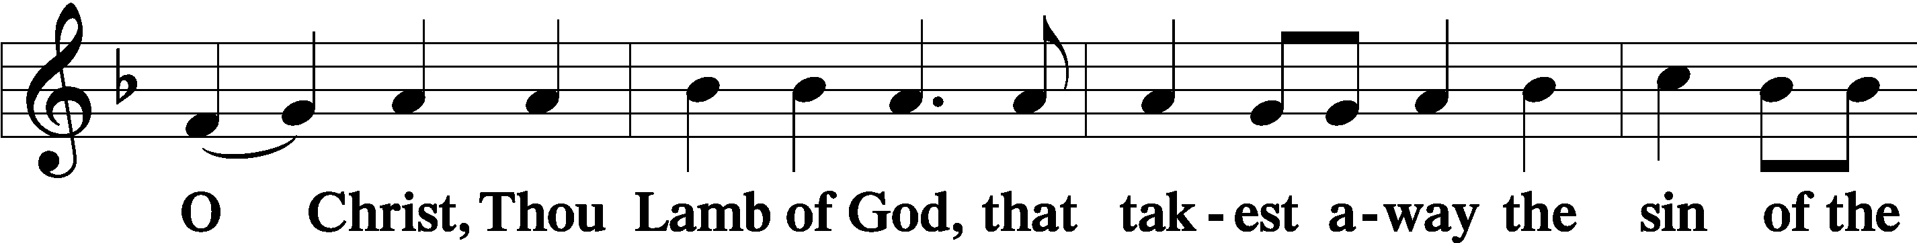
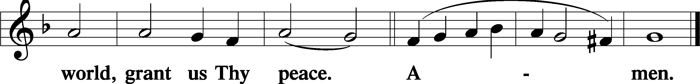
Sit

Distribution
The pastor and those who assist him receive the body and blood of Christ first and then distribute them to those who come to receive, saying:
Take, eat; this is the true body of our Lord and Savior Jesus Christ, given into death for your sins.
Amen.

Take, drink; this is the true blood of our Lord and Savior Jesus Christ, shed for the forgiveness of your sins.
Amen.

In dismissing the communicants, the following is said:
P The body and blood of our Lord Jesus Christ strengthen and preserve you in body and soul to life everlasting. Depart T in peace.
C Amen.

Distribution Hymn: LSB #340 “Lift Up Your Heads, Ye Mighty Gates”

Distribution Hymn: LSB #337 “The Night Will Soon Be Ending”

Distribution Hymn: LSB #353 “Jesus Came, the Heavens Adoring”

Stand

Nunc Dimittis Luke 2:29–32
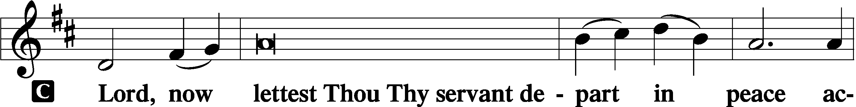
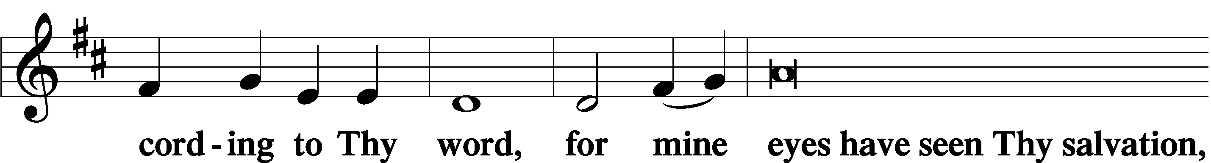
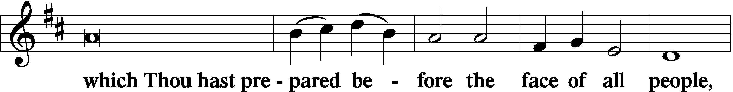
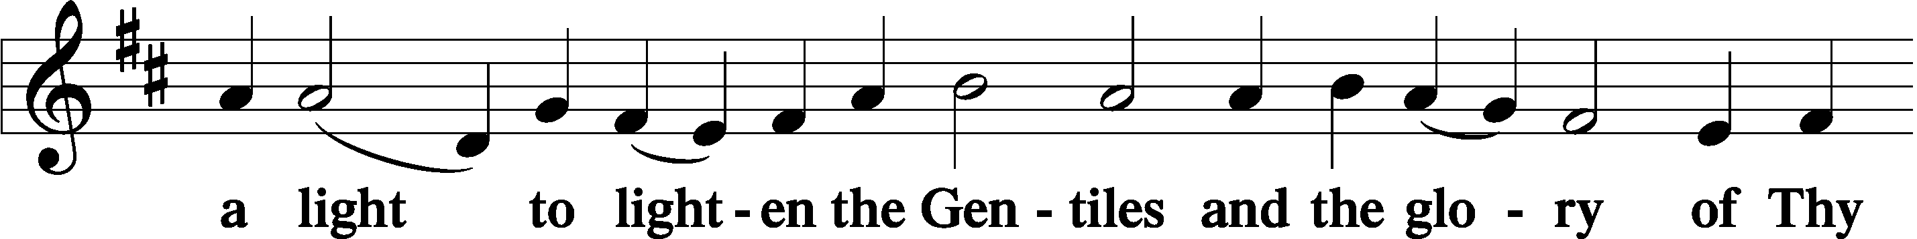
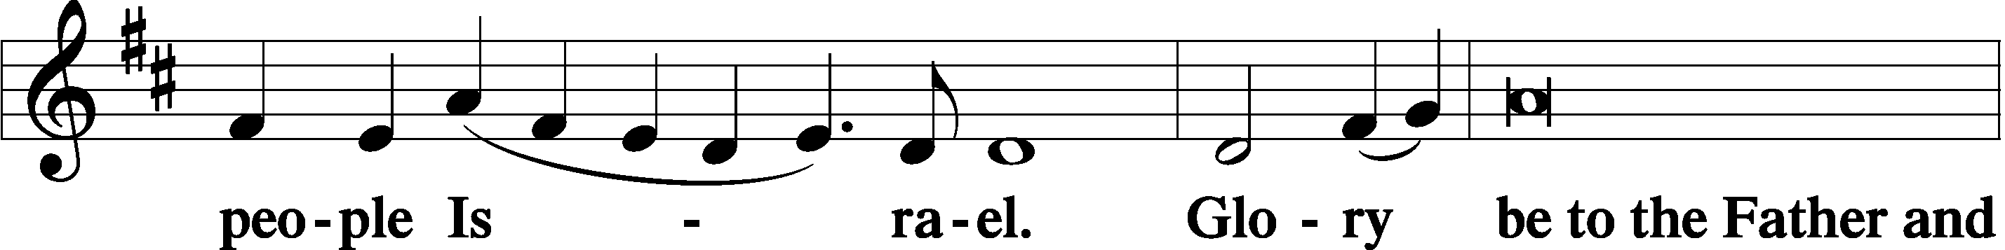
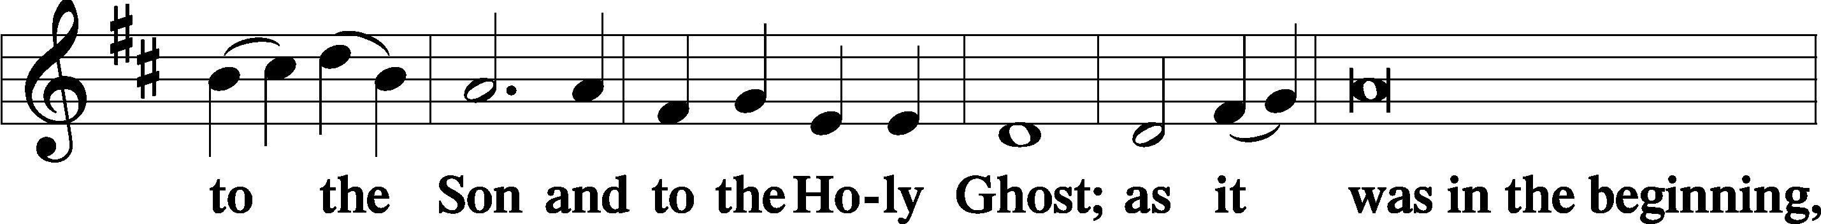
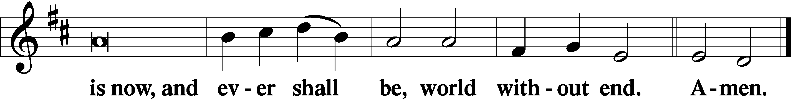

Thanksgiving Psalm 107:1
P O give thanks unto the Lord, for He is good,
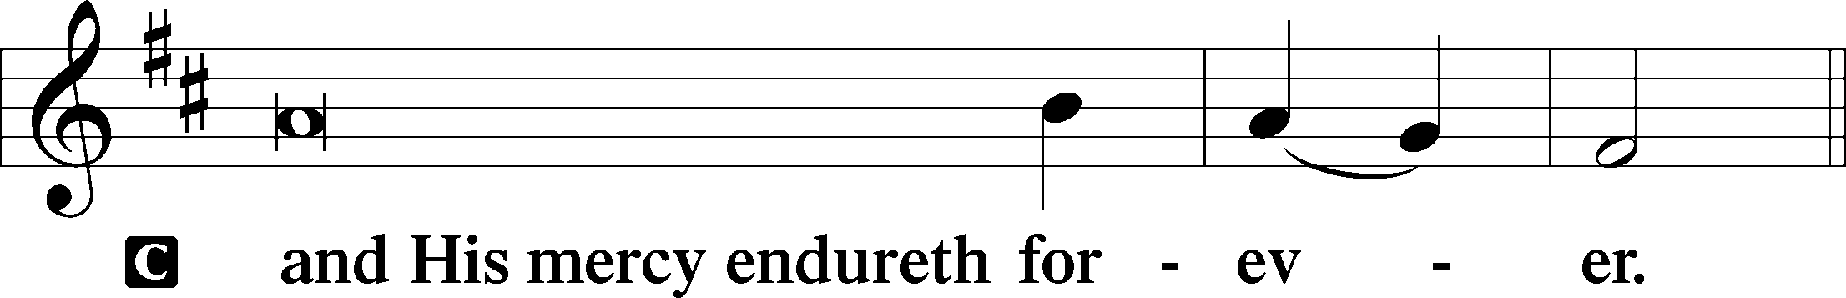

Post-Communion Collect
P Let us pray.
We give thanks to You, almighty God, that You have refreshed us through this salutary gift, and we implore You that of Your mercy You would strengthen us through the same in faith toward You and in fervent love toward one another; through Jesus Christ, Your Son, our Lord, who lives and reigns with You and the Holy Spirit, one God, now and forever.
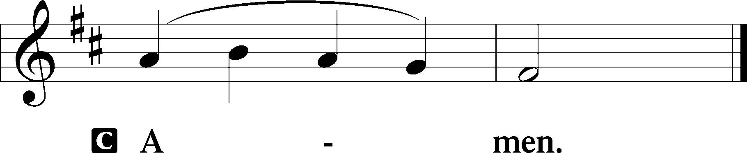

Salutation 2 Timothy 4:22
P The Lord be with you.
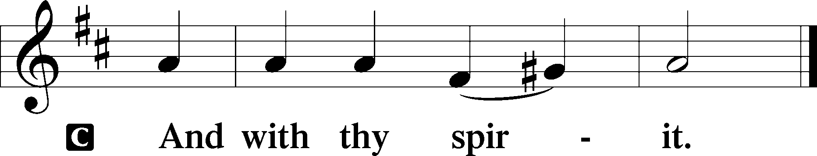

Benedicamus Psalm 103:1
P Bless we the Lord.
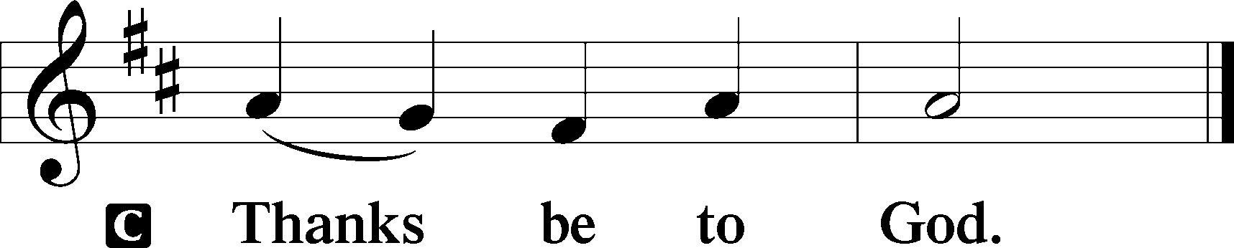

Benediction Numbers 6:24–26
P The Lord bless you and keep you.
The Lord make His face shine upon you and be gracious unto you.
The Lord lift up His countenance upon you and T give you peace.
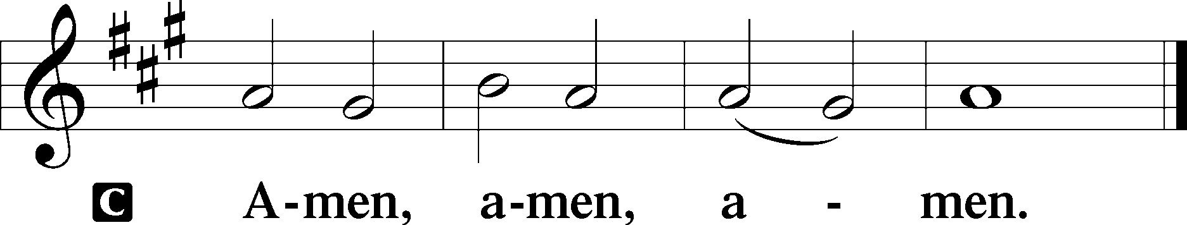

Closing Hymn: LSB #333 “Once He Came in Blessing”

Silent prayer after worship: Thank You, dear God, for Your great love in Jesus Christ. Lead me to share Your word and Your love during this joyful season and always, so that others can know You as Savior and Lord. In Jesus’ name. Amen.

Acknowledgments
Unless otherwise indicated, Scripture quotations are from the ESV® Bible (The Holy Bible, English Standard Version®), copyright © 2001 by Crossway, a publishing ministry of Good News Publishers. Used by permission. All rights reserved.
Created by Lutheran Service Builder © 2023 Concordia Publishing House.
fffffffffffffffffffffffffffffffffff

SCHEDULE THROUGH DECEMBER 10, 2023:

:

Today, following Worship, Fellowship Hall: Voters’ Assembly
7 pm, Fellowship Hall: AA Meeting
Tuesday, 7-9 pm, Fellowship Hall: Penn-Ohio Singers
Wednesday, 10 am, Sanctuary: Advent Midweek Matins Service Week 1
7 pm, Sanctuary: Advent Midweek Vespers Service Week 1
7:30 pm, Fellowship Hall: NA Meeting
Saturday, 10 am, Sanctuary: Church Decorating
Next Sunday, 8 am, Fellowship Hall: Bible Study
9 am, Sanctuary: Divine Service
Following Worship, Fellowship Hall: Coffee & Cookies Fellowship
7 pm, Fellowship Hall: AA Meeting
fffffffffffffffffffffffffffffffffff
Attendance: Wednesday, November 22, 2023: 12
Sunday, November 26, 2023: 38
fffffffffffffffffffffffffffffffffff

THANK YOU FOR SERVING IN DECEMBER: Elder: Jonathan Baisch; Ushers: Cheryl Fedele, Mike Flaugher, & Jesse Riffle; Altarware ~ Sundays: (prior) Marie Flaugher (12.10 & 12.31) & Diane Riefstahl; (after) Marie Flaugher (12.10 & 12.31) & Elizabeth Haenftling (12.03, 12.17, & 12.24); Special Divine Service: December 25th ~ Diane Riefstahl.
fffffffffffffffffffffffffffffffffff
Poinsettia order forms are available on the tables in the narthex and next to the nursery. Forms and payment are due to the secretary’s office TODAY.
fffffffffffffffffffffffffffffffffff
The December issue of “The Rock and the Sword” newsletter along with 2023 Advent Devotions are available this morning on the tables in the narthex and next to the nursery.
fffffffffffffffffffffffffffffffffff
Our Stewardship of Treasures for the Lord:
In order to do the Lord’s work, we need $2,553.63 each week to meet our 2023 budget for general purposes and $76.92 for the SELC.

Figures for Wednesday, November 22, 2023
General Fund: $145.00
Online Figure for Friday, November 24, 2023
General Fund: $80.00
Figures for Sunday, November 26, 2023
General Fund: $1,342.00
SELC: $0.00
Food Pantry: $0.00
Quarterly Missions: $0.00
Capital Campaign: $395.00
Other: $17.00

For online giving, check out https://www.saintspeterandpaul.net/online-giving.
fffffffffffffffffffffffffffffffffff
Christmas cards for our shut-ins will be available at this morning’s Voters’ Assembly and next Sunday’s Coffee Fellowship for you to sign and add good wishes.
fffffffffffffffffffffffffffffffffff
Bible Memory Verses ~ Week of December 3rd:
For Adults: I am the way, and the truth, and the life. No one comes to the Father except through me. John 14:6

For Children: Behold, your king is coming to you; righteous and having salvation is he. Zechariah 9:9
fffffffffffffffffffffffffffffffffff
Advent Midweek Services will begin this Wednesday, December 6th. Two services will be offered this year: a 10 am Matins Service and a 7 pm Vesper Service. This year’s theme will focus on Christ in the Old Testament, “The Seen Yahweh”.
fffffffffffffffffffffffffffffffffff
IMPORTANT: A Voters’ Assembly will be held this morning in the Fellowship Hall 10 minutes following the conclusion of worship. Your attendance will be greatly appreciated at this meeting. Among items to be discussed are the 2024 Church Budget and the election of 2024 Church Officers and Boards. Copies of the tentative agenda and proposed budget are on the table in the narthex.
fffffffffffffffffffffffffffffffffff
Your Help Is Needed! At 10 am this Saturday, December 9th, we will gather to decorate the church property and sanctuary for the Christmas season. Please join us as “many hands will make for light work”.
fffffffffffffffffffffffffffffffffff
Altar Guild members are encouraged to sign up on the cookie donation sheet which is available on the table in the narthex for bringing 1-2 dozen cookies (no more, please) to the Coffee Fellowship, next Sunday, December 10th.
Also available on the table are the 2024 “How May I Serve” sheets. If you haven’t already done so, please return yours to Marie Flaugher ASAP so that 2024 schedules may be planned.
fffffffffffffffffffffffffffffffffff
Next Sunday is “Stock the Food Pantry” Sunday. Although financial donations are always welcomed, this month we are seeking donations of paper products (toilet tissue, paper towels, and face tissue) to share with our clients. There will be a container by the parking lot entrance next Sunday for your donations. “Thanks” in advance for your participation in this outreach mission.
Remember the following in Prayer…
~The Hurting and Healing: Amy, Mary Jane Anderson, Steve Antolovich, Ellen Baron^{CA}, Amy Blomenberg, Lois Bortner^{CA}, Sara Brubaker, Dee Bullock, Bev & Joe Chlpka, Susan Davies, Loretta Deal, Tim Dudash, Judith & Eddy Furey, Griffin, Austin Hamilton, Pastor Charles Henrickson, Joan, Keith Jozwiakowski, Darla Krajci, Barbara Kreske, Jess Lavoie, Paul Lucas^{CA}, Sandy Marshall, Frank Niemeyer^{CA}, Juanita Rentschler, Richard Reuning^{CA}, Nancy Robertson^{CA}, Kriss Svidro^{CA}, Rudy Tomko, Joel & Peggy Wasson, Angela Weser^{CA}, and Ruth Wolf.
~The Homebound: Anna Mae Daris, Millie Elavsky, Jean Tomko, Betty Wolf, and Ed & Millie Zachar.
~Celebrating this Week: Birthdays: Rev. Jacob Deal (12.04) & Marie Flaugher (12.05); Anniversary: Ralph & Judie Dorman (12.09).
~Serving in the Military: Alex (Sasha) Carr, Duncan Vaupel, Curtis Sinewe, and Joshua Solyan.
~Community & World Needs: Those suffering due to the conflicts in the Middle East and between Ukraine and Russia; those suffering from loss and dislocation because weather disasters; those suffering from addiction and their families; Local, State, and National Government Leaders; safety for all Police Officers, Firefighters, & First Responders; the unemployed; our Fourth Quarter Local Mission: Willow Women’s Center.
*CA represents cancer.
fffffffffffffffffffffffffffffffffff

December 2023 Worship Services

Sunday, December 3 9 am Divine Service ~ Ad Te Levavi

Wednesday, December 6 10 am Matins Service ~ Advent Midweek 1
7 pm Vespers Service ~ Advent Midweek 1

Sunday, December 10 9 am Divine Service ~ Populus Zion

Wednesday, December 13 10 am Matins Service ~ Advent Midweek 2
7 pm Vespers Service ~ Advent Midweek 2

Sunday, December 17 9 am Divine Service ~ Gaudete

Wednesday, December 20 10 am Matins Service ~ Advent Midweek 3
7 pm Vespers Service ~ Advent Midweek 3

Sunday, December 24 9 am Divine Service ~ Rorate Coeli
8 pm Christmas Eve Service

Monday, December 25 9 am Divine Service ~ Christmas Day

Tuesday, December 26 7 pm Vespers Service
Feast of St. Stephen, Martyr

Wednesday, December 27 7 pm Vespers Service
Feast of St. John, Apostle & Evangelist

Thursday, December 28 7 pm Vespers Service
Feast of the Holy Innocents, Martyrs

Sunday, December 31 9 am Divine Service ~ First Sunday after
Christmas
Here to Serve
Pastor………………………………………………...……………Rev. Jacob Deal
E-mail …………………………….……pastordeal@saintspeterandpaul.net
Phone Number……………………..…………………724-347-3620 (Option 2)
Church Office………………………..…………………724-347-3620 (Option 3)
Website …………………………………………www.saintspeterandpaul.net
Secretary…………………………………………………………Diane Riefstahl
E-mail ………………………………………church@saintspeterandpaul.net
Website …………………………………………www.saintspeterandpaul.net
Food Pantry (email): ……………foodpantry@saintspeterandpaul.net
Congregation President………………………………….…Jonathan Baisch
Church Elder …………………………………………...……. Jonathan Baisch
Organist………………………………………………..….…Rebecca Marquette
AA Contact: Steve………………………………………………...…724-813-2358
NA Contact: Larry……………………………………..…………..724-977-8733
fffffffffffffffffffffffffffffffffff
If needing to get into the church building during the week, please phone first to make certain someone is here to let you in.

