Sts. Peter & Paul
Evangelical Lutheran Church
Lutheran Church-Missouri Synod
Founded-1917

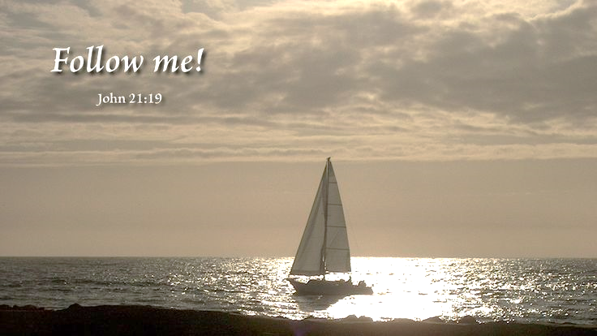

December 27, 2023

699 Stambaugh Avenue
Sharon, Pennsylvania 16146

“I was glad when they said to me,
Let us go to the house of the LORD!”
Psalm 122:1
Sts. Peter & Paul Evangelical Lutheran Church, LC-MS
FEAST OF SAINT JOHN, APOSTLE & EVANGELIST
December 27, 2023

Silent prayer before worship: Dear heavenly Father, help me to remember that I am Your child. Give me a childlike faith, so I can trust that through Your Son Jesus I have life and hope always. In Jesus’ name. Amen.

VESPERS
Opening Hymn: LSB #381 “Let Our Gladness Have No End”
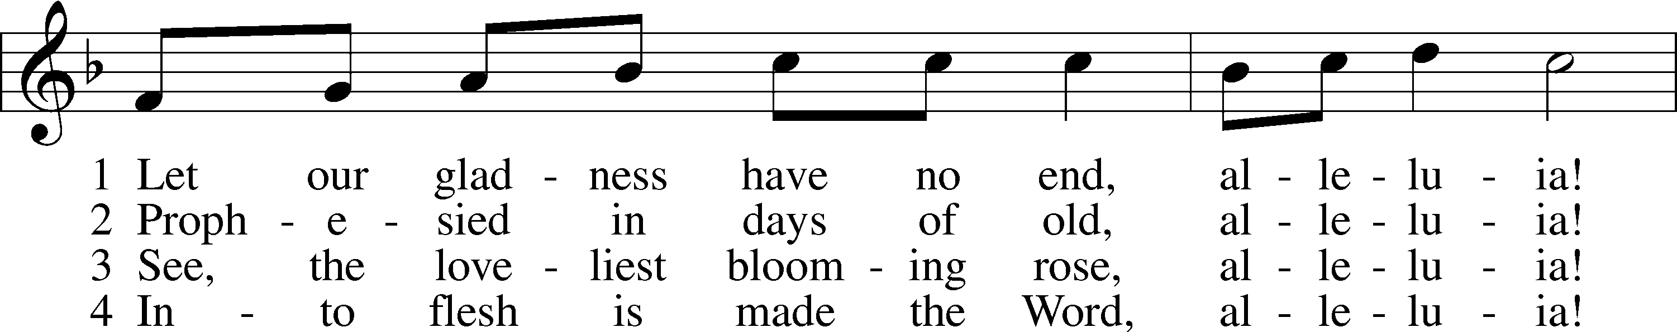
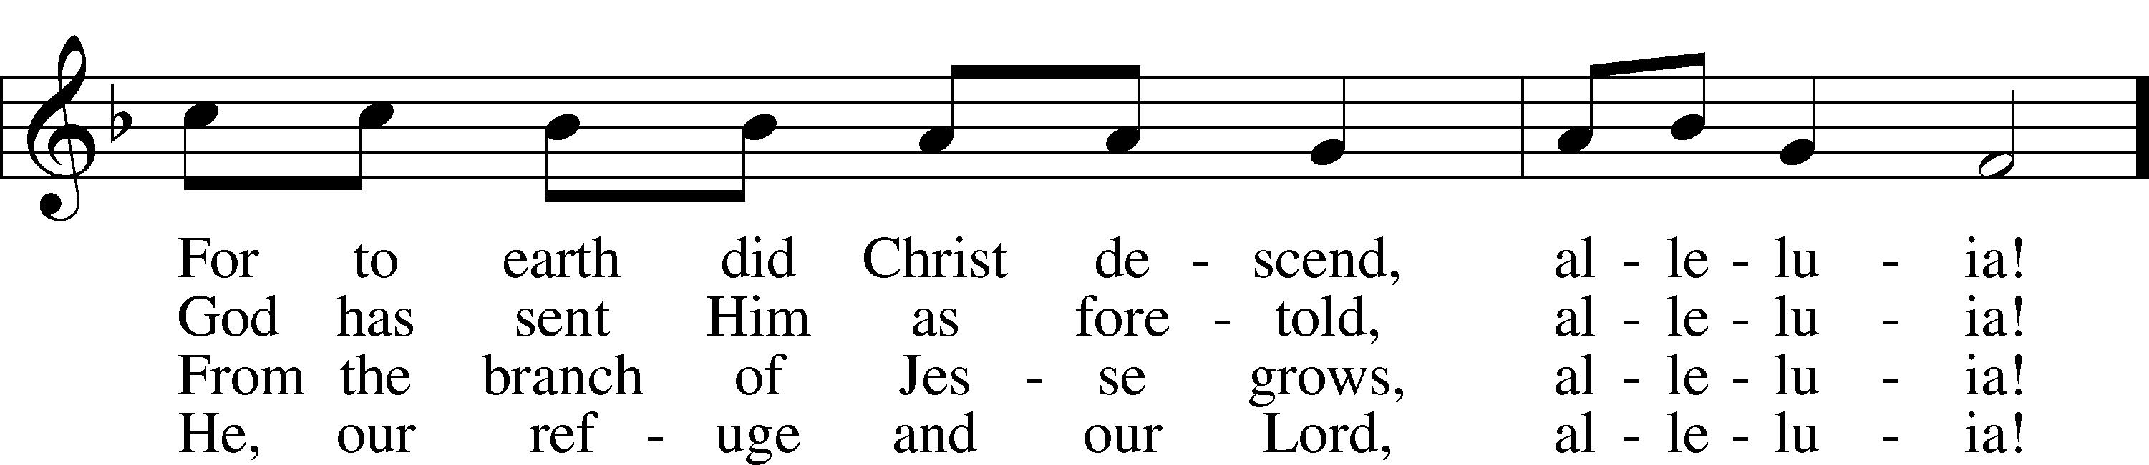
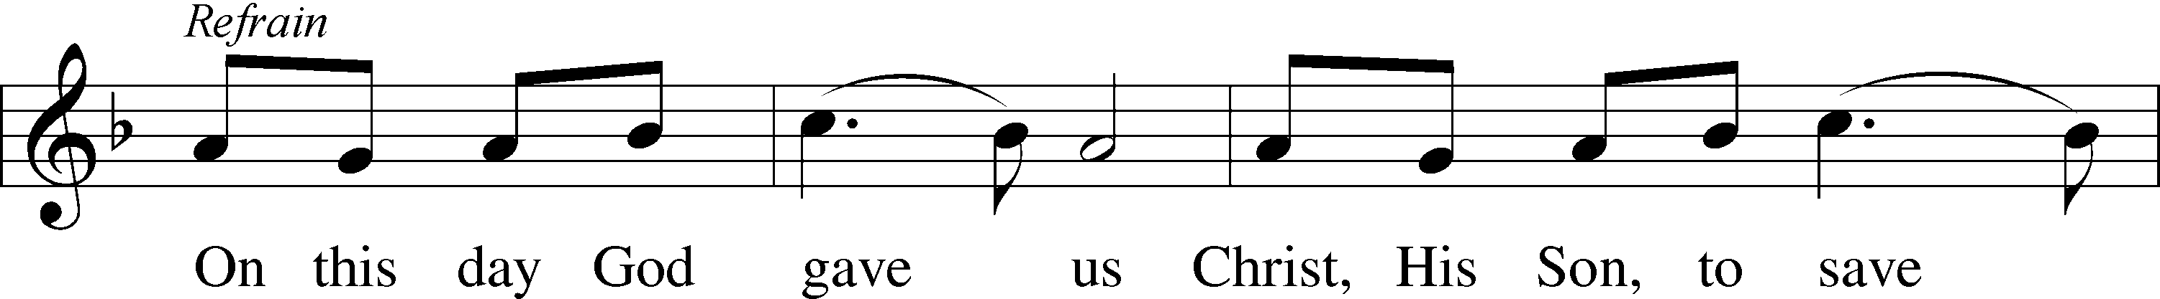
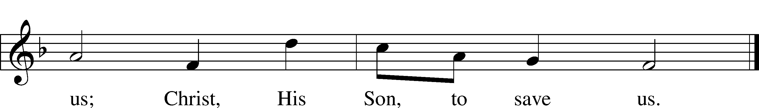

Text (sts. 1, ref, 3–4): tr. unknown, alt.; (st. 2): tr. Vincent Pisek, 1859–1930 Text and tune: Bohemian, 15th cent. Text and tune: Public domain

Stand

Common Versicles LSB 229
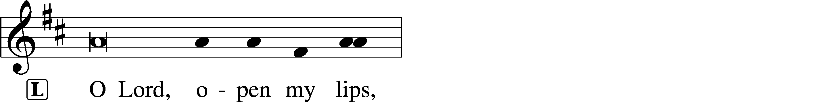
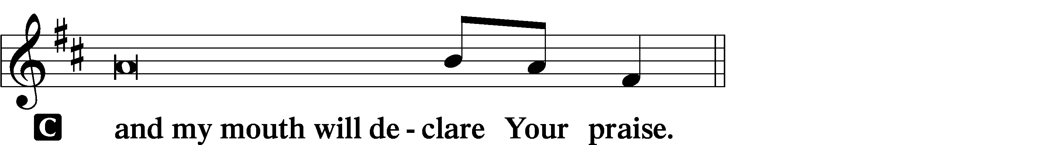

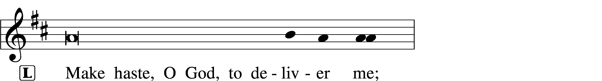
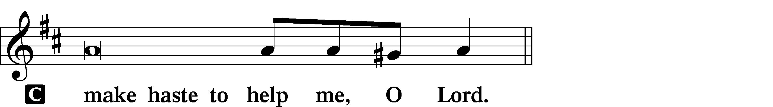

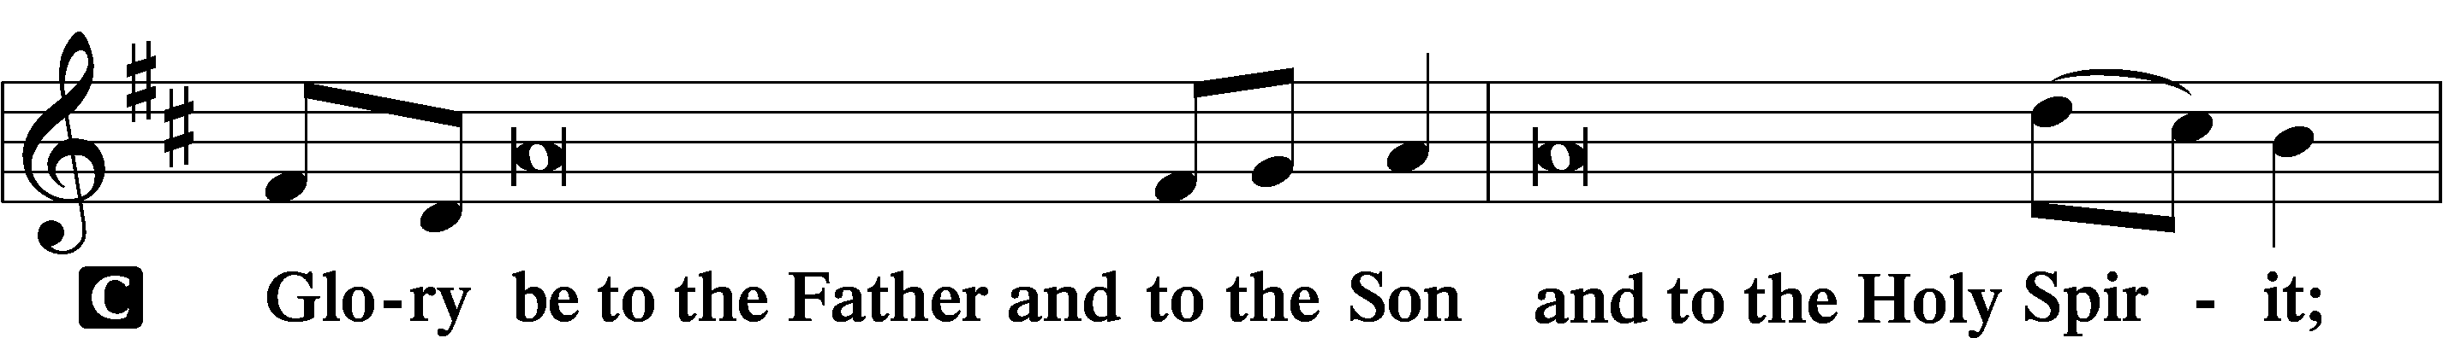
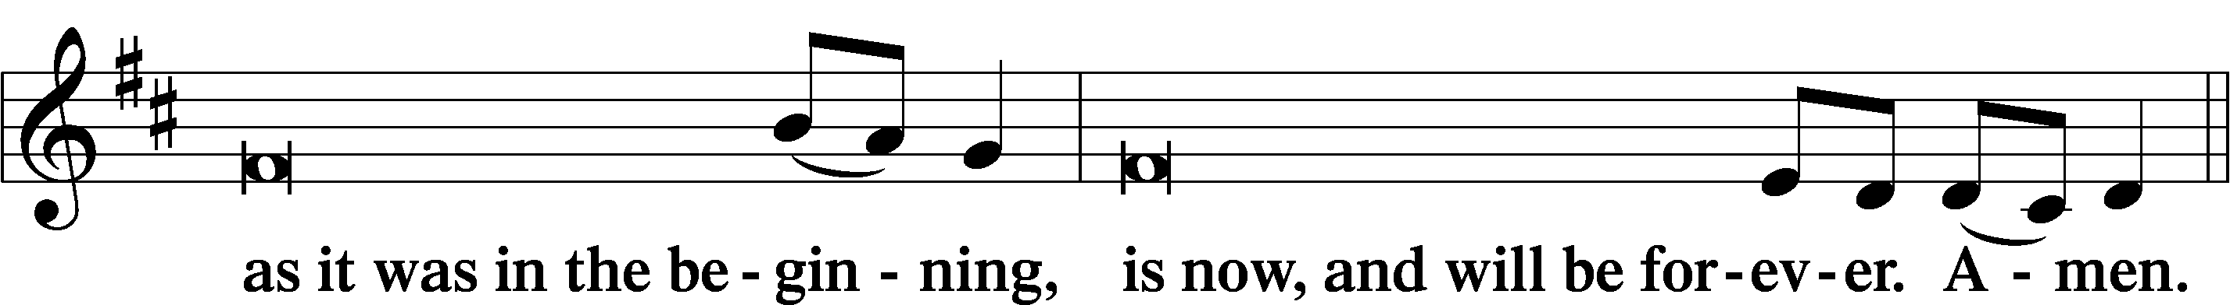
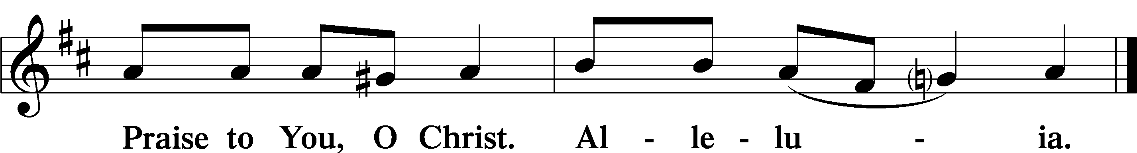

Psalmody

Psalm Reading: Psalm 11 (NKJV)
In the Lord I put my trust;
How can you say to my soul,
“Flee as a bird to your mountain”?
For look! The wicked bend their bow,
They make ready their arrow on the string,
That they may shoot secretly at the upright in heart.
If the foundations are destroyed,
What can the righteous do?
The Lord is in His holy temple,
The Lord’s throne is in heaven;
His eyes behold,
His eyelids test the sons of men.
The Lord tests the righteous,
But the wicked and the one who loves violence His soul hates.
Upon the wicked He will rain coals;
Fire and brimstone and a burning wind
Shall be the portion of their cup.
For the Lord is righteous,
He loves righteousness;
His countenance beholds the upright.

Sit

Hymn of the Day: LSB #523 “O Word of God Incarnate”
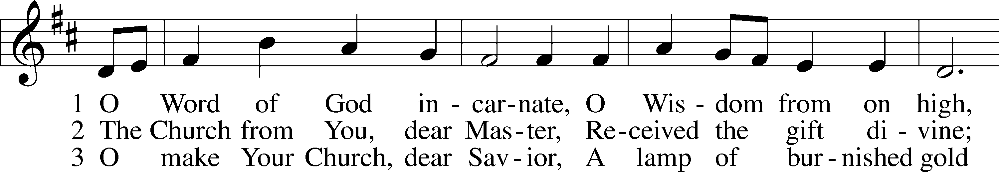
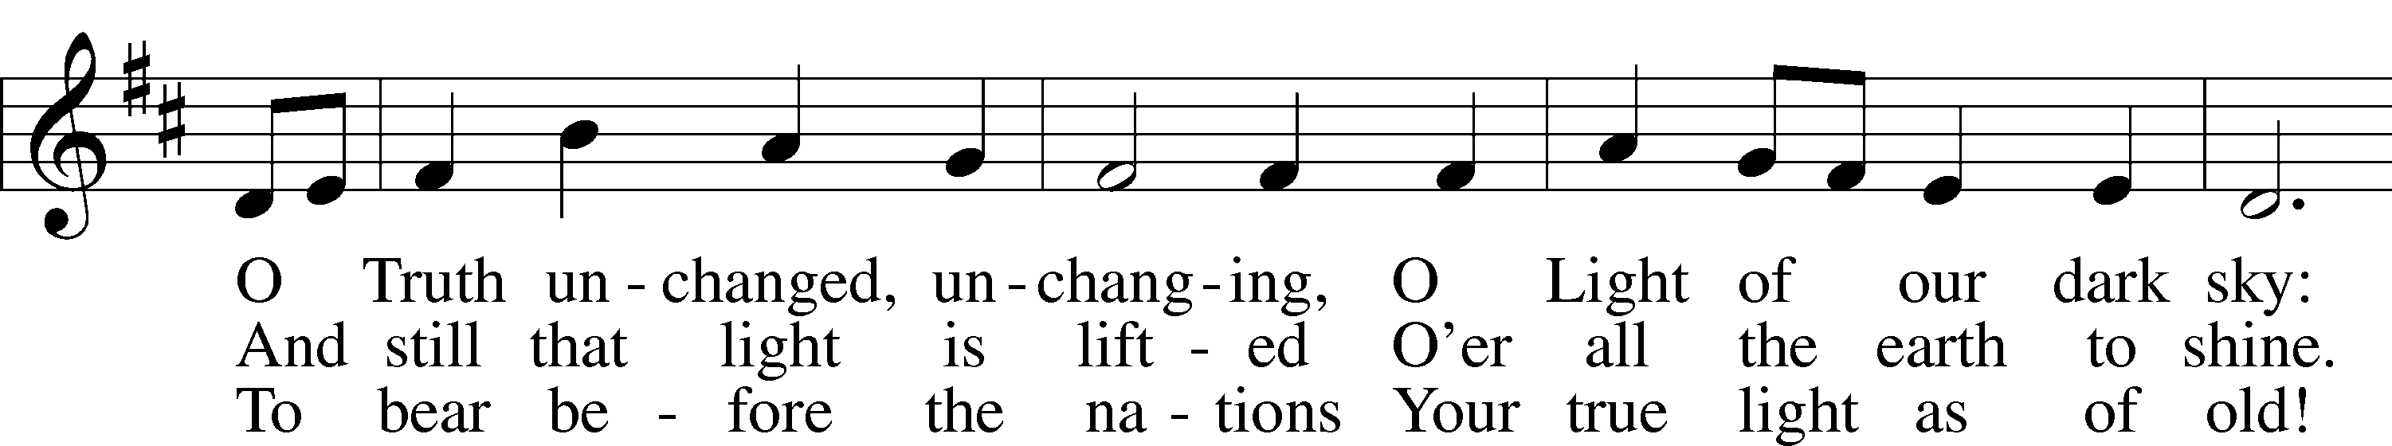
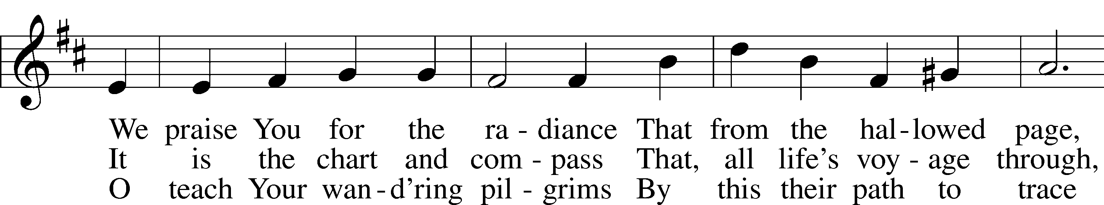
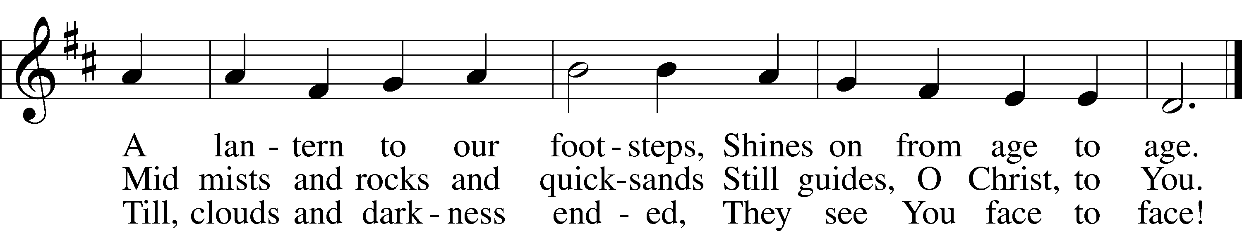

Text: William W. How, 1823–97, alt. Tune: Neu-vermehrtes . . . Gesangbuch, 1693, 3rd ed., Meiningen Text and tune: Public domain

Readings

Prophecy: Sirach 15:1-2a, 3-6 (NKJV)
The man who fears the Lord will do good, and he who holds to the law will obtain wisdom. She will come to meet him like a mother. She will feed him with the bread of understanding and give him the water of wisdom to drink. He will lean on her and will not fall, and he will attend to her and will not be put to shame. She will exalt him above his neighbors and will open his mouth in the midst of the assembly. He will find gladness and a crown of rejoicing and will acquire an everlasting name, even the Lord our God.

P O Lord, have mercy on us.
C Thanks be to God.

Epistle: 1 John 1:1—2:2 (NKJV)
Dearly Beloved: That which was from the beginning, which we have heard, which we have seen with our eyes, which we have looked upon, and our hands have handled, concerning the Word of life—the life was manifested, and we have seen, and bear witness, and declare to you that eternal life which was with the Father and was manifested to us—that which we have seen and heard we declare to you, that you also may have fellowship with us; and truly our fellowship is with the Father and with His Son Jesus Christ. And these things we write to you that your joy may be full. This is the message which we have heard from Him and declare to you, that God is light and in Him is no darkness at all. If we say that we have fellowship with Him, and walk in darkness, we lie and do not practice the truth. But if we walk in the light as He is in the light, we have fellowship with one another, and the blood of Jesus Christ His Son cleanses us from all sin. If we say that we have no sin, we deceive ourselves, and the truth is not in us. If we confess our sins, He is faithful and just to forgive us our sins and to cleanse us from all unrighteousness. If we say that we have not sinned, we make Him a liar, and His word is not in us. My little children, these things I write to you, so that you may not sin. And if anyone sins, we have an Advocate with the Father, Jesus Christ the righteous. And He Himself is the propitiation for our sins, and not for ours only but also for the whole world.

P O Lord, have mercy on us.
C Thanks be to God.

Gospel: John 21:19b-24 (NKJV)
At that time: Jesus said to Peter, “Follow Me.” Then Peter, turning around, saw the disciple whom Jesus loved following, who also had leaned on His breast at the supper, and said, “Lord, who is the one who betrays You?” Peter, seeing him, said to Jesus, “But Lord, what about this man?” Jesus said to him, “If I will that he remain till I come, what is that to you? You follow Me.” Then this saying went out among the brethren that this disciple would not die. Yet Jesus did not say to him that he would not die, but, “If I will that he remain till I come, what is that to you?” This is the disciple who testifies of these things, and wrote these things; and we know that his testimony is true.

P This is the Word of the Lord.
C Thanks be to God.

Responsory LSB 230
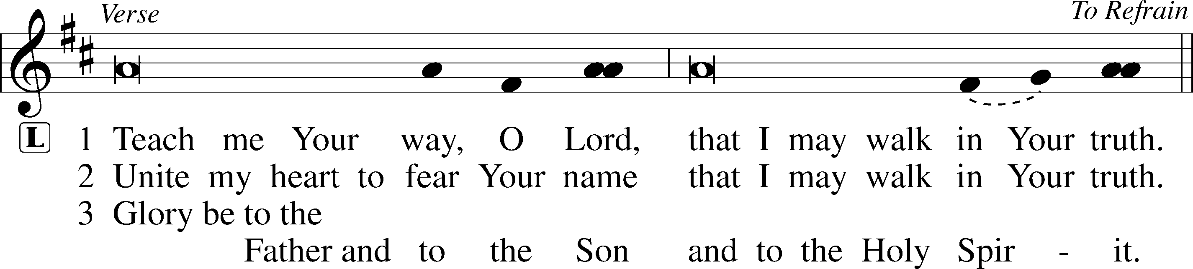
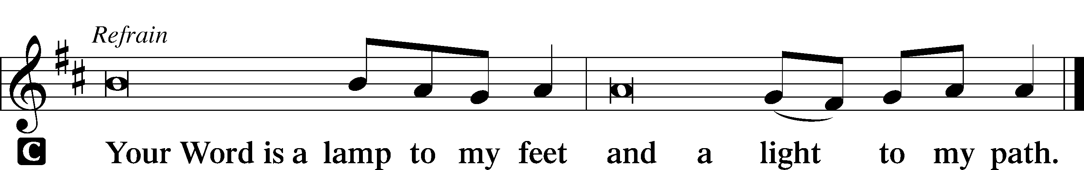

Sermon

Canticle

Stand

Antiphon (Common) 231
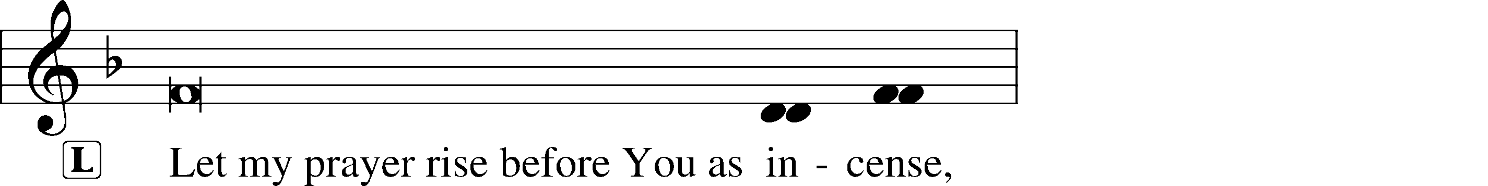
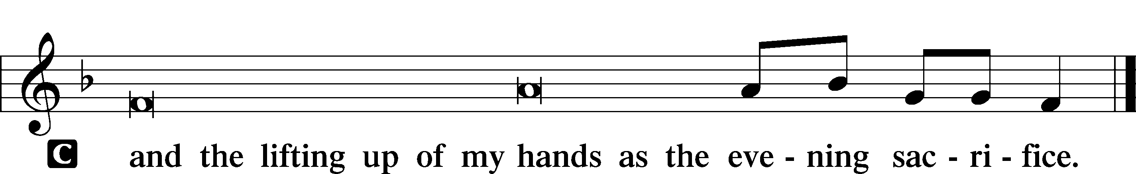

Magnificat 231
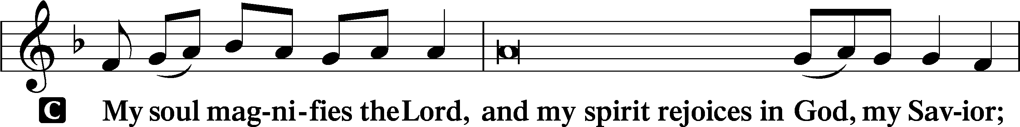
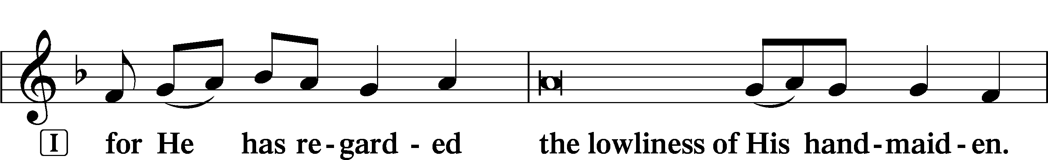
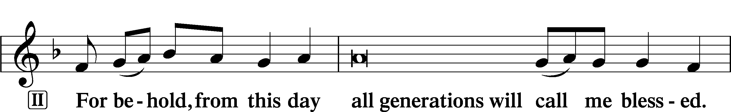
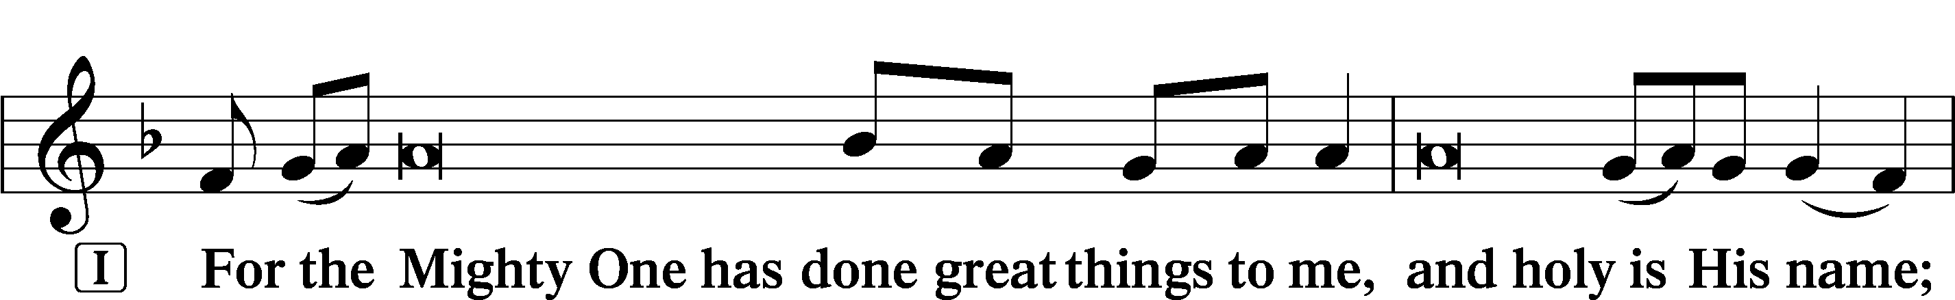
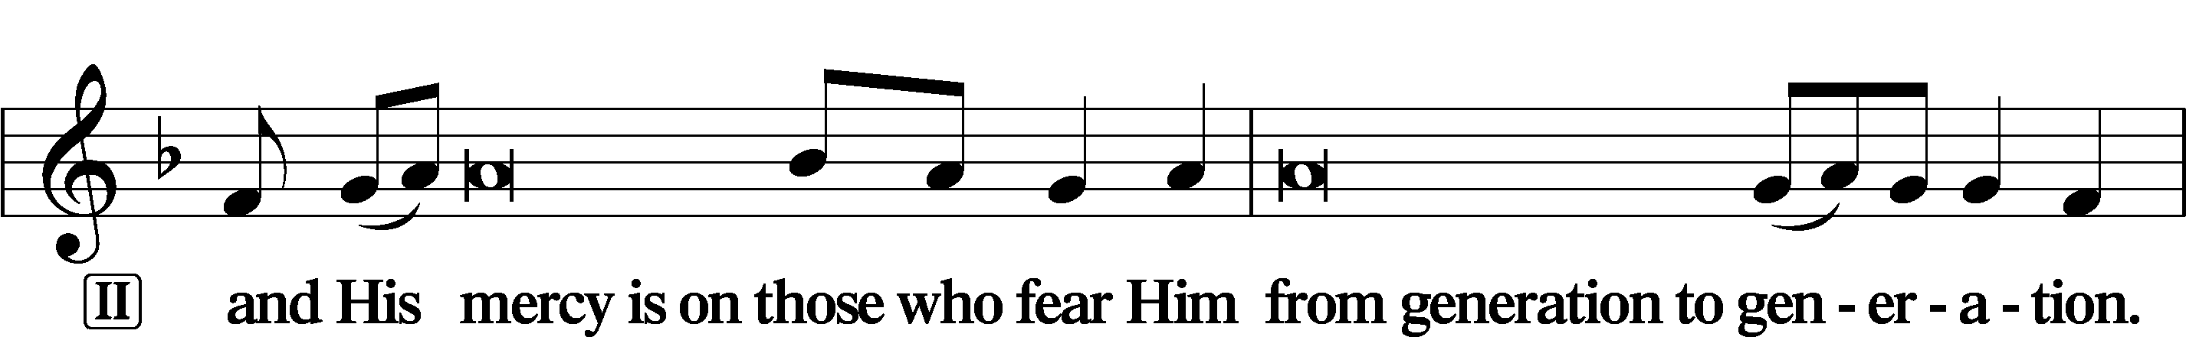
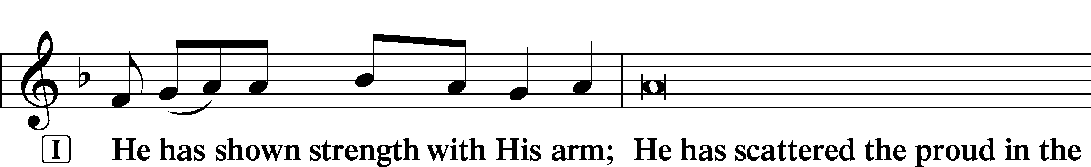
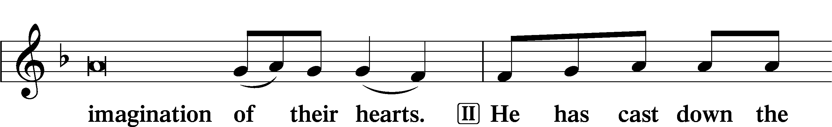
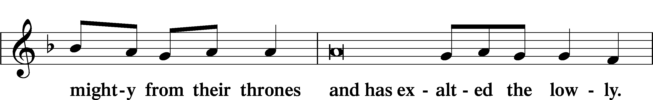
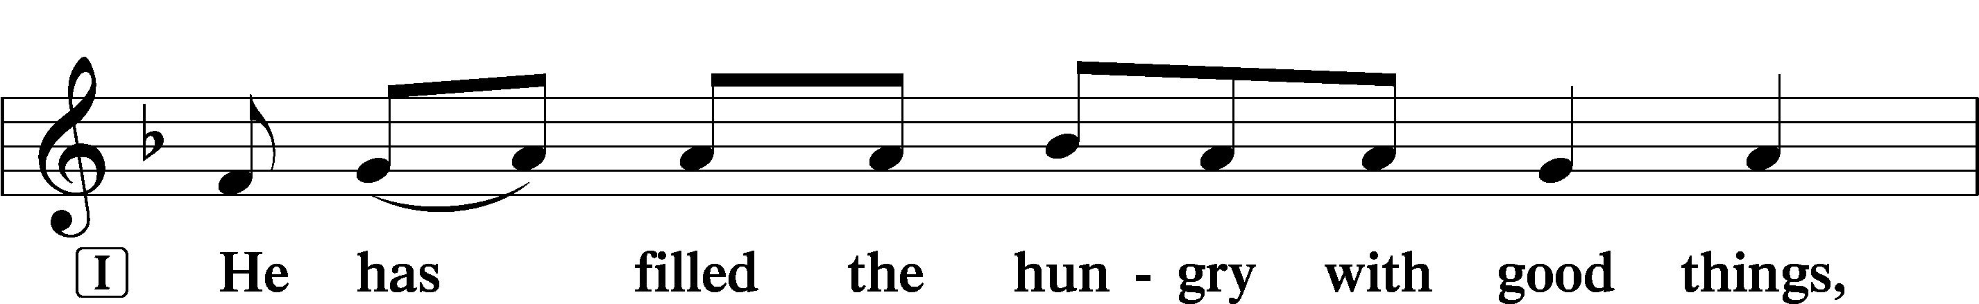
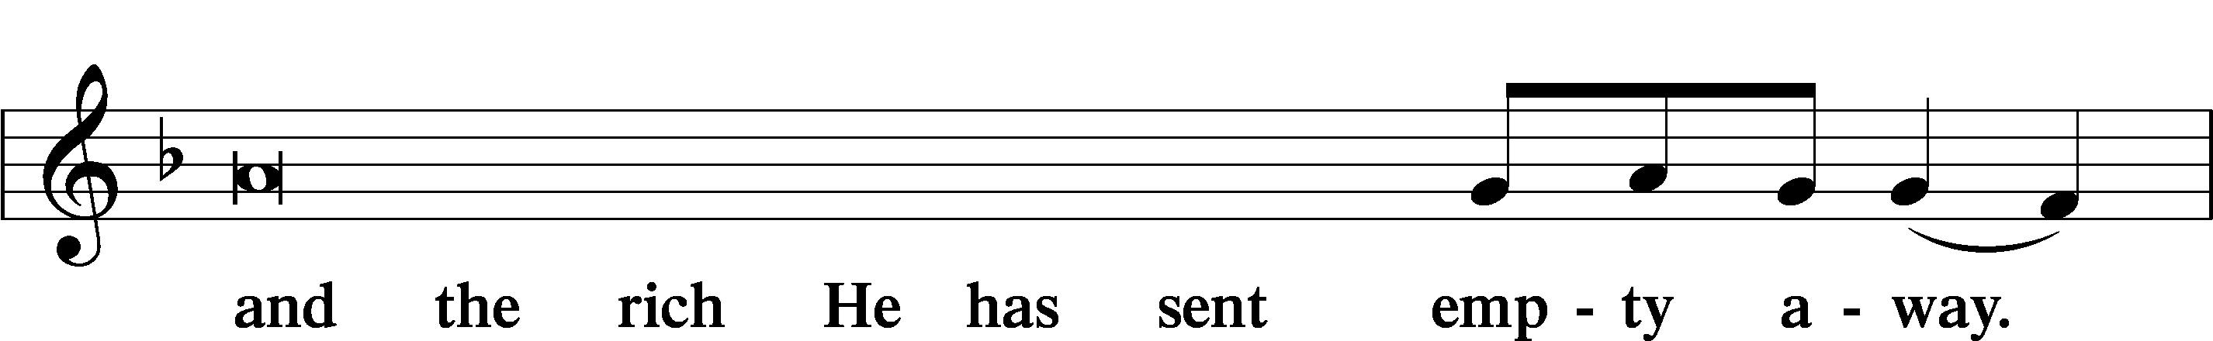
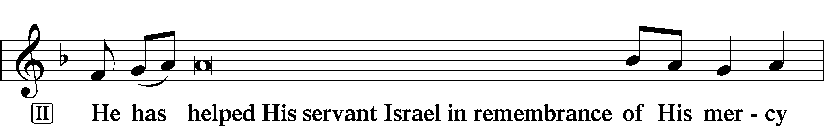
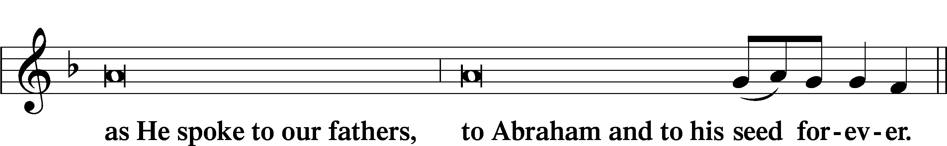
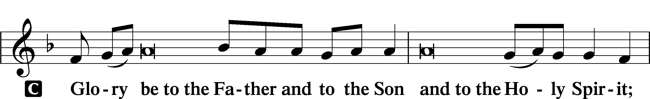
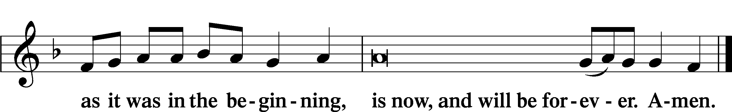
Prayer

Kyrie LSB 233
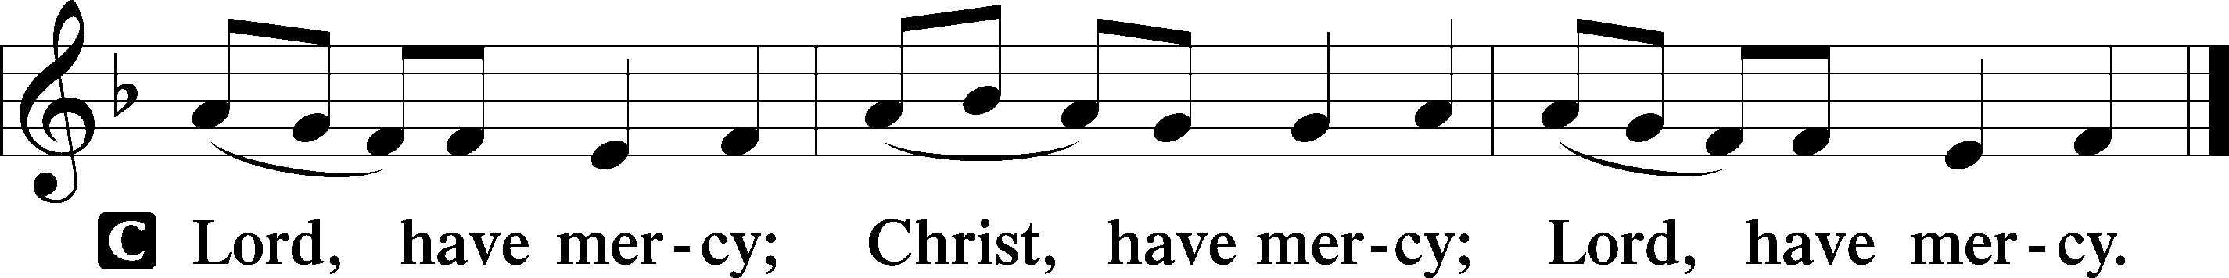

The Lord’s Prayer LSB 957
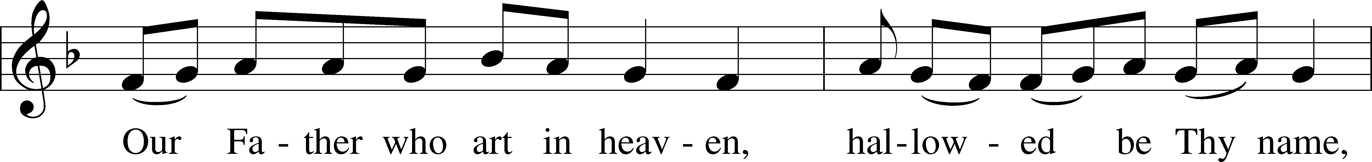
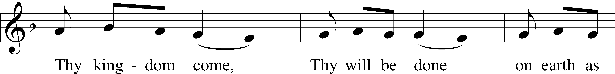
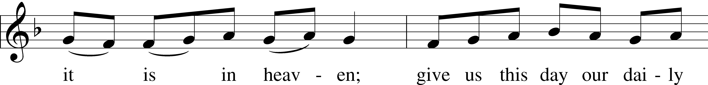
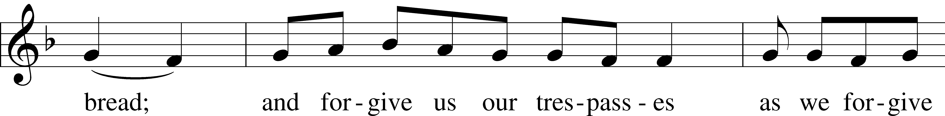
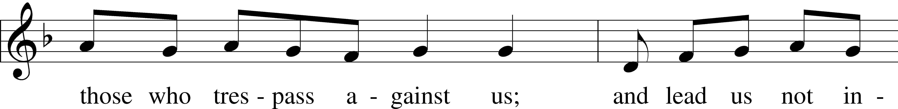
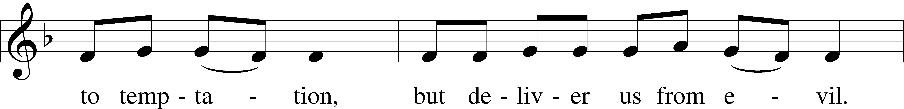
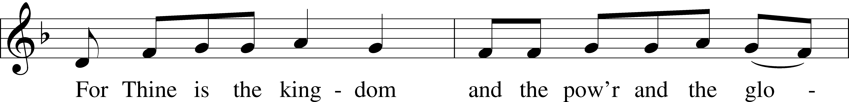
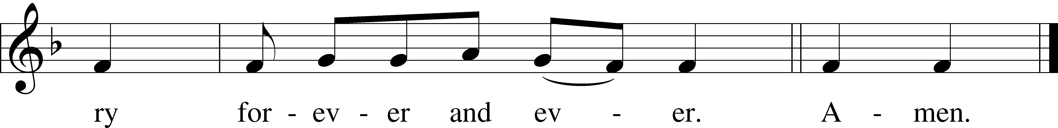

Collects

Introduction to Collects LSB 233
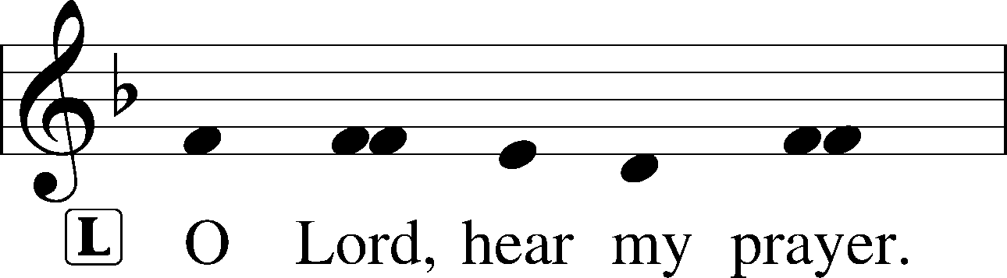
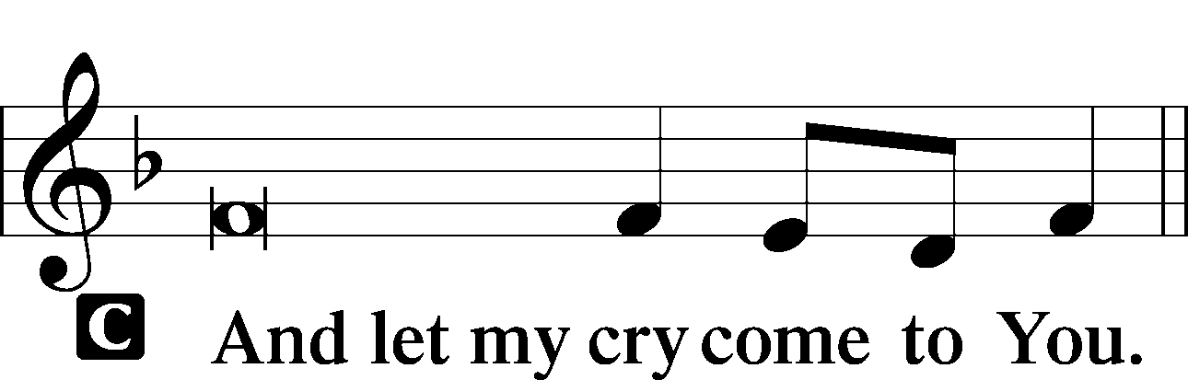

Collect of the Day: Saint John
P Merciful Lord, cast the bright beams of Your light upon Your Church that we, being instructed in the doctrine of Your blessed apostle and evangelist John, may come to the light of everlasting life; for You live and reign with the Father and the Holy Spirit, one God, now and forever.

Collect for Peace
P O God, from whom come all holy desires, all good counsels, and all just works, give to us, Your servants, that peace which the world cannot give, that our hearts may be set to obey Your commandments and also that we, being defended from the fear of our enemies, may live in peace and quietness; through Jesus Christ, Your Son, our Lord, who lives and reigns with You and the Holy Spirit, one God, now and forever.
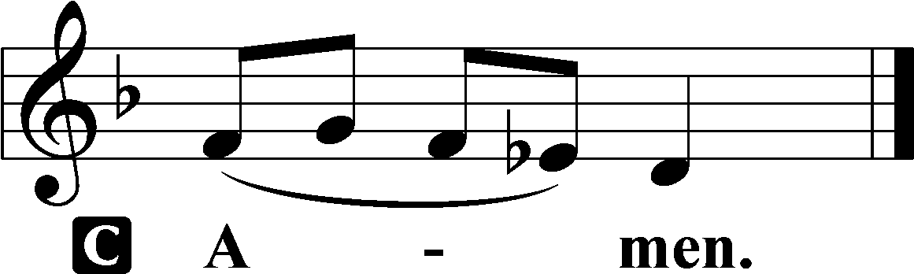

Benedicamus LSB 234
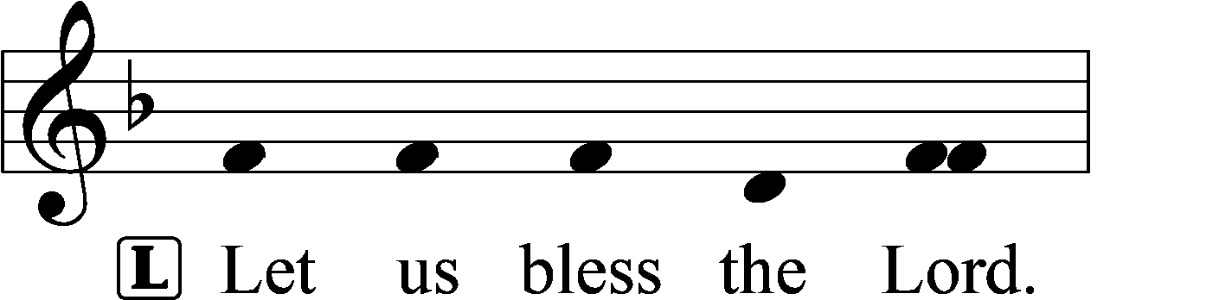
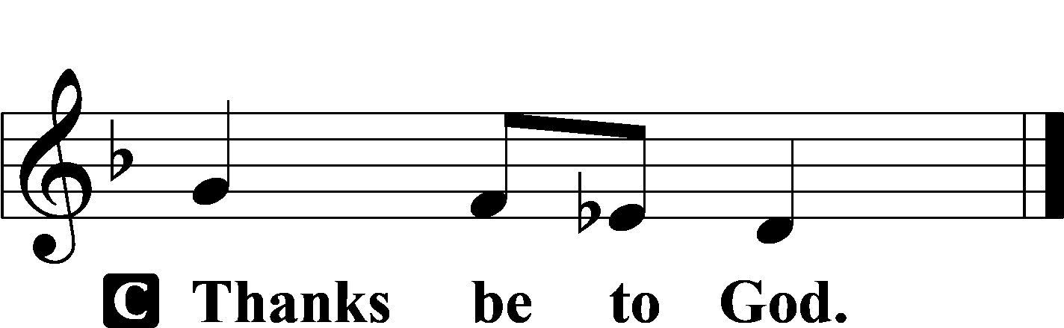

Benediction LSB 234
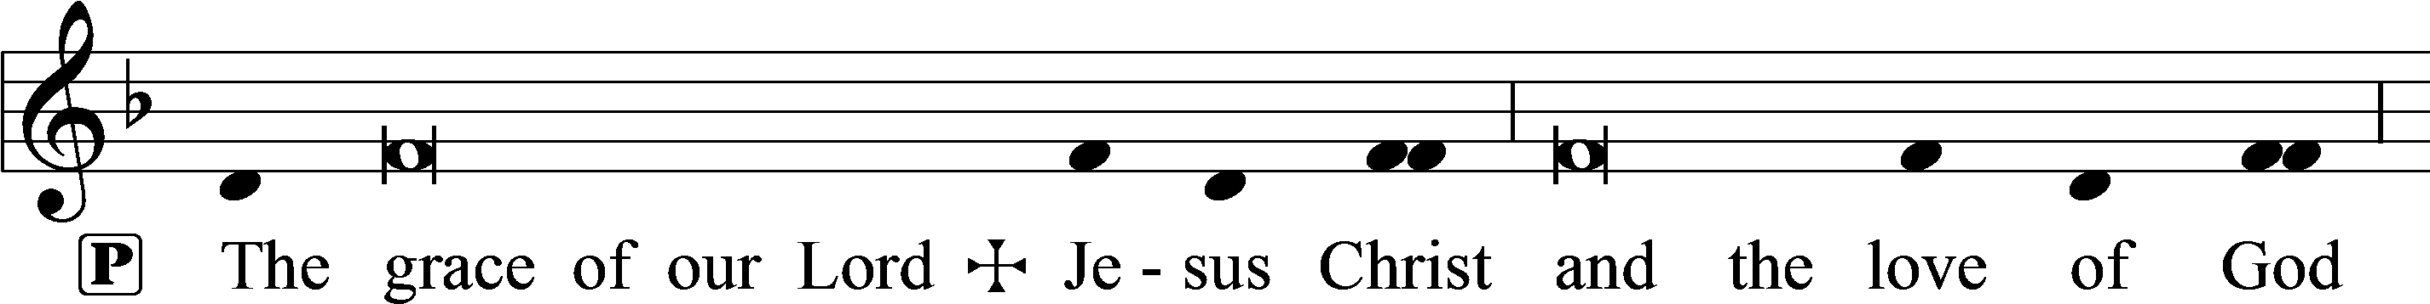
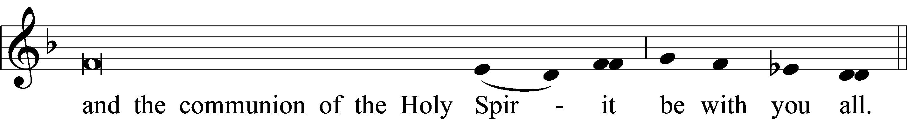

Closing Hymn: #383 “A Great and Mighty Wonder”
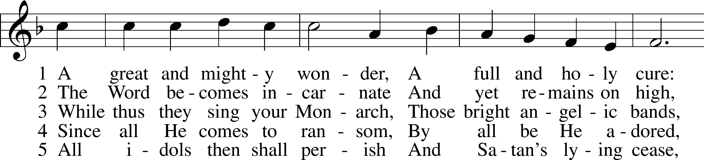
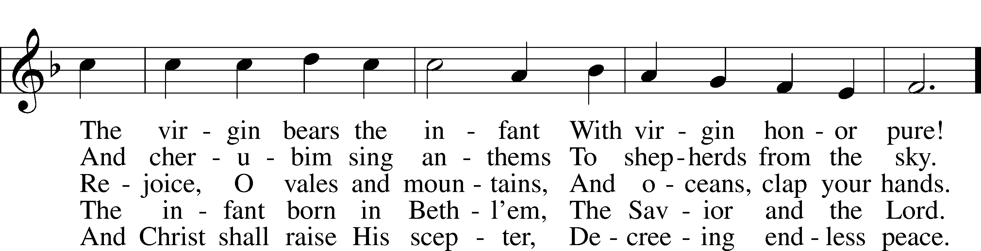
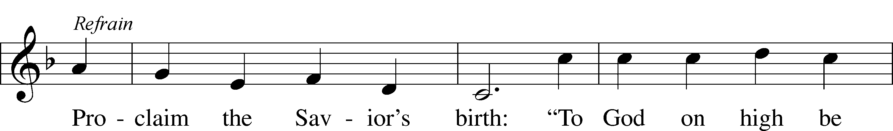
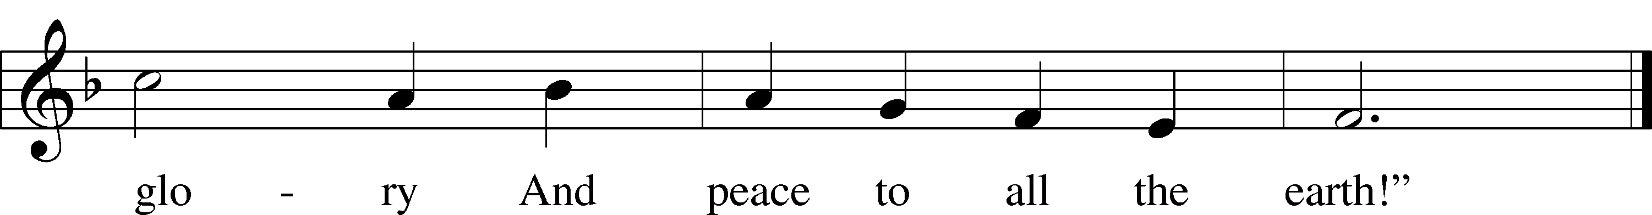

Text: Germanus, c. 634–c. 734; tr. John Mason Neale, 1818–66, alt. Tune: Alte Catholische Geistliche Kirchengeseng, 1599, Köln Text and tune: Public domain


Silent prayer after worship: Lord Jesus, let me not forget that You were born to be my Savior so that I can have forgiveness of sins, peace, hope and life everlasting. Fill me with Your love, and lead me to share that love always. Amen.

Acknowledgments
Unless otherwise indicated, Scripture quotations are from the ESV® Bible (The Holy Bible, English Standard Version®), copyright © 2001 by Crossway, a publishing ministry of Good News Publishers. Used by permission. All rights reserved.Created by Lutheran Service Builder © 2023 Concordia Publishing House.

