Sts. Peter & Paul
Evangelical Lutheran Church
Lutheran Church-Missouri Synod
Founded-1917

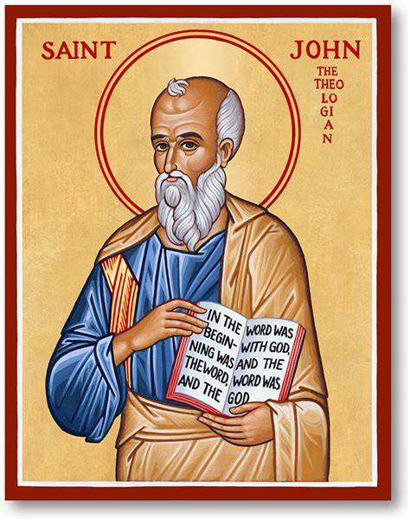

Festival of St. John,
Apostle & Evangelist
December 27, 2022

699 Stambaugh Avenue
Sharon, Pennsylvania 16146

“I was glad when they said to me,
Let us go to the house of the LORD!”
Psalm 122:1
Sts. Peter & Paul Evangelical Lutheran Church, LC-MS

FESTIVAL OF ST. JOHN,
APOSTLE & EVANGELIST
December 27, 2022

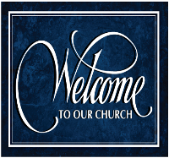
A special welcome to our guests this day! If you would like more information about The Lutheran Church - Missouri Synod, or this congregation, please speak with Pastor Deal or an Elder after the service.
Members & Guests: Don’t be embarrassed if your children make noise during the worship service, all children do. We encourage families to worship together but, if you feel the need, there are pews in the rear of the Church which are reserved for young families on both sides of the sanctuary. There is also a quiet room available to you during our service which is located down the hallway past the offices on the right side of the church as well as a children’s area in the Fellowship Hall where you are able to follow along with the service.

CONTACT INFORMATION
Pastor Deal: pastordeal@saintspeterandpaul.net or 724-347-3620 (opt. 2)
Church Office: church@saintspeterandpaul.net or 724-347-3620 (opt. 3)

Silent prayer before worship: Dearest Lord Jesus, You have come to me as the Holy Child of Bethlehem. I come to You this hour to receive Your gifts peace, hope, love, joy and life. Help me to value these more than anything else. Amen.

VESPERS

Opening Hymn: LSB #384 “Of the Father’s Love Begotten”

Stand

Common Versicles LSB 229
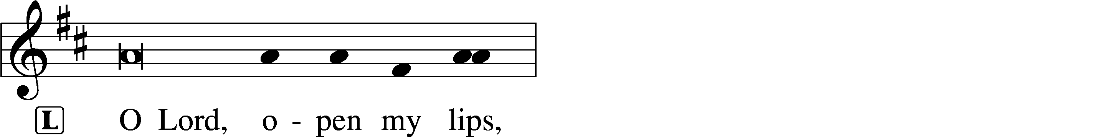
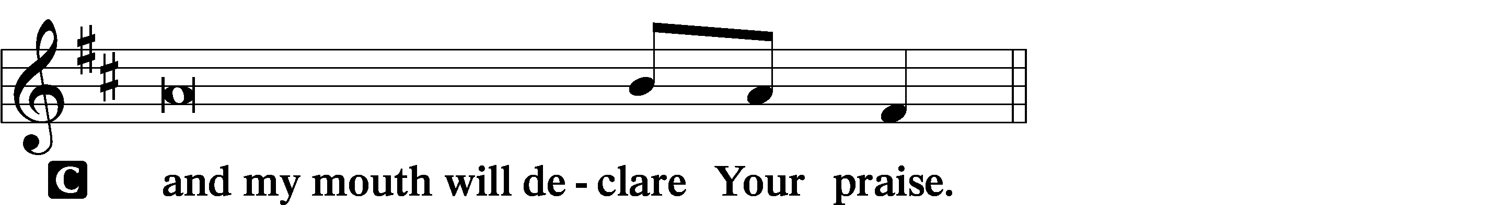

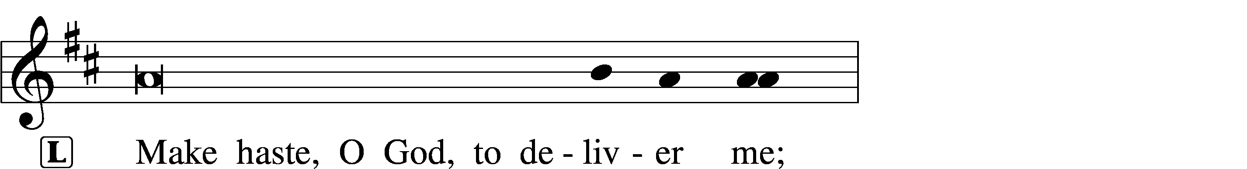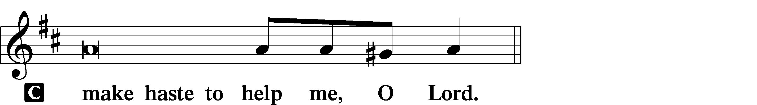

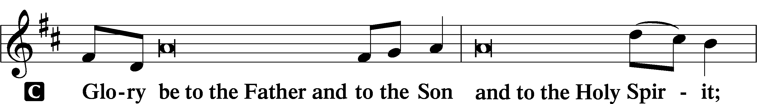
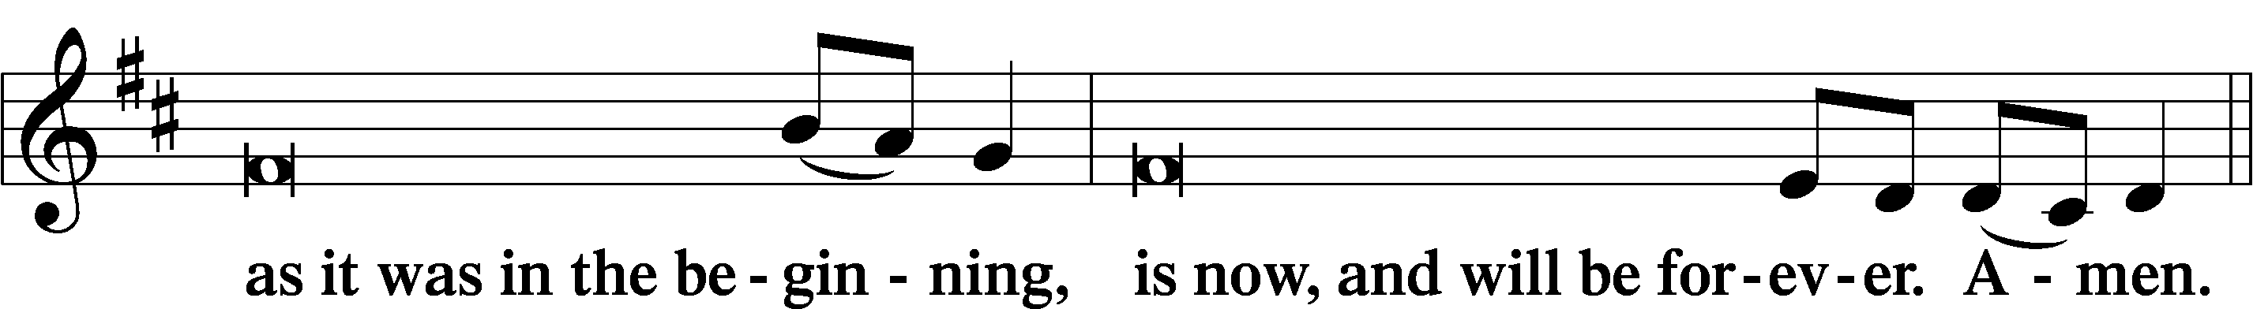
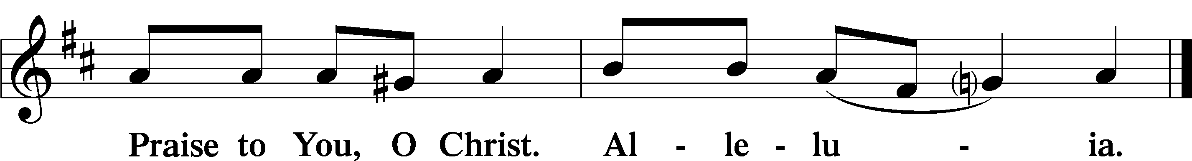

Psalmody

Psalm 11
In the Lord I take refuge;
how can you say to my soul,
“Flee like a bird to your mountain,
for behold, the wicked bend the bow;
they have fitted their arrow to the string
to shoot in the dark at the upright in heart;
if the foundations are destroyed,
what can the righteous do?”
The Lord is in his holy temple;
the Lord’s throne is in heaven;
his eyes see, his eyelids test, the children of man.
The Lord tests the righteous,
but his soul hates the wicked and the one who loves violence.
Let him rain coals on the wicked;
fire and sulfur and a scorching wind shall be the portion of their cup.
For the Lord is righteous;
he loves righteous deeds;
the upright shall behold his face.

Sit

Hymn of the Day: LSB #523 “O Word of God Incarnate”

Readings
Prophecy: Sirach 15:1–2a, 3–6
The man who fears the Lord will do good, and he who holds to the law will obtain wisdom. She will come to meet him like a mother, she will feed him with the bread of understanding, and give him the water of wisdom to drink. He will lean on her and will not fall, and he will rely on her and will not be put to shame. She will exalt him above his neighbors, and will open his mouth in the midst of the assembly. He will find gladness and a crown of rejoicing, and will acquire an everlasting name, even the Lord our God.

P This is the Word of the Lord.
C Thanks be to God.

Epistle: 1 John 1:1—2:2
Dearly Beloved: That which was from the beginning, which we have heard, which we have seen with our eyes, which we have looked upon, and our hands have handled, concerning the Word of life—the life was manifested, and we have seen, and bear witness, and declare to you that eternal life which was with the Father and was manifested to us—that which we have seen and heard we declare to you, that you also may have fellowship with us; and truly our fellowship is with the Father and with His Son Jesus Christ. And these things we write to you that your joy may be full. This is the message which we have heard from Him and declare to you, that God is light and in Him is no darkness at all. If we say that we have fellowship with Him, and walk in darkness, we lie and do not practice the truth. But if we walk in the light as He is in the light, we have fellowship with one another, and the blood of Jesus Christ His Son cleanses us from all sin. If we say that we have no sin, we deceive ourselves, and the truth is not in us. If we confess our sins, He is faithful and just to forgive us our sins and to cleanse us from all unrighteousness. If we say that we have not sinned, we make Him a liar, and His word is not in us. My little children, these things I write to you, so that you may not sin. And if anyone sins, we have an Advocate with the Father, Jesus Christ the righteous. And He Himself is the propitiation for our sins, and not for ours only but also for the whole world.

P This is the Word of the Lord.
C Thanks be to God.

Gospel: John 21:19b–24
At that time: Jesus said to Peter, “Follow Me.” Then Peter, turning around, saw the disciple whom Jesus loved following, who also had leaned on His breast at the supper, and said, “Lord, who is the one who betrays You?” Peter, seeing him, said to Jesus, “But Lord, what about this man?” Jesus said to him, “If I will that he remain till I come, what is that to you? You follow Me.” Then this saying went out among the brethren that this disciple would not die. Yet Jesus did not say to him that he would not die, but, “If I will that he remain till I come, what is that to you?” This is the disciple who testifies of these things, and wrote these things; and we know that his testimony is true.

P This is the Word of the Lord.
C Thanks be to God.

Sermon
Canticle
Stand

Antiphon (Common) 231
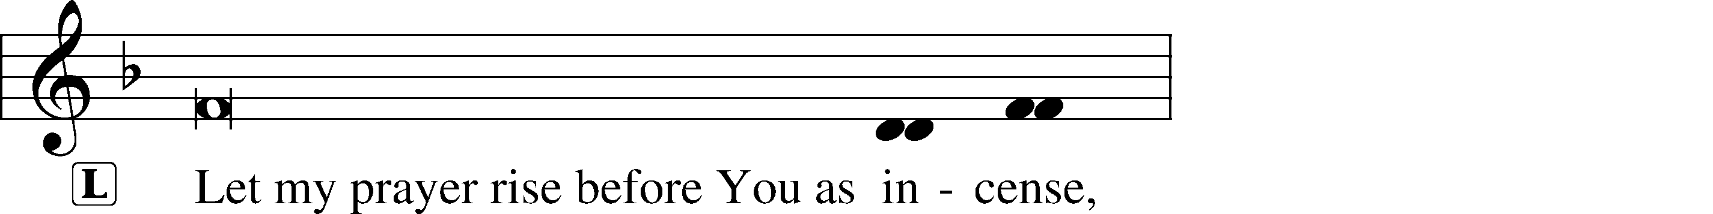
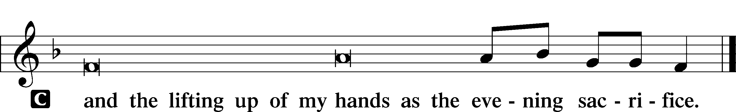

Magnificat 231
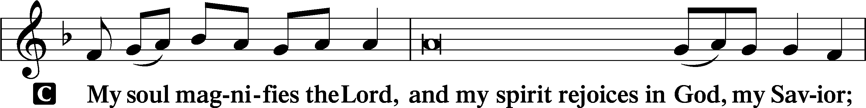
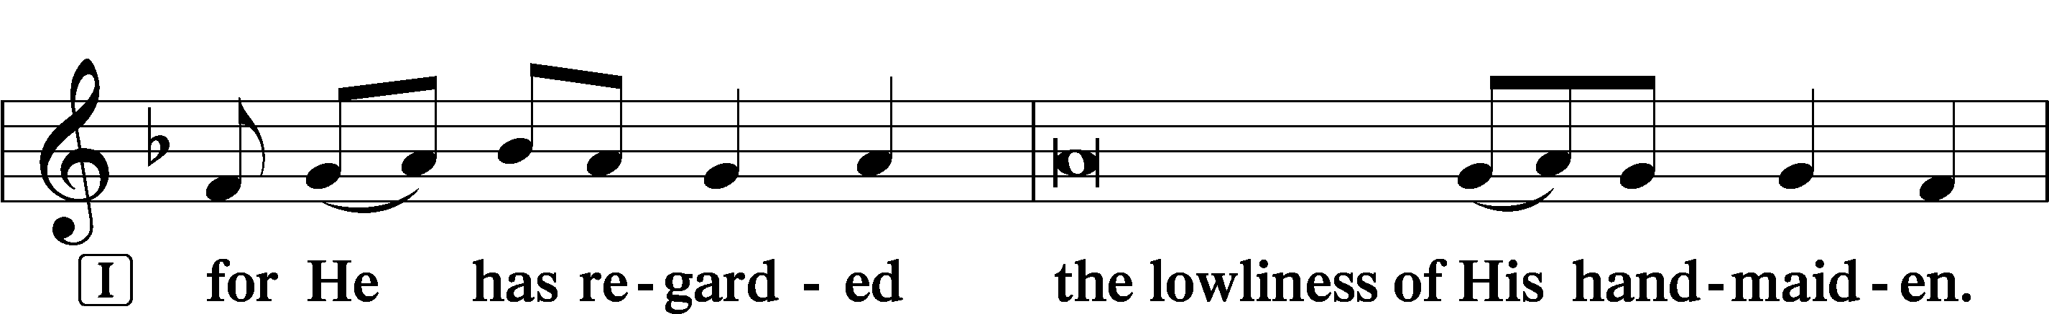
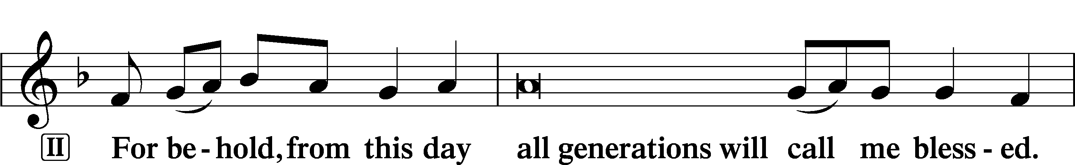
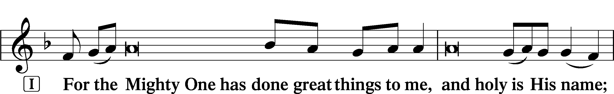
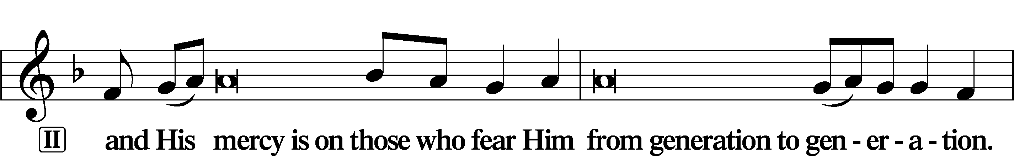
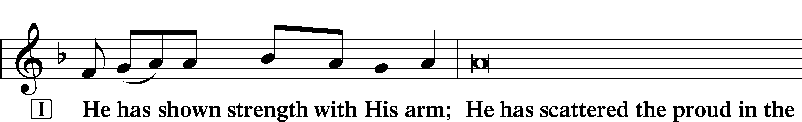
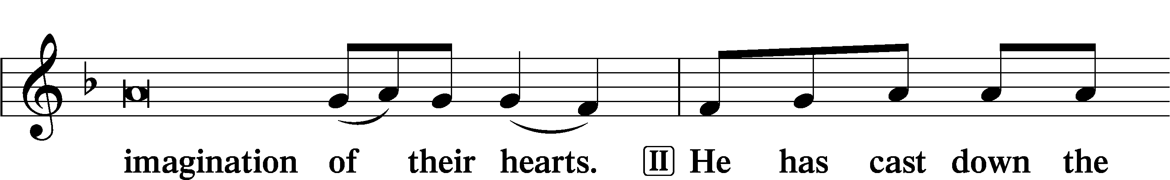
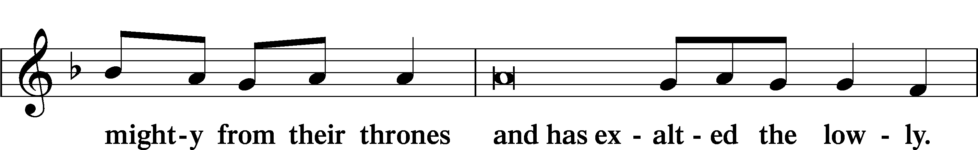
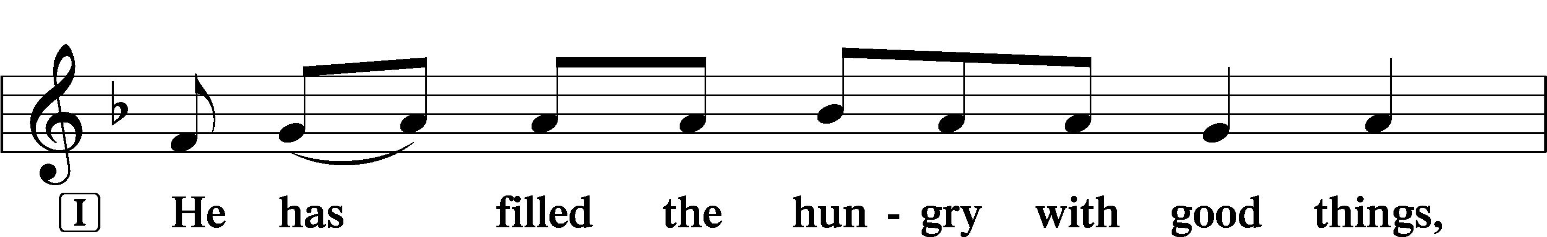
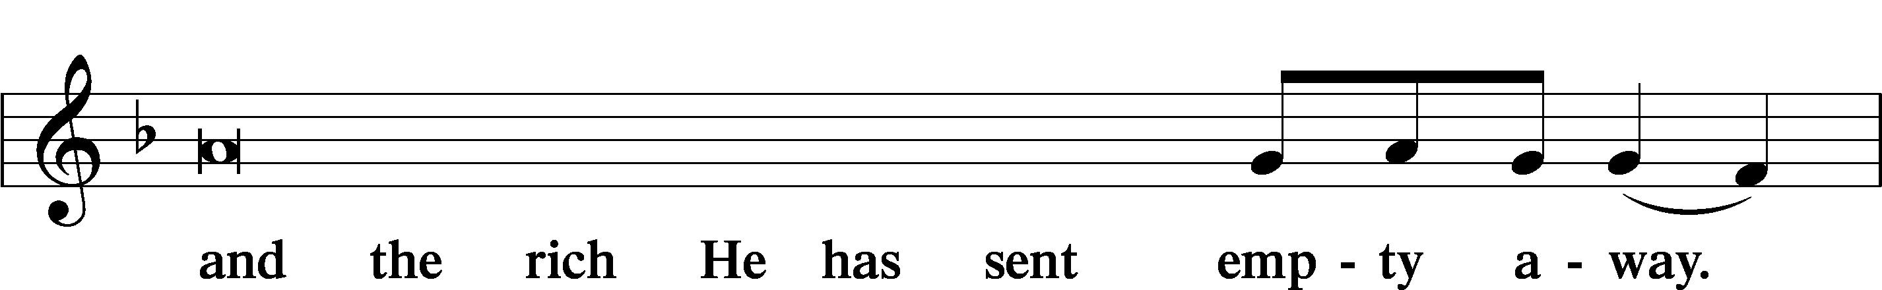
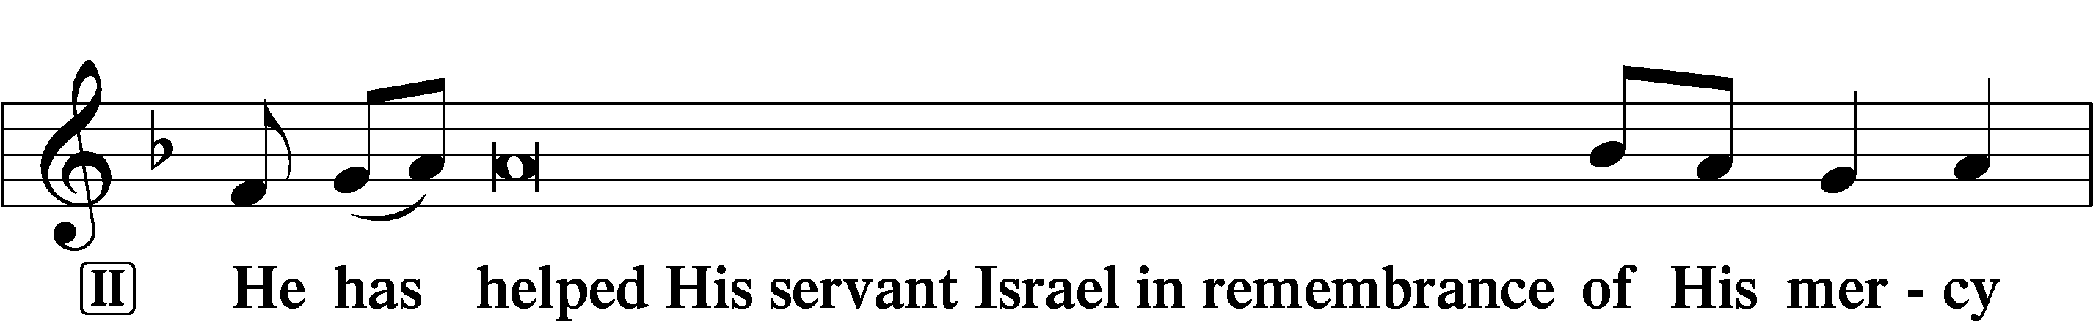
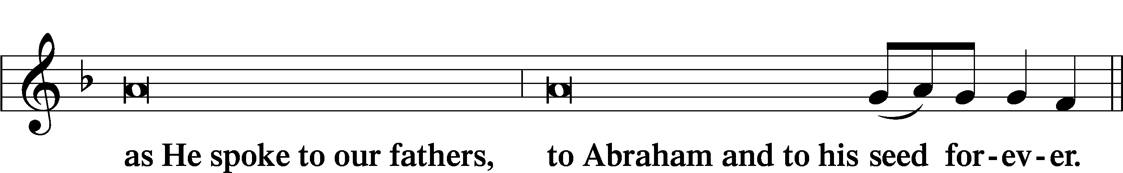
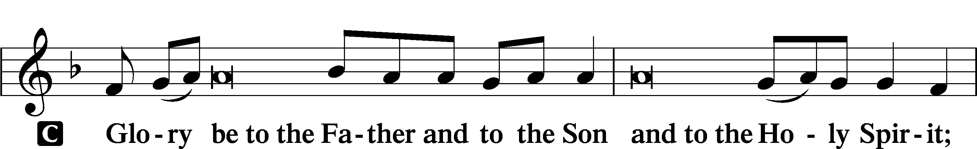
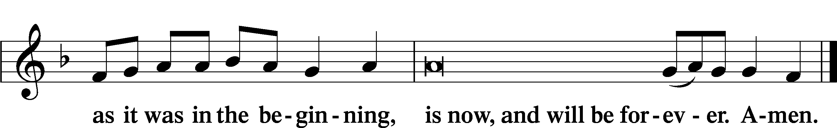

Prayer

Kyrie LSB 233
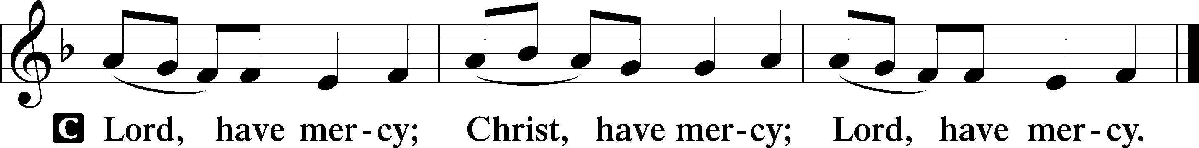

Lord’s Prayer
C Our Father who art in heaven,
hallowed be Thy name,
Thy kingdom come,
Thy will be done on earth
as it is in heaven;
give us this day our daily bread;
and forgive us our trespasses
as we forgive those
who trespass against us;
and lead us not into temptation,
but deliver us from evil.
For Thine is the kingdom
and the power and the glory
forever and ever. Amen.

Collects
Introduction to Collects LSB 233
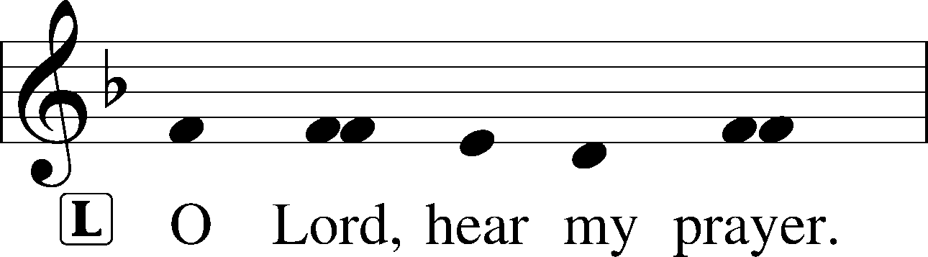
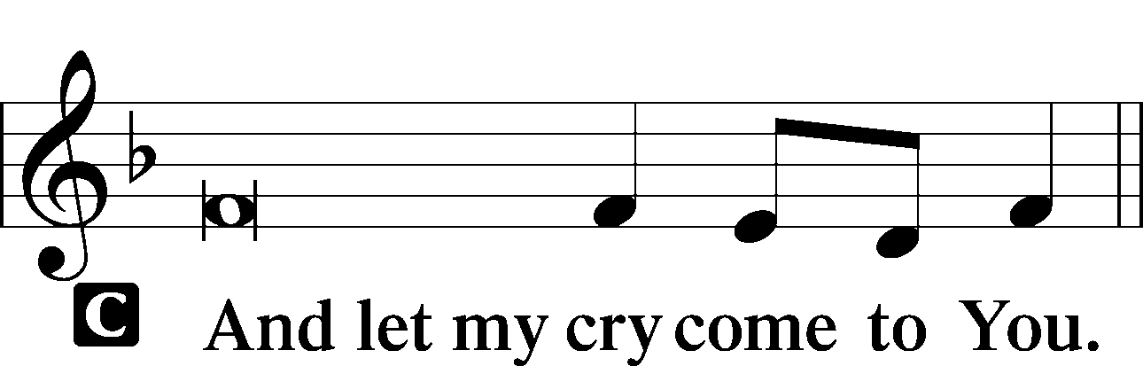

Collect of the Day: St. John
P Merciful Lord, cast the bright beams of Your light upon Your Church that we, being instructed in the doctrine of Your blessed apostle and evangelist John, may come to the light of everlasting life; for You live and reign with the Father and the Holy Spirit, one God, now and forever.

Collect for Peace
P O God, from whom come all holy desires, all good counsels, and all just works, give to us, Your servants, that peace which the world cannot give, that our hearts may be set to obey Your commandments and also that we, being defended from the fear of our enemies, may live in peace and quietness; through Jesus Christ, Your Son, our Lord, who lives and reigns with You and the Holy Spirit, one God, now and forever.
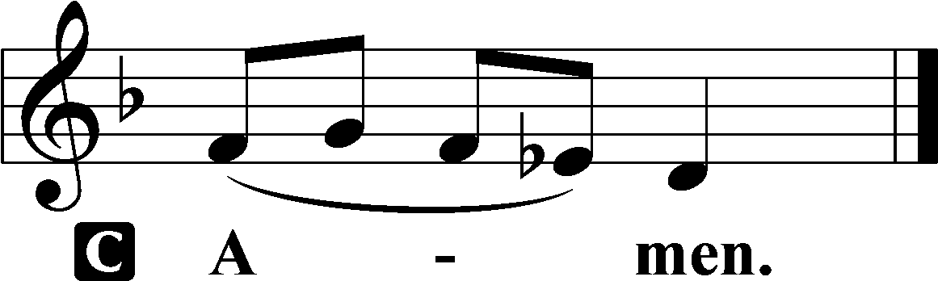

Benedicamus LSB 234
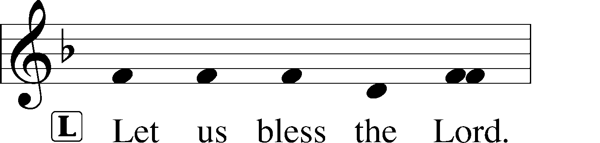
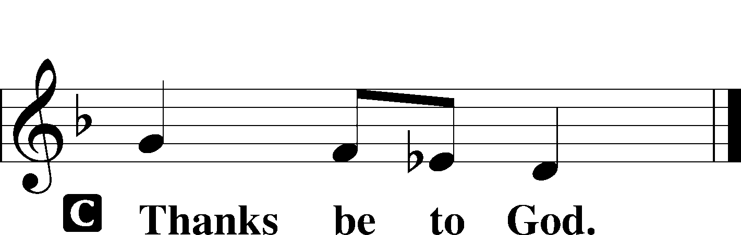

Benediction LSB 234
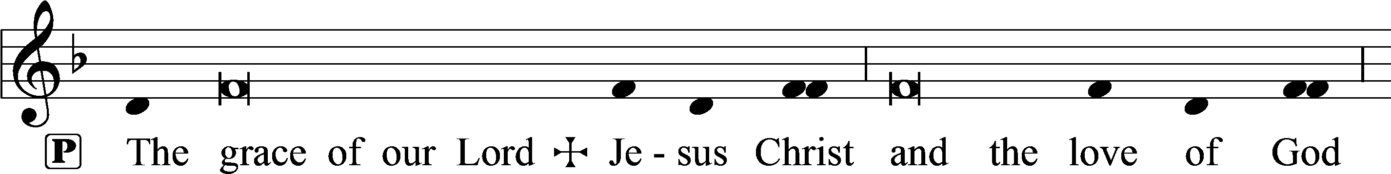
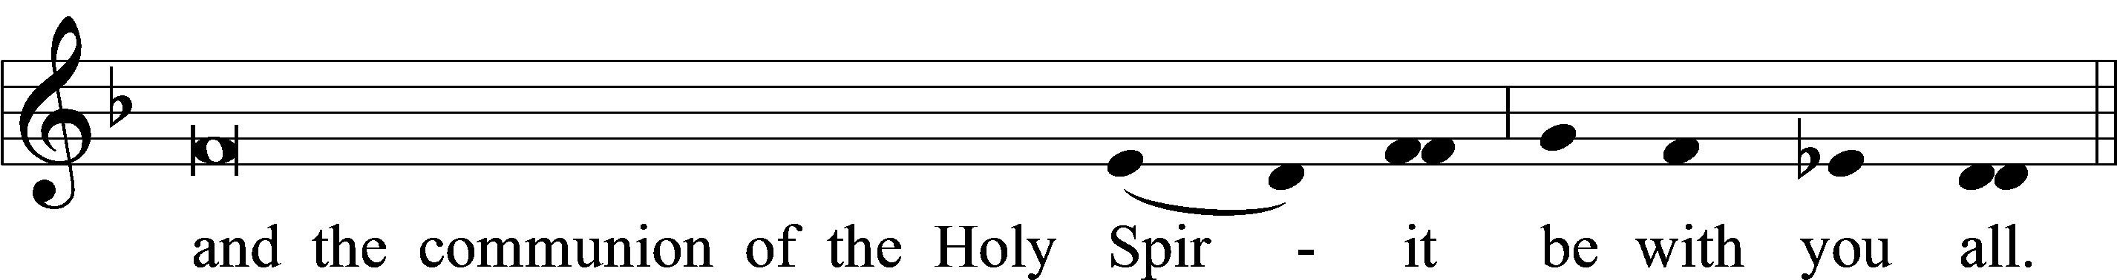

Closing Hymn: LSB #381 “Let Our Gladness Have No End”

Silent prayer after worship: Thank You, Lord Jesus, for leaving Your throne in heaven to come and be my Savior. Lead me to daily rejoice and give thanks for Your gift of salvation, and to share with others the good news of Your birth. Amen.
fffffffffffffffffffffffffffffffffff
Acknowledgments
Unless otherwise indicated, Scripture quotations are from the ESV® Bible (The Holy Bible, English Standard Version®), copyright © 2001 by Crossway, a publishing ministry of Good News Publishers. Used by permission. All rights reserved.
Created by Lutheran Service Builder © 2022 Concordia Publishing House.

Please consider joining us for the following upcoming services:

Festival of the Holy Innocents, Martyrs
7 pm, Vespers
Wednesday, December 28, 2022

New Year’s Eve
4 pm, Vespers
Saturday, December 31, 2022

The Circumcision and Name of Jesus
9 am, Divine Service
Sunday, January 1, 2023

Here to Serve

Pastor………………………………………………...……………Rev. Jacob Deal
E-mail …………………………….……pastordeal@saintspeterandpaul.net
Phone Number……………………..…………………724-347-3620 (Option 2)
Church Office………………………..…………………724-347-3620 (Option 3)
Website …………………………………………www.saintspeterandpaul.net
Secretary…………………………………………………………Diane Riefstahl
E-mail ………………………………………church@saintspeterandpaul.net
Website …………………………………………www.saintspeterandpaul.net
Food Pantry: Please leave message……………724-347-3620 (Option 3)
AA Contact: Steve………………………………………………..…724-813-2358
NA Contact: Larry………………………………………………..724-977-8733
Choir Director………………………………………………………Chris Nelson
Congregation President……………………………………Jonathan Baisch
Elder Chairman…………………………………………...………Barry Nelson
fffffffffffffffffffffffffffffffffff
If needing to get into the church building during the week, please phone first to make certain someone is here to let you in.

