Sts. Peter & Paul
Evangelical Lutheran Church
Lutheran Church-Missouri Synod
Founded-1917

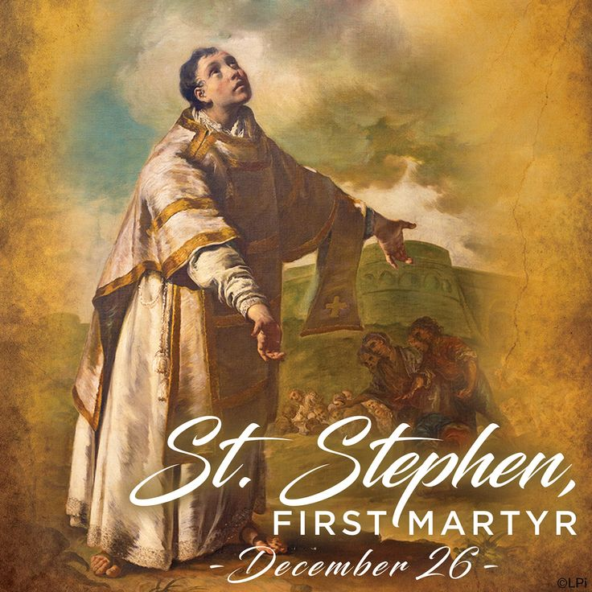

Festival of St. Stephen, Martyr
December 26, 2022

699 Stambaugh Avenue
Sharon, Pennsylvania 16146

“I was glad when they said to me,
Let us go to the house of the LORD!”
Psalm 122:1

Sts. Peter & Paul Evangelical Lutheran Church, LC-MS

FESTIVAL OF ST. STEPHEN, MARTYR
December 26, 2022

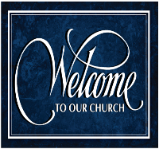
A special welcome to our guests this day! If you would like more information about The Lutheran Church - Missouri Synod, or this congregation, please speak with Pastor Deal or an Elder after the service.
Members & Guests: Don’t be embarrassed if your children make noise during the worship service, all children do. We encourage families to worship together but, if you feel the need, there are pews in the rear of the Church which are reserved for young families on both sides of the sanctuary. There is also a quiet room available to you during our service which is located down the hallway past the offices on the right side of the church as well as a children’s area in the Fellowship Hall where you are able to follow along with the service.

CONTACT INFORMATION
Pastor Deal: pastordeal@saintspeterandpaul.net or 724-347-3620 (opt. 2)
Church Office: church@saintspeterandpaul.net or 724-347-3620 (opt. 3)

Silent prayer before worship: Dearest Lord Jesus, You have come to me as the Holy Child of Bethlehem. I come to You this hour to receive Your gifts peace, hope, love, joy and life. Help me to value these more than anything else. Amen.

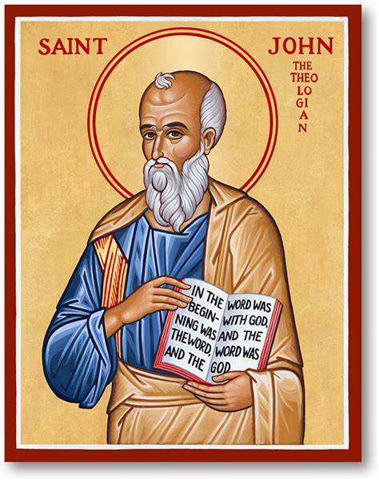
VESPERS

Opening Hymn: LSB #517 “By All Your Saints in Warfare” (1 ,7, 3)

Stand

Common Versicles LSB 229
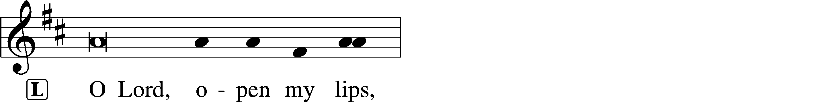
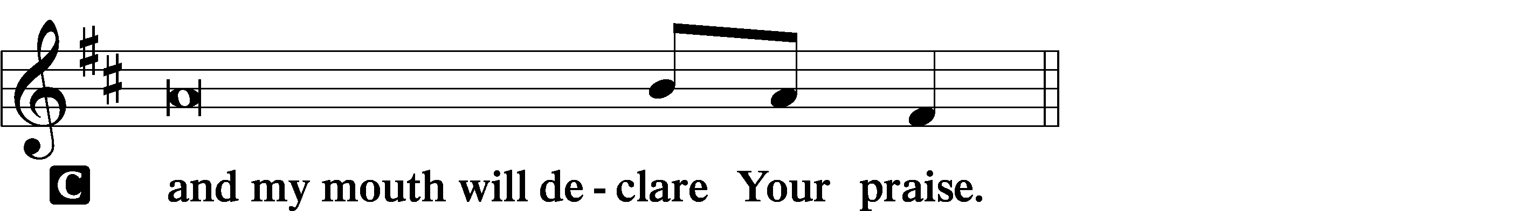

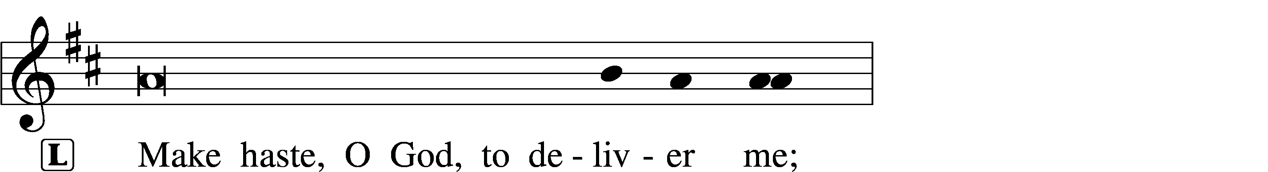
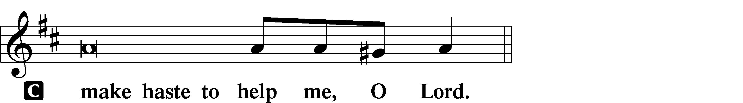

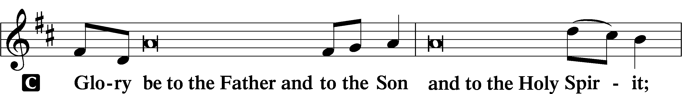
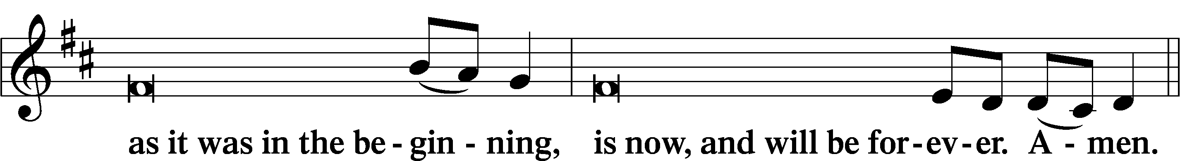
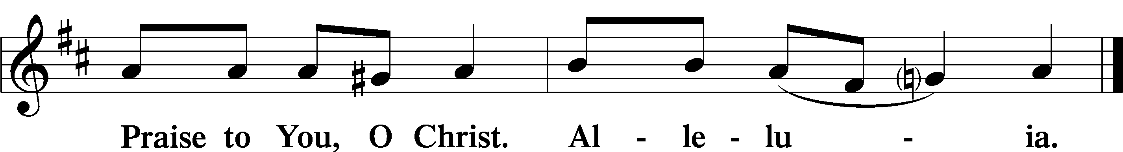

Psalmody

Psalm 119:137–144
Righteous are you, O Lord,
and right are your just decrees.
You have appointed your testimonies in righteousness
and in all faithfulness.
My zeal consumes me,
because my foes forget your words.
Your promise is well tried,
and your servant loves it.
I am small and despised,
yet I do not forget your precepts.
Your righteousness is righteous forever,
and your law is true.
Trouble and anguish have found me out,
but your commandments are my delight.
Your testimonies are righteous forever;
give me understanding that I may live.
Sit

Hymn of the Day: TLH #470 “Rise Again, Ye Lion-Hearted”

Readings

Prophecy: 2 Chronicles 24:17–22
In those days: After the death of Jehoiada the priest, the leaders of Judah came and bowed down to the king. And the king listened to them. Therefore they left the house of the Lord God of their fathers, and served wooden images and idols; and wrath came upon Judah and Jerusalem because of their trespass. Yet He sent prophets to them, to bring them back to the Lord; and they testified against them, but they would not listen. Then the Spirit of God came upon Zechariah the son of Jehoiada the priest, who stood above the people, and said to them, “Thus says God: ‘Why do you transgress the commandments of the Lord, so that you cannot prosper? Because you have forsaken the Lord, He also has forsaken you.’ ” So they conspired against him, and at the command of the king they stoned him with stones in the court of the house of the Lord. Thus Joash the king did not remember the kindness which Jehoiada his father had done to him, but killed his son; and as he died, he said, “The Lord look on it, and repay!”

P This is the Word of the Lord.
C Thanks be to God.

Epistle: Acts 6:8-10; 7:54-60
In those days: Stephen, full of faith and power, did great wonders and signs among the people. Then there arose some from what is called the Synagogue of the Freedmen (Cyrenians, Alexandrians, and those from Cilicia and Asia), disputing with Stephen. And they were not able to resist the wisdom and the Spirit by which he spoke. When they heard him they were cut to the heart, and they gnashed at him with their teeth. But he, being full of the Holy Spirit, gazed into heaven and saw the glory of God, and Jesus standing at the right hand of God, and said, “Look! I see the heavens opened and the Son of Man standing at the right hand of God!” Then they cried out with a loud voice, stopped their ears, and ran at him with one accord; and they cast him out of the city and stoned him. And the witnesses laid down their clothes at the feet of a young man named Saul. And they stoned Stephen as he was calling on God and saying, “Lord Jesus, receive my spirit.” Then he knelt down and cried out with a loud voice, “Lord, do not charge them with this sin.” And when he had said this, he fell asleep in the Lord.

P O Lord, have mercy on us.
C Thanks be to God.

Gospel: Matthew 23:34–39
At that time Jesus said to the multitude of the Jews and the chief priests: “Therefore, indeed, I send you prophets, wise men, and scribes: some of them you will kill and crucify, and some of them you will scourge in your synagogues and persecute from city to city, that on you may come all the righteous blood shed on the earth, from the blood of righteous Abel to the blood of Zechariah, son of Berechiah, whom you murdered between the temple and the altar. Assuredly, I say to you, all these things will come upon this generation. O Jerusalem, Jerusalem, the one who kills the prophets and stones those who are sent to her! How often I wanted to gather your children together, as a hen gathers her chicks under her wings, but you were not willing! See! Your house is left to you desolate; for I say to you, you shall see Me no more till you say, ‘Blessed is He who comes in the name of the Lord!’ ”

P O Lord, have mercy on us.
C Thanks be to God.

Reading Response
P This is the Word of the Lord.
C Thanks be to God.

Sermon
Canticle
Stand

Antiphon (Common) 231
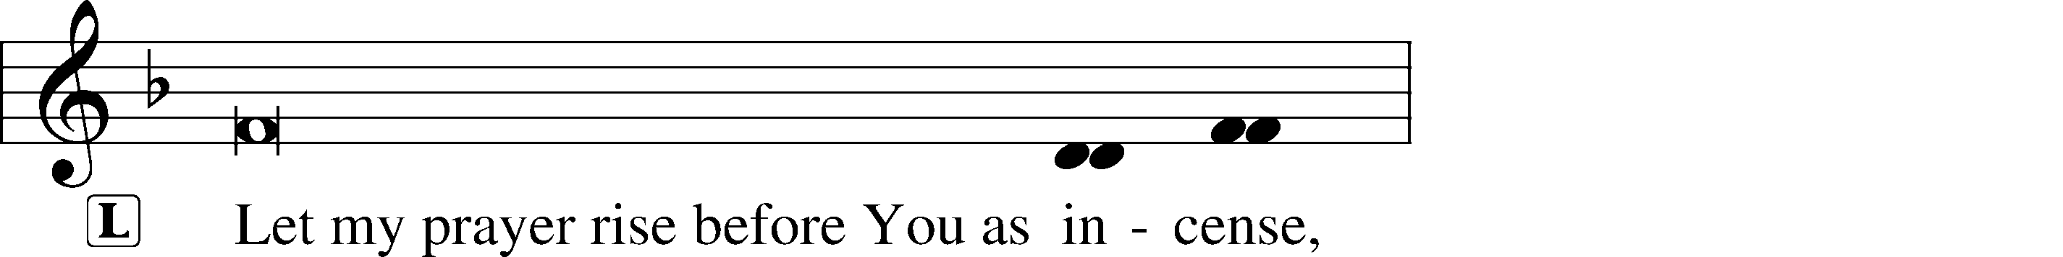
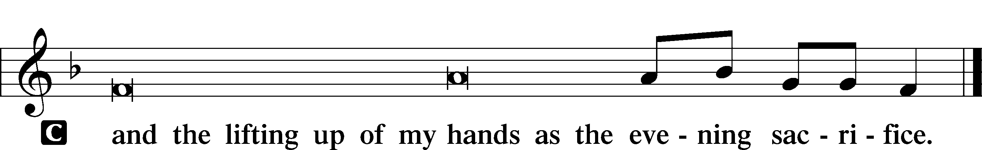
231
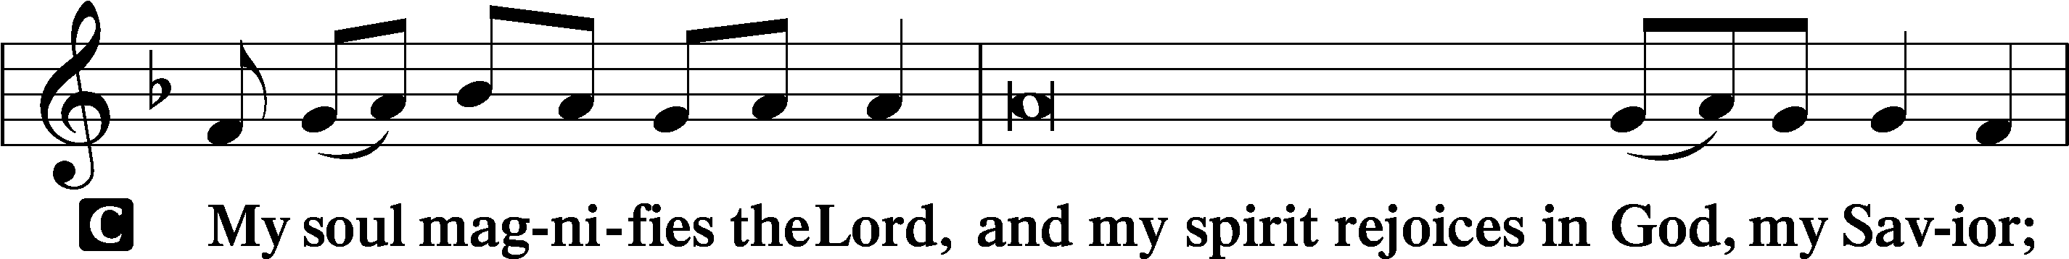
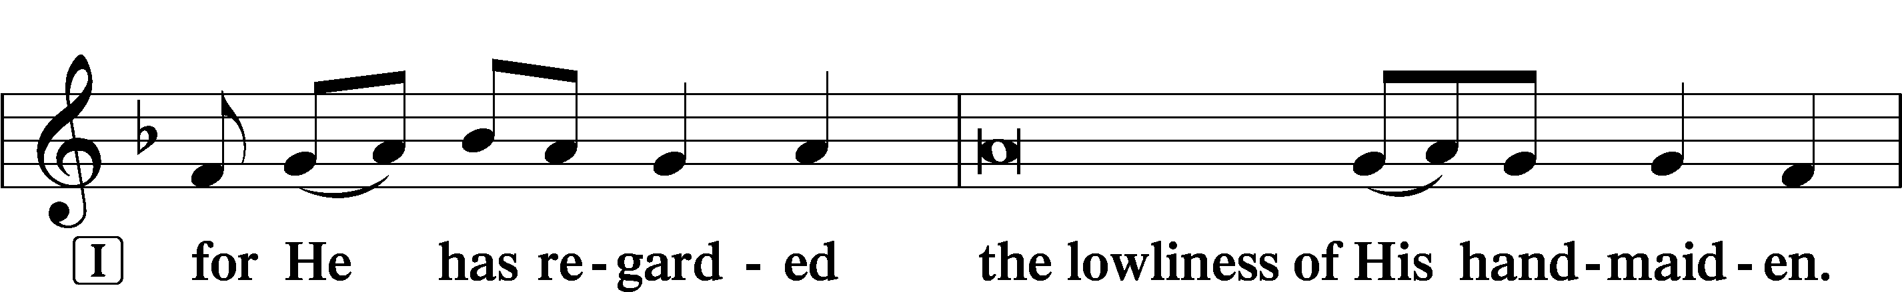
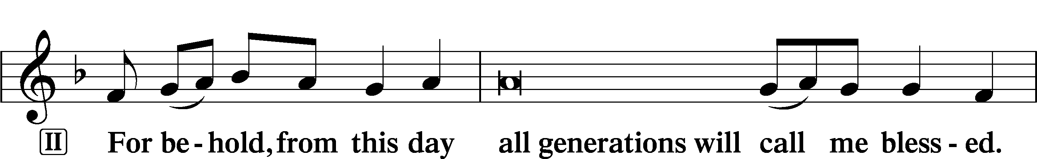
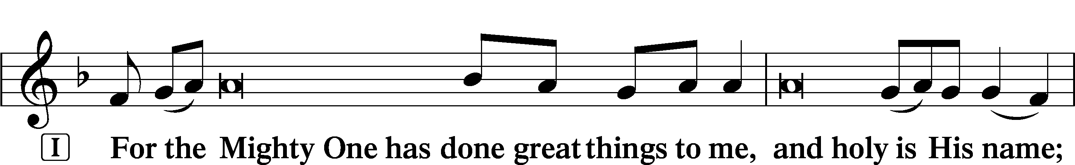
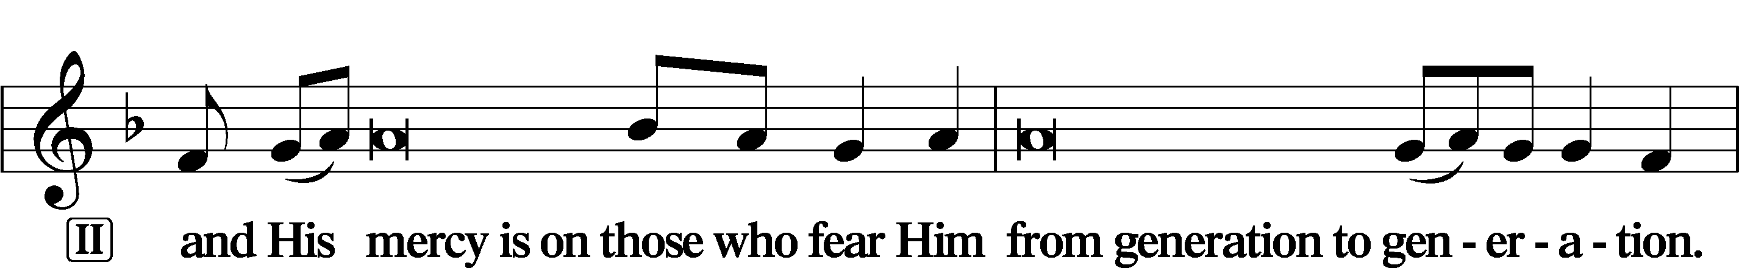
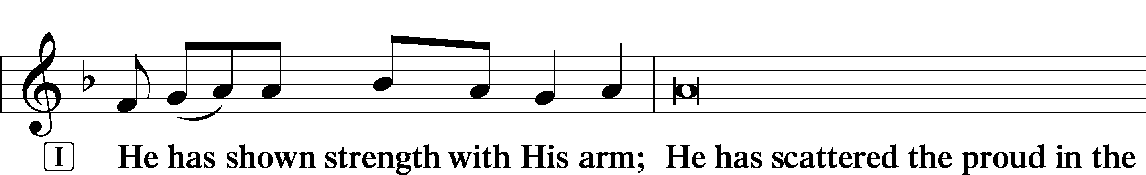
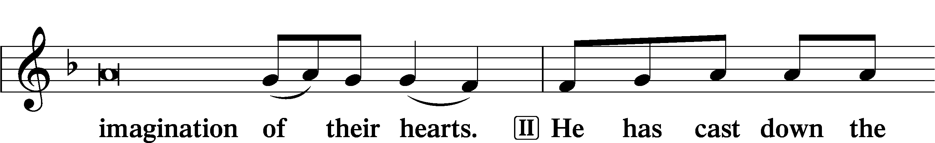
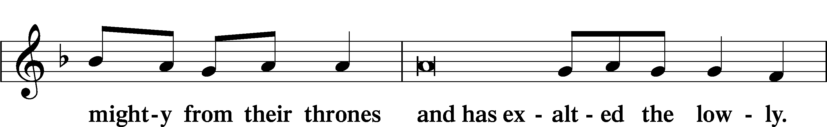
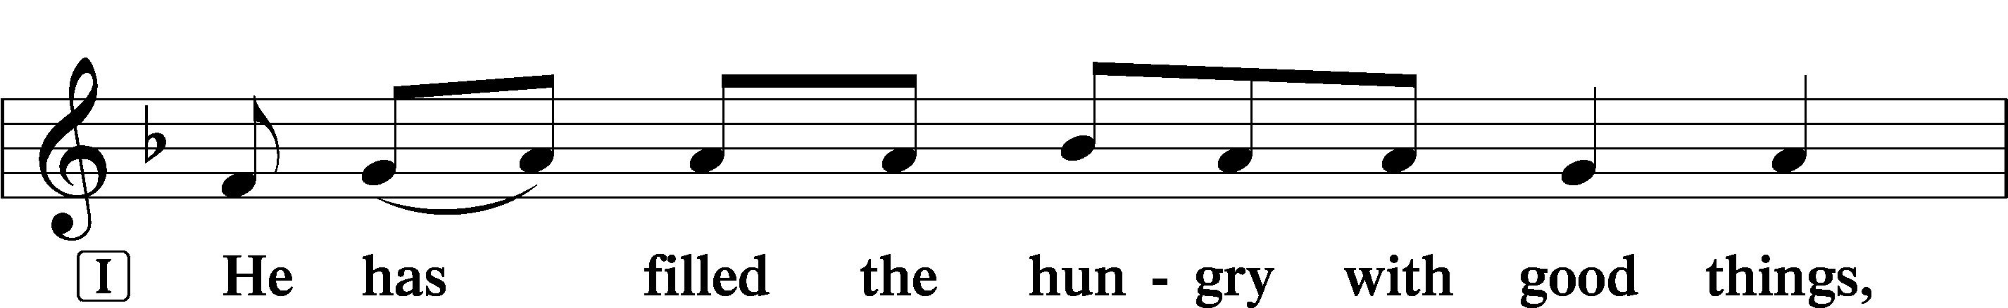
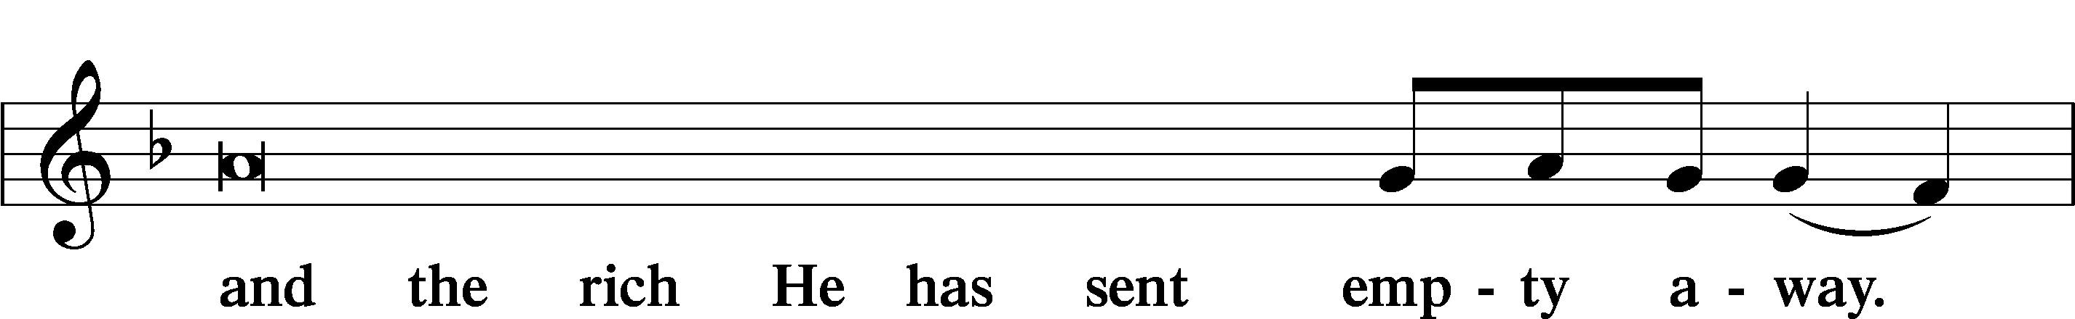
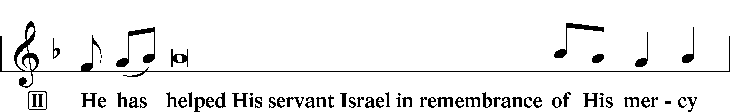
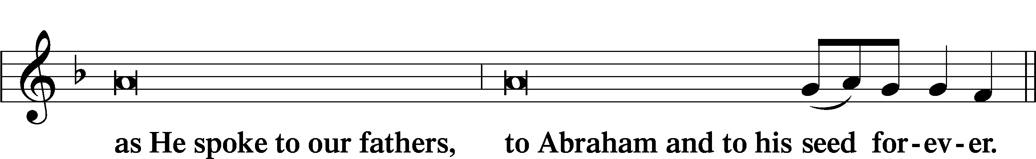
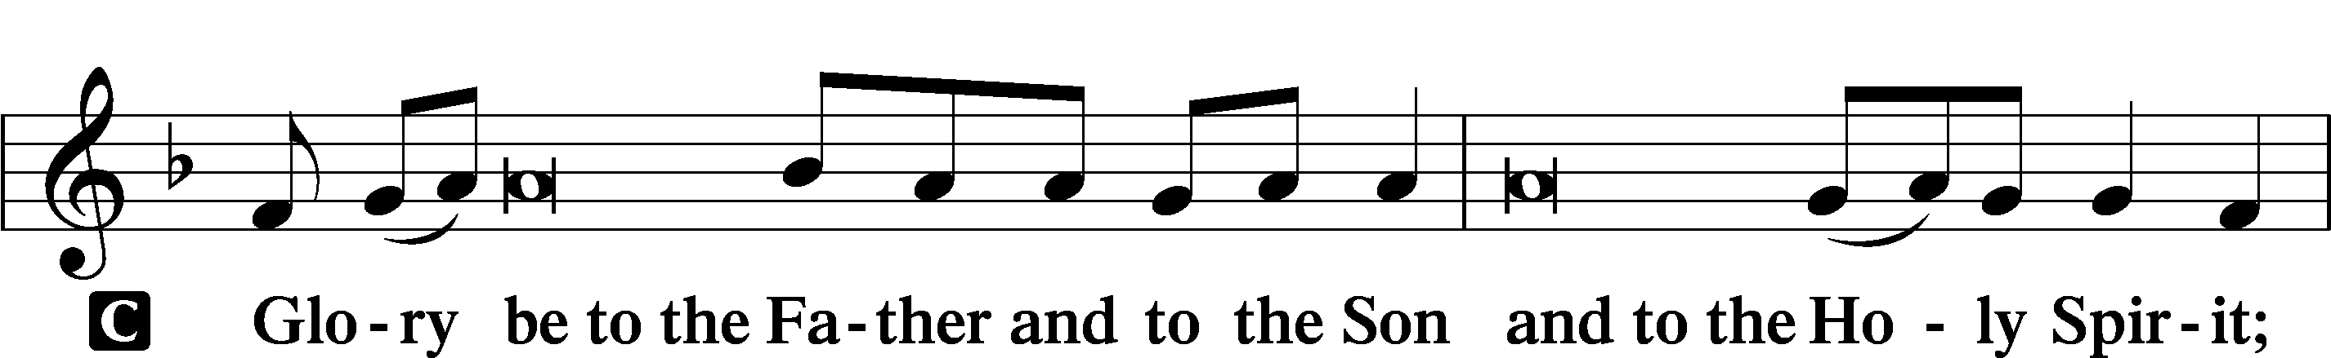
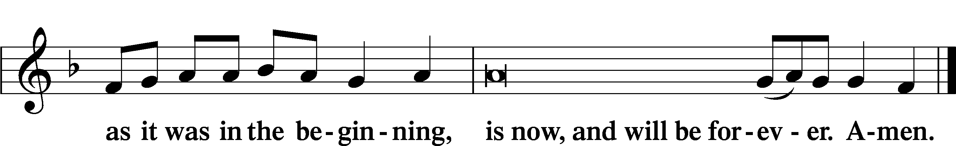

Prayer
Kyrie LSB 233
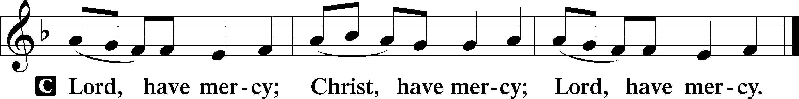
Lord’s Prayer
C Our Father who art in heaven,
hallowed be Thy name,
Thy kingdom come,
Thy will be done on earth
as it is in heaven;
give us this day our daily bread;
and forgive us our trespasses
as we forgive those
who trespass against us;
and lead us not into temptation,
but deliver us from evil.
For Thine is the kingdom
and the power and the glory
forever and ever. Amen.

Collects
Introduction to Collects LSB 233
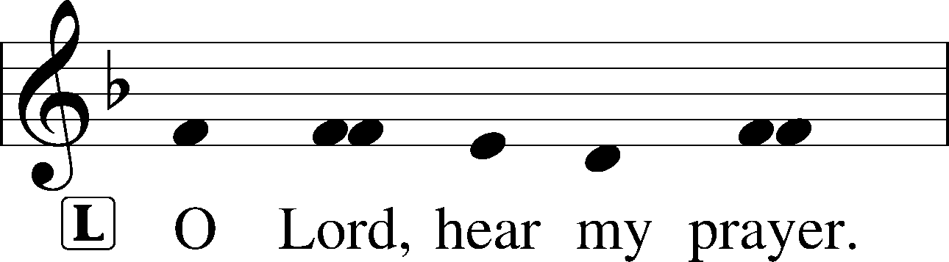
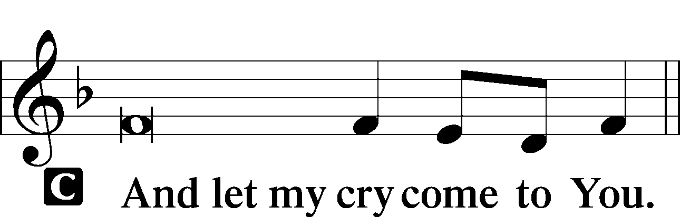

Collect of the Day: St. Stephen
P Heavenly Father, in the midst of our sufferings for the sake of Christ grant us grace to follow the example of the first martyr, Stephen, that we also may look to the One who suffered and was crucified on our behalf and pray for those who do us wrong; through Jesus Christ, our Lord, who lives and reigns with You and the Holy Spirit, one God, now and forever.

Collect for Peace
P O God, from whom come all holy desires, all good counsels, and all just works, give to us, Your servants, that peace which the world cannot give, that our hearts may be set to obey Your commandments and also that we, being defended from the fear of our enemies, may live in peace and quietness; through Jesus Christ, Your Son, our Lord, who lives and reigns with You and the Holy Spirit, one God, now and forever.
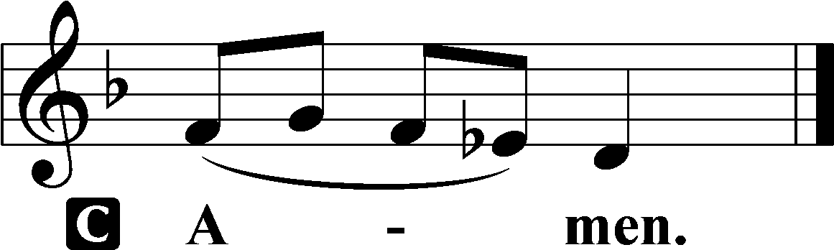

Benedicamus LSB 234
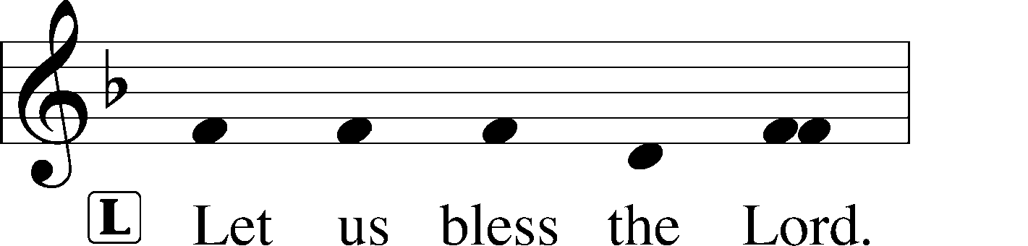
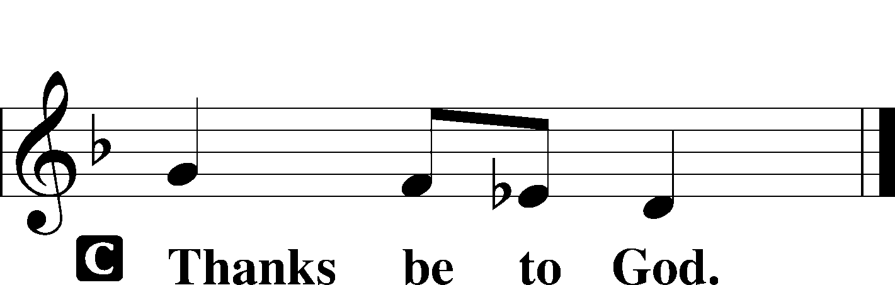

Benediction LSB 234
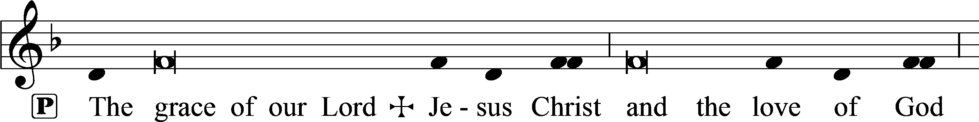
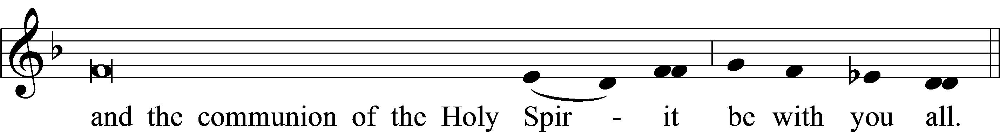

Closing Hymn: LSB #661 “The Son of God Goes Forth to War”

Silent prayer after worship: Thank You, Lord Jesus, for leaving Your throne in heaven to come and be my Savior. Lead me to daily rejoice and give thanks for Your gift of salvation, and to share with others the good news of Your birth. Amen.
fffffffffffffffffffffffffffffffffff
Acknowledgments
Unless otherwise indicated, Scripture quotations are from the ESV® Bible (The Holy Bible, English Standard Version®), copyright © 2001 by Crossway, a publishing ministry of Good News Publishers. Used by permission. All rights reserved.
Created by Lutheran Service Builder © 2021 Concordia Publishing House.

Please consider joining us for the following upcoming services:
Festival of St. John, Apostle and Evangelist
7 pm, Vespers
Tuesday, December 27, 2022

Festival of the Holy Innocents, Martyrs
7 pm, Vespers
Wednesday, December 28, 2022

New Year’s Eve
4 pm, Vespers
Saturday, December 31, 2022

The Circumcision and Name of Jesus
9 am, Divine Service
Sunday, January 1, 2023

Here to Serve

Pastor………………………………………………...……………Rev. Jacob Deal
E-mail …………………………….……pastordeal@saintspeterandpaul.net
Phone Number……………………..…………………724-347-3620 (Option 2)
Church Office………………………..…………………724-347-3620 (Option 3)
Website …………………………………………www.saintspeterandpaul.net
Secretary…………………………………………………………Diane Riefstahl
E-mail ………………………………………church@saintspeterandpaul.net
Website …………………………………………www.saintspeterandpaul.net
Food Pantry: Please leave message……………724-347-3620 (Option 3)
AA Contact: Steve………………………………………………..…724-813-2358
NA Contact: Larry………………………………………………..724-977-8733
Choir Director………………………………………………………Chris Nelson
Congregation President……………………………………Jonathan Baisch
Elder Chairman…………………………………………...………Barry Nelson
fffffffffffffffffffffffffffffffffff
If needing to get into the church building during the week, please phone first to make certain someone is here to let you in.

