Sts. Peter & Paul
Evangelical Lutheran Church
Lutheran Church-Missouri Synod
Founded-1917

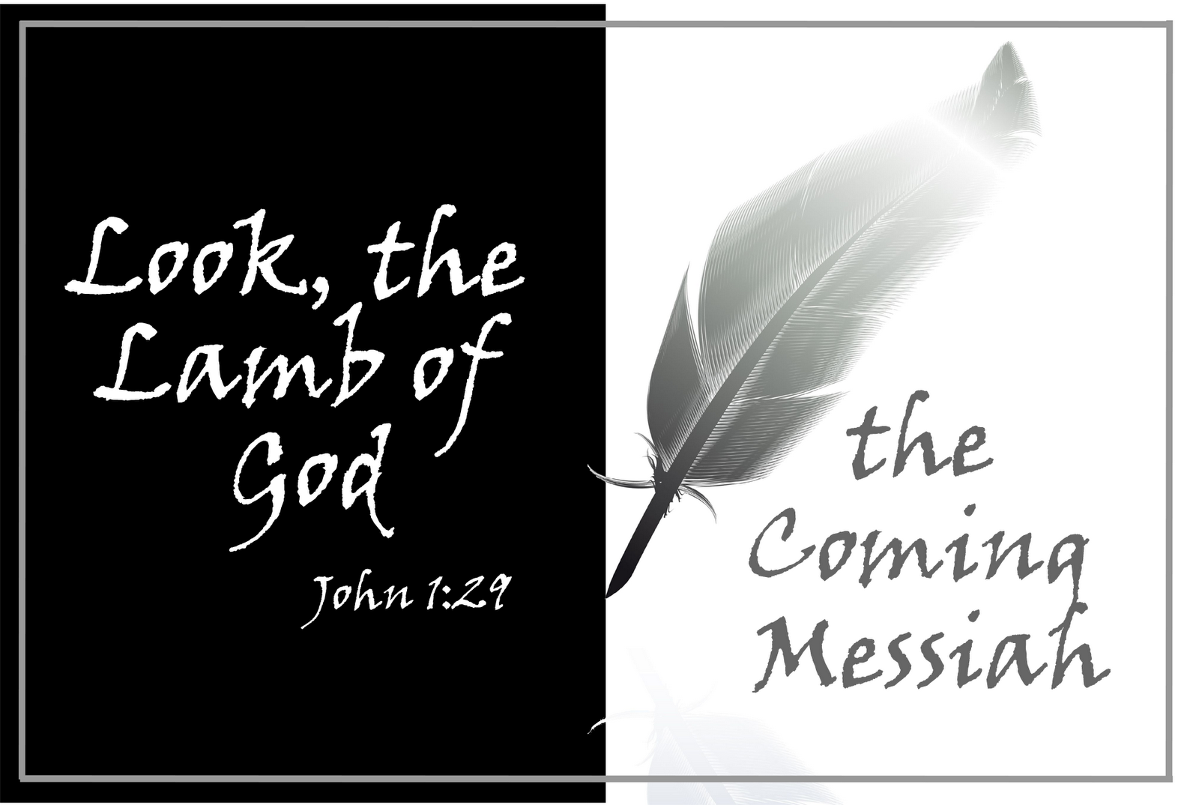

December 24, 2023

699 Stambaugh Ave.
Sharon, Pennsylvania 16146

“I was glad when they said to me,
Let us go to the house of the LORD!”
Psalm 122:1
Sts. Peter & Paul Evangelical Lutheran Church, LC-MS
RORATE COELI
December 24, 2023

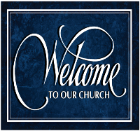
A special welcome to our guests this day! If you would like more information about The Lutheran Church - Missouri Synod, or this congregation, please speak with Pastor Deal or an Elder after the service.
Members & Guests: Don’t be embarrassed if your children make noise during the worship service, all children do. We encourage families to worship together but, if you feel the need, there are pews in the rear of the Church which are reserved for young families on both sides of the sanctuary. There is also a quiet room available to you, located next to the sanctuary (formerly the Pastor’s office), where you would be able to follow along with the service.

Today’s service includes the Sacrament of Holy Communion. If during this past year, you have not worshipped with us and been communed, we respectfully ask that you do not partake of this sacrament this day before first speaking with Pastor Deal.
If visiting from a sister congregation of the LC-MS and are in good standing, please inform Pastor Deal of your desire to commune prior to the service.
If wishing to receive a blessing during communion, please approach with your arms crossed.

CONTACT INFORMATION
Pastor Deal: pastordeal@saintspeterandpaul.net or 724-347-3620 (opt. 2)
Church Office: church@saintspeterandpaul.net or 724-347-3620 (opt. 3)
Secretary’s Office: The office will be open Tuesday & Wednesday (8:30 am-4:30 pm).

Silent prayer before worship: Dear heavenly Father, help me to remember that I am Your child. Give me a childlike faith, so I can trust that through Your Son Jesus I have life and hope always. In Jesus’ name. Amen.

Confession and Absolution

Opening Hymn: LB #344 “On Jordan’s Bank the Baptist’s Cry”

Stand

The sign of the cross may be made by all in remembrance of their Baptism.

Invocation
P In the name of the Father and of the T Son and of the Holy Spirit.
C Amen.

Exhortation Hebrews 10:22; Psalm 124:8; Psalm 32:5
P Beloved in the Lord! Let us draw near with a true heart and confess our sins unto God our Father, beseeching Him in the name of our Lord Jesus Christ to grant us forgiveness.

P Our help is in the name of the Lord,
C who made heaven and earth.
P I said, I will confess my transgressions unto the Lord,
C and You forgave the iniquity of my sin.

Silence for reflection on God’s Word and for self-examination.

Confession of Sins
P O almighty God, merciful Father,
C I, a poor, miserable sinner, confess unto You all my sins and iniquities with which I have ever offended You and justly deserved Your temporal and eternal punishment. But I am heartily sorry for them and sincerely repent of them, and I pray You of Your boundless mercy and for the sake of the holy, innocent, bitter sufferings and death of Your beloved Son, Jesus Christ, to be gracious and merciful to me, a poor, sinful being.

Absolution [John 20:19–23]
P Upon this your confession, I, by virtue of my office, as a called and ordained servant of the Word, announce the grace of God unto all of you, and in the stead and by the command of my Lord Jesus Christ I forgive you all your sins in the name of the Father and of the T Son and of the Holy Spirit.
C Amen.

Service of the Word

Introit Psalm 19:1, 4–6; antiphon: Isaiah 45:8a
Shower, O heavens, | from above,*
and let the clouds rain down | righteousness;
let the earth open, that salvation and righteousness may | bear fruit;*
let the earth cause them | both to sprout.
The heavens declare the glo- | ry of God,*
and the sky above proclaims his | handiwork.
Their measuring line goes out through all the earth, and their words to the end | of the world.*
In them he has set a tent | for the sun,
which comes out like a bridegroom leaving his | chamber,*
and, like a strong man, runs its | course with joy.
Its rising is from the end of the heavens, and its circuit to the | end of them,*
and there is nothing hidden | from its heat.
Shower, O heavens, | from above,*
and let the clouds rain down | righteousness;
let the earth open, that salvation and righteousness may | bear fruit;*
let the earth cause them | both to sprout.

Gloria Patri
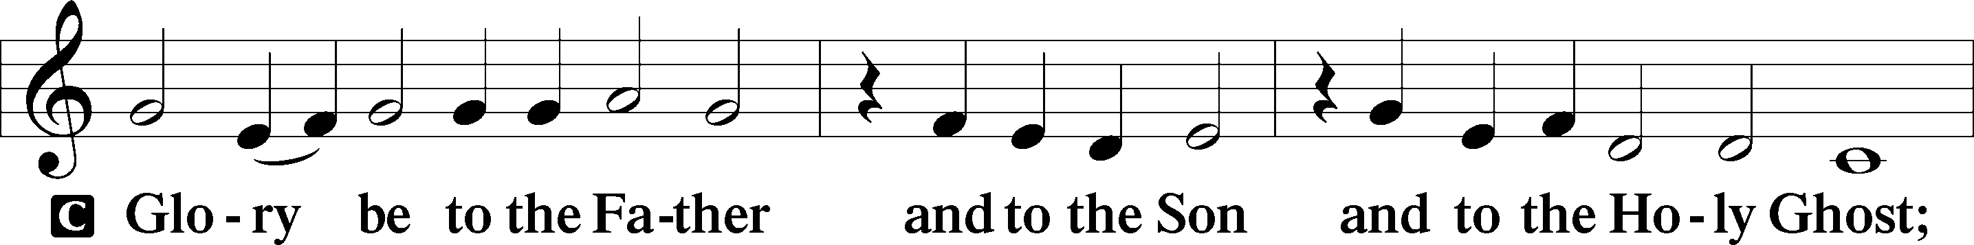
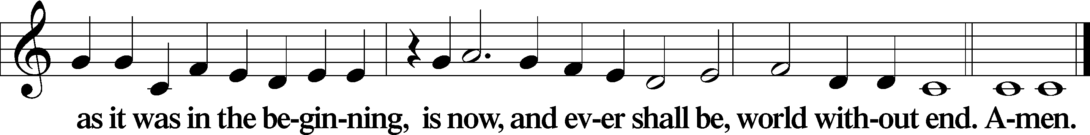

Kyrie Mark 10:47
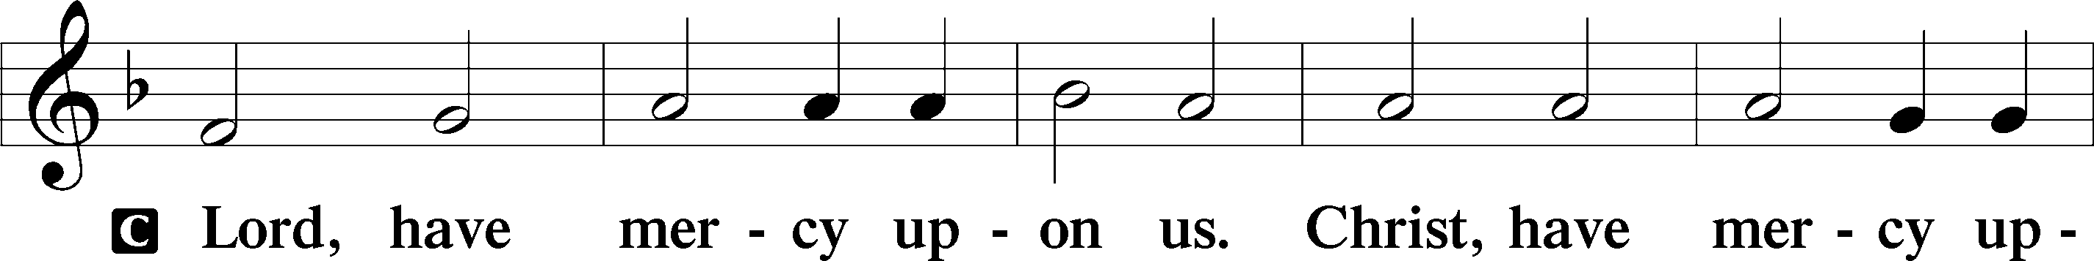
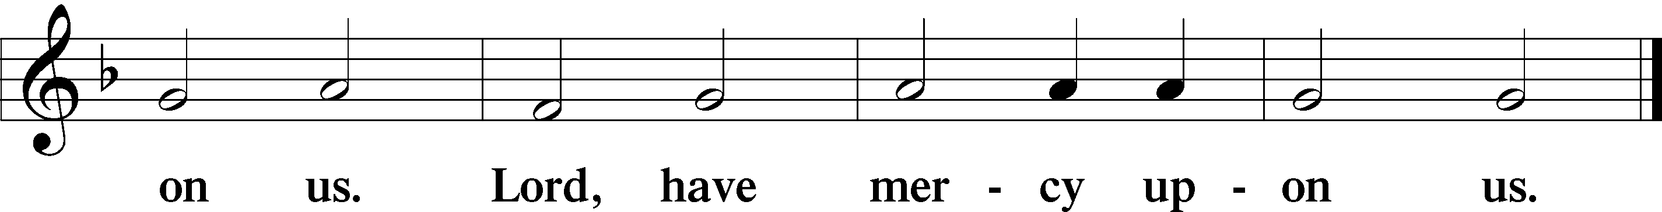

Salutation and Collect of the Day: Rorate Coeli
P The Lord be with you.
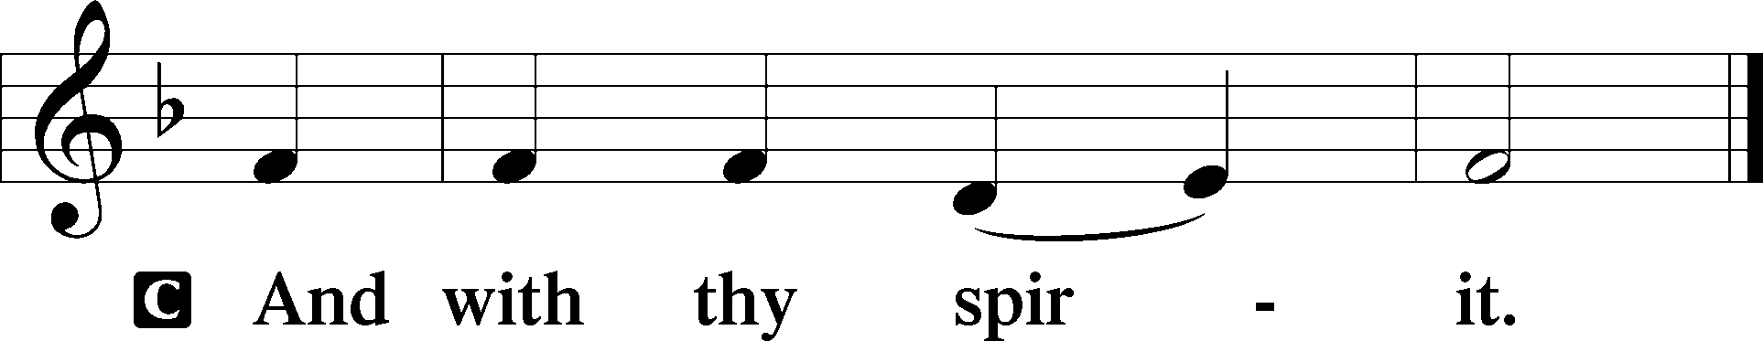

P Let us pray.
Stir up Your power, O Lord, and come and help us by Your might, that the sins which weigh us down may be quickly lifted by Your grace and mercy; for You live and reign with the Father and the Holy Spirit, one God, now and forever.
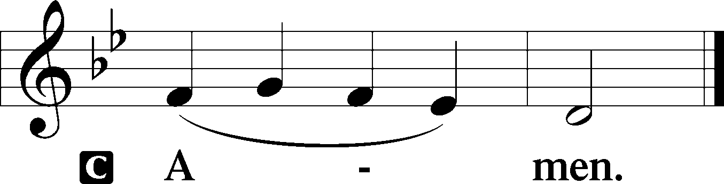
Sit

Prophecy: Deuteronomy 18:15–19 (NKJV)
In those days Moses spoke to the children of Israel, saying: “The Lord your God will raise up for you a Prophet like me from your midst, from your brethren. Him you shall hear, according to all you desired of the Lord your God in Horeb in the day of the assembly, saying, ‘Let me not hear again the voice of the Lord my God, nor let me see this great fire anymore, lest I die.’ And the Lord said to me: ‘What they have spoken is good. I will raise up for them a Prophet like you from among their brethren, and will put My words in His mouth, and He shall speak to them all that I command Him. And it shall be that whoever will not hear My words, which He speaks in My name, I will require it of him.’ ”

P This is the Word of the Lord.
C Thanks be to God.

Gradual Psalm 145:18, 21
The Lord is near to all who | call on him,*
to all who call on | him in truth.
My mouth will speak the praise | of the Lord,*
and let all flesh bless his holy name forever and | ever.

Epistle: Philippians 4:4–7 (NKJV)
Brethren: Rejoice in the Lord always. Again I will say, rejoice! Let your gentleness be known to all men. The Lord is at hand. Be anxious for nothing, but in everything by prayer and supplication, with thanksgiving, let your requests be made known to God; and the peace of God, which surpasses all understanding, will guard your hearts and minds through Christ Jesus our Lord.

P This is the Word of the Lord.
C Thanks be to God.

Stand

Verse Psalm 40:17b
Alleluia. You are my help and my deliverer; do not delay, O my God! Alleluia.

Alleluia
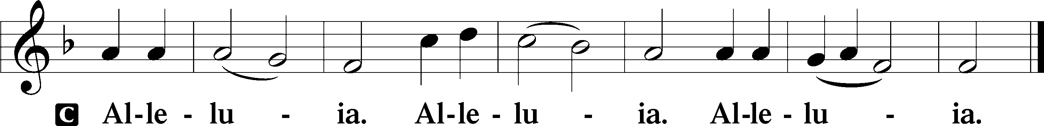

Holy Gospel: John 1:19b-28 (NKJV)
P The Holy Gospel according to St. John, the first chapter.
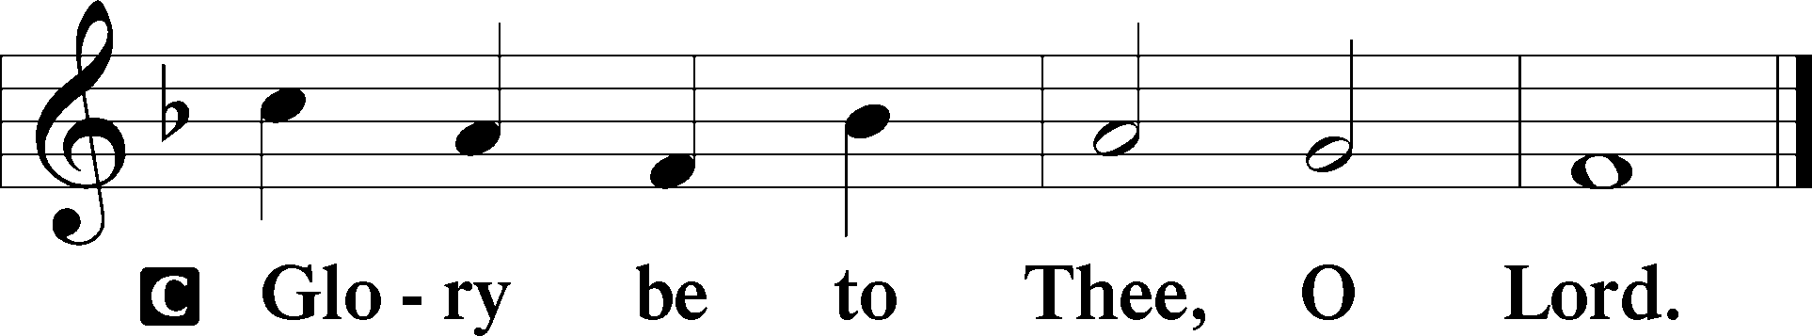

At that time: When the Jews sent priests and Levites from Jerusalem to ask John, “Who are you?” he confessed, and did not deny, but confessed, “I am not the Christ.” And they asked him, “What then? Are you Elijah?” He said, “I am not.” “Are you the Prophet?” And he answered, “No.” Then they said to him, “Who are you, that we may give an answer to those who sent us? What do you say about yourself?” He said: “I am ‘The voice of one crying in the wilderness: “Make straight the way of the Lord,” ’ as the prophet Isaiah said.” Now those who were sent were from the Pharisees. And they asked him, saying, “Why then do you baptize if you are not the Christ, nor Elijah, nor the Prophet?” John answered them, saying, “I baptize with water, but there stands One among you whom you do not know. It is He who, coming after me, is preferred before me, whose sandal strap I am not worthy to loose.” These things were done in Bethabara beyond the Jordan, where John was baptizing.

P This is the Gospel of the Lord.
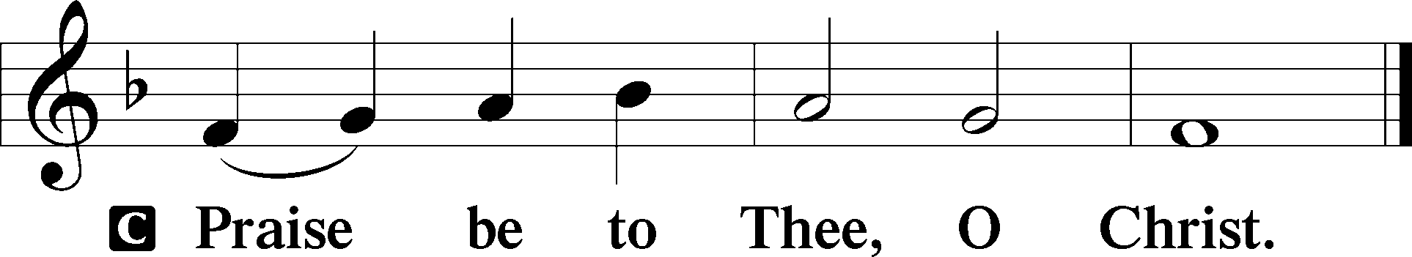

Nicene Creed
C I believe in one God,
the Father Almighty,
maker of heaven and earth
and of all things visible and invisible.
And in one Lord Jesus Christ,
the only-begotten Son of God,
begotten of His Father before all worlds,
God of God, Light of Light,
very God of very God,
begotten, not made,
being of one substance with the Father,
by whom all things were made;
who for us men and for our salvation came down from heaven
and was incarnate by the Holy Spirit of the virgin Mary
and was made man;
and was crucified also for us under Pontius Pilate.
He suffered and was buried.
And the third day He rose again according to the Scriptures
and ascended into heaven
and sits at the right hand of the Father.
And He will come again with glory to judge both the living and the dead,
whose kingdom will have no end.

And I believe in the Holy Spirit,
the Lord and giver of life,
who proceeds from the Father and the Son,
who with the Father and the Son together is worshiped and glorified,
who spoke by the prophets.
And I believe in one holy Christian and apostolic Church,
I acknowledge one Baptism for the remission of sins,
and I look for the resurrection of the dead
and the life T of the world to come. Amen.
Sit

Hymn of the Day: LSB #347 “Comfort, Comfort Ye My People”

Sermon

Stand

Offertory Psalm 51:10–12
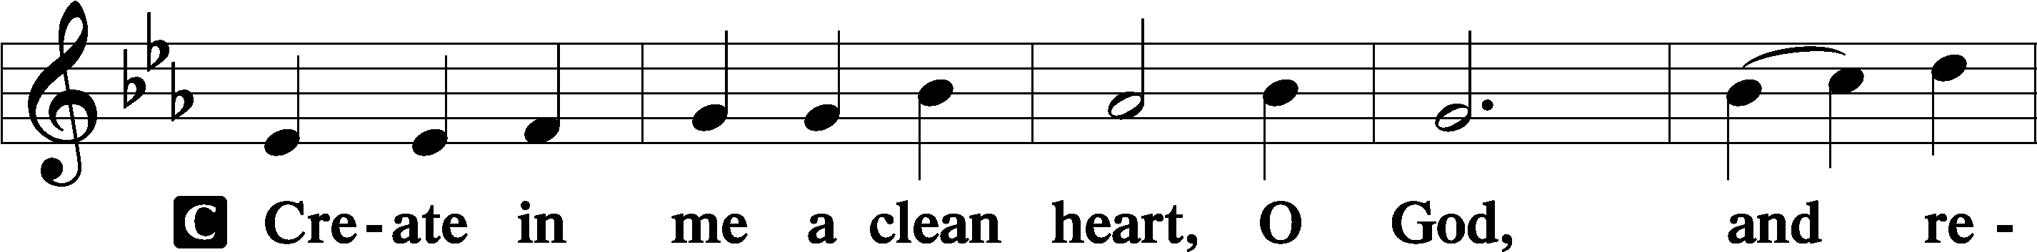
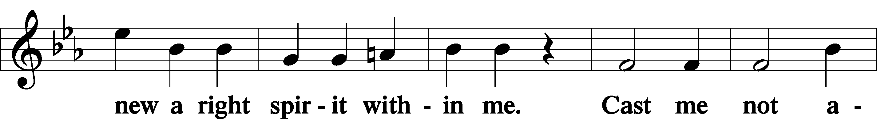
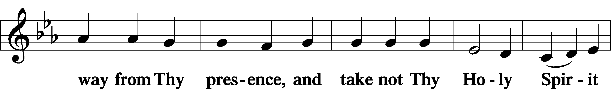
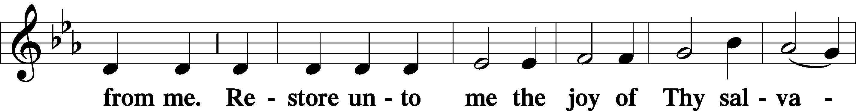
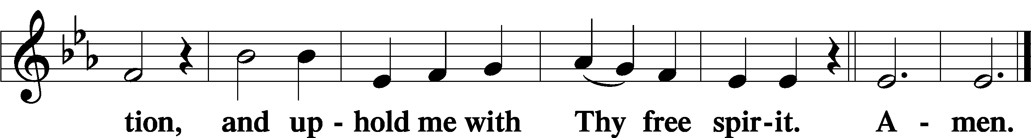

Prayer of the Church

Sit

Preparatory Hymn: LSB #348 “The King Shall Come When Morning Dawns”

Stand

Service of the Sacrament

Preface 2 Timothy 4:22; Colossians 3:1 Psalm 136
P The Lord be with you.
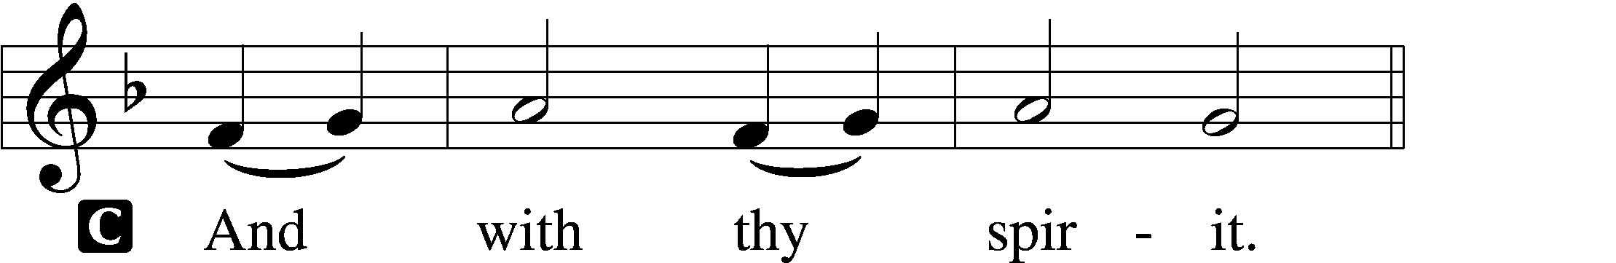
P Lift up your hearts.
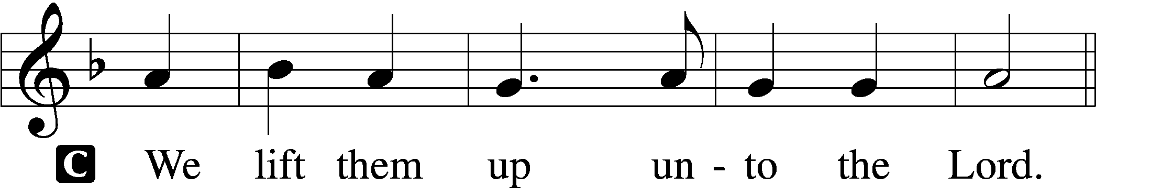

P Let us give thanks unto the Lord, our God.
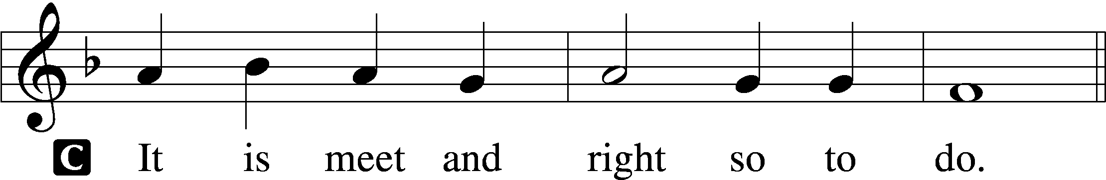

Proper Preface (Abbreviated) LSB 194
P It is truly meet, right, and salutary . . . evermore praising You and saying:

Sanctus Isaiah 6:3; Matthew 21:9
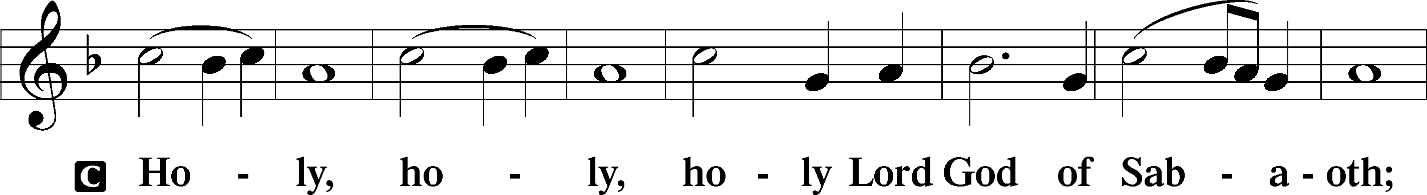
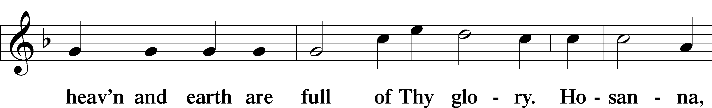
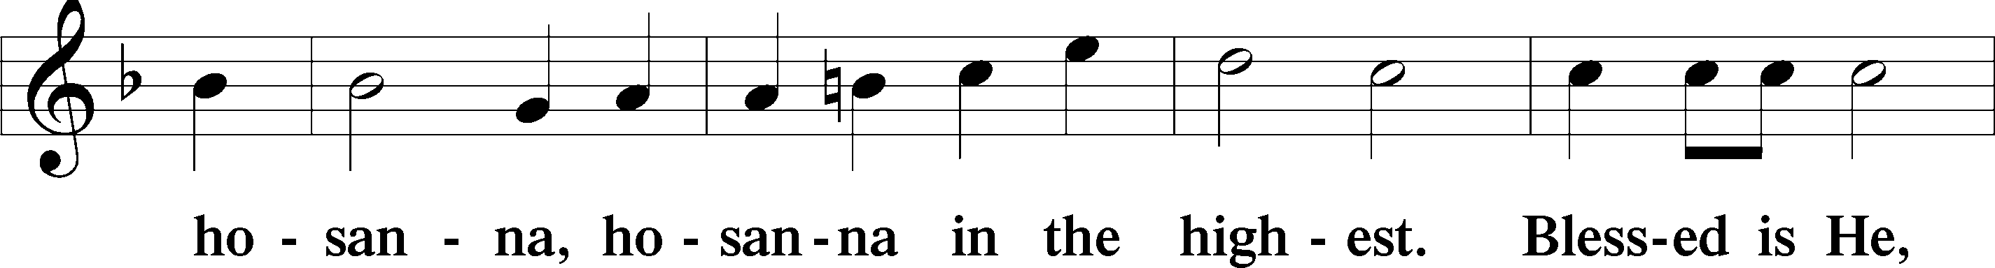
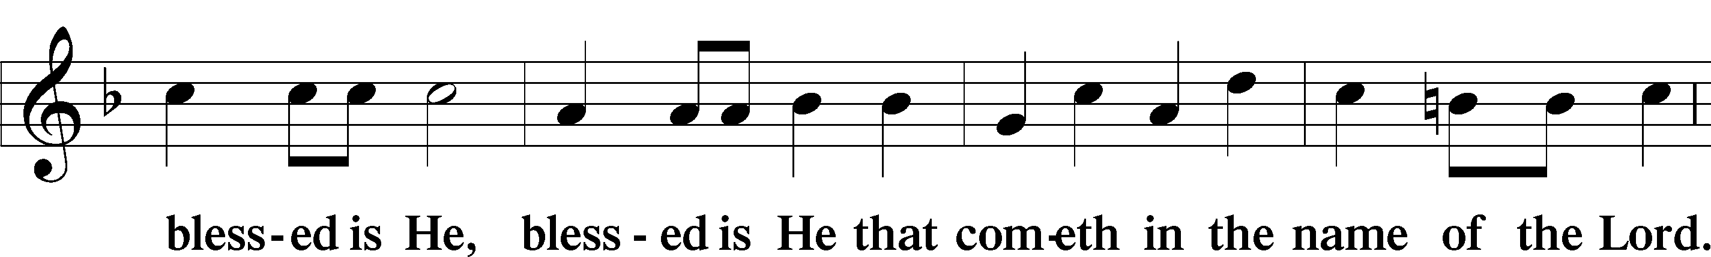
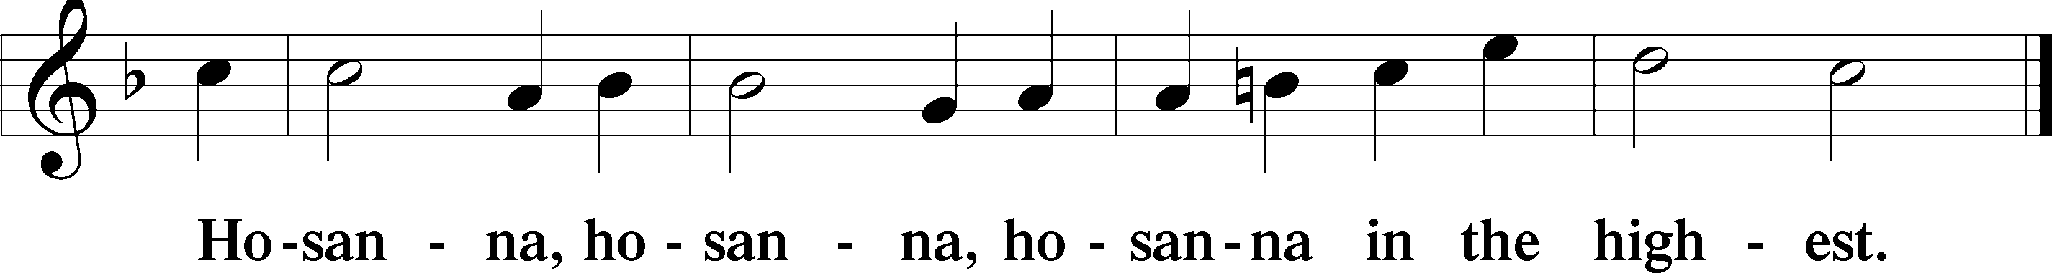

Lord’s Prayer The congregation is encouraged to silently pray the Lord’s Prayer as it is chanted. Matthew 6:9–13
P Our Father who art in heaven,
hallowed be Thy name,
Thy kingdom come,
Thy will be done on earth as it is in heaven;
give us this day our daily bread;
and forgive us our trespasses as we forgive those who trespass against us;
and lead us not into temptation,
but deliver us from evil.
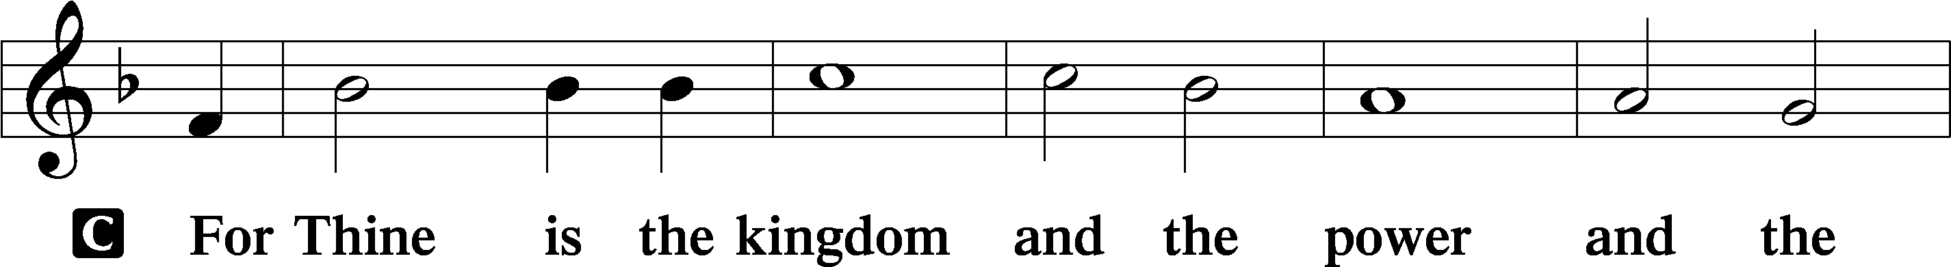
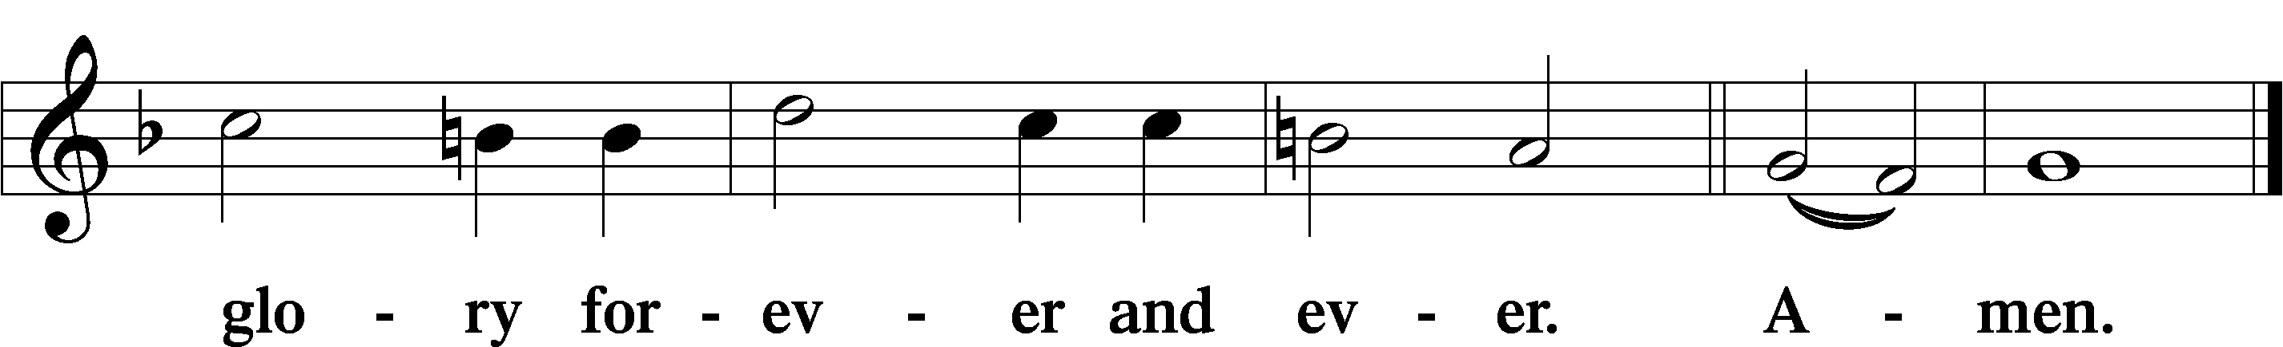

The Words of Our Lord Matthew 26:26–28; Mark 14:22–24; Luke 22:19–20; 1 Corinthians 11:23–25
P Our Lord Jesus Christ, on the night when He was betrayed, took bread, and when He had given thanks, He broke it and gave it to the disciples and said: “Take, eat; this is My T body, which is given for you. This do in remembrance of Me.”

In the same way also He took the cup after supper, and when He had given thanks, He gave it to them, saying: “Drink of it, all of you; this cup is the new testament in My T blood, which is shed for you for the forgiveness of sins. This do, as often as you drink it, in remembrance of Me.”

Pax Domini John 20:19
P The peace of the Lord be with you always.
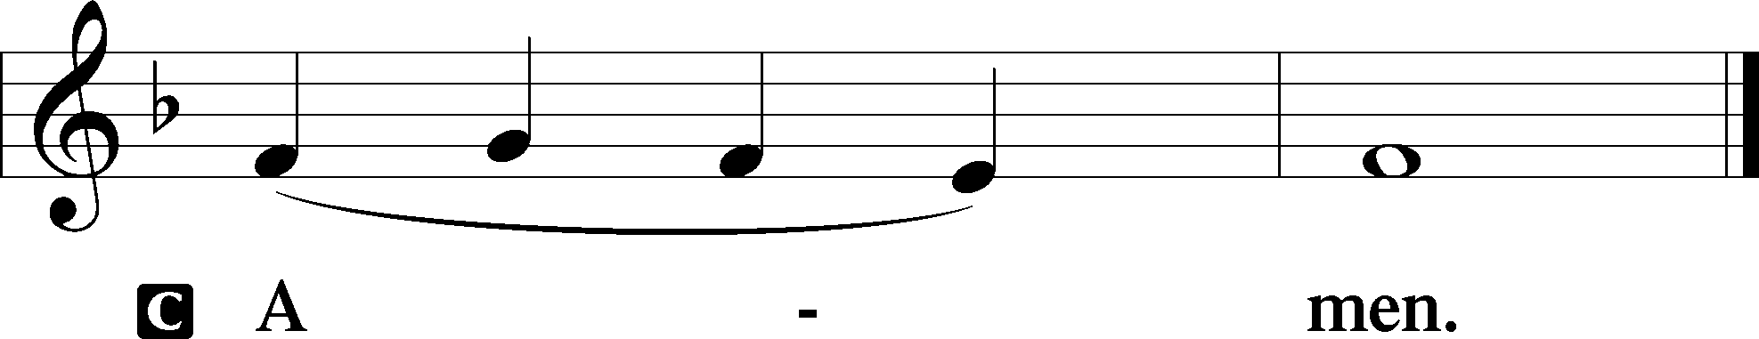

Agnus Dei John 1:29
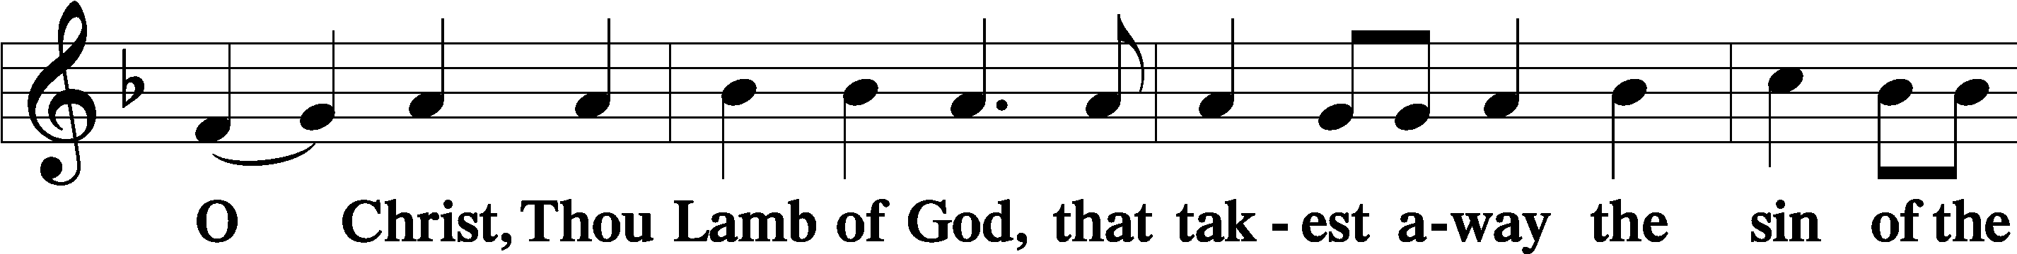
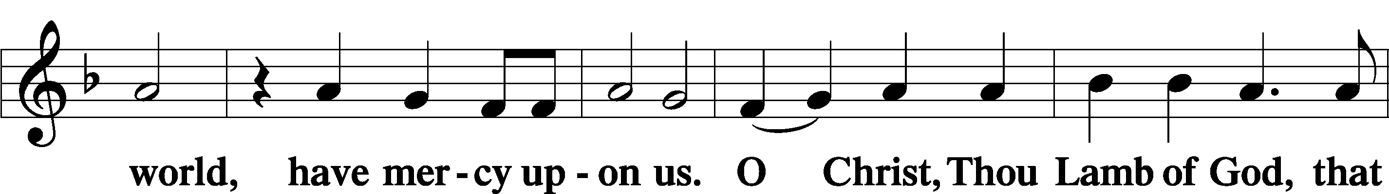
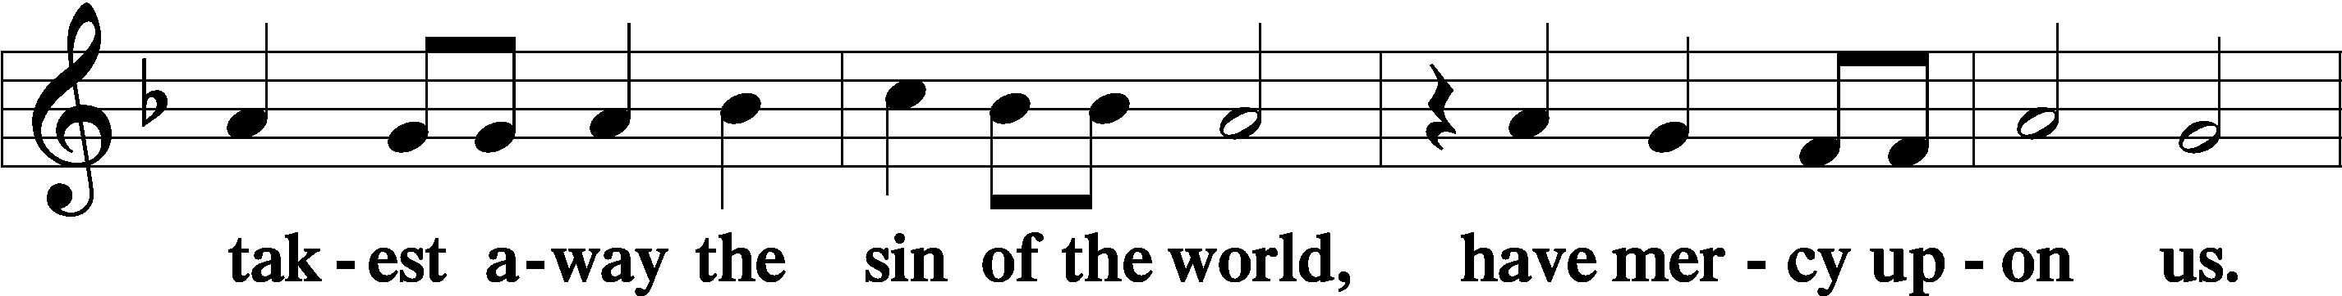
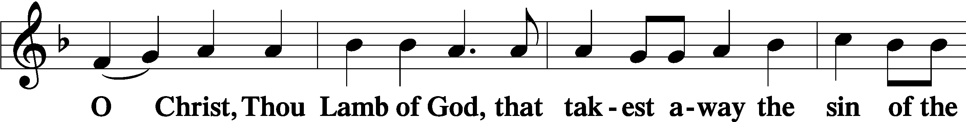
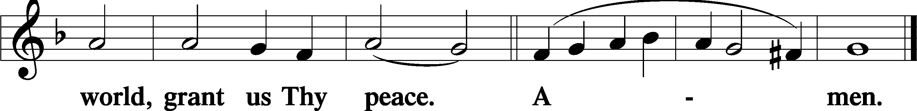
Sit

Distribution
The pastor and those who assist him receive the body and blood of Christ first and then distribute them to those who come to receive, saying:
Take, eat; this is the true body of our Lord and Savior Jesus Christ, given into death for your sins.
Amen.

Take, drink; this is the true blood of our Lord and Savior Jesus Christ, shed for the forgiveness of your sins.
Amen.

In dismissing the communicants, the following is said:
P The body and blood of our Lord Jesus Christ strengthen and preserve you in body and soul to life everlasting. Depart T in peace.
C Amen.

Distribution Hymn: LSB #350 “Come, Thou Precious Ransom, Come”

Distribution Hymn: LSB #622 “Lord Jesus Christ, You Have Prepared”

Distribution Hymn: LSB #594 “God’s Own Child, I Gladly Say It”

Stand

Nunc Dimittis Luke 2:29–32
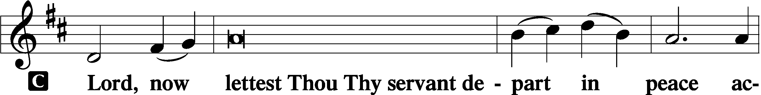
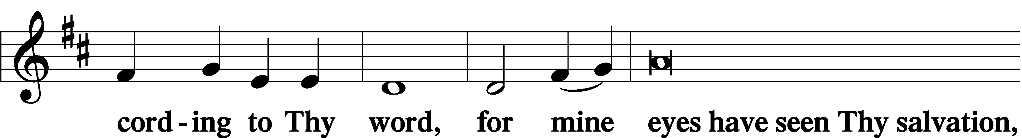
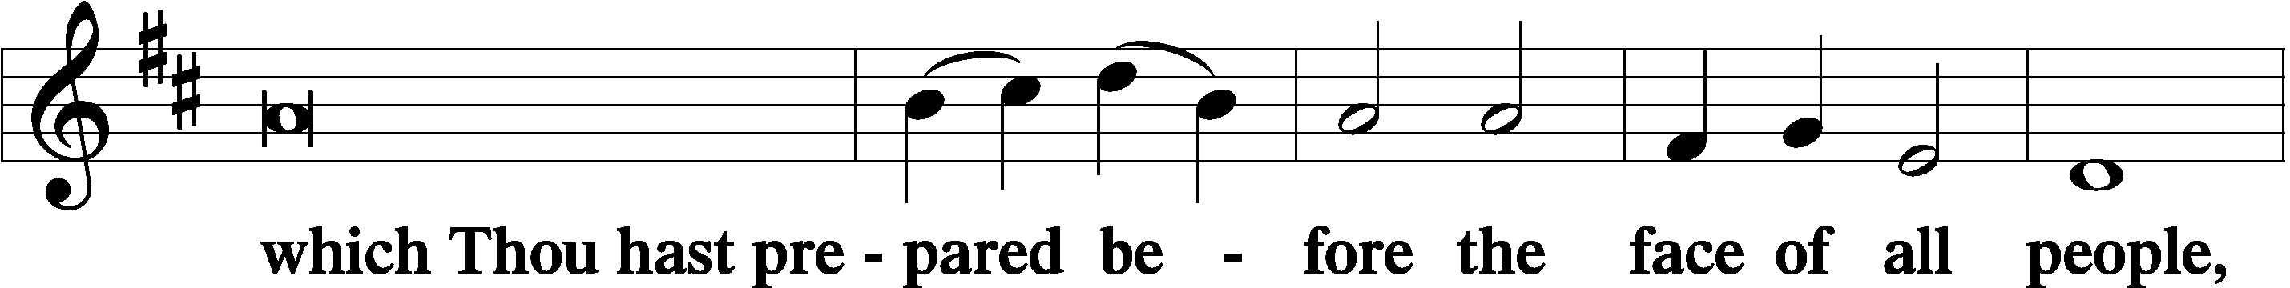
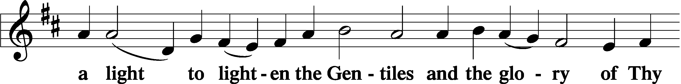
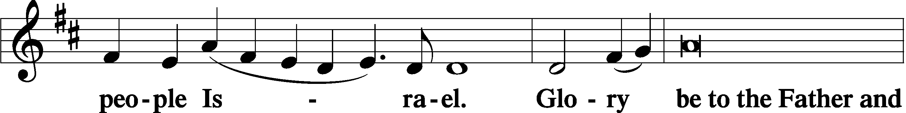
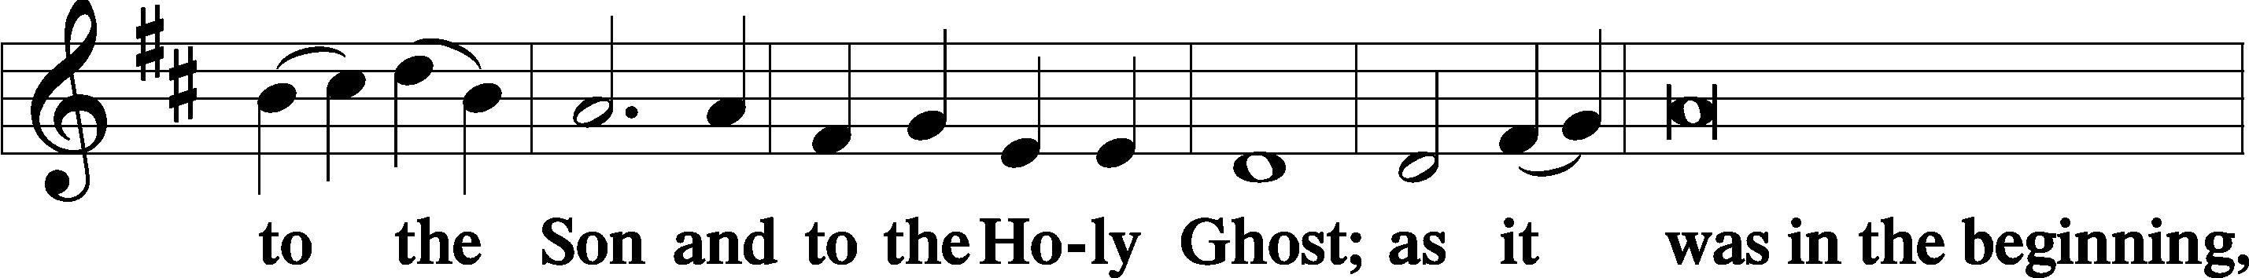
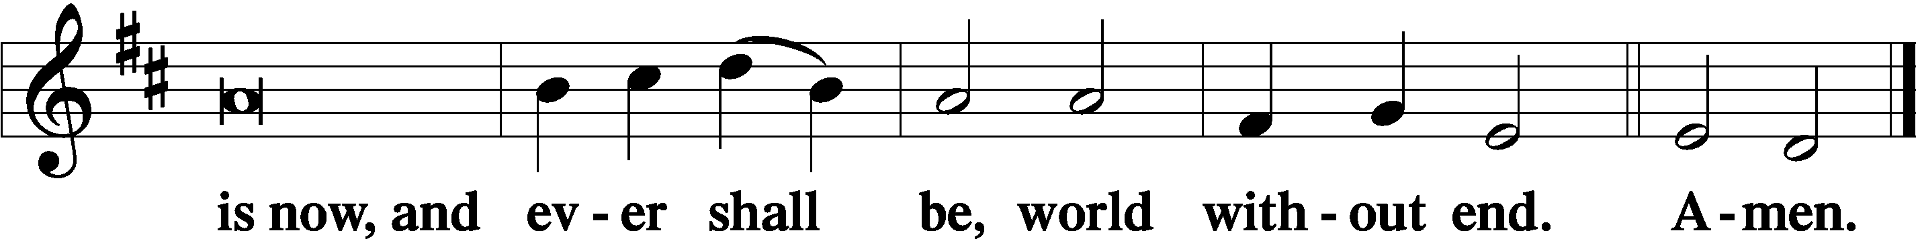

Thanksgiving Psalm 107:1
P O give thanks unto the Lord, for He is good,
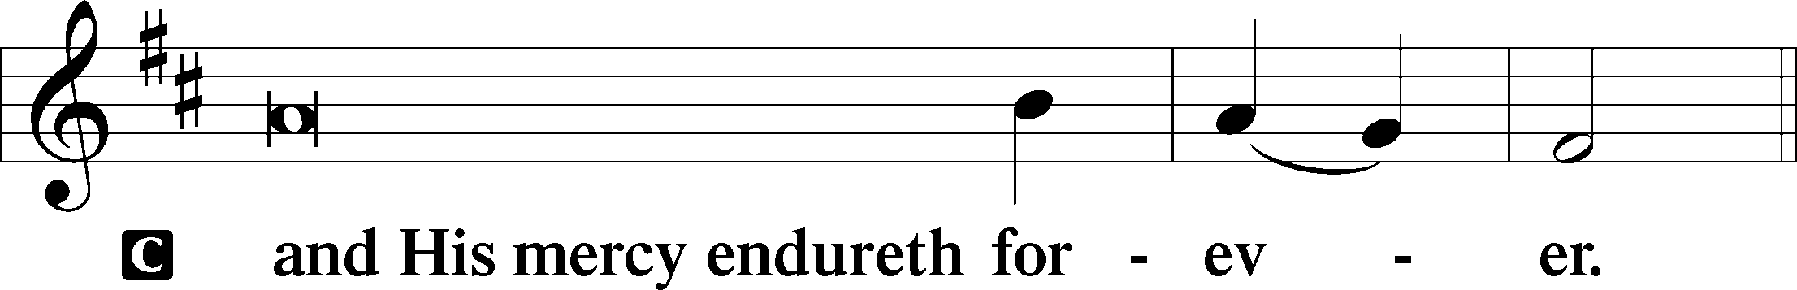

Post-Communion Collect
P Let us pray.
We give thanks to You, almighty God, that You have refreshed us through this salutary gift, and we implore You that of Your mercy You would strengthen us through the same in faith toward You and in fervent love toward one another; through Jesus Christ, Your Son, our Lord, who lives and reigns with You and the Holy Spirit, one God, now and forever.
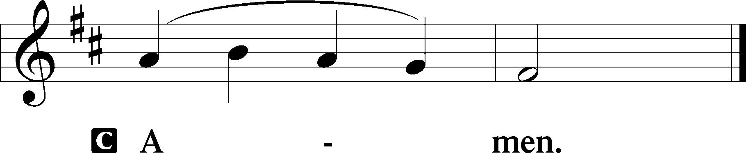

Salutation 2 Timothy 4:22
P The Lord be with you.
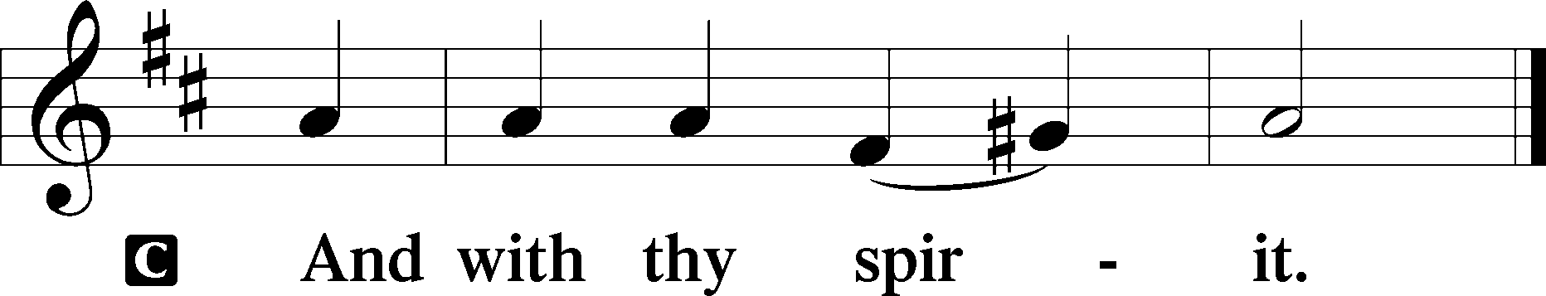

Benedicamus Psalm 103:1
P Bless we the Lord.
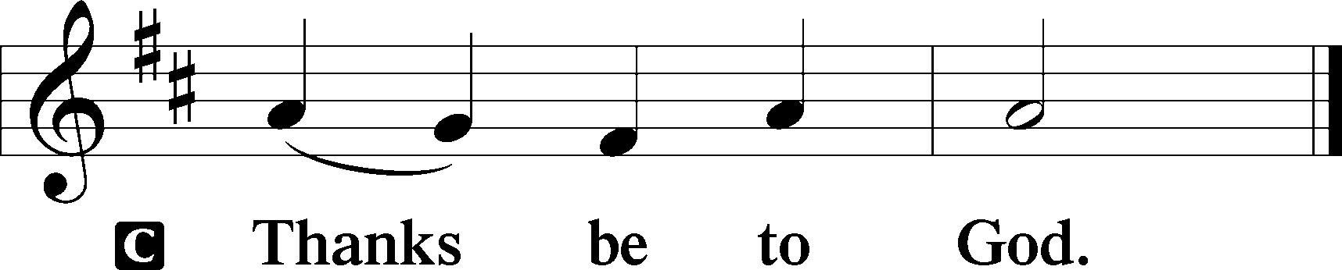

Benediction Numbers 6:24–26
P The Lord bless you and keep you.
The Lord make His face shine upon you and be gracious unto you.
The Lord lift up His countenance upon you and T give you peace.
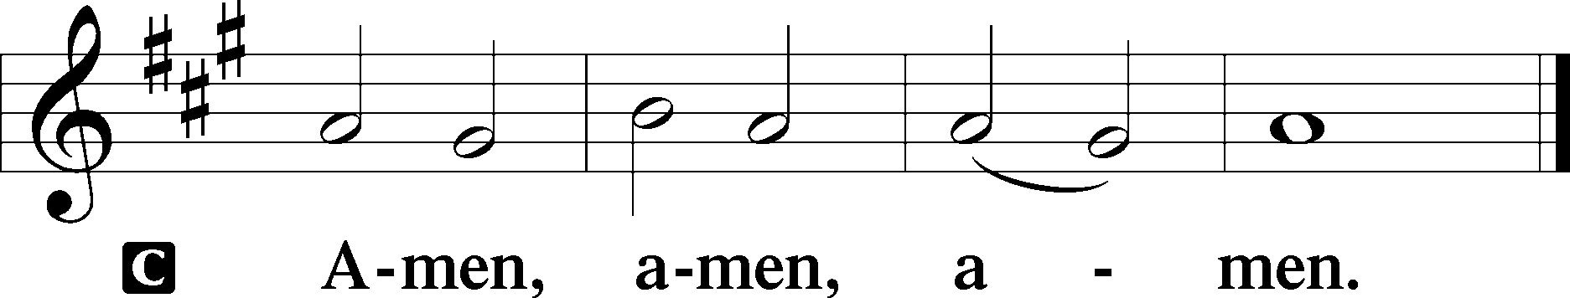

Closing Hymn: LSB #331 “The Advent of Our King”

Silent prayer after worship: Lord Jesus, let me not forget that You were born to be my Savior so that I can have forgiveness of sins, peace, hope and life everlasting. Fill me with Your love, and lead me to share that love always. Amen.

Acknowledgments
Unless otherwise indicated, Scripture quotations are from the ESV® Bible (The Holy Bible, English Standard Version®), copyright © 2001 by Crossway, a publishing ministry of Good News Publishers. Used by permission. All rights reserved.
Created by Lutheran Service Builder © 2023 Concordia Publishing House.
fffffffffffffffffffffffffffffffffff
fffffffffffffffffffffffffffffffffff
In Loving Memory of Father, Paul Petro, and Cousin, Karen Arthur: Patty Parker (Capital Campaign).
In Loving Memory of Karen & Marie Arthur: Gerald F. Arthur (Major Repair).
In Loving Memory of Jayne Kucera Reichard: Dolores Fee.
In Loving Memory of Timith Riffle: Mark Gabriel and Edeltraud Sulek (Capital Campaign).
fffffffffffffffffffffffffffffffffff
A sign-up sheet is available in the narthex for anyone willing to donate appetizers, finger-foods, and/or desserts to the AA “alcohol-free” New Year’s Eve party which they are sponsoring for their members next Sunday evening, December 31st. Items may be dropped off in the Fellowship Hall kitchen that day. Please label items for “AA” and leave instructions (if needed). Also, be sure to refrigerate items as needed. Many thanks!
fffffffffffffffffffffffffffffffffff
Attendance: Sunday, December 17, 2023: 45
Wednesday, December 20, 2023: 15 (10 am); __ (7 pm)
fffffffffffffffffffffffffffffffffff
SCHEDULE THROUGH DECEMBER 31, 2023:

:

Today, 7 pm, Fellowship Hall: AA Meeting
8 pm, Sanctuary: Christmas Eve Service of Lessons and Carols
Monday, 9 am, Sanctuary: Christmas Day Divine Service
Tuesday, 7 pm, Sanctuary: Vespers Service (St. Stepen, Martyr)
7-9 pm, Fellowship Hall: Penn-Ohio Singers
Wednesday, 7 pm, Sanctuary: Vespers Service (Feast of St. John, Apostle &
Evangelist)
7 pm, Fellowship Hall: NA Meeting
Thursday, 9 am, Downstairs: Food Pantry
7 pm, Sanctuary: Vespers Service celebrating the Holy Innocents, Martyrs
Next Sunday, 9 am, Sanctuary: Divine Service
7 pm, Fellowship Hall: AA New Year’s Eve Celebration
THANK YOU FOR SERVING IN DECEMBER: Elder: Jonathan Baisch; Ushers: Cheryl Fedele, Mike Flaugher, & Jesse Riffle; Altarware ~ Sundays: (prior) Marie Flaugher (12.31) & Diane Riefstahl; (after) Marie Flaugher (12.31) & Elizabeth Haenftling (12.24); Special Divine Service: Diane Riefstahl (12.25).
fffffffffffffffffffffffffffffffffff
The minutes from the December 3, 2023, Voters’ Assembly are available.
fffffffffffffffffffffffffffffffffff
Bible Memory Verses ~ Week of December 24th:
For Adults: Therefore, if anyone is in Christ, he is a new creation. The old has passed away; behold, the new has come. 2 Corinthians 5:17
For Children: My soul magnifies the Lord, and my spirit rejoices in God my Savior. Luke 1:46-47
fffffffffffffffffffffffffffffffffff
Our Stewardship of Treasures for the Lord:
In order to do the Lord’s work, we need $2,553.63 each week to meet our 2023 budget for general purposes and $76.92 for the SELC.

Online Figures for December 7 & 13, 2023
General Fund: $230.00
Capital Campaign: $200.00
Figure for Wednesday, December 13, 2023
General Fund: $30.00
Figures for Sunday, December 17, 2023
General Fund: $2,297.00
SELC: $20.00
Food Pantry: $0.00
Quarterly Mission: $0.00
Capital Campaign: $1,051.00
Major Repair: $500.00
Other: $28.00

For online giving, check out https://www.saintspeterandpaul.net/online-giving.
fffffffffffffffffffffffffffffffffff
Our Food Pantry is still accepting donations of paper products (toilet tissue, paper towels, and face tissue) to share with our clients. Donations may be placed on the pew by the secretary’s office. “Thanks” in advance for your participation in this outreach mission.
fffffffffffffffffffffffffffffffffff
Interested in finding out more about Luther Classical College? Check out the “On the Line” podcast available on YouTube: “How Luther Classical College Could Change Everything…”
fffffffffffffffffffffffffffffffffff
Remember the following in Prayer…
~The Hurting and Healing: Amy, Mary Jane Anderson, Steve Antolovich, Ellen Baron^{CA}, Amy Blomenberg, Lois Bortner^{CA}, Sara Brubaker, Dee Bullock, Bev & Joe Chlpka, Susan Davies, Loretta Deal, Tim Dudash, Judith & Eddy Furey, Griffin, Austin Hamilton, Pastor Charles Henrickson, Joan, Keith Jozwiakowski, Rhyan Kirsch, Darla Krajci, Barbara Kreske, Jess Lavoie, Paul Lucas^{CA}, Sandy Marshall, Frank Niemeyer^{CA}, Juanita Rentschler, Richard Reuning^{CA}, Rosemary (Posey) Rice^{CA}, Nancy Robertson^{CA}, Kriss Svidro^{CA}, Rudy Tomko, Bob Usnarski, Joel & Peggy Wasson, Angela Weser^{CA}, and Ruth Wolf.
~The Homebound: Anna Mae Daris, Millie Elavsky, Jean Tomko, Betty Wolf, and Ed & Millie Zachar.
~Celebrating this Week: Birthday: Jean Tomko (12.28).
~Serving in the Military: Alex (Sasha) Carr, Duncan Vaupel, Curtis Sinewe, and Joshua Solyan.
~Community & World Needs: Those suffering due to the conflicts in the Middle East and between Ukraine and Russia; those suffering from loss and dislocation because weather disasters; those suffering from addiction and their families; Local, State, and National Government Leaders; safety for all Police Officers, Firefighters, & First Responders; the unemployed; our Fourth Quarter Local Mission: Willow Women’s Center.
*CA represents cancer.
fffffffffffffffffffffffffffffffffff
Copies of the 1st Quarter “Portals of Prayer” for 2024 are available on the table in the narthex and next to the sign-in table by the nursery.
THANK YOU FOR SERVING IN JANUARY: Elder: Jonathan Baisch; Ushers: Cheryl Fedele, Mike Flaugher, & Jesse Riffle; Altarware ~ Sundays: (prior) Elizabeth Haenftling (01.07), Marie Flaugher (01.14) & Diane Riefstahl (01.21 & 01.28); (after) Cheryl Fedele & Clara Krivosh; Special Divine Service: Diane Riefstahl (01.06).
fffffffffffffffffffffffffffffffffff
Up-Coming Worship Services

Sunday, December 24 8 pm Christmas Eve Service of Lessons & Carols

Monday, December 25 9 am Divine Service ~ Christmas Day

Tuesday, December 26 7 pm Vespers Service
Feast of St. Stephen, Martyr

Wednesday, December 27 7 pm Vespers Service
Feast of St. John, Apostle & Evangelist

Thursday, December 28 7 pm Vespers Service
Feast of the Holy Innocents, Martyrs

Sunday, December 31 9 am Divine Service ~ First Sunday after
Christmas

Monday, January 1 7 pm Vespers Service
Circumcision and the Name of Jesus

Saturday, January 6 7 pm Divine Service ~ The Epiphany of Our Lord

Here to Serve
Pastor………………………………………………...……………Rev. Jacob Deal
E-mail …………………………….……pastordeal@saintspeterandpaul.net
Phone Number……………………..…………………724-347-3620 (Option 2)
Church Office………………………..…………………724-347-3620 (Option 3)
Website …………………………………………www.saintspeterandpaul.net
Secretary…………………………………………………………Diane Riefstahl
E-mail ………………………………………church@saintspeterandpaul.net
Website …………………………………………www.saintspeterandpaul.net
Food Pantry (email): ……………foodpantry@saintspeterandpaul.net
Congregation President………………………………….…Jonathan Baisch
Church Elder …………………………………………...……. Jonathan Baisch
Organist………………………………………………..….…Rebecca Marquette
AA Contact: Steve………………………………………………...…724-813-2358
NA Contact: Larry……………………………………..…………..724-977-8733
fffffffffffffffffffffffffffffffffff
If needing to get into the church building during the week, please phone first to make certain someone is here to let you in.

