Sts. Peter & Paul Evangelical Lutheran Church LC-MS
Monthly Newsletter --- December 2021
699 Stambaugh Avenue, Sharon, PA 16146
Phone: 724.347.3620 (Opt. 2, Pastor Deal; Opt. 3, Office)
E-mail: church@saintspeterandpaul.net www.saintspeterandpaul.net

“THE ROCK and THE SWORD”
“Built upon the Rock of Christ and wielding the
Sword of the Spirit, the Word of God.”

From the Pastor:
The following is a continuation of last month’s article concerning whether women should cover their heads in worship. If you have not read the first article (or need to refresh the material), please pick up a copy of the Nov. newsletter or check it out online at www.saintspeterandpaul.net/newsletter.

Should Women Cover Their Heads in Worship—Part Two: A Deeper Dive Into 1 Corinthians 11

To frame this “deeper dive” into 1 Corinthians 11, consider that Saint Paul has spent the last 10 chapters admonishing the saints gathered in Corinth for departing from the faith which he delivered over to them and which was being practiced throughout all of Christendom. Paul’s appeal to them concerning this specific tradition of veiling is threefold in nature:
- Apostolic tradition and custom of the universal Church
- Order of creation and interrelated relationship between God: Father, Son, and Holy Spirit.
- What is fitting from Nature: What is fitting for a man and a woman with gender roles.

To the first point, we must recognize that the faith in which Paul instructed them was not unique to Corinth, but shared among churches. He was continuing with the doctrines of Christ, being himself inspired by the Holy Spirit as he wrote. When the Corinthians turned from his teachings, they were also turning from the fellowship of the Saints of God. Men leaving their heads unveiled during worship and women veiling their heads was not practice in just this one place, it was common to the church catholic.
Remember, Paul didn’t allow Jewish Law to subvert the Gospel. When in Galatia, there were false brothers who had slipped in to spy on Paul and Titus; they wanted to subject the Church back to the yoke of the Law by circumcision (Galatians 2:5). But Paul did not yield to them. Similarly, Paul speaks about Christian freedom elsewhere, when he writes, “Therefore let no one pass judgment on you in questions of food and drink, or with regard to a festival or a new moon or a Sabbath” (Colossians 2:16). We should believe that when Paul speaks about these traditions of the church, he is not doing so as a way to subject Christians to a righteousness that comes by way of obedience to the Law. Rather, we should understand this instruction as following in line with his previous words from 1 Corinthians 10, “whether you eat or drink, or whatever you do, do all to the glory of God” (1 Cor 10:31). If he is writing this as an instruction for men and women to practice, then it is all to the glory of God.
To the second point, what is Paul’s primary concern? It is not with veiling itself, but with the relationship between man, woman, and God. His teaching shows that the practice of covering and uncovering the head is intrinsically related to a theological reality. This Jewish custom of veiling is not merely a Jewish cultural practice, but it accurately reflects the reality of the relationship between God, man, and woman in God’s created order. If Paul’s three arguments in 1 Corinthians 11:2-16 are taken seriously they testify to a natural connection between the veiling practice in Christian worship and God’s created order.
In short, we can look at it like this: A man who covers his head shames his head, namely, Christ and a woman who is uncovered shames her head, namely, man. This personal shame is the result of not acting in accordance with the divine hierarchy which is shown in verse three, “For on the one hand a man ought not cover his head because he is the image and glory of God, but on the other hand woman is the glory of man” (v 7). How is man the image and glory of God? It is with respect to his dominion and authority, so he ought not cover his head which would be a symbol of denying this responsibility and charge. This is a reflection of creation as Adam was made first, and then, from his side, one was made for him who is bone of his bone and flesh of his flesh (in Hebrew “ish” means man and “ishah” means woman, for she was taken from man).
So why “ought” this be practiced among churches? It grows out of the relationship with God, namely, that man is “the image and glory of God,” but woman is the glory of man. TO BE CLEAR, Paul here is not denying that woman is made in the image of God as Genesis says, “God created man in his own image, in the image of God he created him; male and female he created them” (Genesis 1:27). Paul clearly asserts that women share in the same justification and dignity with men before God (Galatians 3:28). The same forgiveness which God gives to men, he also equally gives to women, but in regard to headship, man is the image and glory of God and, in this sense, woman is not. This instruction of Saint Paul makes this practice less about a cultural ideal and more about the eternal theological reality. Truly, this custom is inherently connected to the relationship between God and man, and man and woman.
Paul further emphasizes this by adding, “for the sake of the angels” (v10). This simple phrase reinforces Paul’s argument that the practice of veiling is inherently tied to the divine order. We confess that the angels are present in the worshiping congregation (Psalm 138:1), they witness the repentance of people (Luke 15:10), and we share in the joy of singing their song (Sanctus). These created spiritual beings who serve the Lord should be offended by the Christian’s upending of God’s created order. They are offended because the women are committing the same sin of inversion of divine order that the demons did. It's like seeing your brother die of alcoholism, and then you see someone turning into an alcoholic. Their sin is summarily, pride, which is Lucifer's sin. The angels are meant to be present at the assembly of the faithful to hear the Gospel and join in praise, but they are generally ashamed of the Corinthians.
Veiling is not the biggest issue the Church faces today nor was it for the Corinthians; however, the definition of man and woman and their relationship to one another and to God is certainly one of the biggest. The Corinthians were sinning and becoming a poor witness of Christianity. Paul writes, “That is why I sent you Timothy, my beloved and faithful child in the Lord, to remind you of my ways in Christ, as I teach them everywhere in every church” (1 Corinthians 4:17). This is important because we are not considering head coverings as an isolated topic for Paul, but they come as a teaching within the context of God’s order and his design of relationships. Both the uncovering of the head (for men), and the covering of the head (for women), is meant to be a visible symbol of God’s order of creation and the humility both men and women are to have living under God’s authority.

Your servant in Christ,
Pastor Jacob Deal
llllllllllllllllllllllllllll
CAPITAL CAMPAIGN AT A GLANCE

Blue: Pledged as of 11.15.2021 (56.67%)
Orange: Remaining (43.33%)

Total Contributions
as of 11.21.21: $49,193.00

Previous: $40,703.00 (20.35%)
New: $8,490.00 (4.24%)
Remaining: $150,807 (75.41%)
llllllllllllllllllllllllllll
It’s not too late to submit a Capital Campaign pledge card! Pledge cards are available on the table outside Pastor’s office.
llllllllllllllllllllllllllll
Pastor Deal continues to serve as Vacancy Pastor for All Saints Lutheran Church in Slippery Rock, PA until further notice. As he must leave shortly following our worship service in order to travel safely to Slippery Rock, Pastor will be available one hour prior to our service for those wishing to speak with him.
llllllllllllllllllllllllllll
Homebound Members & Friends
Please keep the following in your prayers:
Marion Roberts
The Lakes at Jefferson
7271 W. Market St.
Mercer, PA 16137
724-946-2236
lll lll lll lll lll lll lll lll lll lll lll lll lll lll lll
Betty Ann Wolf
7777 Arthur St., SC
Masury, OH 44438
330-448-1080
lll lll lll lll lll lll lll lll lll lll lll lll lll lll lll
Ed & Millie Zachar
1320 Old Forge Rd.
Niles, OH 44446
330-652-9316
llllllllllllllllllllllllllll
SCRIP Program:
The next date for SCRIP orders and payments is Sunday, December 5th. Checks should be made out to Sts. Peter & Paul’s and are to be given to Matt Berent or placed in the offering plate. You should receive your gift cards the following week.
Looking for that Christmas gift guaranteed to fit and sure to bring joy? Consider giving a SCRIP gift card!
llllllllllllllllllllllllllll
TRUSTEES’ UPDATE
By Mike Flaugher, Chairman
Trustees met on November 16th to review options for the church water issue. After reviewing options and quotes, the Trustees recommended to Church Council, who will recommend to the voters, Greenawalt Excavating as the best option. They will attack the issue from the outside of the church with improved drainage away from the church. Additionally, they will remove the stuck baseball and two other obstructions which are plugging the drains, and remove courtyard shrubbery along with replacing the drainage tile out to Stambaugh Avenue as needed and adding a 14" X 14" plastic catch basin between the alley and the church tying into the storm drain.
On December 11th at 10am Christmas decorations are scheduled to go up. Help is needed!
One more thing: The water consumption has been monitored for the past several months. The church averaged 16.6 gallons per day in September, 15.8 GPD in October and 16.4 GPD in November. This seems to be the normal with increases in usage as the church is utilized more going forward.
llllllllllllllllllllllllllll
ATTENTION AUDITORS! The November monthly audit of deposits and the Food Pantry account will take place following worship, Sunday, December 19th in the library. If unable to attend, please phone Bev Chlpka at 724-962-4806.
llllllllllllllllllllllllllll
We hope you’ll be able to join us Thursday evening, December 2nd for a POT LUCK DINNER celebrating the unveiling of our historical pictures in the Fellowship Hall!

Doors will open at 5:30 with dinner beginning at 6 pm.

The meat entrée will be provided. Bring a side dish and come join in the fun!
llllllllllllllllllllllllllll
To listen to Pastor Deal’s sermons, phone 724-347-3620 and press Opt. 6.

CELEBRATING IN DECEMBER!
Birthdays
Rev. Jacob Deal 12-4
Marie Flaugher 12-5
Brittany Nelson Forbis 12-10
Rebekah Baisch 12-13
Rev. Edward Kucera 12-13
Joan Rice 12-16
Bill Wolf 12-16
Debbie Zurawsky 12-17
Viola Sakony 12-19
Titus Deal 12-23
Jean Tomko 12-28

Anniversaries
Ralph & Judie Dorman 12-9
Anson & Henrietta Holcroft 12-18

*If birthdays or anniversaries have been omitted, please let the church office know. Thank You!
llllllllllllllllllllllllllll
LIKE & FOLLOW our Church’s Facebook page (Saints Peter and Paul Evangelical Lutheran Church)!
Remember to like, comment, and share to help us reach as many people as possible.
llllllllllllllllllllllllllll
STS. PETER & PAUL’S
FOOD PANTRY UPDATE
We are so grateful to the two members of our congregation who have generously donated hand-made sweaters and hats for our Food Pantry clients and their families. Your time and talents are greatly appreciated.
At this time, our Food Pantry is not in need of additional donations. Please consider re-directing money which you might typically give to other funds in our church which have need.
Thank You for Serving in December:
Head Elder: Jonathan Baisch
Assisting Elder: Barry Nelson
Ushers: To be determined.
Altarware: (Before service) Marie Flaugher & Diane Riefstahl; (After service) Cheryl Fedele & Traudi Sulek
Finance Committee: Joan Rice, Rev. & Evelyn Baisch
llllllllllllllllllllllllllll
If you do not have an email account or do not receive emails from the church but wish to be notified of significant information concerning your fellow church members (such as births or deaths), please put a note in the Secretary’s mail slot asking to receive a phone call. Every attempt will be made to phone you within 24 hours of an email being sent out.
llllllllllllllllllllllllllll
Please join us following worship December 12th for a special Coffee & Cookies Fellowship sponsored by the Altar Guild. Sample a variety of homemade cookies while sharing in Christian fellowship with your church family. There may even be a chance to take a few cookies home to enjoy later!
Altar Guild members are asked to bring their cookies to the Fellowship Hall kitchen prior to the service.
llllllllllllllllllllllllllll
UP-COMING MEETING:
VOTERS’ ASSEMBLY
Following worship, Sunday,
December 5, 2021
Fellowship Hall
(Copies of the agenda and proposed 2022 budget are available in the narthex.)
llllllllllllllllllllllllllll

Advent Season is Underway!
Additional December Services
In addition to our regularly-scheduled Sunday morning 10 am Divine Services and Midweek Advent Services (noon/6 pm December 1-22), please join us for the following:

Friday, December 24th at 8 pm
Christmas Eve Service of
Readings and Carols

Saturday, December 25th at 10 am
Christmas Day Divine Service

Tuesday, December 28th at 6 pm
Vespers Service celebrating
the Festival of the Holy Innocents, Martyrs

Friday, December 30th at 4 pm
New Year’s Eve
Vespers Service
The new church year officially began November 28th with the First Sunday in Advent. Advent is a time of penitence and preparation for the Christmas season. For that reason, you will notice that the Hymn of Praise (Gloria in Excelsis) is omitted. Additionally, no flowers will adorn our altar until Christmas Eve arrives.
Our Sunday morning Divine Service will shift to Setting One during this time until the pre-Lent season begins February 13, 2022.
Midweek Advent services will be offered each Wednesday in December prior to Christmas at both noon (Service of Morning Prayer) and 6 pm (Vespers Service). This year, we will focus on the book of Malachi with the theme “For Whom the Lord Loves, He Chastens”. Corresponding Advent devotions are available in both the narthex and by the parking lot entrance.
Escape the frantic pace of the outside world and join us for these opportunities to prepare to welcome the Prince of Peace.
llllllllllllllllllllllllllll
The 2022 Coffee & Fellowship Sponsor sheet has been posted on the bulletin board in the narthex. Please consider becoming a sponsor! Sponsors need to bring 2-3 dozen donuts/muffins (or other treats!) and 1 qt. orange juice on the day they are scheduled and place them in the Fellowship Hall prior to the worship service. Set up and clean-up will be done for you. Freewill donations will help cover the cost of coffee, tea, creamers, sugar, and miscellaneous supplies.
llllllllllllllllllllllllllll
llllllllllllllllllllllllllll
Deepest sympathy is expressed to the family and friends of Anne Colt, who passed away November 24, 2021. Although she will be greatly missed, we rejoice knowing she is with our Lord and Savior.
A private funeral service was held November 26th.
llllllllllllllllllllllllllll
.REMINDER: If you would like someone’s name to be added to or deleted from our prayer list, please put a written note in the secretary’s mail slot by the office door.
llllllllllllllllllllllllllll
Remember the
following in Prayer…
~The Hurting and Healing: The family and friends of Anne Colt, who passed away November 24th; also Ellen Baron^{CA}, Lois Bortner^{CA}, Richard Brandes, Jean Brillinger, John Burdette, Ron Carson, Kathleen Coughenour, Kim, Susan Davies, Sophia Dean, Tim Dudash, Joseph Fleet, Eddy Furey, Neale & Melissa Huston, Michelle Kelly^{CA}, Donna Kennedy, Jess Lavoie, Greg Lawrence, Paul Lucas^{CA}, Sandy Marshall, Ernie Meszaros, David Nelson, Juanita Rentschler, Richard Reuning^{CA}, Marty Scott, and Angela Weser^{CA}.
~The Homebound: Marion Roberts, Betty Wolf, and Millie Zachar.
~Serving in the Military: Curtis Sinewe and Joshua Solyan.
~Community & World Needs: Those suffering from or affected by the coronavirus; those suffering from loss and dislocation because weather disasters; those suffering from addiction and their families; Local, State, and National Government Leaders; safety for all Police Officers, Firefighters, & First Responders; the unemployed; our Fourth Quarter Local Mission: Keystone Blind Association of Hermitage, PA.
*CA represents cancer
llllllllllllllllllllllllllll
Our Fourth Quarter Local Mission
is the Keystone Blind
Association of Hermitage, PA.
Your support is appreciated!
For more information, check out
keystoneblind.org.
llllllllllllllllllllllllllll
REMINDER: Please let the church office know of any changes to your address, phone, cell phone or your e-mail address!
FROM YOUR ALTAR GUILD:
I found the following article on Lutheran Advent Traditions written by Deaconess Betsy Karkan at LutheranReformation.org. I hope you find it as informative and interesting as I did! -Marie Flaugher

At a time when much of the world is frantically gift shopping, putting up Christmas lawn decorations and anticipating the arrival of Santa Claus, Christians around the world are observing the liturgical season of Advent. From the Latin word for “coming”, Advent is a time of preparation and anticipation for the coming of Christ both in the past in His incarnation as the baby Jesus, but also in the future with His promised second coming as Christ Triumphant. Furthermore, Advent is a time to focus on His present coming to us in the Word and Sacrament. In the Lutheran church, there have been many traditions observed during Advent that help Christians to both prepare for and anticipate His coming at this time. Martin Luther encouraged families to observe Advent as a time for them to teach their children about the coming of Christ.
Advent marks the beginning of the church calendar. It traditionally starts on the Sunday closest to St. Andrew’s Day (November 30th) and continues for four Sundays until Christmas. During this time, the liturgical paraments and vestments in many churches will change to violet to recognize Advent as a time of preparation and repentance as well as a symbol of the royalty of the coming King. The color blue can also be used as a symbol of anticipation and hope.
Christians in many countries have adopted various traditions of lighting candles during Advent to observe this as the time of the coming of Christ who is the light of the world. One widespread tradition is the use of an Advent wreath both in the church and the home to mark each Sunday in the Advent season. While the origin of this as an Advent tradition dates back to the Lutheran church following the Reformation, the current form commonly used today was developed more recently and is used in many other Christian churches throughout the world. The wreath is made out of evergreens in the shape of a circle to represent eternal life. It consisted of four candles originally; three purple or blue candles to match the liturgical colors and one pink candle lit on the 3rd Sunday in Advent. This 3rd Sunday is known as Gaudete Sunday, meaning “rejoice” in Latin and comes from Philippians 4:4. Lighting this 3rd candle, Christians relax the fast to rejoice for the promised Messiah is coming soon. Many Advent wreaths also have a 5th candle, the Christ candle, which is lit during the time of Christmas, symbolizing that Christ, the light of the world, has entered the darkness.
Another tradition, is the observance of special commemoration days during the season of Advent, namely St. Nicholas, Bishop of Myra on December 6th and St. Lucia, Martyr on December 13th. As numerous stories surrounding St. Nicholas spread and became legend, Martin Luther was concerned that the observance of St. Nicholas day was becoming separated from Christ the true giver of gifts. As a response and an effort to replace St. Nicholas Day, Luther began the tradition of celebrating the Christkindt or Christ Child who would bring gifts to children on Christmas Eve. Though Luther hoped to eliminate the secular traditions surrounding St. Nicholas, Lutherans today still observe his commemoration and give thanks to God for the gifts He gave him to bless others and confess Christ in a time of darkness and persecution.
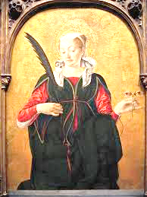
St. Lucia was a Christian martyr in the 4th century who is traditionally known as wearing a candle-lit crown to light her way through the catacombs as she brought food to Christians who were being persecuted. Her commemoration is meant to signal that Christmas is coming soon when Christ, the Light of the World, will arrive. Today many Christians throughout the world celebrate by lighting candles and attending major festivals not only to commemorate her confession of faith and care for persecuted Christians, but in anticipation of the coming of the Christ child.
There is so much beauty and rich tradition during the season of Advent to prepare Christians for the coming of Jesus, the babe of Bethlehem. When you see the altar draped in purple (or blue), remember your King who came to bring you life and salvation. If you don’t have one already, consider getting an Advent wreath for your home as you prepare for the coming of Christ, the Light of the World. Give thanks to God for the confession of faith He gave to His people to shine His light in dark places. Learn about the tradition of reciting the O Antiphons (found in the Lutheran Service Book along with hymn # 357 “O Come, O Come, Emmanuel) and incorporate it into your Advent devotions. Finally, anticipate with joy, the coming of our Lord!
Deaconess Betsy Karkan serves at Concordia University-Chicago.
llllllllllllllllllllllllllll
Other Altar Guild News
The Altar Guild wishes to sincerely thank all who supported its Autumn Pie Sale. Thanks to your support, we made a net profit of over $212! A similar spring fundraiser is being considered and will include the sale of stromboli (due to popular demand).
December 4th will be our first Ladies Christmas Luncheon beginning at 11 am. This luncheon is open to all females attending our church and you are welcome to bring a friend or relative. Did you forget to sign up? Join us anyway! There’s sure to be enough for all.
The Altar Guild is also sponsoring the December Fellowship following worship on the 12th. Come sample our homemade cookies and share time and conversation with your fellow congregation members.
There will be a mini-polishing session beginning at 1 pm Wednesday, December 15th to prepare our communion ware for the Christmas season. Contact Elizabeth Loughan if you are able to help out.
Beginning with our January 8th meeting , Pastor Deal will be presenting a half-hour Bible study at the beginning of each meeting when available. Our first topic will center on women in the Bible.
New members to the Altar Guild are always welcome! Please consider joining us!
llllllllllllllllllllllllllll
A note from Pastor Deal: Please let me know if you or a loved one are in the hospital or have a special need. Also, please ask the hospital or family members to phone me or the church office as I wish to visit those who may be hurting.
llllllllllllllllllllllllllll
Submissions for the January issue of “The Rock and the Sword” newsletter are due to the secretary’s office Monday, December 20th at noon. This includes meeting dates and times for the church calendar.
llllllllllllllllllllllllllll
We were chosen! By directing designated Choice Dollars through Thrivent Choice, eligible Thrivent members choose where Thrivent Financial for Lutherans distributes some of its charitable outreach grant dollars among thousands of participating Lutheran nonprofit organizations and congregations.
Many thanks to Thrivent Financial members Evelyn Baisch and Traudi Sulek who recently directed Choice dollars to our church!
llllllllllllllllllllllllllll
From December 1-22, the secretary’s office will be open Mondays (8:30 am-5 pm) and Wednesdays (8:30 am-noon and 12:45-5pm) and Thursday/Friday, as needed. Regular office hours (Mondays & Thursdays 8:30-4:30) will resume the week following Christmas. As always, please phone the church first if needing to get in to make certain someone is there to let you in.
The following “thank you” note was received from our 3rd Quarter Local Mission: Meals on Wheels~Shenango Valley:

Dear Friends at Saints Peter and Paul,
We have received your generous donation of $645 to the Shenango Valley Meals on Wheels program from your local quarterly mission.
In this hard tine with the coronavirus pandemic, this money will help us buy more food and supplies for our increase of clients since the spring of last year.
We thankyou for your most thoughtful contribution in support of our program to provide affordale, healthy and nutritious meals to our clinents.
Again, thank you for remembering us with your generous, appreciated donation.
Stay Safe!
Sincerely,
~Melissa Adams, Executive Director
llllllllllllllllllllllllllll
Word of Hope: 1-888-217-8679
The only 24/7 CONFIDENTIAL Hotline that is distinctly Lutheran, bringing healing found in Christ, to those whose hearts have been broken by abortion.
llllllllllllllllllllllllllll
Orders and Payments
for Poinsettias
to adorn our altar
at Christmas
are due Sunday, December 5th.
Plants may be taken home following worship Sunday, January 2nd.

BIBLE MEMORY VERSES FROM NOVEMBER
For Adults
Nov. 7: But our citizenship is in heaven, and from it we await a Savior, the Lord Jesus Christ, who will transform our lowly body to be like his glorious body, by the power that enables him even to subject all things to himself. Philippians 3:20-21
Nov. 14: And it will be said in that day, "Behold, this is our God for whom we have waited that He might save us. This is the LORD for whom we have waited; Let us rejoice and be glad in His salvation." Isaiah 25:9
Nov. 21: But since we belong to the day, let us be sober, having put on the breastplate of faith and love, and for a helmet the hope of salvation. 1 Thessalonians 5:8
Nov. 28: I am the way, and the truth, and the life. No one comes to the Father except through me. John 14:6
1
For Children
Nov. 7: The King of kings and Lord of lords, who alone has immortality, to him be honor and eternal dominion. 1 Timothy 6:15-16
Nov. 14: Give thanks to the Father, who has qualified you to share in the inheritance of the saints in light. Colossians 1:2
Nov. 21: Stay dressed for action and keep your lamps burning.
Luke 12:35
Nov. 28: Behold, your king is coming to you; righteous and having salvation is he. Zechariah 9:9
llllllllllllllllllllllllllll
By the grace of God, choir is starting up again! Rehearsals will be on Wednesdays at 5:00 beginning December 1. We will be singing during the Christmas Eve service. All voices are welcome!
llllllllllllllllllllllllllll
THANK YOU! Heartfelt appreciation is extended to Marie Flaugher (and Mike!) for all the work done with the restoration and reframing of our historical pictures! This project of posting historical pictures originated with John Zachar many, many years ago. We are grateful to Marie for cleaning, remounting, and overseeing the reframing of these wonderful memories.
llllllllllllllllllllllllllll
Bible Study is back in session! Join us Sunday mornings at 9 am in the Fellowship Hall. We are currently studying Baptism with examining how it is referenced in both the Old and New Testaments. Classes are open to all ages!
llllllllllllllllllllllllllll
TRUNK OR TREAT took place Saturday, October 30th in our parking lot and Fellowship Hall. It is estimated that we had between 175-200 children participate. Guests were invited to come indoors for pizza and the showing of “Monsters University”. A good time was had by all!
Guests voted on their favorite “trunk” and cash prizes were awarded. First place went to Mike and Marie Flaugher, second place to Diane Riefstahl and Bob Kozar, and third place to Nancy Robertson. We hope there will be more participants in the future!
The following are some pictures from the event.
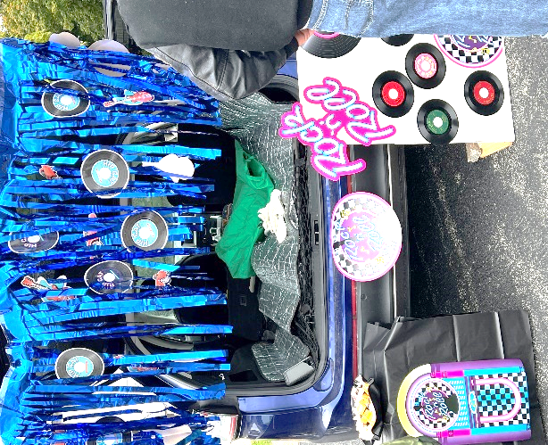
Mike and Marie Flaugher’s prize-winning trunk sported a 50’s theme.

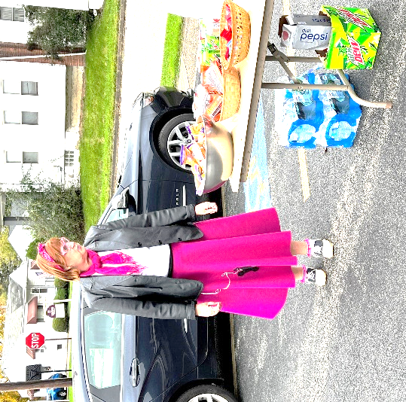
Marie got into the spirit of Halloween with her poodle skirt and leather jacket!

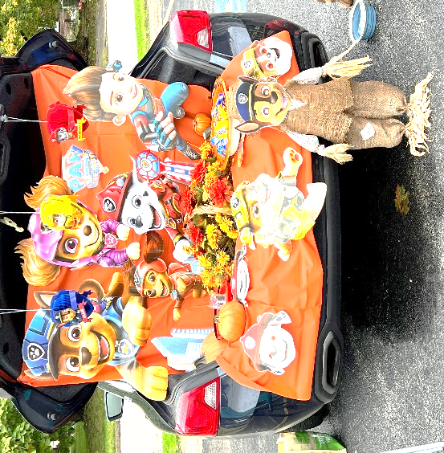
Children enjoyed the Paw Patrol trunk.

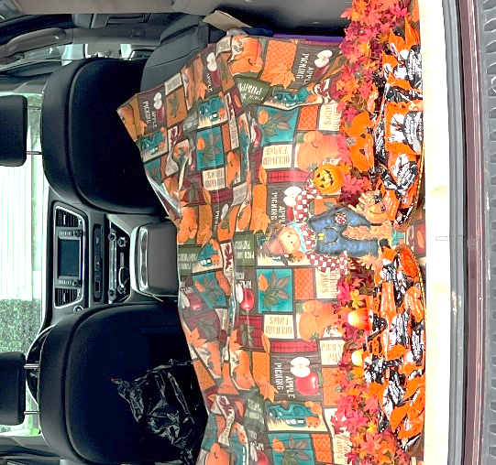
A fall theme was presented by Nancy Robertson.

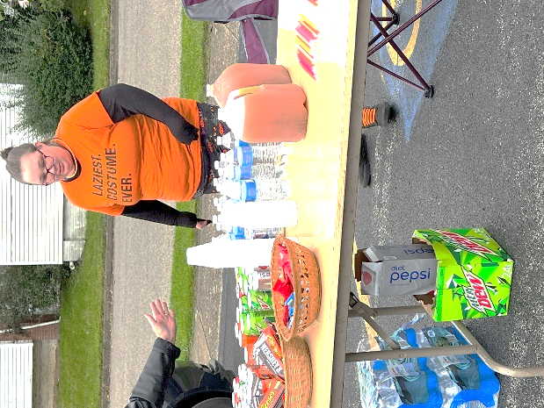

Elizabeth Haenftling manned the refreshment table.

Who doesn’t love a dog who
is a super hero?
Everyone got into to the fun!

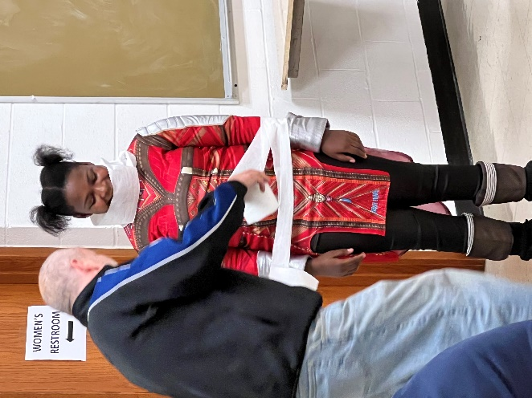

Indoors, the “It’s a Wrap” mummy contest took place.
