Sts. Peter & Paul
Evangelical Lutheran Church
Lutheran Church-Missouri Synod
Founded-1917

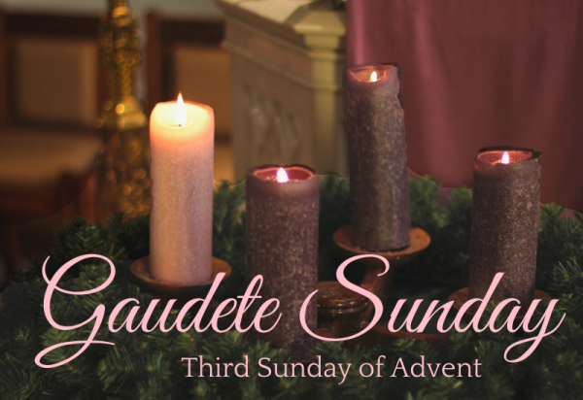

December 17, 2023

699 Stambaugh Ave.
Sharon, Pennsylvania 16146

“I was glad when they said to me,
Let us go to the house of the LORD!”
Psalm 122:1
Sts. Peter & Paul Evangelical Lutheran Church, LC-MS
GAUDETE
December 17, 2023

A special welcome to our guests this day! If you would like more information about The Lutheran Church - Missouri Synod, or this congregation, please speak with Pastor Deal or an Elder after the service.
Members & Guests: Don’t be embarrassed if your children make noise during the worship service, all children do. We encourage families to worship together but, if you feel the need, there are pews in the rear of the Church which are reserved for young families on both sides of the sanctuary. There is also a quiet room available to you, located next to the sanctuary (formerly the Pastor’s office), where you would be able to follow along with the service.

Today’s service includes the Sacrament of Holy Communion. If during this past year, you have not worshipped with us and been communed, we respectfully ask that you do not partake of this sacrament this day before first speaking with Pastor Deal.
If visiting from a sister congregation of the LC-MS and are in good standing, please inform Pastor Deal of your desire to commune prior to the service.
If wishing to receive a blessing during communion, please approach with your arms crossed.

CONTACT INFORMATION
Pastor Deal: pastordeal@saintspeterandpaul.net or 724-347-3620 (opt. 2)
Church Office: church@saintspeterandpaul.net or 724-347-3620 (opt. 3)
Secretary’s Office: The office will be open Monday (8:30-5:00) & Wednesday (8:30-10:00; 10:45-5:00).

Silent prayer before worship: Lord Jesus, You came as the Wonderful Counselor, Mighty God, Everlasting Father, and Prince of Peace. Lead me to read and study the Scriptures, that You may bless me with Your counsel, strength, love, and peace. Amen.
Confession and Absolution

Opening Hymn: LSB #346 “When All the World Was Cursed”

Stand

The sign of the cross may be made by all in remembrance of their Baptism.

Invocation
P In the name of the Father and of the T Son and of the Holy Spirit.
C Amen.

Exhortation Hebrews 10:22; Psalm 124:8; Psalm 32:5
P Beloved in the Lord! Let us draw near with a true heart and confess our sins unto God our Father, beseeching Him in the name of our Lord Jesus Christ to grant us forgiveness.

P Our help is in the name of the Lord,
C who made heaven and earth.
P I said, I will confess my transgressions unto the Lord,
C and You forgave the iniquity of my sin.

Silence for reflection on God’s Word and for self-examination.

Confession of Sins
P O almighty God, merciful Father,
C I, a poor, miserable sinner, confess unto You all my sins and iniquities with which I have ever offended You and justly deserved Your temporal and eternal punishment. But I am heartily sorry for them and sincerely repent of them, and I pray You of Your boundless mercy and for the sake of the holy, innocent, bitter sufferings and death of Your beloved Son, Jesus Christ, to be gracious and merciful to me, a poor, sinful being.

Absolution [John 20:19–23]
P Upon this your confession, I, by virtue of my office, as a called and ordained servant of the Word, announce the grace of God unto all of you, and in the stead and by the command of my Lord Jesus Christ I forgive you all your sins in the name of the Father and of the T Son and of the Holy Spirit.
C Amen.

Service of the Word

Introit Psalm 85:1–2, 6, 8; antiphon: Philippians 4:4–5
Rejoice in the Lord | always;*
again I will | say, Rejoice.
Let your reasonableness be known to | everyone.*
The Lord | is at hand.
Lord, you were favorable | to your land;*
you restored the fortunes of | Jacob.
You forgave the iniquity of your | people;*
you covered | all their sin.
Will you not revive | us again,*
that your people may re- | joice in you?
Let me hear what God the | Lord will speak,*
for he will speak peace to his people, to his saints; but let them not turn back to | folly.
Rejoice in the Lord | always;*
again I will | say, Rejoice.
Let your reasonableness be known to | everyone.*
The Lord | is at hand.

Gloria Patri
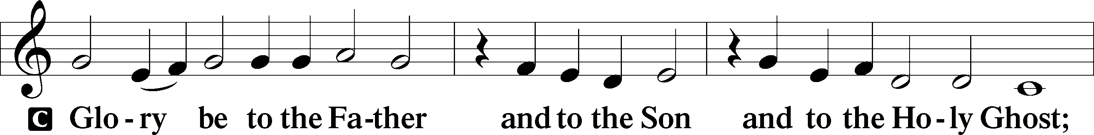
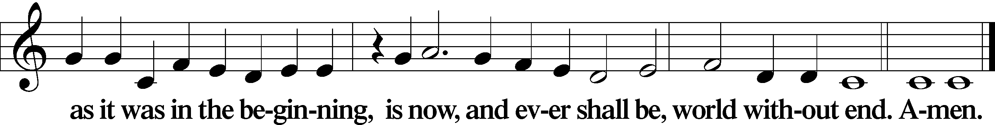

Kyrie Mark 10:47
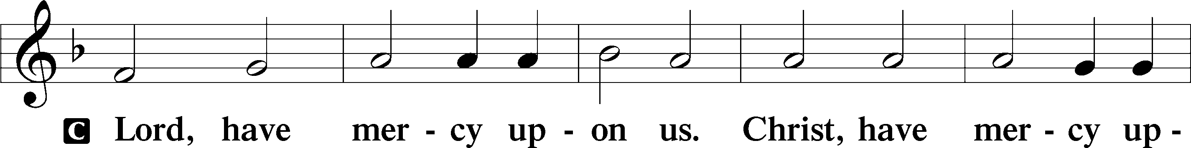
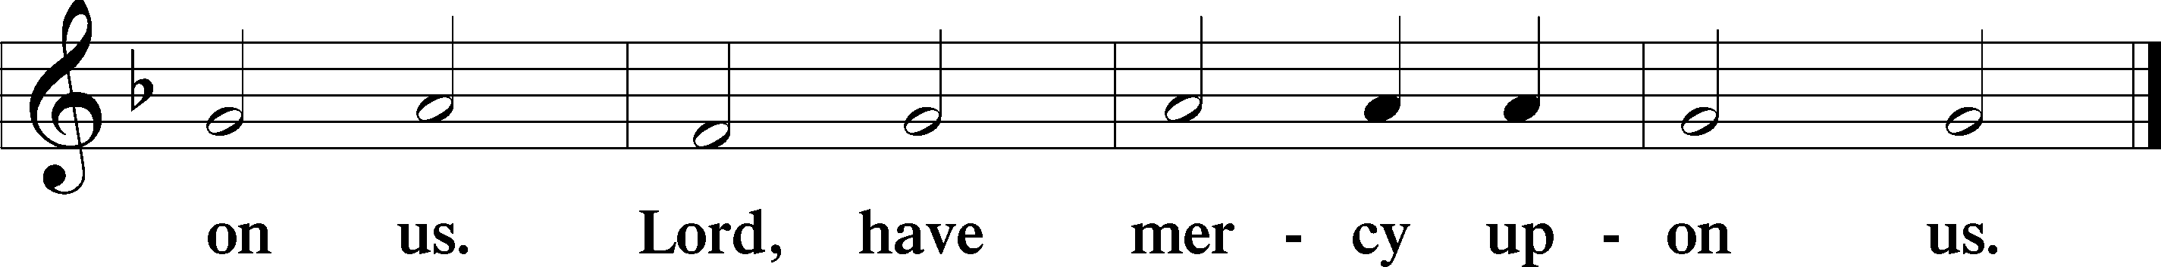

Salutation and Collect of the Day: Gaudete
P The Lord be with you.
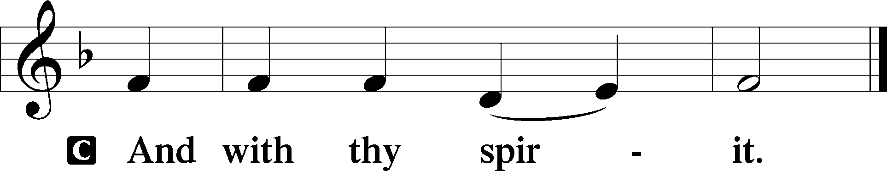

P Let us pray.
Lord Jesus Christ, we implore You to hear our prayers and to lighten the darkness of our hearts by Your gracious visitation; for You live and reign with the Father and the Holy Spirit, one God, now and forever.
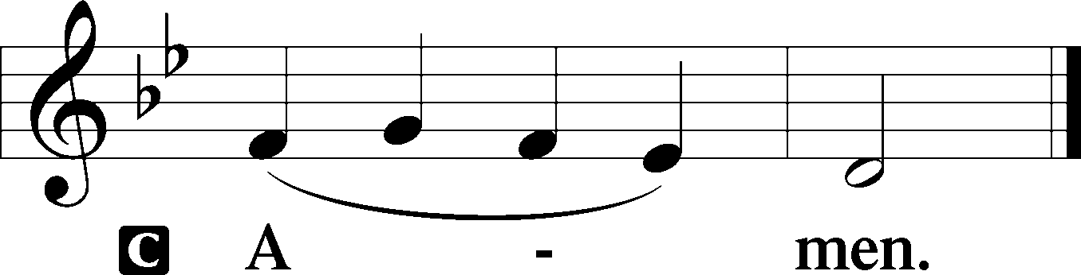
Sit

Prophecy: Isaiah 40:1–8 (NKJV)
Thus says the Lord God: “Comfort, yes, comfort My people!” says your God. “Speak comfort to Jerusalem, and cry out to her, that her warfare is ended, that her iniquity is pardoned; for she has received from the Lord’s hand double for all her sins.” The voice of one crying in the wilderness: “Prepare the way of the Lord; make straight in the desert a highway for our God. Every valley shall be exalted and every mountain and hill brought low; the crooked places shall be made straight and the rough places smooth; the glory of the Lord shall be revealed, and all flesh shall see it together; for the mouth of the Lord has spoken.” The voice said, “Cry out!” And he said, “What shall I cry?” “All flesh is grass, and all its loveliness is like the flower of the field. The grass withers, the flower fades, because the breath of the Lord blows upon it; surely the people are grass. The grass withers, the flower fades, but the word of our God stands forever.”

P This is the Word of the Lord.
C Thanks be to God.

Gradual Psalm 80:1–2
You who are enthroned upon the cherubim, | shine forth.*
Stir up your might and come to | save us!
Give ear, O Shepherd of | Israel,*
you who lead Joseph | like a flock!

Epistle: 1 Corinthians 4:1–5 (NKJV)
Brethren: Let a man so consider us, as servants of Christ and stewards of the mysteries of God. Moreover it is required in stewards that one be found faithful. But with me it is a very small thing that I should be judged by you or by a human court. In fact, I do not even judge myself. For I know of nothing against myself, yet I am not justified by this; but He who judges me is the Lord. Therefore judge nothing before the time, until the Lord comes, who will both bring to light the hidden things of darkness and reveal the counsels of the hearts. Then each one’s praise will come from God.

P This is the Word of the Lord.
C Thanks be to God.

Stand

Verse Psalm 80:2b
Alleluia. Stir up your might and come to save us. Alleluia.

Alleluia
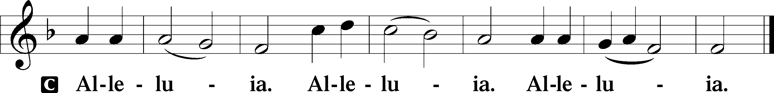

Holy Gospel: Matthew 11:2–10 (NKJV)
P The Holy Gospel according to St. Matthew, the eleventh chapter.
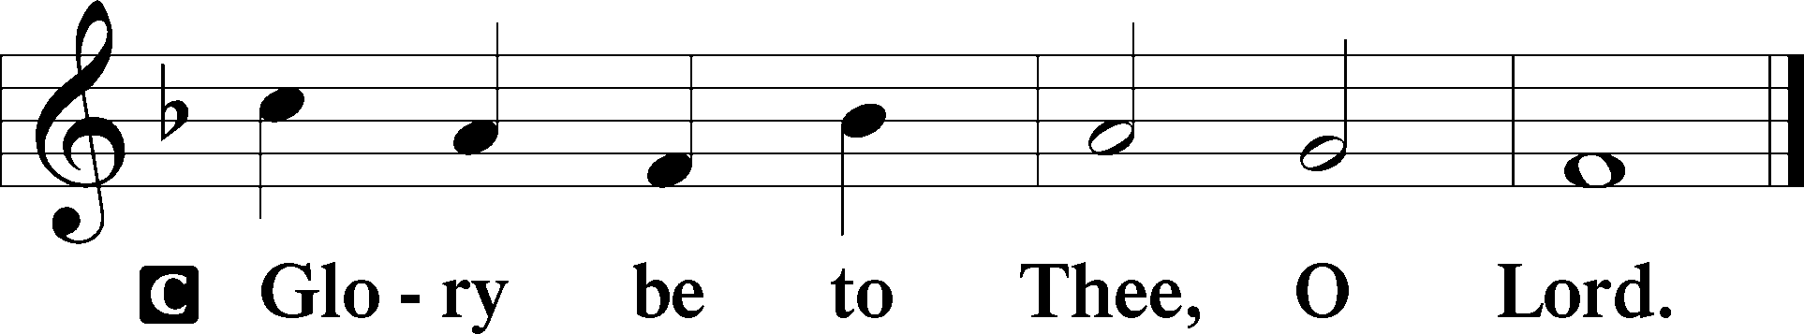

At that time: When John had heard in prison about the works of Christ, he sent two of his disciples and said to Him, “Are You the Coming One, or do we look for another?” Jesus answered and said to them, “Go and tell John the things which you hear and see: the blind see and the lame walk; the lepers are cleansed and the deaf hear; the dead are raised up and the poor have the gospel preached to them. And blessed is he who is not offended because of Me.” As they departed, Jesus began to say to the multitudes concerning John: “What did you go out into the wilderness to see? A reed shaken by the wind? But what did you go out to see? A man clothed in soft garments? Indeed, those who wear soft clothing are in kings’ houses. But what did you go out to see? A prophet? Yes, I say to you, and more than a prophet. For this is he of whom it is written: ‘Behold, I send My messenger before Your face, who will prepare Your way before You.’ ”

P This is the Gospel of the Lord.
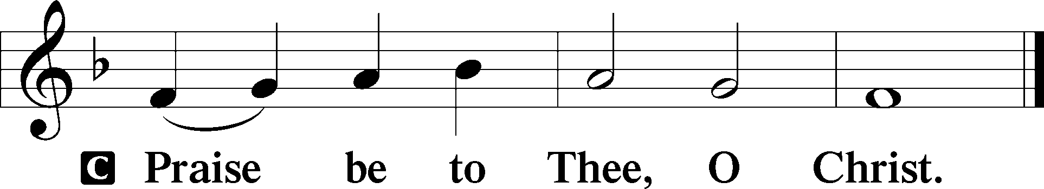

Nicene Creed
C I believe in one God,
the Father Almighty,
maker of heaven and earth
and of all things visible and invisible.

And in one Lord Jesus Christ,
the only-begotten Son of God,
begotten of His Father before all worlds,
God of God, Light of Light,
very God of very God,
begotten, not made,
being of one substance with the Father,
by whom all things were made;
who for us men and for our salvation came down from heaven
and was incarnate by the Holy Spirit of the virgin Mary
and was made man;
and was crucified also for us under Pontius Pilate.
He suffered and was buried.
And the third day He rose again according to the Scriptures
and ascended into heaven
and sits at the right hand of the Father.
And He will come again with glory to judge both the living and the dead,
whose kingdom will have no end.

And I believe in the Holy Spirit,
the Lord and giver of life,
who proceeds from the Father and the Son,
who with the Father and the Son together is worshiped and glorified,
who spoke by the prophets.
And I believe in one holy Christian and apostolic Church,
I acknowledge one Baptism for the remission of sins,
and I look for the resurrection of the dead
and the life T of the world to come. Amen.
Sit

Hymn of the Day: LSB #354 “Arise, O Christian People”

Sermon

Stand

Offertory Psalm 51:10–12
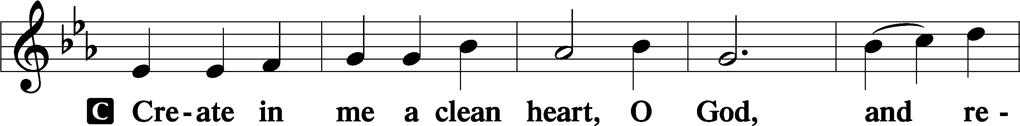
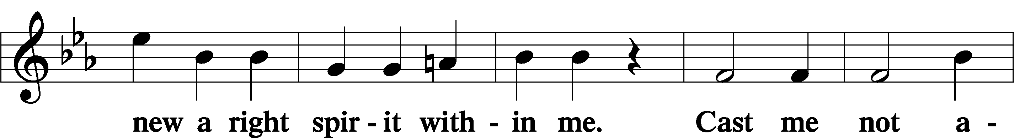
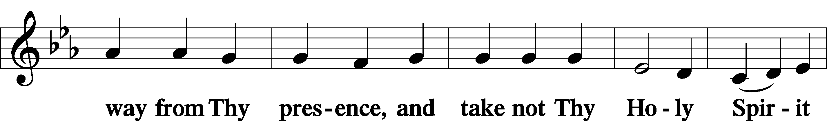
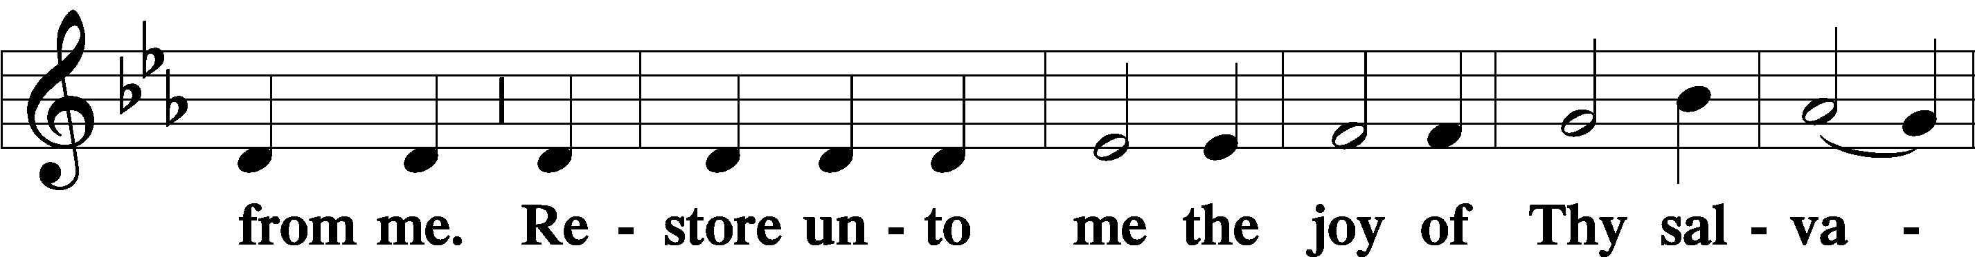
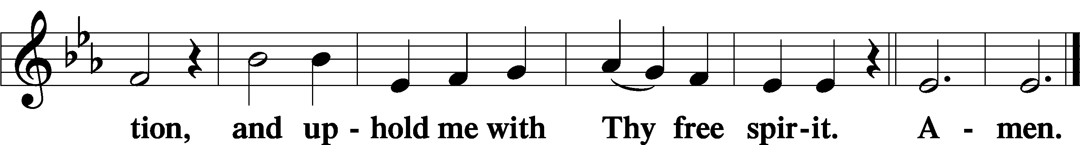

Prayer of the Church

Sit

Preparatory Hymn: LSB #398 “Hail to the Lord’s Anointed”

Stand

Service of the Sacrament

Preface 2 Timothy 4:22; Colossians 3:1 Psalm 136
P The Lord be with you.
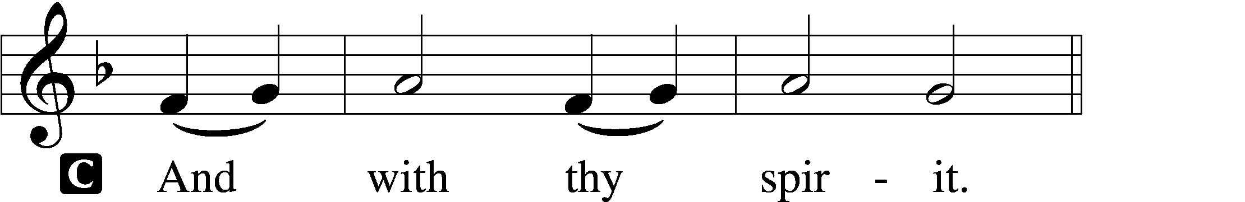

P Lift up your hearts.
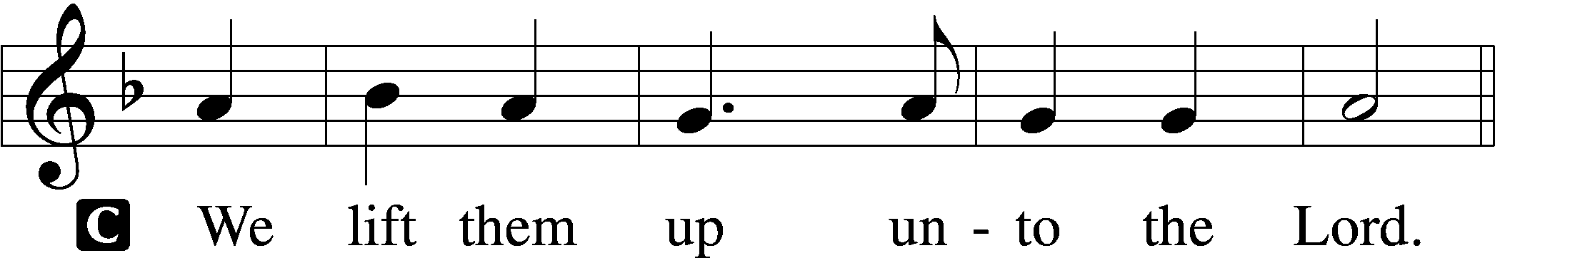

P Let us give thanks unto the Lord, our God.
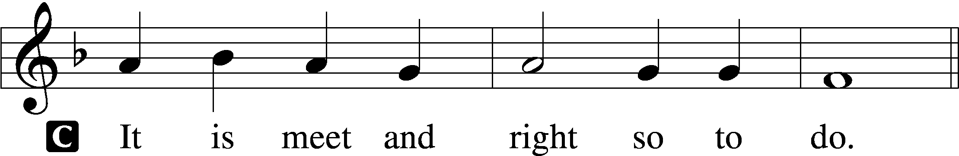

Proper Preface (Abbreviated) LSB 194
P It is truly meet, right, and salutary . . . evermore praising You and saying:

Sanctus Isaiah 6:3; Matthew 21:9
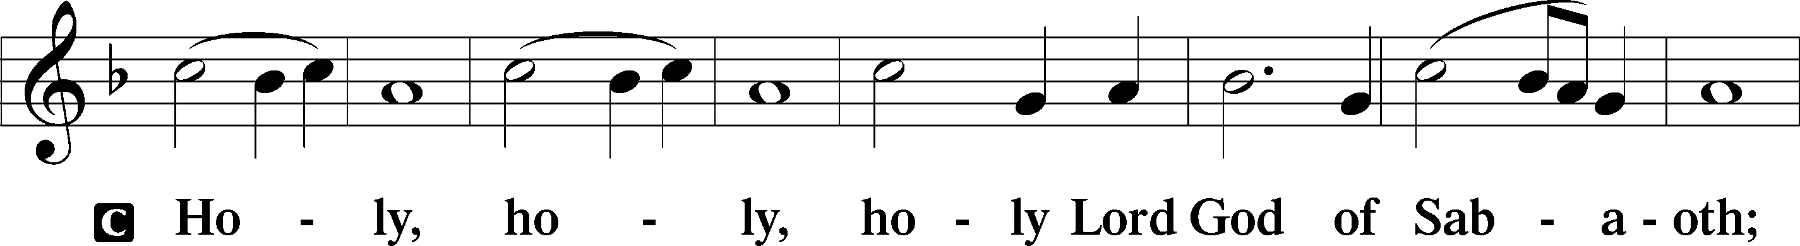
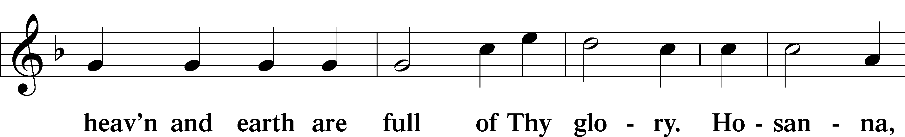
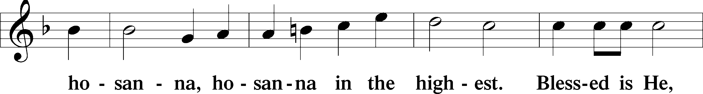
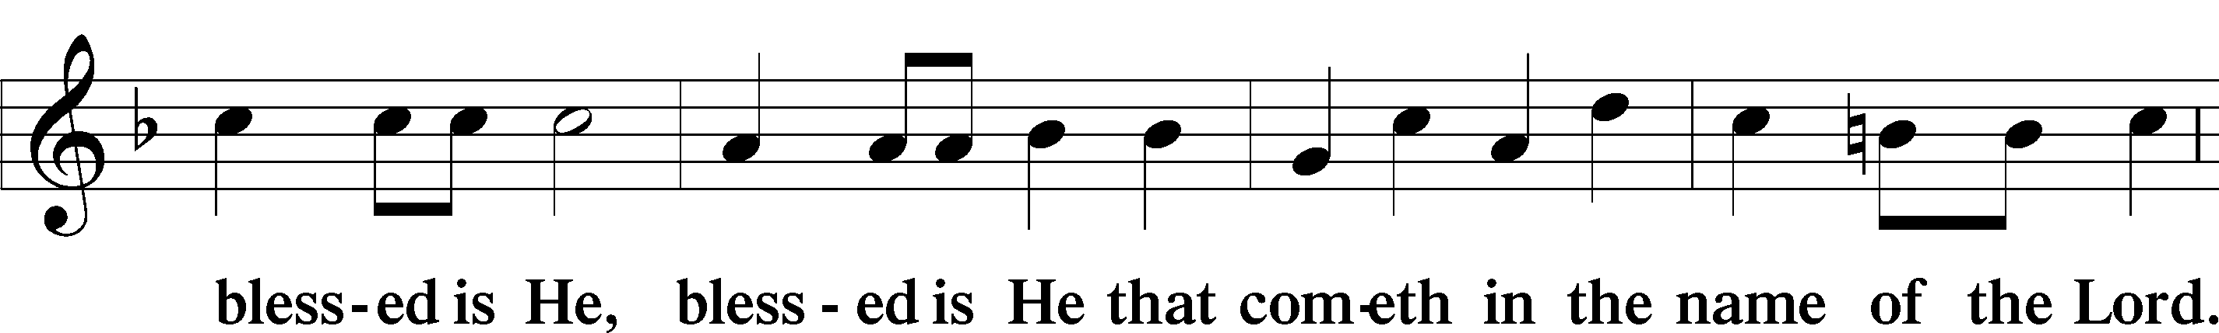
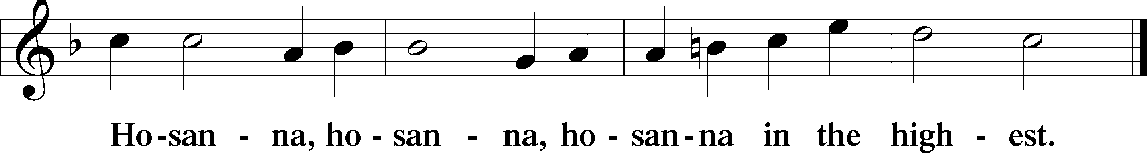

Lord’s Prayer The congregation is encouraged to silently pray the Lord’s Prayer as it is chanted. Matthew 6:9–13
P Our Father who art in heaven,
hallowed be Thy name,
Thy kingdom come,
Thy will be done on earth as it is in heaven;
give us this day our daily bread;
and forgive us our trespasses as we forgive those who trespass against us;
and lead us not into temptation,
but deliver us from evil.
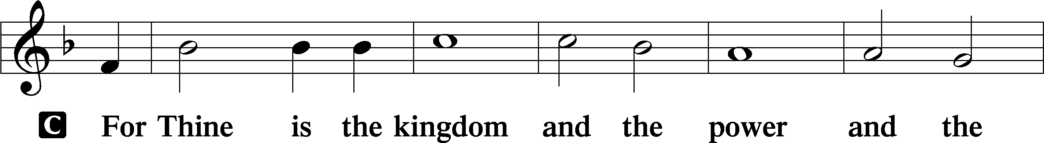
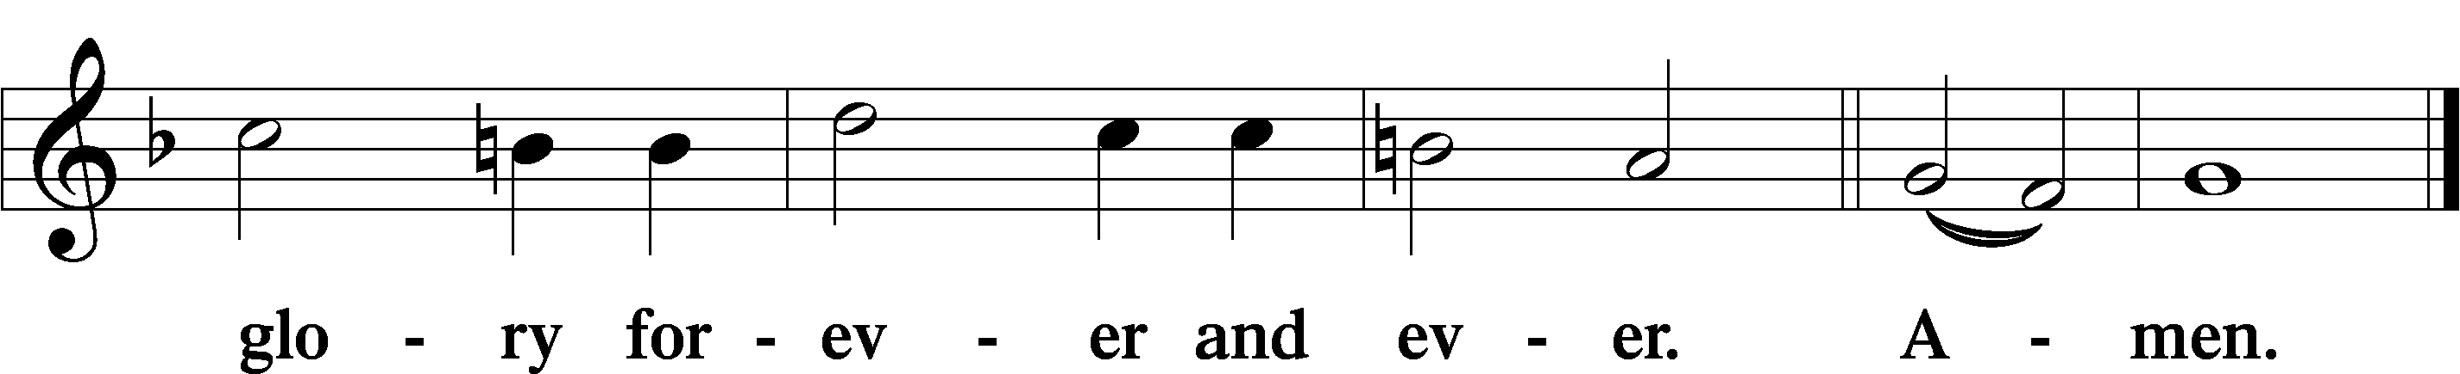

The Words of Our Lord Matthew 26:26–28; Mark 14:22–24; Luke 22:19–20; 1 Corinthians 11:23–25
P Our Lord Jesus Christ, on the night when He was betrayed, took bread, and when He had given thanks, He broke it and gave it to the disciples and said: “Take, eat; this is My T body, which is given for you. This do in remembrance of Me.”

In the same way also He took the cup after supper, and when He had given thanks, He gave it to them, saying: “Drink of it, all of you; this cup is the new testament in My T blood, which is shed for you for the forgiveness of sins. This do, as often as you drink it, in remembrance of Me.”

Pax Domini John 20:19
P The peace of the Lord be with you always.
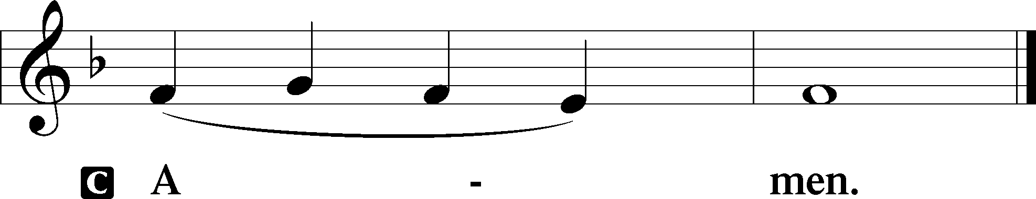

Agnus Dei John 1:29
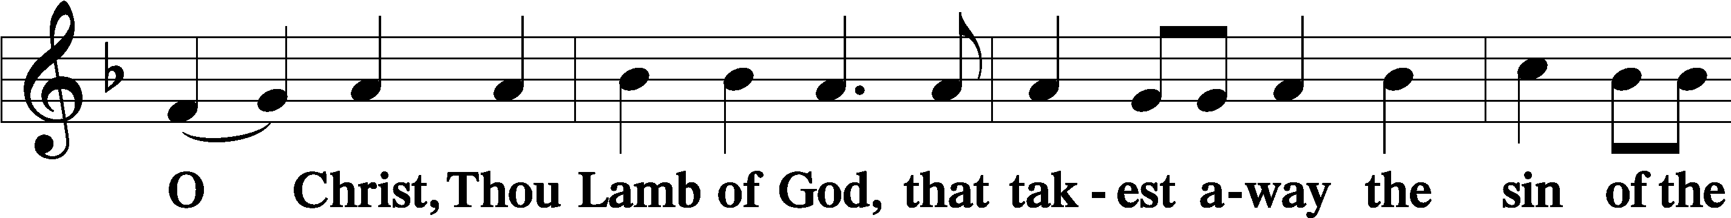
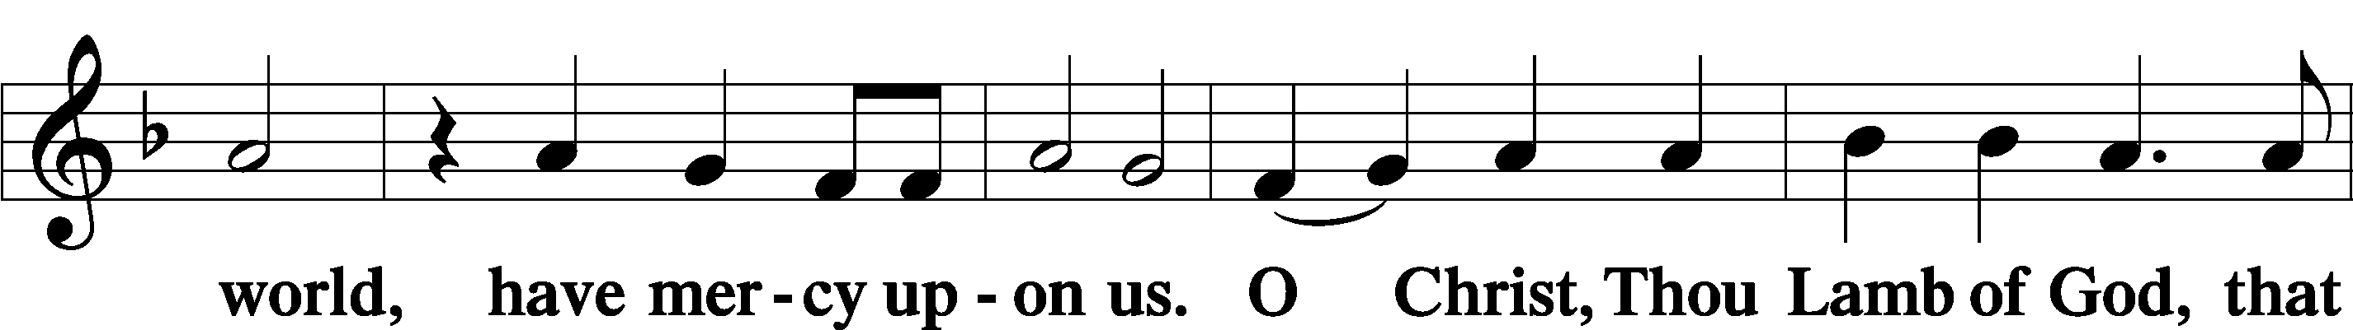
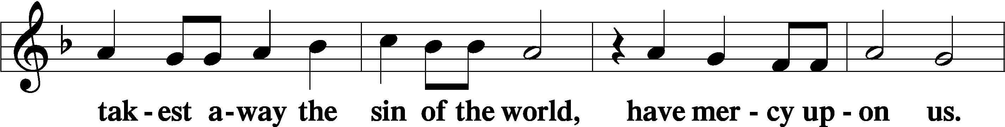
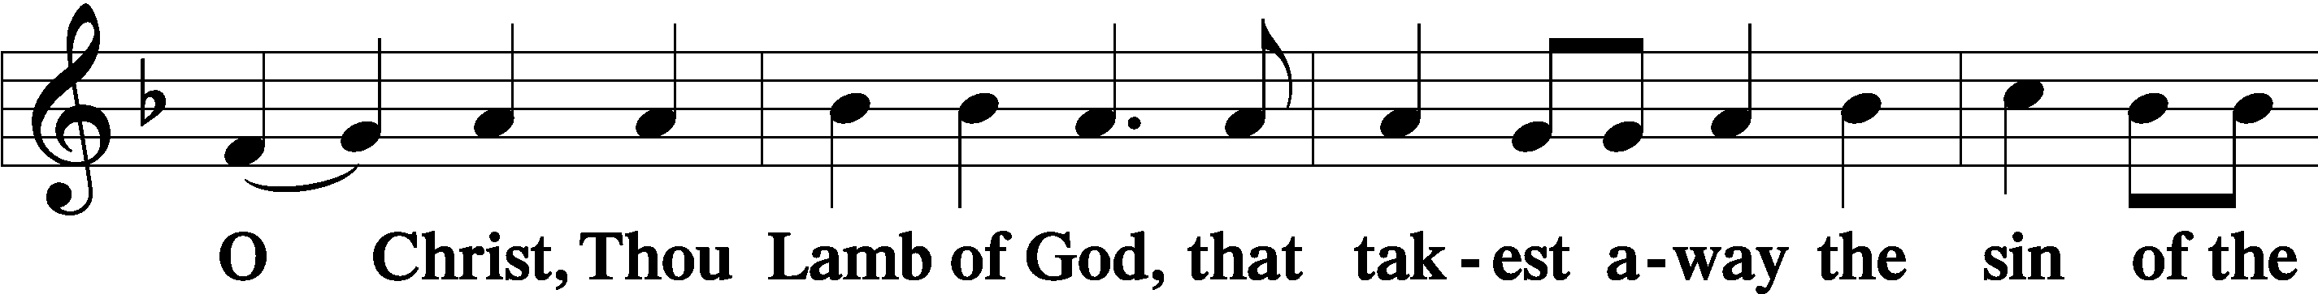
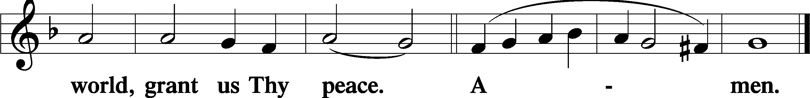
Sit

Distribution
The pastor and those who assist him receive the body and blood of Christ first and then distribute them to those who come to receive, saying:
Take, eat; this is the true body of our Lord and Savior Jesus Christ, given into death for your sins.
Amen.

Take, drink; this is the true blood of our Lord and Savior Jesus Christ, shed for the forgiveness of your sins.
Amen.

In dismissing the communicants, the following is said:
P The body and blood of our Lord Jesus Christ strengthen and preserve you in body and soul to life everlasting. Depart T in peace.
C Amen.

Distribution Hymn: LSB #335 “O Bride of Christ, Rejoice”

Distribution Hymn: LSB #737 “Rejoice, My Heart, Be Glad and Sing”

Distribution Hymn: LSB #338 “Come, Thou Long-Expected Jesus”

Stand

Nunc Dimittis Luke 2:29–32
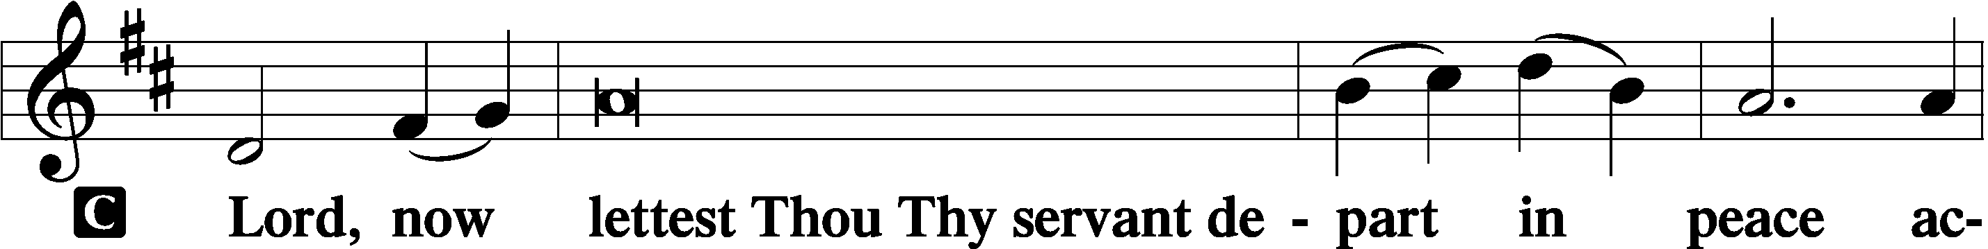
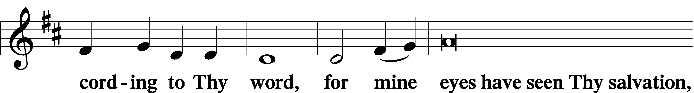
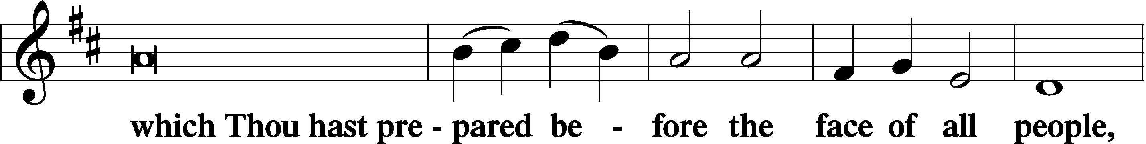
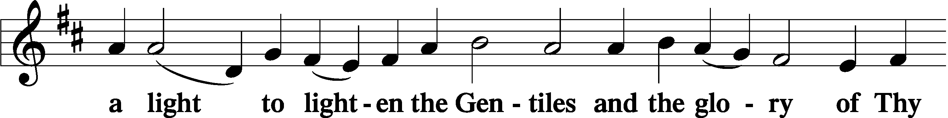
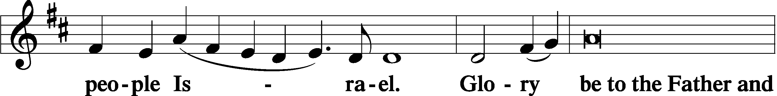
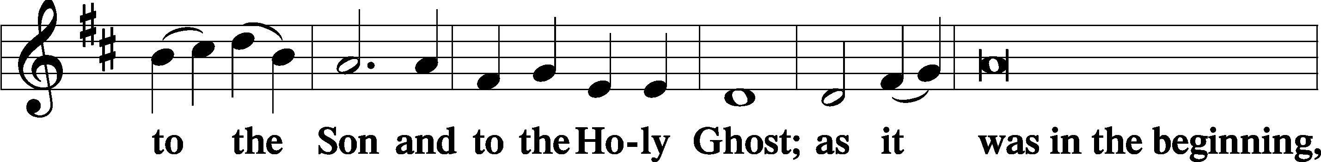
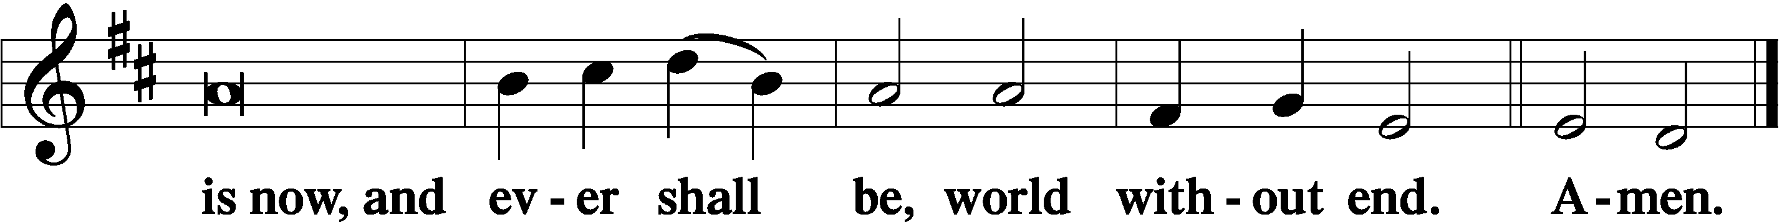

Thanksgiving Psalm 107:1
P O give thanks unto the Lord, for He is good,
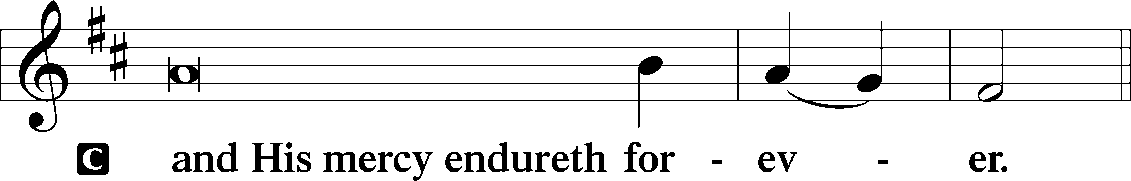

Post-Communion Collect
P Let us pray.
We give thanks to You, almighty God, that You have refreshed us through this salutary gift, and we implore You that of Your mercy You would strengthen us through the same in faith toward You and in fervent love toward one another; through Jesus Christ, Your Son, our Lord, who lives and reigns with You and the Holy Spirit, one God, now and forever.
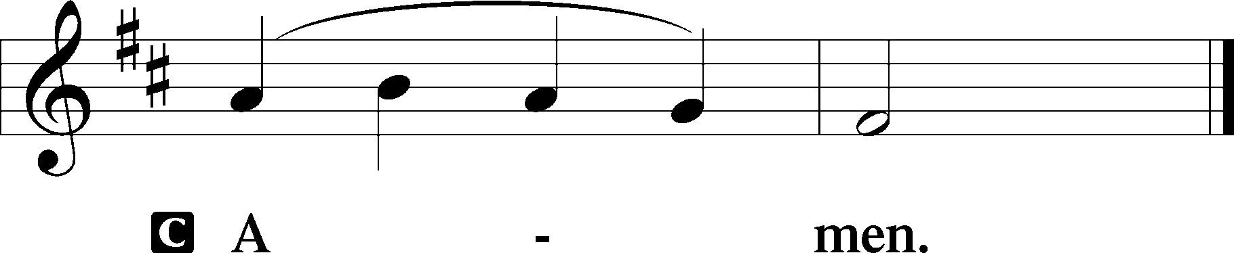

Salutation 2 Timothy 4:22
P The Lord be with you.
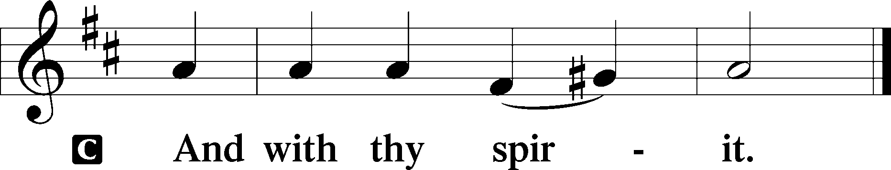

Benedicamus Psalm 103:1
P Bless we the Lord.
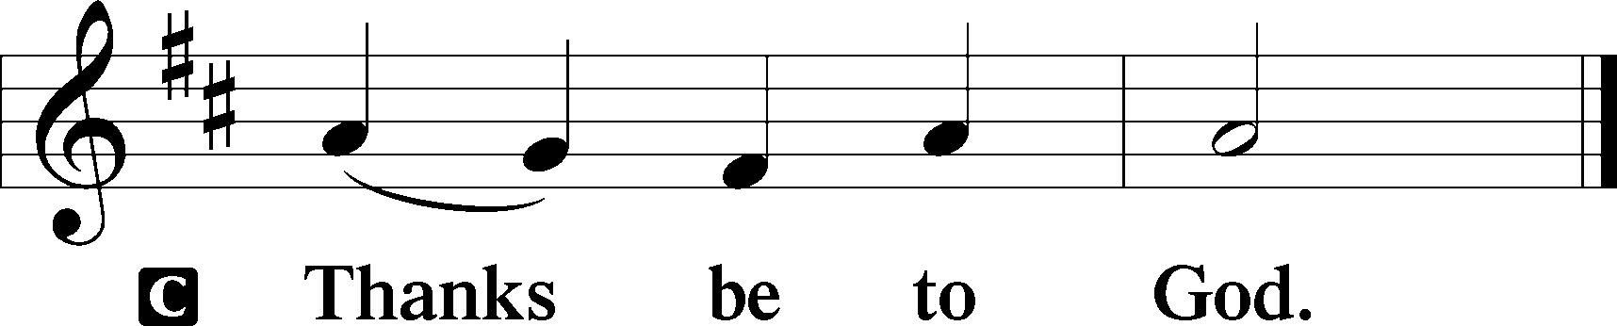

Benediction Numbers 6:24–26
P The Lord bless you and keep you.
The Lord make His face shine upon you and be gracious unto you.
The Lord lift up His countenance upon you and T give you peace.
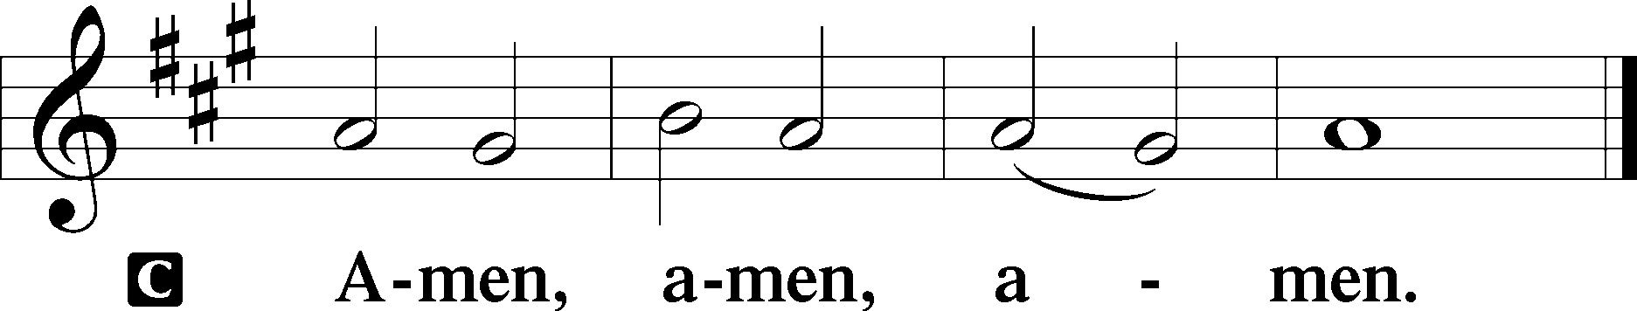

Closing Hymn: LSB #357 “O Come, O Come, Emmanuel”

Silent prayer after worship: Almighty God, be with me and be near me always. Bless me with the Holy Spirit, who works through Your Word, so that the true spirit of Christmas may fill me and show itself in my life. In Jesus’ name. Amen.

Acknowledgments
Unless otherwise indicated, Scripture quotations are from the ESV® Bible (The Holy Bible, English Standard Version®), copyright © 2001 by Crossway, a publishing ministry of Good News Publishers. Used by permission. All rights reserved.
Created by Lutheran Service Builder © 2023 Concordia Publishing House.
fffffffffffffffffffffffffffffffffff
fffffffffffffffffffffffffffffffffff
In Loving Memory of Mother, Betty Petro: Michael A. Petro (Capital Campaign).
In Loving Memory of Sister, Betty Hardell, and Viola Sakony: Patty Parker (Capital Campaign).
In Loving Memory of Rev. Timothy Carr: Catherine Carr (Capital Campaign).
In Loving Memory of my Brother, Richard Dorfi: Edeltraud Sulek (Capital Campaign).
fffffffffffffffffffffffffffffffffff
Sincere sympathy is extended to the family and friends of Timith L. Riffle who passed into the arms of the Lord Saturday, December 9, 2023. May those who mourn his loss find peace in the knowledge that he now rests with his Lord and Savior.
fffffffffffffffffffffffffffffffffff
Attendance: Sunday, December 10, 2023: 42
Wednesday, December 13, 2023: 12 (10 am); 11 (7 pm)
fffffffffffffffffffffffffffffffffff

SCHEDULE THROUGH DECEMBER 24, 2023:

:

Today, following Worship, Library: Audit of Deposits
7 pm, Fellowship Hall: AA Meeting
Tuesday, 7-9 pm, Fellowship Hall: Penn-Ohio Singers
Wednesday, 10 am, Sanctuary: Advent Midweek Matins Service Week 3
7 pm, Sanctuary: Advent Midweek Vespers Service Week 3
7:30 pm, Fellowship Hall: NA Meeting
Next Sunday, 9 am, Sanctuary: Divine Service
7 pm, Fellowship Hall: AA Meeting
8 pm, Sanctuary: Christmas Eve Service of Lessons and Carols
fffffffffffffffffffffffffffffffffff
THANK YOU FOR SERVING IN DECEMBER: Elder: Jonathan Baisch; Ushers: Cheryl Fedele, Mike Flaugher, & Jesse Riffle; Altarware ~ Sundays: (prior) Marie Flaugher (12.31) & Diane Riefstahl; (after) Marie Flaugher (12.31) & Elizabeth Haenftling (12.17, & 12.24); Special Divine Service: Diane Riefstahl (12.25).
fffffffffffffffffffffffffffffffffff
Shelves have been placed in front of the secretary’s office for recent copies of items generally found in the narthex (seasonal devotionals, Church Council/Voters’ Assembly agendas & minutes, etc.). Items will now be available in both locations for your convenience.
fffffffffffffffffffffffffffffffffff
The minutes from the December 3, 2023, Voters’ Assembly are available this morning.
fffffffffffffffffffffffffffffffffff
Bible Memory Verses ~ Week of December 17th:
For Adults: For by grace you have been saved through faith. And this is not your own doing; it is the gift of God, not a result of works, so that no one may boast.
Ephesians 2:8-9
For Children: Prepare the way of the Lord; behold, the Lord God comes with might. Isaiah 40:3, 10
fffffffffffffffffffffffffffffffffff
Auditors will meet in the library following worship this morning.
Our Stewardship of Treasures for the Lord:
In order to do the Lord’s work, we need $2,553.63 each week to meet our 2023 budget for general purposes and $76.92 for the SELC.

Figures for Wednesday, December 6, 2023
General Fund: $195.00
Capital Campaign: $125.00
Figures for Sunday, December 10, 2023
General Fund: $1,815.00
SELC: $97.00
Food Pantry: $13.00
Quarterly Mission: $75.00
Capital Campaign: $235.00
Other: $1,505.00

For online giving, check out https://www.saintspeterandpaul.net/online-giving.
fffffffffffffffffffffffffffffffffff
Our final Advent Midweek Services will take place this Wednesday, December 20th. Two services are offered this year: a 10 am Matins Service and a 7 pm Vespers Service. Please join us as we conclude our focus on this year’s theme: Christ in the Old Testament, “The Seen Yahweh”.
fffffffffffffffffffffffffffffffffff
Our Food Pantry is still seeking donations of paper products (toilet tissue, paper towels, and face tissue) to share with our clients. Donations may be placed on the pew by the secretary’s office. “Thanks” in advance for your participation in this outreach mission.
fffffffffffffffffffffffffffffffffff
Please note the following new address: The Suttons, 268 Mitchell Rd., West Middlesex, PA 16159.
fffffffffffffffffffffffffffffffffff
Interested in finding out more about Luther Classical College? Check out the “On the Line” podcast available on YouTube: “How Luther Classical College Could Change Everything…”
fffffffffffffffffffffffffffffffffff

Remember the following in Prayer…
~The Hurting and Healing: The family and friends of Timith L. Riffle, who passed December 9th; also, Amy, Mary Jane Anderson, Steve Antolovich, Ellen Baron^{CA}, Amy Blomenberg, Lois Bortner^{CA}, Sara Brubaker, Dee Bullock, Bev & Joe Chlpka, Susan Davies, Loretta Deal, Tim Dudash, Judith & Eddy Furey, Griffin, Austin Hamilton, Pastor Charles Henrickson, Joan, Keith Jozwiakowski, Darla Krajci, Barbara Kreske, Jess Lavoie, Paul Lucas^{CA}, Sandy Marshall, Frank Niemeyer^{CA}, Juanita Rentschler, Richard Reuning^{CA}, Nancy Robertson^{CA}, Kriss Svidro^{CA}, Rudy Tomko, Bob Usnarski, Joel & Peggy Wasson, Angela Weser^{CA}, and Ruth Wolf.
~The Homebound: Anna Mae Daris, Millie Elavsky, Jean Tomko, Betty Wolf, and Ed & Millie Zachar.
~Celebrating this Week: Birthdays: Debbie Zuwarsky (12.17) and Titus Deal (12.23).
~Serving in the Military: Alex (Sasha) Carr, Duncan Vaupel, Curtis Sinewe, and Joshua Solyan.
~Community & World Needs: Those suffering due to the conflicts in the Middle East and between Ukraine and Russia; those suffering from loss and dislocation because weather disasters; those suffering from addiction and their families; Local, State, and National Government Leaders; safety for all Police Officers, Firefighters, & First Responders; the unemployed; our Fourth Quarter Local Mission: Willow Women’s Center.
*CA represents cancer.
fffffffffffffffffffffffffffffffffff
Congratulations to Alex (Sasha) Carr who recently graduated from his second phase of military training in Virginia. Sasha will soon be moving to Kentucky where he will be stationed for the next two years.
If wishing to send Sasha notes or cards during this time of transition, please send them to his mother’s address (2449 Romar Dr., Hermitage, PA 16148). She will make certain that he gets them!
fffffffffffffffffffffffffffffffffff
Copies of the 1st Quarter “Portals of Prayer” for 2024 are available on the table in the narthex and next to the sign-in table by the nursery.

December 2023 Worship Services

Wednesday, December 20 10 am Matins Service ~ Advent Midweek 3
7 pm Vespers Service ~ Advent Midweek 3

Sunday, December 24 9 am Divine Service ~ Rorate Coeli
8 pm Christmas Eve Service

Monday, December 25 9 am Divine Service ~ Christmas Day

Tuesday, December 26 7 pm Vespers Service
Feast of St. Stephen, Martyr

Wednesday, December 27 7 pm Vespers Service
Feast of St. John, Apostle & Evangelist

Thursday, December 28 7 pm Vespers Service
Feast of the Holy Innocents, Martyrs

Sunday, December 31 9 am Divine Service ~ First Sunday after
Christmas

Here to Serve
Pastor………………………………………………...……………Rev. Jacob Deal
E-mail …………………………….……pastordeal@saintspeterandpaul.net
Phone Number……………………..…………………724-347-3620 (Option 2)
Church Office………………………..…………………724-347-3620 (Option 3)
Website …………………………………………www.saintspeterandpaul.net
Secretary…………………………………………………………Diane Riefstahl
E-mail ………………………………………church@saintspeterandpaul.net
Website …………………………………………www.saintspeterandpaul.net
Food Pantry (email): ……………foodpantry@saintspeterandpaul.net
Congregation President………………………………….…Jonathan Baisch
Church Elder …………………………………………...……. Jonathan Baisch
Organist………………………………………………..….…Rebecca Marquette
AA Contact: Steve………………………………………………...…724-813-2358
NA Contact: Larry……………………………………..…………..724-977-8733
fffffffffffffffffffffffffffffffffff
If needing to get into the church building during the week, please phone first to make certain someone is here to let you in.

