Sts. Peter & Paul
Evangelical Lutheran Church
Lutheran Church-Missouri Synod
Founded-1917

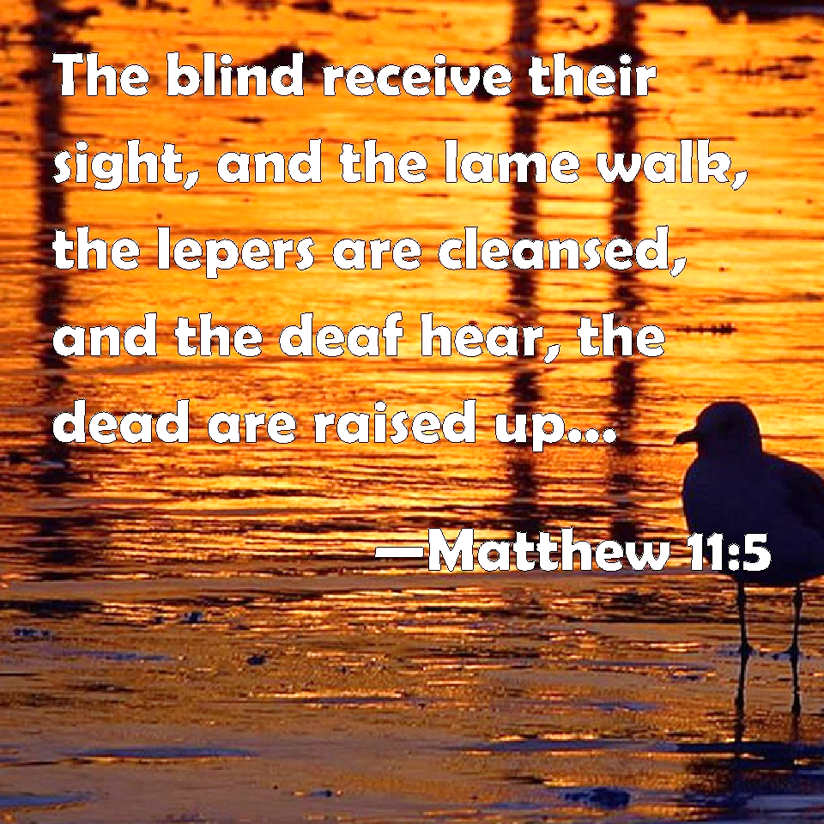

December 11, 2022

699 Stambaugh Avenue
Sharon, Pennsylvania 16146

“I was glad when they said to me,
Let us go to the house of the LORD!”
Psalm 122:1
Sts. Peter & Paul Evangelical Lutheran Church, LC-MS
GAUDETE
December 11, 2022

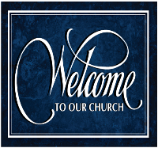
A special welcome to our guests this day! If you would like more information about The Lutheran Church - Missouri Synod, or this congregation, please speak with Pastor Deal or an Elder after the service.
Members & Guests: Don’t be embarrassed if your children make noise during the worship service, all children do. We encourage families to worship together but, if you feel the need, there are pews in the rear of the Church which are reserved for young families on both sides of the sanctuary. There is also a quiet room available to you during our service which is located down the hallway past the offices on the right side of the church as well as a children’s area in the Fellowship Hall where you are able to follow along with the service.

Today’s service includes the Sacrament of Holy Communion. If during this past year, you have not worshipped with us and been communed, we respectfully ask that you do not partake of this sacrament this day before first speaking with Pastor Deal.
If visiting from a sister congregation of the LC-MS and are in good standing, please inform Pastor Deal of your desire to commune prior to the service.
If wishing to receive a blessing during communion, please approach with your arms crossed.

CONTACT INFORMATION
Pastor Deal: pastordeal@saintspeterandpaul.net or 724-347-3620 (opt. 2)
Church Office: church@saintspeterandpaul.net or 724-347-3620 (opt. 3)

Silent prayer before worship: Lord Jesus, You came as the Wonderful Counselor, Mighty God, Everlasting Father, and Prince of Peace. Lead me to read and study the Scriptures, that You may bless me with Your counsel, strength, love, and peace. Amen.

Divine Service ~ Setting 1 ~ p. 151
Confession and Absolution

Opening Hymn: LSB #346 “When All the World Was Cursed”

Stand

The sign of the cross may be made by all in remembrance of their Baptism.
Invocation
P In the name of the Father and of the T Son and of the Holy Spirit.
C Amen.

Exhortation LSB 151
P If we say we have no sin, we deceive ourselves, and the truth is not in us.
C But if we confess our sins, God, who is faithful and just, will forgive our sins and cleanse us from all unrighteousness.

Silence for reflection on God’s Word and for self-examination.
Confession of Sins LSB 151
P Let us then confess our sins to God our Father.
C Most merciful God, we confess that we are by nature sinful and unclean. We have sinned against You in thought, word, and deed, by what we have done and by what we have left undone. We have not loved You with our whole heart; we have not loved our neighbors as ourselves. We justly deserve Your present and eternal punishment. For the sake of Your Son, Jesus Christ, have mercy on us. Forgive us, renew us, and lead us, so that we may delight in Your will and walk in Your ways to the glory of Your holy name. Amen.

Absolution LSB 151
P Almighty God in His mercy has given His Son to die for you and for His sake forgives you all your sins. As a called and ordained servant of Christ, and by His authority, I therefore forgive you all your sins in the name of the Father and of the T Son and of the Holy Spirit.
C Amen.
Stand
Service of the Word

Introit Psalm 85:1–2, 6, 8; antiphon: Philippians 4:4–5
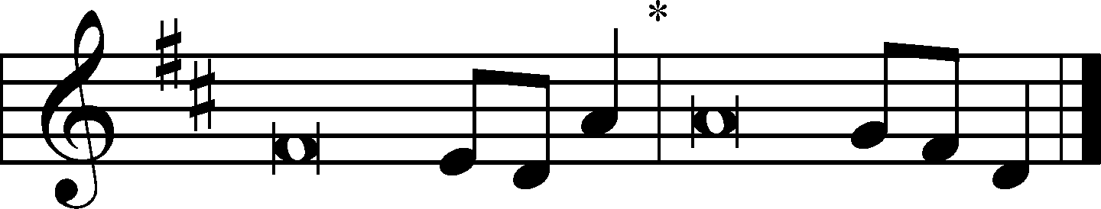
Rejoice in the Lord | always;*
again I will | say, Rejoice.
Let your reasonableness be known to | everyone.*
The Lord | is at hand.
Lord, you were favorable | to your land;*
you restored the fortunes of | Jacob.
You forgave the iniquity of your | people;*
you covered | all their sin.
Will you not revive | us again,*
that your people may re- | joice in you?
Let me hear what God the | Lord will speak,*
for he will speak peace to his people, to his saints; but let them not turn back to | folly.
Rejoice in the Lord | always;*
again I will | say, Rejoice.
Let your reasonableness be known to | everyone.*
The Lord | is at hand.

Kyrie 152
P In peace let us pray to the Lord.
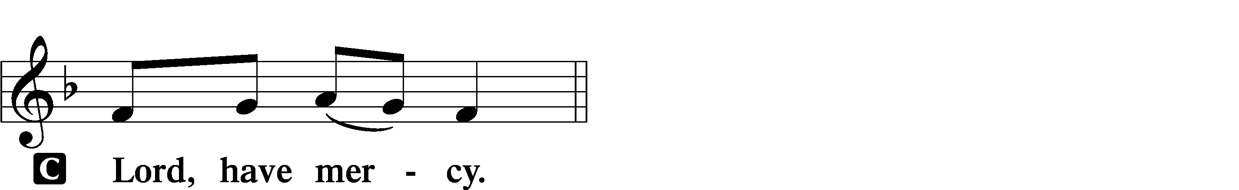

P For the peace from above and for our salvation let us pray to the Lord.
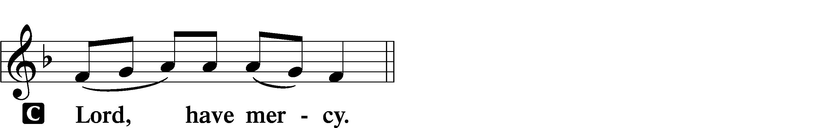

P For the peace of the whole world, for the well-being of the Church of God, and for the unity of all let us pray to the Lord.
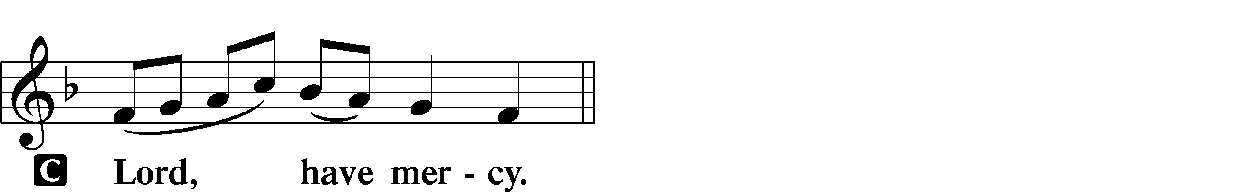

P For this holy house and for all who offer here their worship and praise let us pray to the Lord.
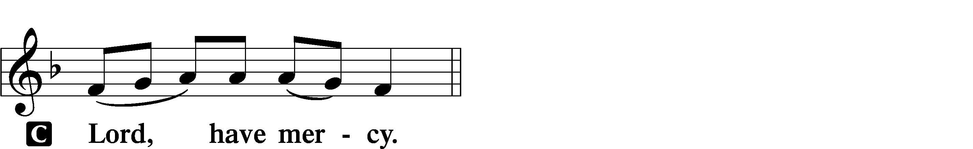

P Help, save, comfort, and defend us, gracious Lord.

Salutation and Collect of the Day: Advent 3
P The Lord be with you.
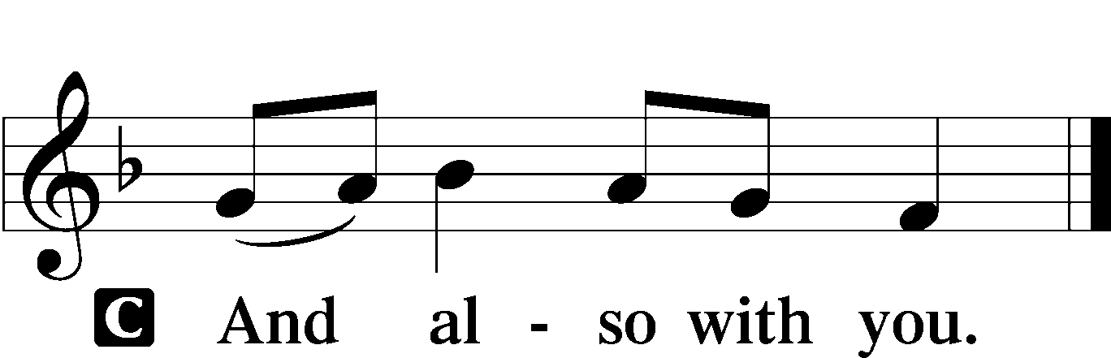

P Let us pray.
Lord Jesus Christ, we implore You to hear our prayers and to lighten the darkness of our hearts by Your gracious visitation; for You live and reign with the Father and the Holy Spirit, one God, now and forever.
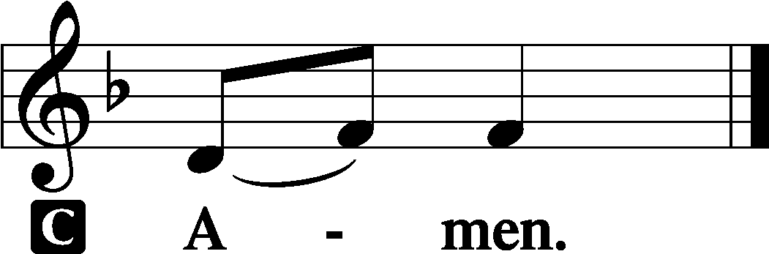
Sit

Prophecy: Isaiah 40:1–8 (NKJV)
Thus says the Lord God: “Comfort, yes, comfort My people!” says your God. “Speak comfort to Jerusalem, and cry out to her, that her warfare is ended, that her iniquity is pardoned; for she has received from the Lord’s hand double for all her sins.” The voice of one crying in the wilderness: “Prepare the way of the Lord; make straight in the desert a highway for our God. Every valley shall be exalted and every mountain and hill brought low; the crooked places shall be made straight and the rough places smooth; the glory of the Lord shall be revealed, and all flesh shall see it together; for the mouth of the Lord has spoken.” The voice said, “Cry out!” And he said, “What shall I cry?” “All flesh is grass, and all its loveliness is like the flower of the field. The grass withers, the flower fades, because the breath of the Lord blows upon it; surely the people are grass. The grass withers, the flower fades, but the word of our God stands forever.”

P This is the Word of the Lord.
C Thanks be to God.

Psalm: Psalm 85; antiphon: v. 9
Lord, you were favorable to your land;
you restored the fortunes of Jacob.
You forgave the iniquity of your people;
you covered all their sin.
You withdrew all your wrath;
you turned from your hot anger.
Restore us again, O God of our salvation,
and put away your indignation toward us!
Will you be angry with us forever?
Will you prolong your anger to all generations?
Will you not revive us again,
that your people may rejoice in you?
Show us your steadfast love, O Lord,
and grant us your salvation.
Let me hear what God the Lord will speak,
for he will speak peace to his people, to his saints;
but let them not turn back to folly.
Surely his salvation is near to those who fear him,
that glory may dwell in our land.
Steadfast love and faithfulness meet;
righteousness and peace kiss each other.
Faithfulness springs up from the ground,
and righteousness looks down from the sky.
Yes, the Lord will give what is good,
and our land will yield its increase.
Righteousness will go before him
and make his footsteps a way.

Epistle: 1 Corinthians 4:1–5 (NKJV)
Brethren: Let a man so consider us, as servants of Christ and stewards of the mysteries of God. Moreover it is required in stewards that one be found faithful. But with me it is a very small thing that I should be judged by you or by a human court. In fact, I do not even judge myself. For I know of nothing against myself, yet I am not justified by this; but He who judges me is the Lord. Therefore judge nothing before the time, until the Lord comes, who will both bring to light the hidden things of darkness and reveal the counsels of the hearts. Then each one’s praise will come from God.

P This is the Word of the Lord.
C Thanks be to God.

Stand

Alleluia and Verse LSB 156
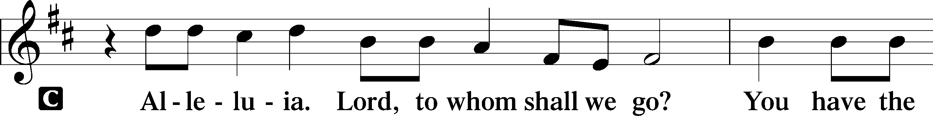
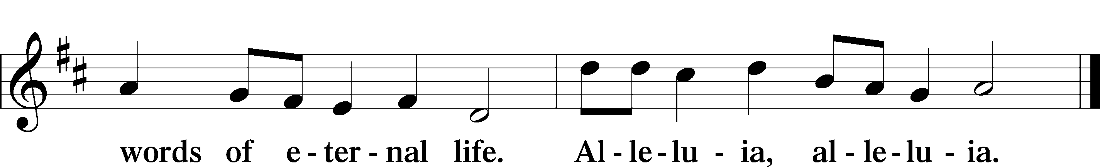

Holy Gospel: Matthew 11:2–10 (NKJV)
P The Holy Gospel according to St. Matthew, the eleventh chapter.
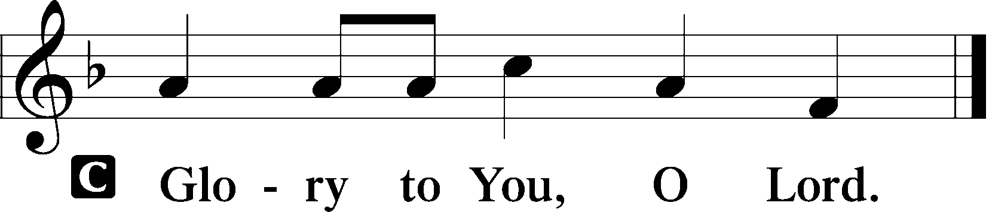

At that time: When John had heard in prison about the works of Christ, he sent two of his disciples and said to Him, “Are You the Coming One, or do we look for another?” Jesus answered and said to them, “Go and tell John the things which you hear and see: the blind see and the lame walk; the lepers are cleansed and the deaf hear; the dead are raised up and the poor have the gospel preached to them. And blessed is he who is not offended because of Me.” As they departed, Jesus began to say to the multitudes concerning John: “What did you go out into the wilderness to see? A reed shaken by the wind? But what did you go out to see? A man clothed in soft garments? Indeed, those who wear soft clothing are in kings’ houses. But what did you go out to see? A prophet? Yes, I say to you, and more than a prophet. For this is he of whom it is written: ‘Behold, I send My messenger before Your face, who will prepare Your way before You.’ ”

P This is the Gospel of the Lord.
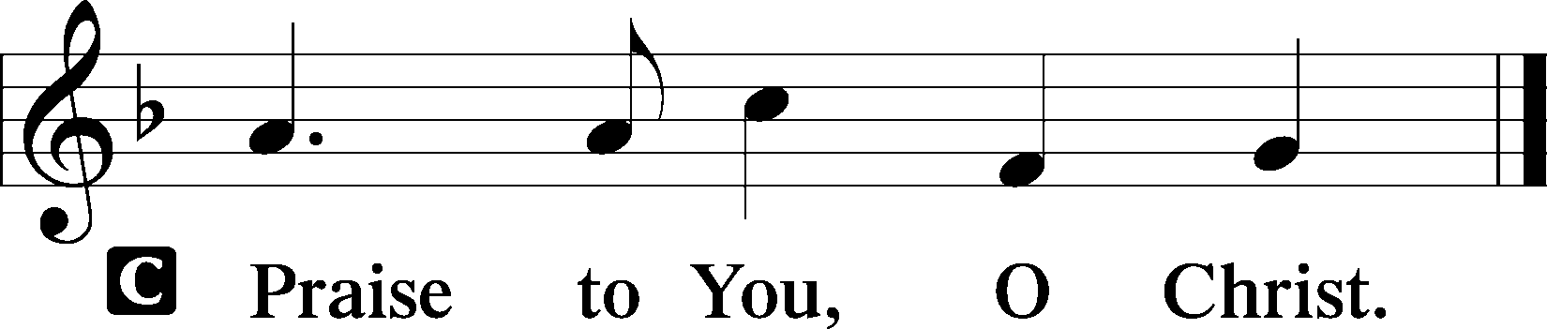

Nicene Creed
C I believe in one God,
the Father Almighty,
maker of heaven and earth
and of all things visible and invisible.

And in one Lord Jesus Christ,
the only-begotten Son of God,
begotten of His Father before all worlds,
God of God, Light of Light,
very God of very God,
begotten, not made,
being of one substance with the Father,
by whom all things were made;
who for us men and for our salvation came down from heaven
and was incarnate by the Holy Spirit of the virgin Mary
and was made man;
and was crucified also for us under Pontius Pilate.
He suffered and was buried.
And the third day He rose again according to the Scriptures
and ascended into heaven
and sits at the right hand of the Father.
And He will come again with glory to judge both the living and the dead,
whose kingdom will have no end.

And I believe in the Holy Spirit,
the Lord and giver of life,
who proceeds from the Father and the Son,
who with the Father and the Son together is worshiped and glorified,
who spoke by the prophets.
And I believe in one holy Christian and apostolic Church,
I acknowledge one Baptism for the remission of sins,
and I look for the resurrection of the dead
and the life T of the world to come. Amen.
Sit

Hymn of the Day: LSB #354 “Arise, O Christian People”

Sermon

Stand

Prayer of the Church

Offertory LSB 159
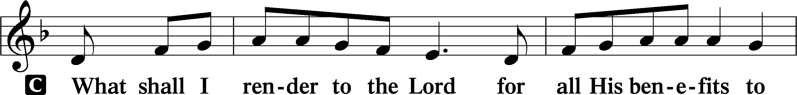
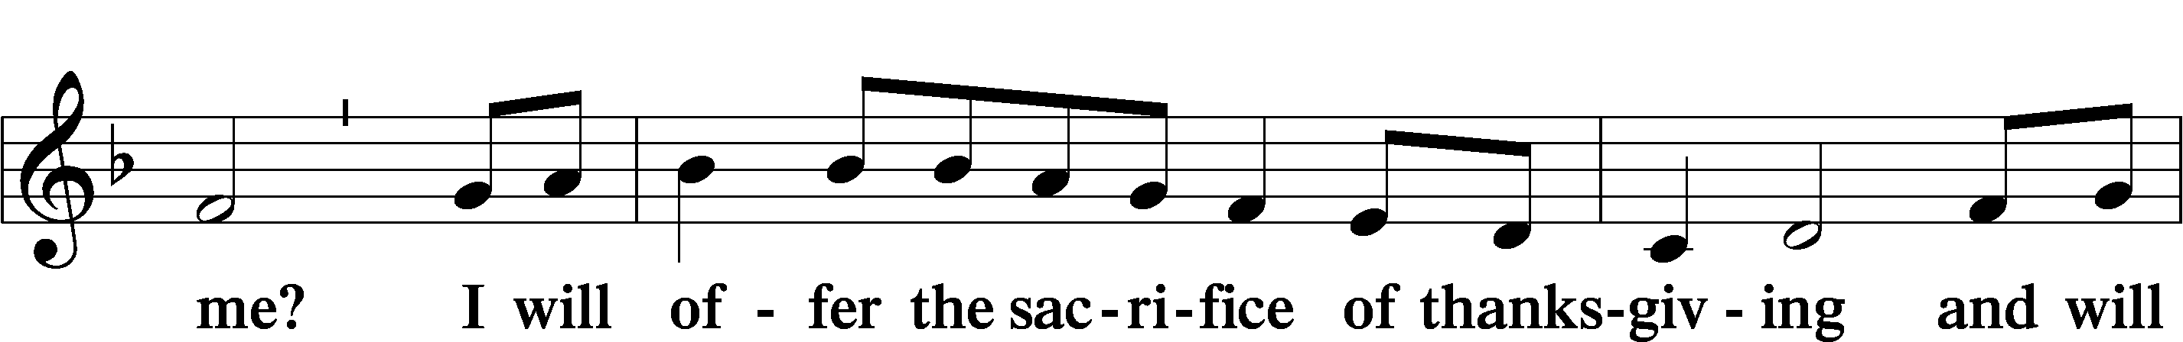
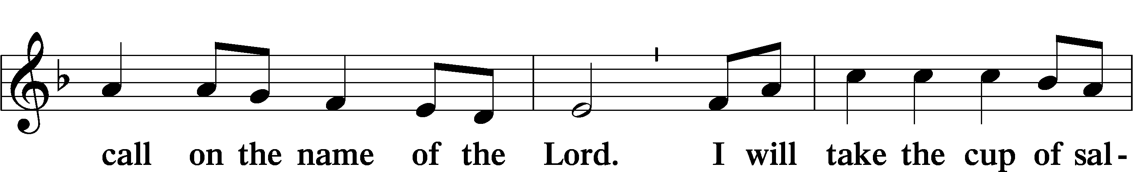
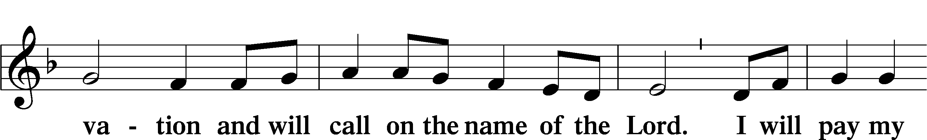
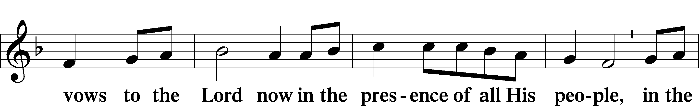
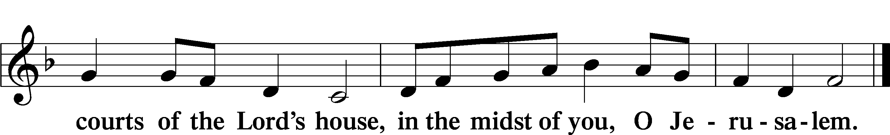

Preparatory Hymn: LSB #617 “O Lord, We Praise Thee”

Service of the Sacrament

Preface LSB 160
P The Lord be with you.
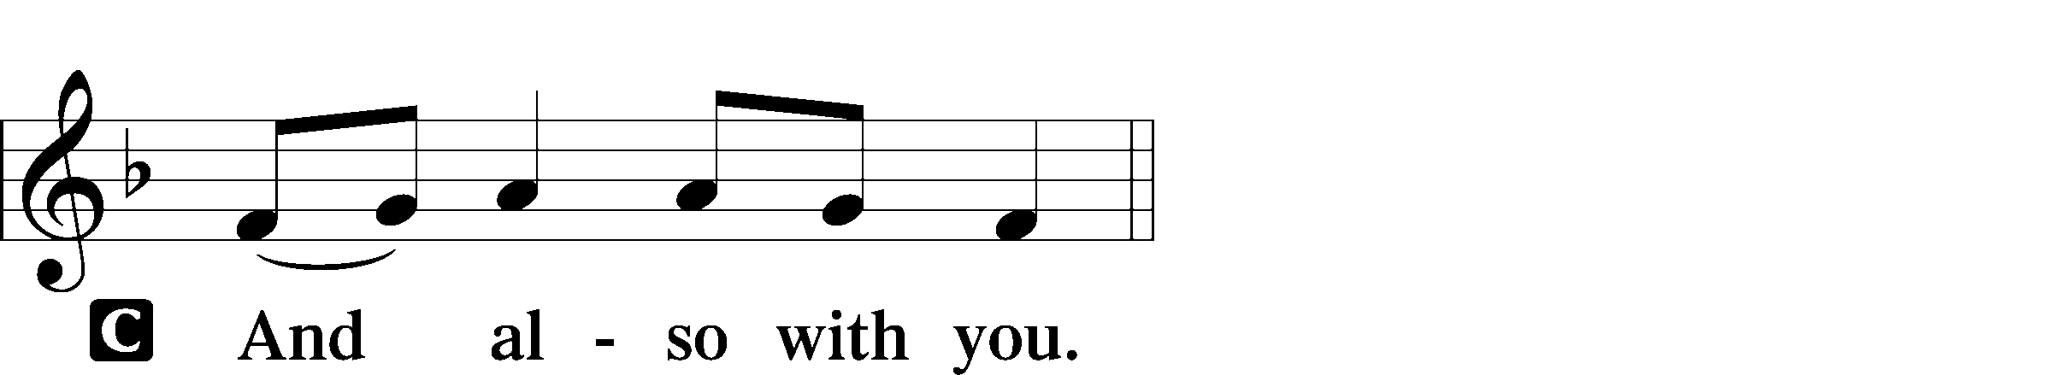

P Lift up your hearts.

P Let us give thanks to the Lord our God.
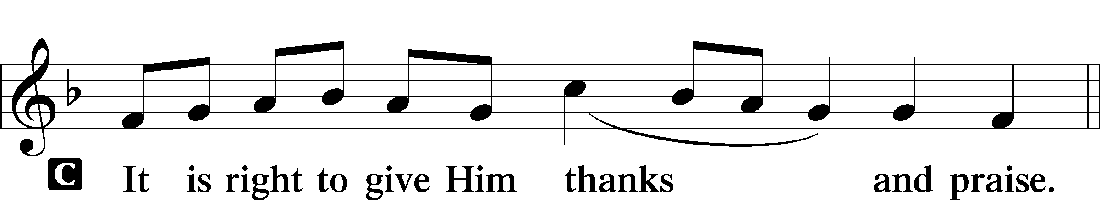

Proper Preface (Abbreviated) LSB 161
P It is truly good, right, and salutary . . . evermore praising You and saying:

Sanctus LSB 161
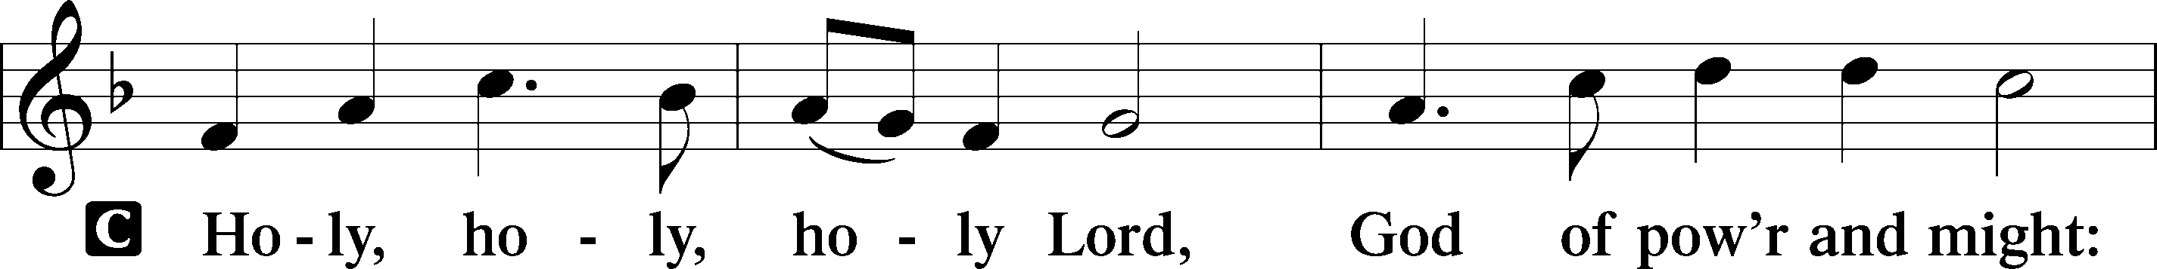
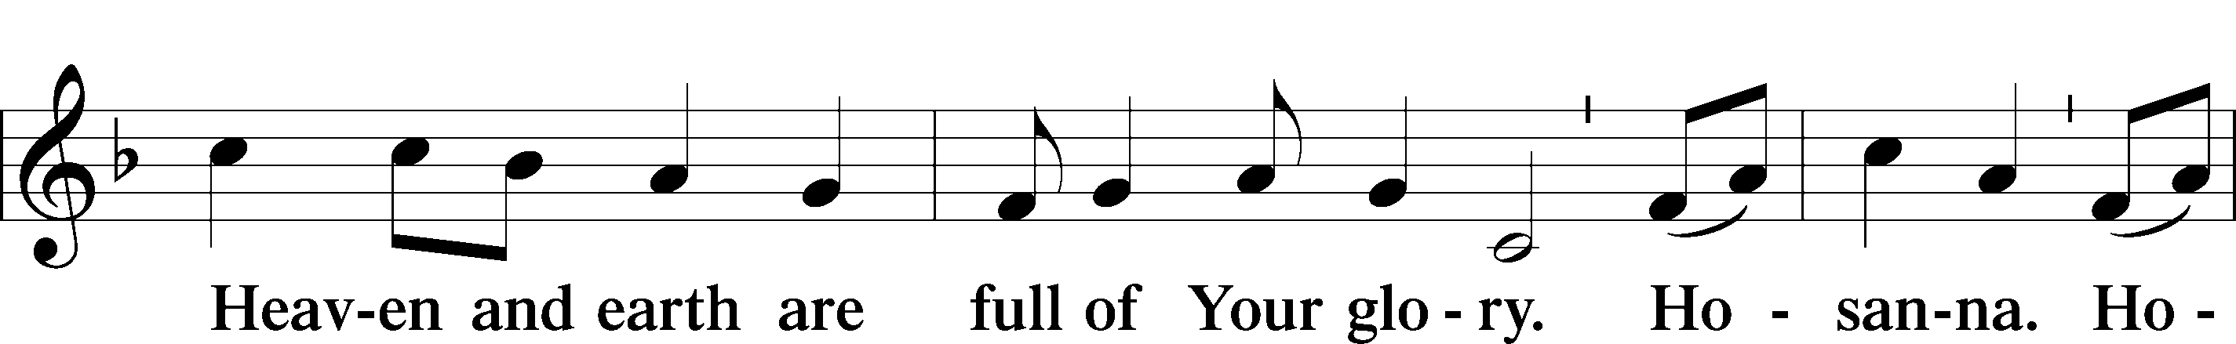
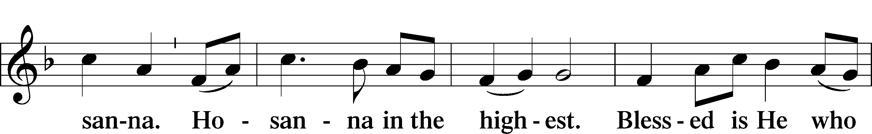
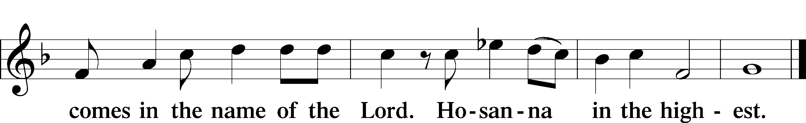

Prayer of Thanksgiving LSB 161
P Blessed are You, Lord of heaven and earth, for You have had mercy on those whom You created and sent Your only-begotten Son into our flesh to bear our sin and be our Savior. With repentant joy we receive the salvation accomplished for us by the all-availing sacrifice of His body and His blood on the cross.

Gathered in the name and the remembrance of Jesus, we beg You, O Lord, to forgive, renew, and strengthen us with Your Word and Spirit. Grant us faithfully to eat His body and drink His blood as He bids us do in His own testament. Gather us together, we pray, from the ends of the earth to celebrate with all the faithful the marriage feast of the Lamb in His kingdom, which has no end. Graciously receive our prayers; deliver and preserve us. To You alone, O Father, be all glory, honor, and worship, with the Son and the Holy Spirit, one God, now and forever.
C Amen.

Lord’s Prayer
C Our Father who art in heaven,
hallowed be Thy name,
Thy kingdom come,
Thy will be done on earth
as it is in heaven;
give us this day our daily bread;
and forgive us our trespasses
as we forgive those
who trespass against us;
and lead us not into temptation,
but deliver us from evil.
For Thine is the kingdom
and the power and the glory
forever and ever. Amen.

The Words of Our Lord Matthew 26:26-28; Mark 14:22-24; Luke 22:19-20; 1 Corinthians 11:23-25
P Our Lord Jesus Christ, on the night when He was betrayed, took bread, and when He had given thanks, He broke it and gave it to the disciples and said: “Take, eat; this is My T body, which is given for you. This do in remembrance of Me.”

In the same way also He took the cup after supper, and when He had given thanks, He gave it to them, saying: “Drink of it, all of you; this cup is the new testament in My T blood, which is shed for you for the forgiveness of sins. This do, as often as you drink it, in remembrance of Me.”

Pax Domini LSB 163
P The peace of the Lord be with you always.

Agnus Dei LSB 163
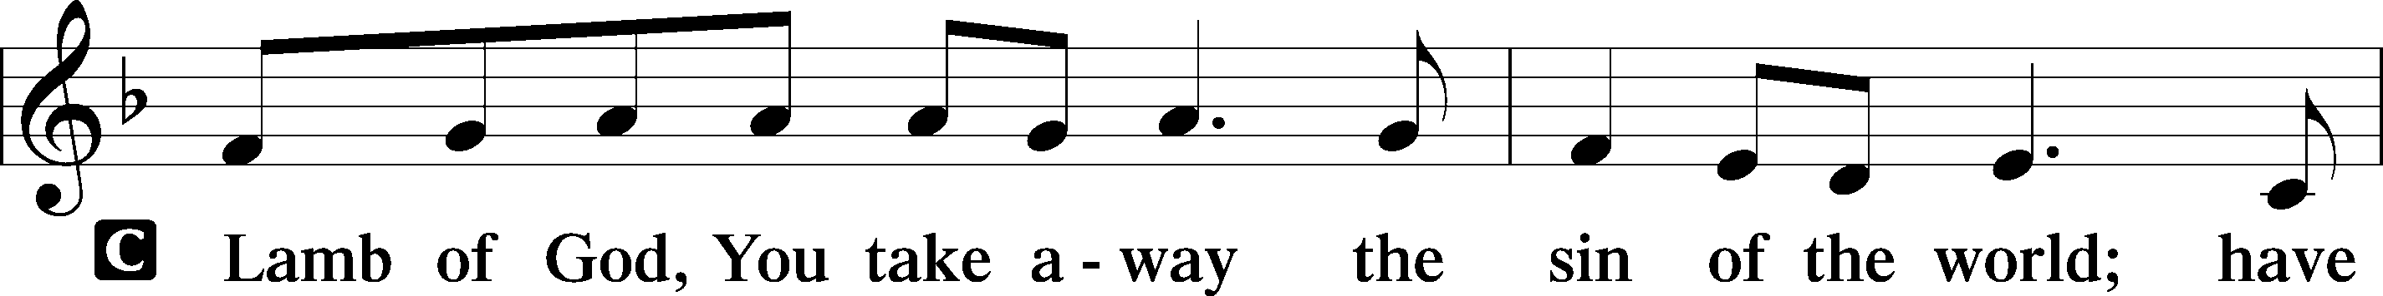
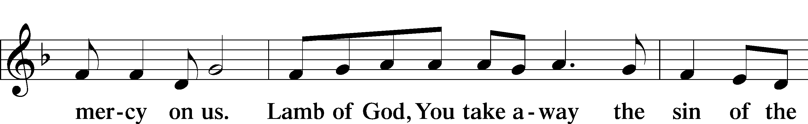
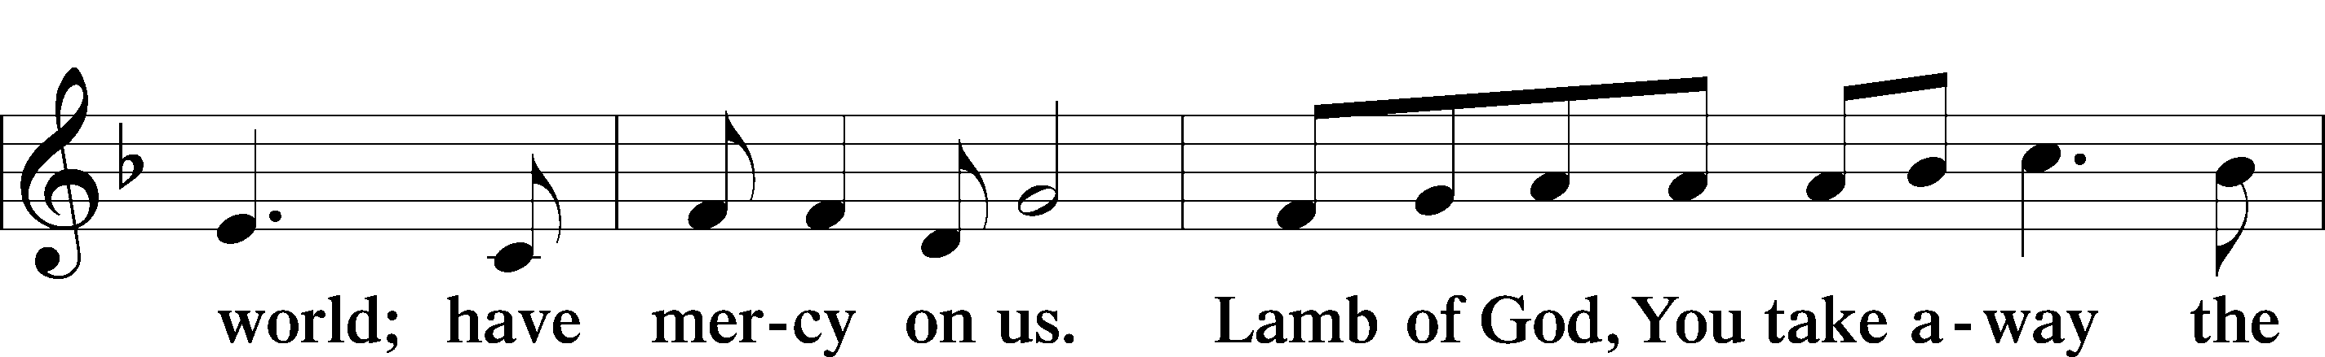
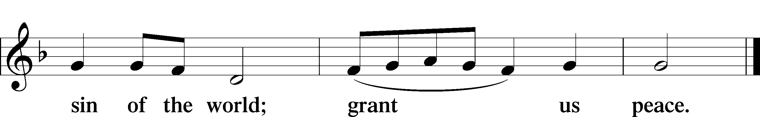
Sit

Distribution
The pastor and those who assist him receive the body and blood of Christ first and then distribute them to those who come to receive, saying:
Take, eat; this is the true body of our Lord and Savior Jesus Christ, given into death for your sins.
Amen.

Take, drink; this is the true blood of our Lord and Savior Jesus Christ, shed for the forgiveness of your sins.
Amen.

In dismissing the communicants, the following is said:
The Dismissal
P The body and blood of our Lord Jesus Christ strengthen and preserve you in body and soul to life everlasting. Depart T in peace.
C Amen.

Distribution Hymn: LSB #636 “Soul, Adorn Yourself with Gladness”

Distribution Hymn: LSB #737 “Rejoice, My Heart, Be Glad and Sing”

Distribution Hymn: LSB #338 “Come, Thou Long-Expected Jesus”

Stand
Nunc Dimittis LSB 165
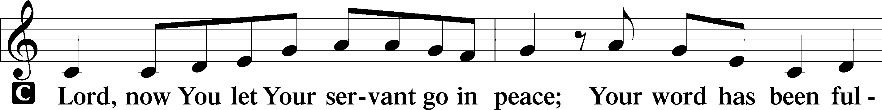
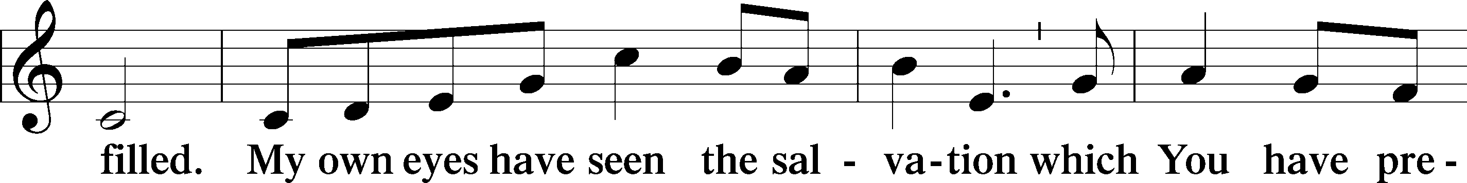
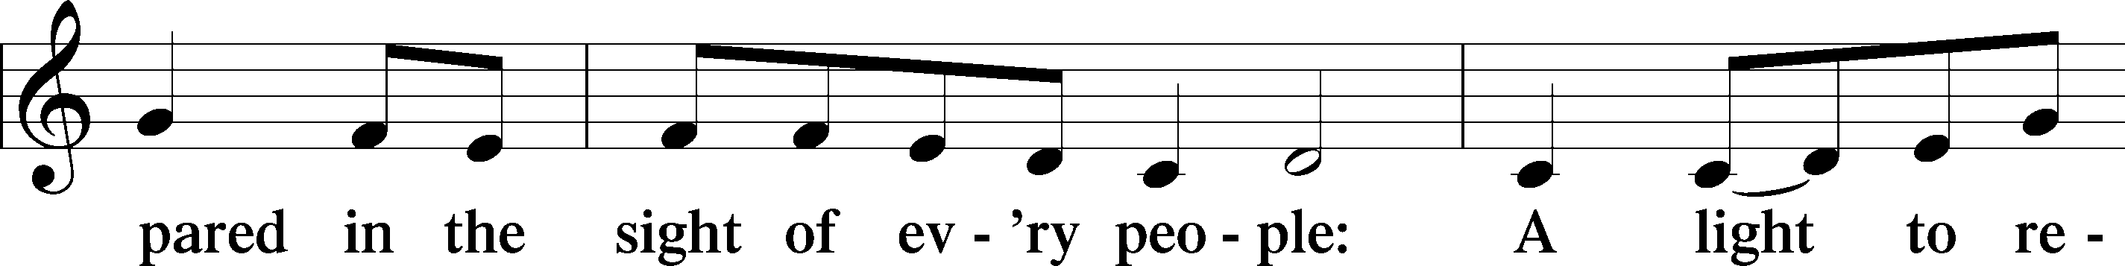
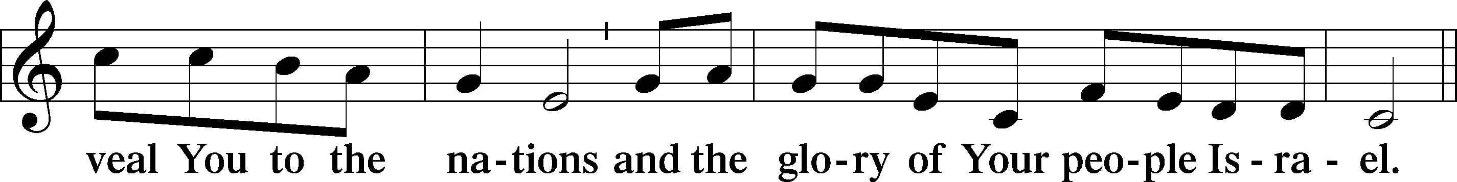
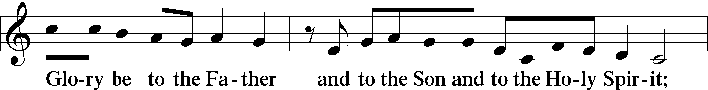
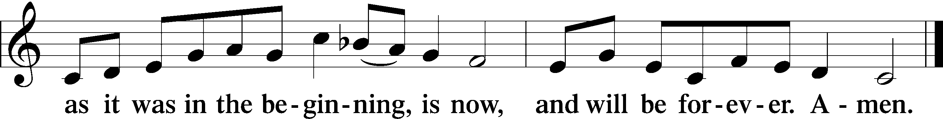

Post-Communion Collect
P Let us pray.
We give thanks to You, almighty God, that You have refreshed us through this salutary gift, and we implore You that of Your mercy You would strengthen us through the same in faith toward You and in fervent love toward one another; through Jesus Christ, Your Son, our Lord, who lives and reigns with You and the Holy Spirit, one God, now and forever.

Benediction LSB 166
P The Lord bless you and keep you.
The Lord make His face shine on you and be gracious to you.
The Lord look upon you with favor and T give you peace.

Closing Hymn: LSB #344 “On Jordan’s Bank the Baptist’s Cry”

Silent prayer after worship: Almighty God, be with me and be near me always. Bless me with the Holy Spirit, who works through Your Word, so that the true spirit of Christmas may fill me and show itself in my life. In Jesus’ name. Amen.
fffffffffffffffffffffffffffffffffff
Acknowledgments
Unless otherwise indicated, Scripture quotations are from the ESV® Bible (The Holy Bible, English Standard Version®), copyright © 2001 by Crossway, a publishing ministry of Good News Publishers. Used by permission. All rights reserved.
Created by Lutheran Service Builder © 2021 Concordia Publishing House.
fffffffffffffffffffffffffffffffffff

