Sts. Peter & Paul
Evangelical Lutheran Church
Lutheran Church-Missouri Synod
Founded-1917

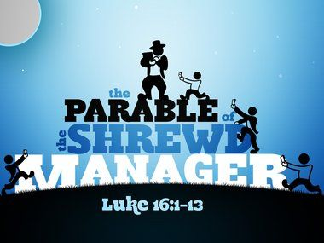

August 6, 2023

699 Stambaugh Ave.
Sharon, Pennsylvania 16146

“I was glad when they said to me,
Let us go to the house of the LORD!”
Psalm 122:1
Sts. Peter & Paul Evangelical Lutheran Church, LC-MS
THE NINTH SUNDAY AFTER TRINITY
August 6, 2023
A special welcome to our guests this day! If you would like more information about The Lutheran Church - Missouri Synod, or this congregation, please speak with Pastor Deal or an Elder after the service.
Members & Guests: Don’t be embarrassed if your children make noise during the worship service, all children do. We encourage families to worship together but, if you feel the need, there are pews in the rear of the Church which are reserved for young families on both sides of the sanctuary. There is also a quiet room available to you, located next to the sanctuary (formerly the Pastor’s office), where you would be able to follow along with the service.

Today’s service includes the Sacrament of Holy Communion. If during this past year, you have not worshipped with us and been communed, we respectfully ask that you do not partake of this sacrament this day before first speaking with Pastor Deal.
If visiting from a sister congregation of the LC-MS and are in good standing, please inform Pastor Deal of your desire to commune prior to the service.
If wishing to receive a blessing during communion, please approach with your arms crossed.

CONTACT INFORMATION
Pastor Deal: pastordeal@saintspeterandpaul.net or 724-347-3620 (opt. 2)
Church Office: church@saintspeterandpaul.net or 724-347-3620 (opt. 3)
Secretary’s Office will be open Monday (8:30-4:30) and Thursday (as needed) this week.

Silent prayer before worship: Heavenly Father, focus my mind on Your Word so that the Holy Spirit may grant me a sure faith and certain hope that is glad to do Your will and walk in Your ways. In Jesus’ name. Amen.

Confession and Absolution

Opening Hymn: LSB #504 “Father Most Holy”

Stand

The sign of the cross may be made by all in remembrance of their Baptism.

Invocation
P In the name of the Father and of the T Son and of the Holy Spirit.
C Amen.

Exhortation Hebrews 10:22; Psalm 124:8; Psalm 32:5
P Beloved in the Lord! Let us draw near with a true heart and confess our sins unto God our Father, beseeching Him in the name of our Lord Jesus Christ to grant us forgiveness.

P Our help is in the name of the Lord,
C who made heaven and earth.
P I said, I will confess my transgressions unto the Lord,
C and You forgave the iniquity of my sin.

Silence for reflection on God’s Word and for self-examination.

Confession of Sins
P O almighty God, merciful Father,
C I, a poor, miserable sinner, confess unto You all my sins and iniquities with which I have ever offended You and justly deserved Your temporal and eternal punishment. But I am heartily sorry for them and sincerely repent of them, and I pray You of Your boundless mercy and for the sake of the holy, innocent, bitter sufferings and death of Your beloved Son, Jesus Christ, to be gracious and merciful to me, a poor, sinful being.

Absolution [John 20:19–23]
P Upon this your confession, I, by virtue of my office, as a called and ordained servant of the Word, announce the grace of God unto all of you, and in the stead and by the command of my Lord Jesus Christ I forgive you all your sins in the name of the Father and of the T Son and of the Holy Spirit.
C Amen.

Service of the Word

Introit Psalm 54:1–3, 7; antiphon: vv. 4–5
Behold, God is my | helper;*
the Lord is the upholder | of my life.
He will return the evil to my | enemies;*
in your faithfulness put an | end to them.
O God, save me, | by your name,*
and vindicate me | by your might.
O God, | hear my prayer;*
give ear to the words | of my mouth.
For strangers have risen against me; ruthless men | seek my life;*
they do not set God be- | fore themselves.
For he has delivered me from every | trouble,*
and my eye has looked in triumph on my | enemies.
Behold, God is my | helper;*
the Lord is the upholder | of my life.
He will return the evil to my | enemies;*
in your faithfulness put an | end to them.

Gloria Patri
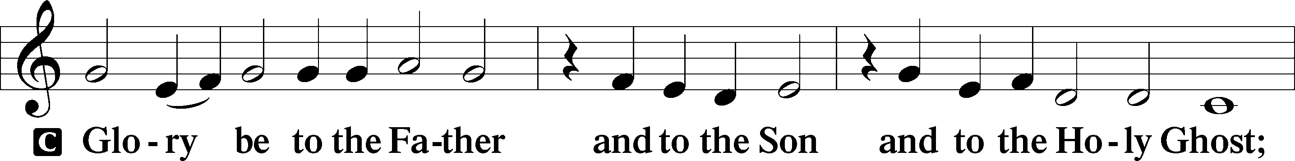
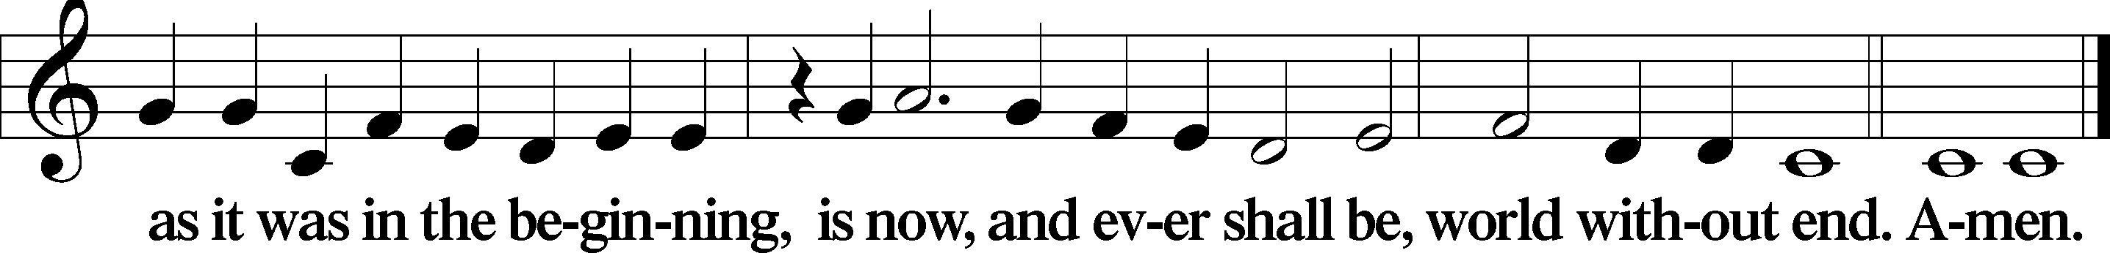

Kyrie Mark 10:47
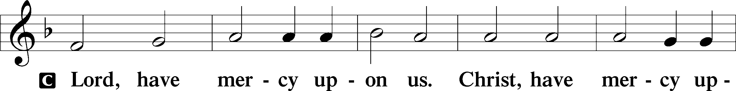
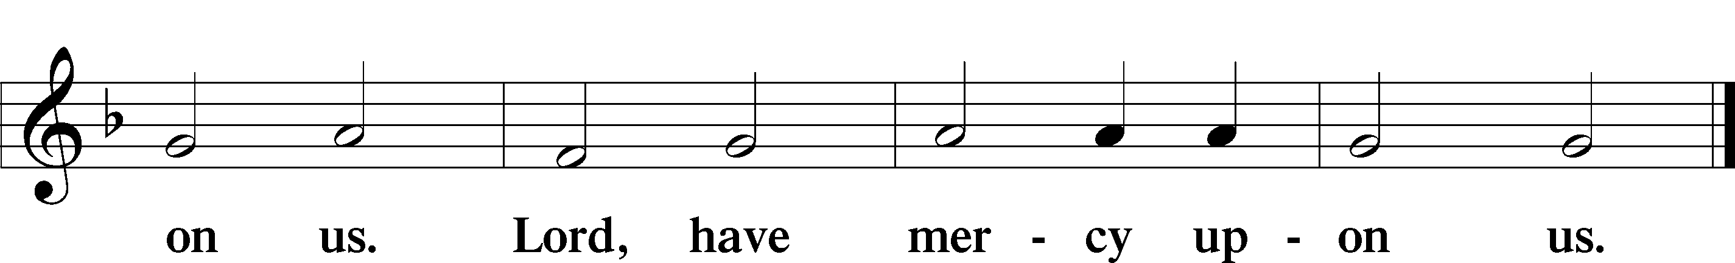

Gloria in Excelsis Luke 2:14; John 1:29
P Glory be to God on high:
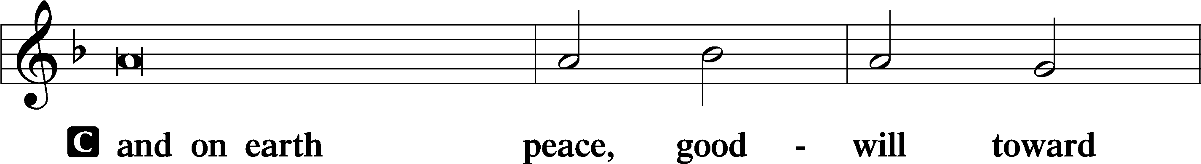
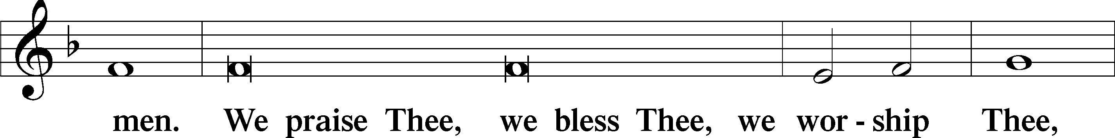
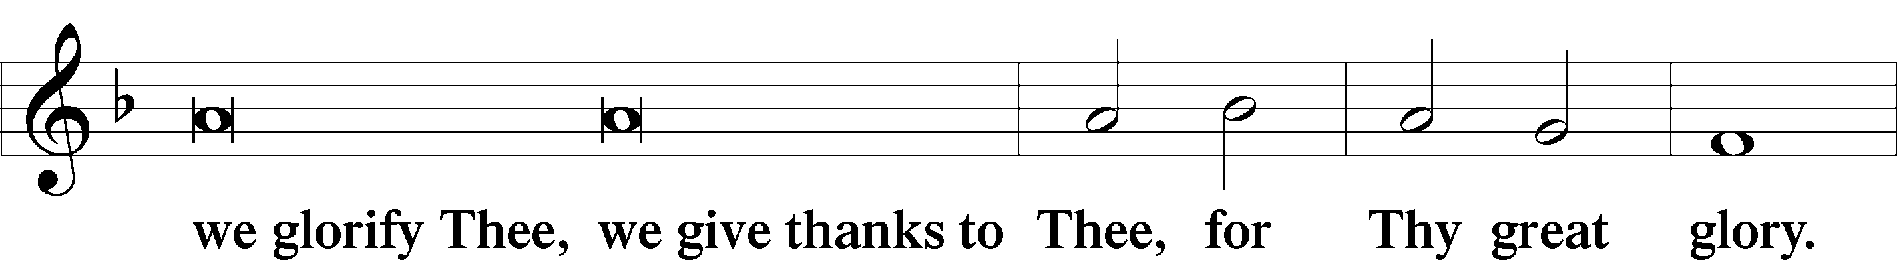
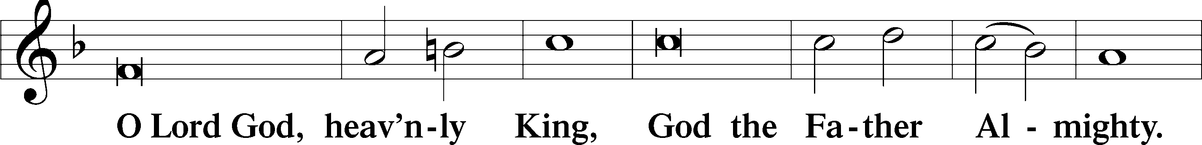
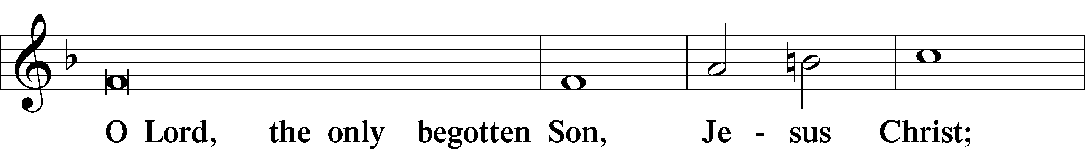
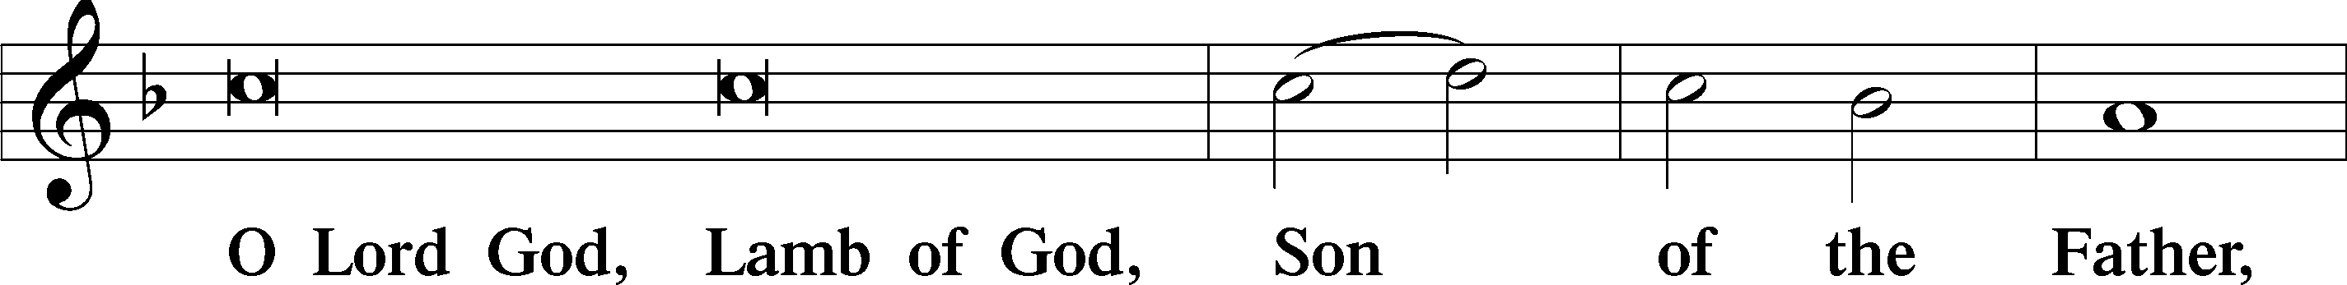
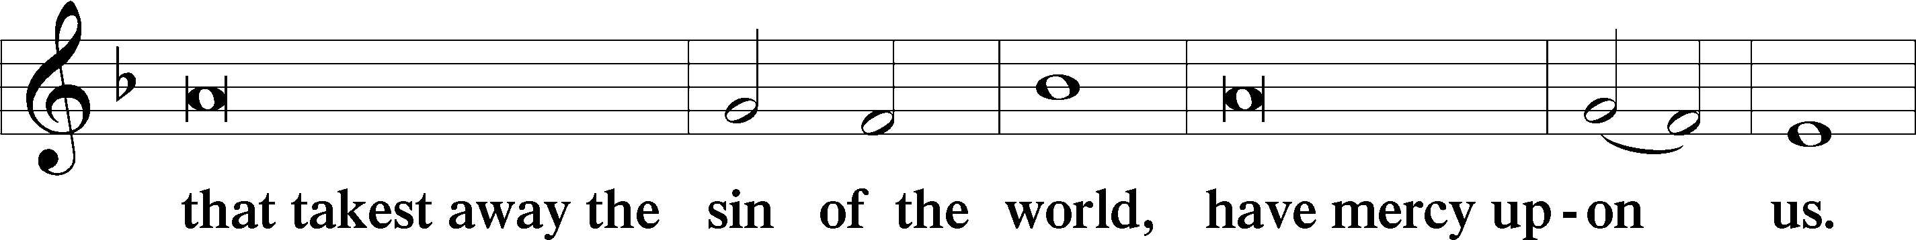
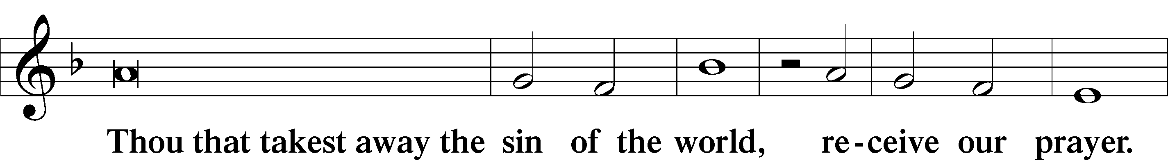
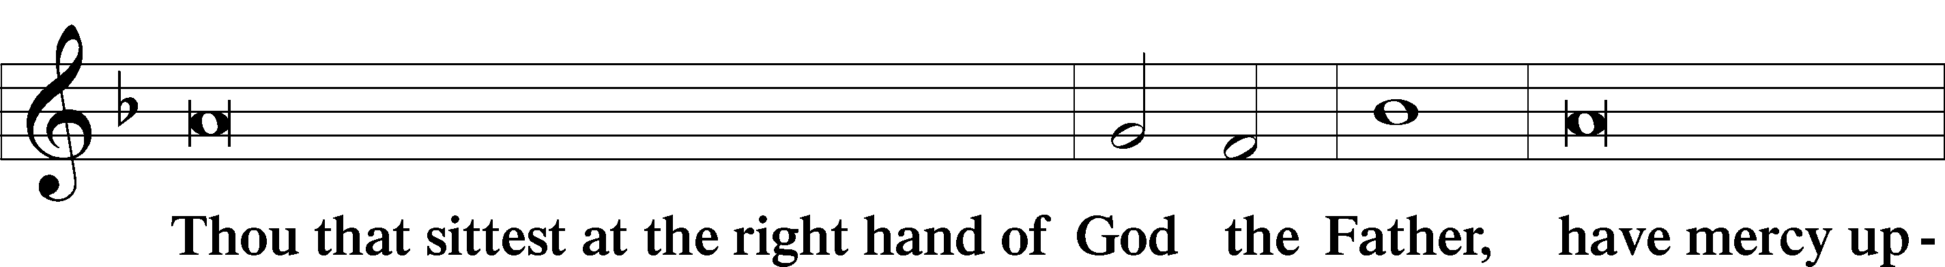
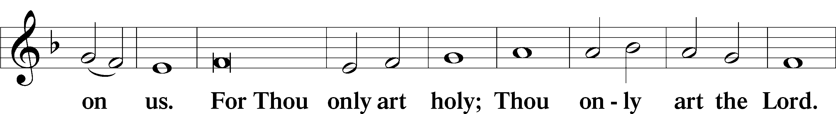
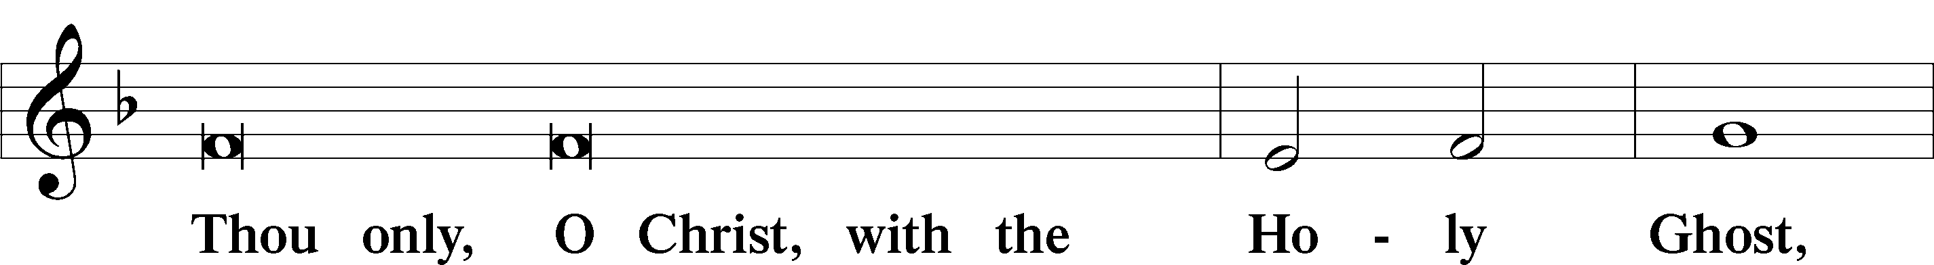
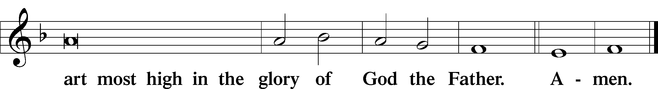

Salutation and Collect of the Day: Trinity 9
P The Lord be with you.
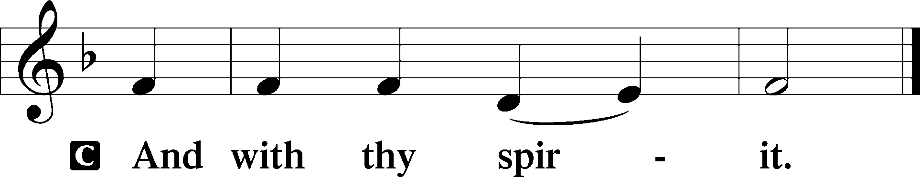

P Let us pray.
Let Your merciful ears, O Lord, be open to the prayers of Your humble servants; and that they may obtain their petitions, make them to ask such things as shall please You; through Jesus Christ, Your Son, our Lord, who lives and reigns with You and the Holy Spirit, one God, now and forever.
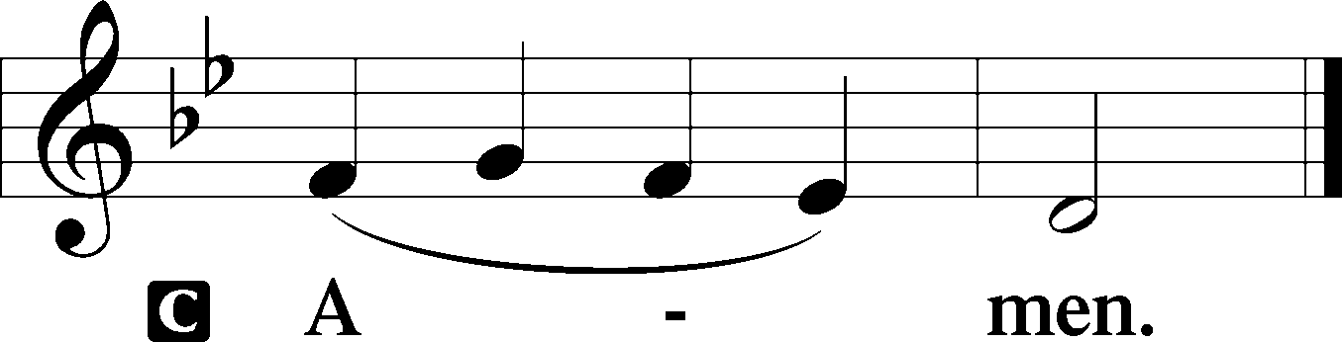
Sit

Prophecy: Proverbs 16:1-9 (NKJV)
The preparations of the heart belong to man, but the answer of the tongue is from the Lord. All the ways of a man are pure in his own eyes, but the Lord weighs the spirits. Commit your works to the Lord, and your thoughts will be established. The Lord has made all for Himself, yes, even the wicked for the day of doom. Everyone proud in heart is an abomination to the Lord; though they join forces, none will go unpunished. In mercy and truth atonement is provided for iniquity; and by the fear of the Lord one departs from evil. When a man’s ways please the Lord, He makes even his enemies to be at peace with him. Better is a little with righteousness, than vast revenues without justice. A man’s heart plans his way, but the Lord directs his steps.

P This is the Word of the Lord.
C Thanks be to God.

Gradual Psalm 8:1
O | Lord, our Lord,*
how majestic is your name in | all the earth!
You have set your | glory*
above the | heavens.

Epistle: 1 Corinthians 10:6b–13 (NKJV)
Brethren: We should not lust after evil things as our fathers lusted. And do not become idolaters as were some of them. As it is written, “The people sat down to eat and drink, and rose up to play.” Nor let us commit sexual immorality, as some of them did, and in one day twenty-three thousand fell; nor let us tempt Christ, as some of them also tempted, and were destroyed by serpents; nor complain, as some of them also complained, and were destroyed by the destroyer. Now all these things happened to them as examples, and they were written for our admonition, upon whom the ends of the ages have come. Therefore let him who thinks he stands take heed lest he fall. No temptation has overtaken you except such as is common to man; but God is faithful, who will not allow you to be tempted beyond what you are able, but with the temptation will also make the way of escape, that you may be able to bear it.

P This is the Word of the Lord.
C Thanks be to God.

Stand
Verse Psalm 112:1
Alleluia. Blessèd is the man who fears the Lord, who greatly delights in his commandments! Alleluia.

Alleluia
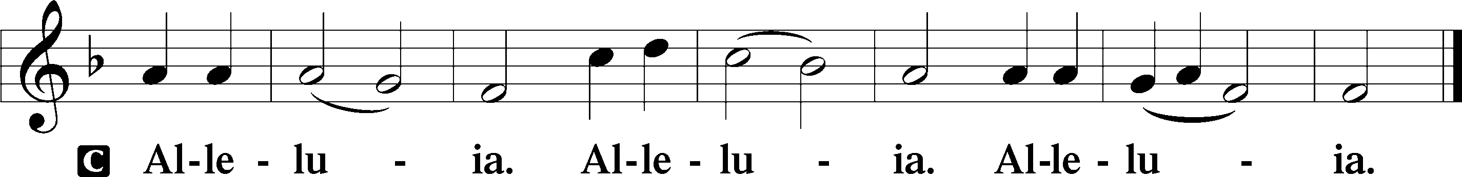

Holy Gospel: Luke 16:1–9 (NKJV)
P The Holy Gospel according to St. Luke, the sixteenth chapter.
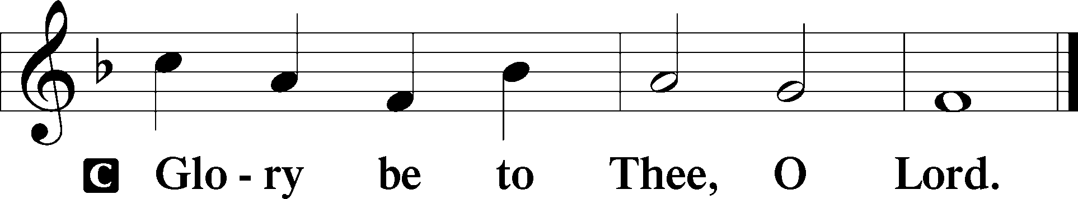

At that time Jesus spoke this parable to His disciples: “There was a certain rich man who had a steward, and an accusation was brought to him that this man was wasting his goods. So he called him and said to him, ‘What is this I hear about you? Give an account of your stewardship, for you can no longer be steward.’ Then the steward said within himself, ‘What shall I do? For my master is taking the stewardship away from me. I cannot dig; I am ashamed to beg. I have resolved what to do, that when I am put out of the stewardship, they may receive me into their houses.’ So he called every one of his master’s debtors to him, and said to the first, ‘How much do you owe my master?’ And he said, ‘A hundred measures of oil.’ So he said to him, ‘Take your bill, and sit down quickly and write fifty.’ Then he said to another, ‘And how much do you owe?’ So he said, ‘A hundred measures of wheat.’ And he said to him, ‘Take your bill, and write eighty.’ So the master commended the unjust steward because he had dealt shrewdly. For the sons of this world are more shrewd in their generation than the sons of light. And I say to you, make friends for yourselves by unrighteous mammon, that when you fail, they may receive you into an everlasting home.”

P This is the Gospel of the Lord.
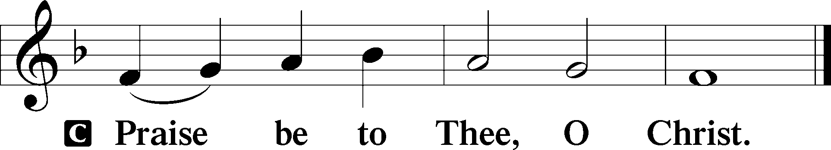

Nicene Creed
C I believe in one God,
the Father Almighty,
maker of heaven and earth
and of all things visible and invisible.

And in one Lord Jesus Christ,
the only-begotten Son of God,
begotten of His Father before all worlds,
God of God, Light of Light,
very God of very God,
begotten, not made,
being of one substance with the Father,
by whom all things were made;
who for us men and for our salvation came down from heaven
and was incarnate by the Holy Spirit of the virgin Mary
and was made man;
and was crucified also for us under Pontius Pilate.
He suffered and was buried.
And the third day He rose again according to the Scriptures
and ascended into heaven
and sits at the right hand of the Father.
And He will come again with glory to judge both the living and the dead,
whose kingdom will have no end.
And I believe in the Holy Spirit,
the Lord and giver of life,
who proceeds from the Father and the Son,
who with the Father and the Son together is worshiped and glorified,
who spoke by the prophets.
And I believe in one holy Christian and apostolic Church,
I acknowledge one Baptism for the remission of sins,
and I look for the resurrection of the dead
and the life T of the world to come. Amen.
Sit

Hymn of the Day: LSB #730 “What Is the World to Me”

Sermon

Stand

Offertory Psalm 51:10–12
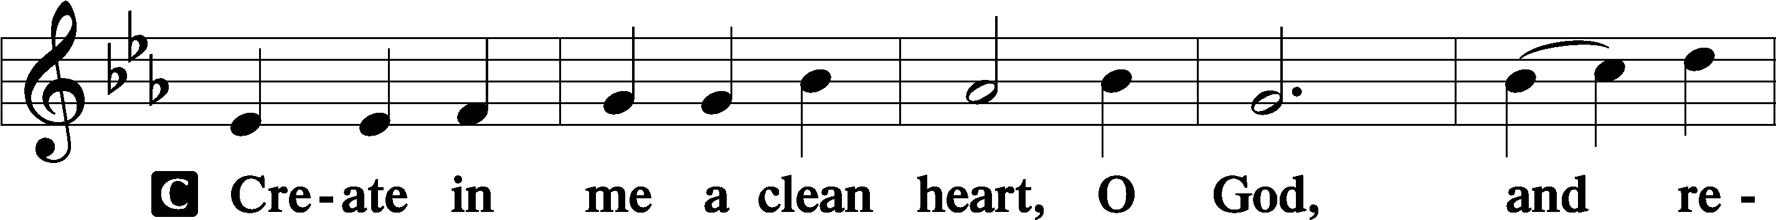
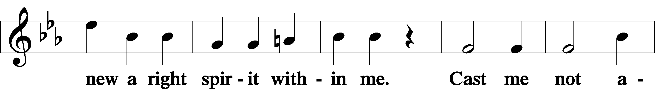
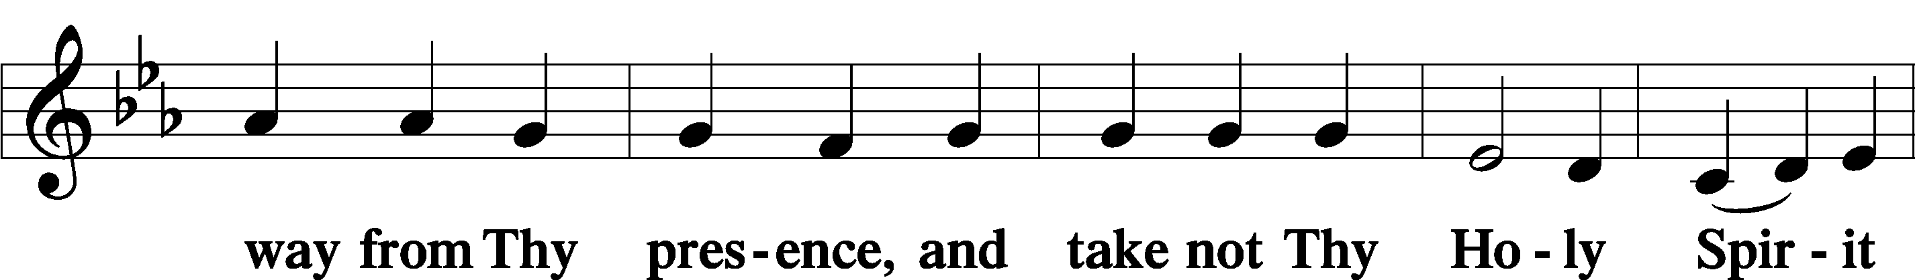
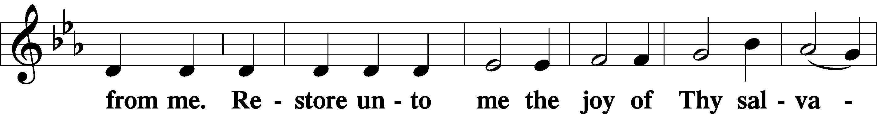
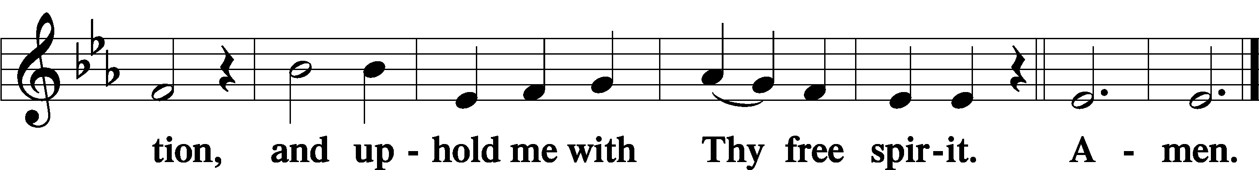
Sit

Prayer of the Church

Preparatory Hymn: LSB #536 “One Thing’s Needful”

Stand
Service of the Sacrament

Preface 2 Timothy 4:22; Colossians 3:1 Psalm 136
P The Lord be with you.
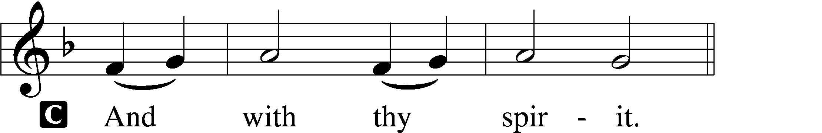

P Lift up your hearts.
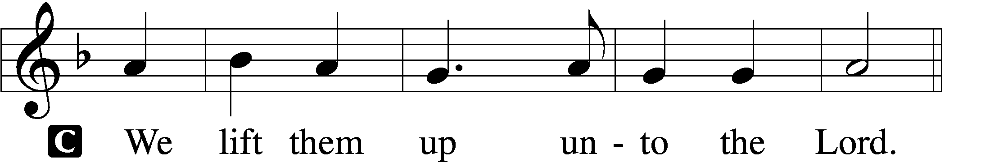

P Let us give thanks unto the Lord, our God.
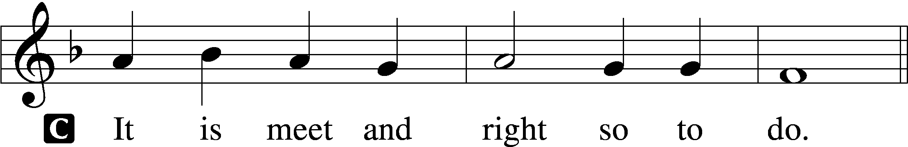

Proper Preface (Abbreviated) LSB 194
P It is truly meet, right, and salutary . . . evermore praising You and saying:

Sanctus Isaiah 6:3; Matthew 21:9
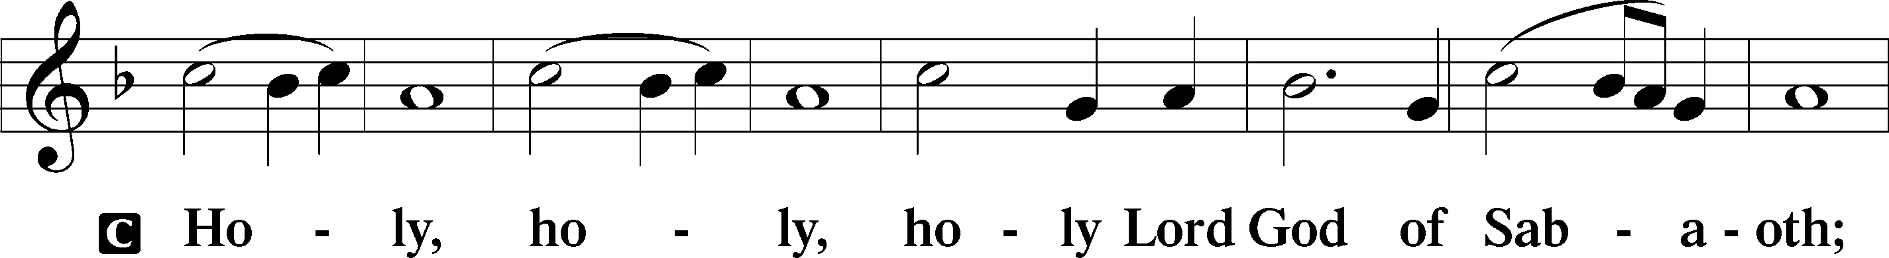
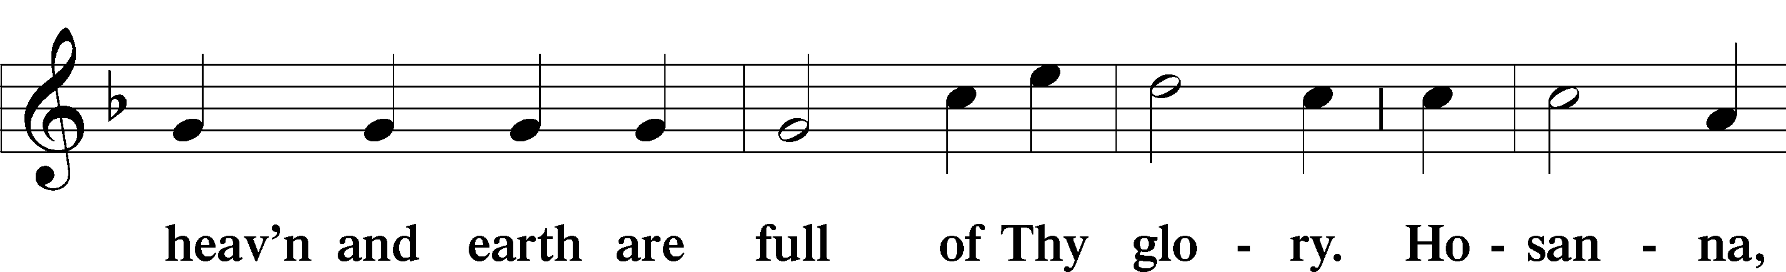
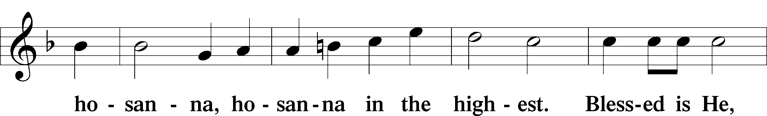
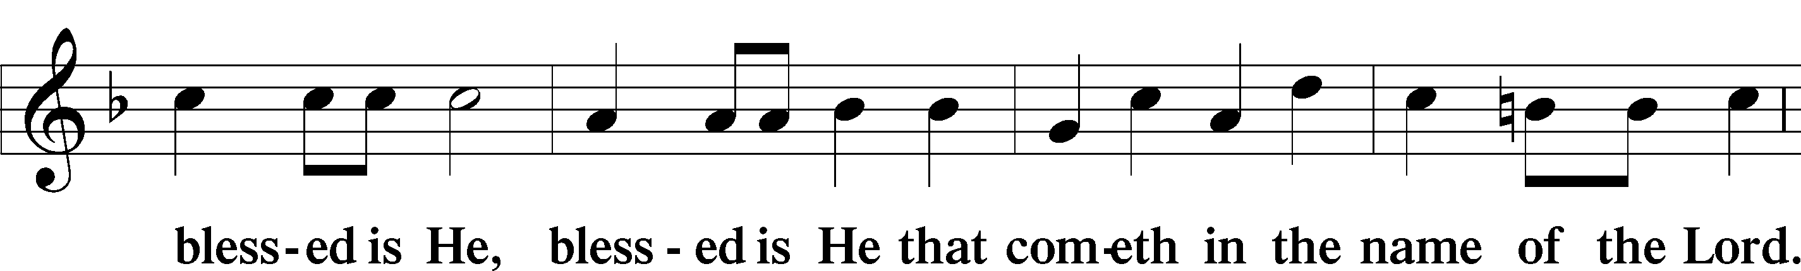
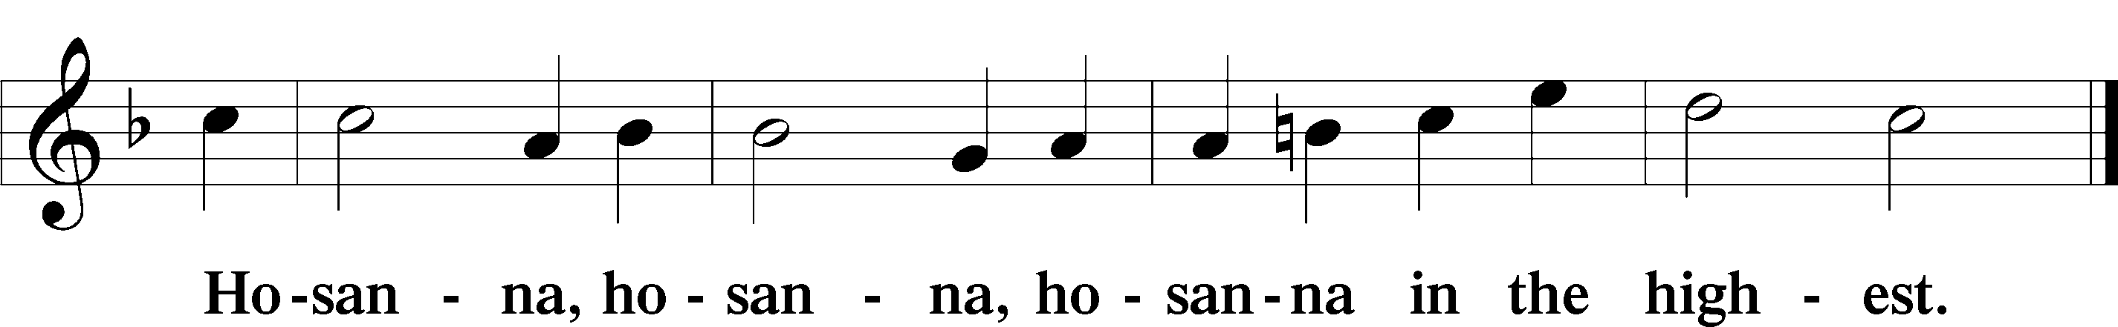

Lord’s Prayer Matthew 6:9–13
C Our Father who art in heaven,
hallowed be Thy name,
Thy kingdom come,
Thy will be done on earth as it is in heaven;
give us this day our daily bread;
and forgive us our trespasses as we forgive those who trespass against us;
and lead us not into temptation,
but deliver us from evil.
For Thine is the kingdom and the power and the glory forever and ever. Amen.

The Words of Our Lord Matthew 26:26–28; Mark 14:22–24; Luke 22:19–20; 1 Corinthians 11:23–25
P Our Lord Jesus Christ, on the night when He was betrayed, took bread, and when He had given thanks, He broke it and gave it to the disciples and said: “Take, eat; this is My T body, which is given for you. This do in remembrance of Me.”

In the same way also He took the cup after supper, and when He had given thanks, He gave it to them, saying: “Drink of it, all of you; this cup is the new testament in My T blood, which is shed for you for the forgiveness of sins. This do, as often as you drink it, in remembrance of Me.”
Pax Domini John 20:19
P The peace of the Lord be with you always.
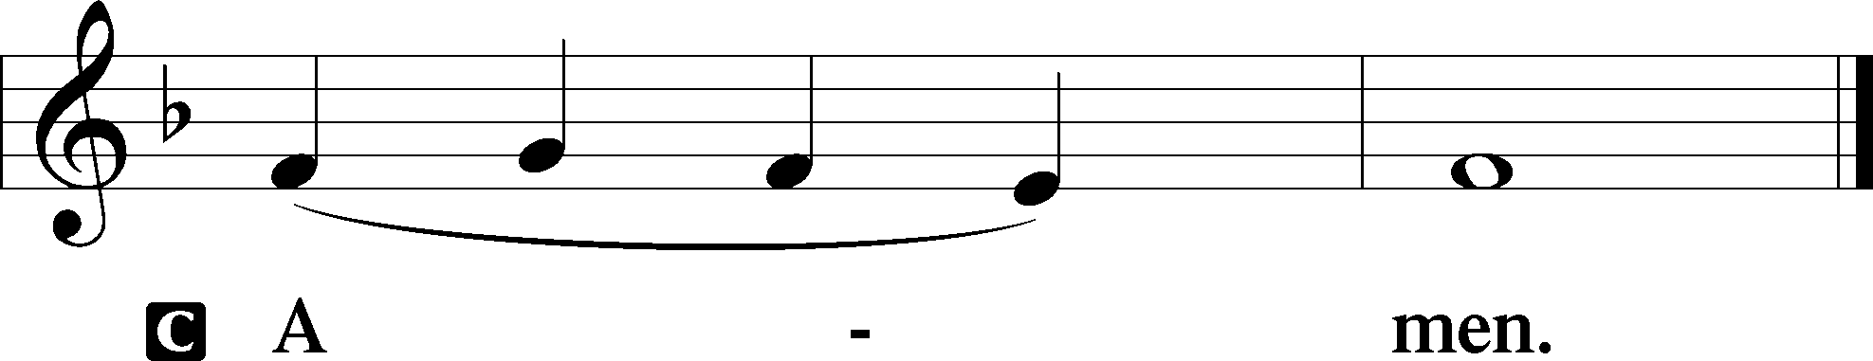

Agnus Dei John 1:29
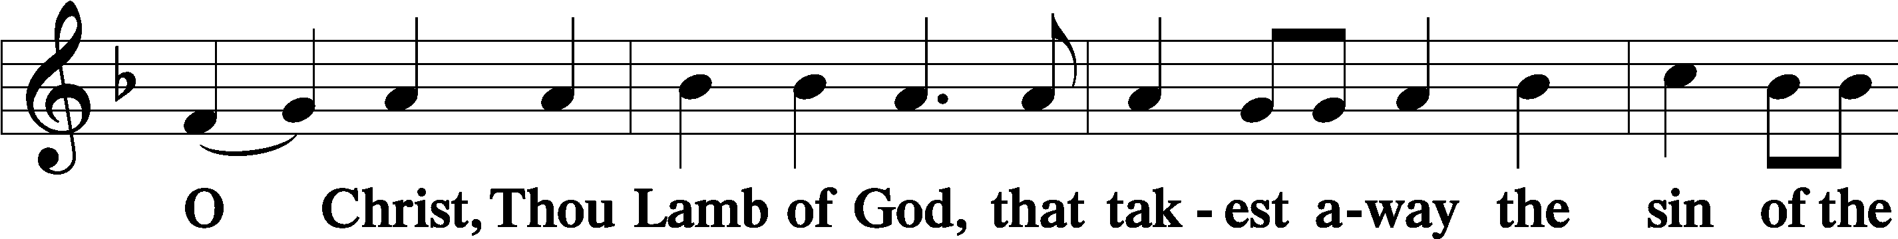
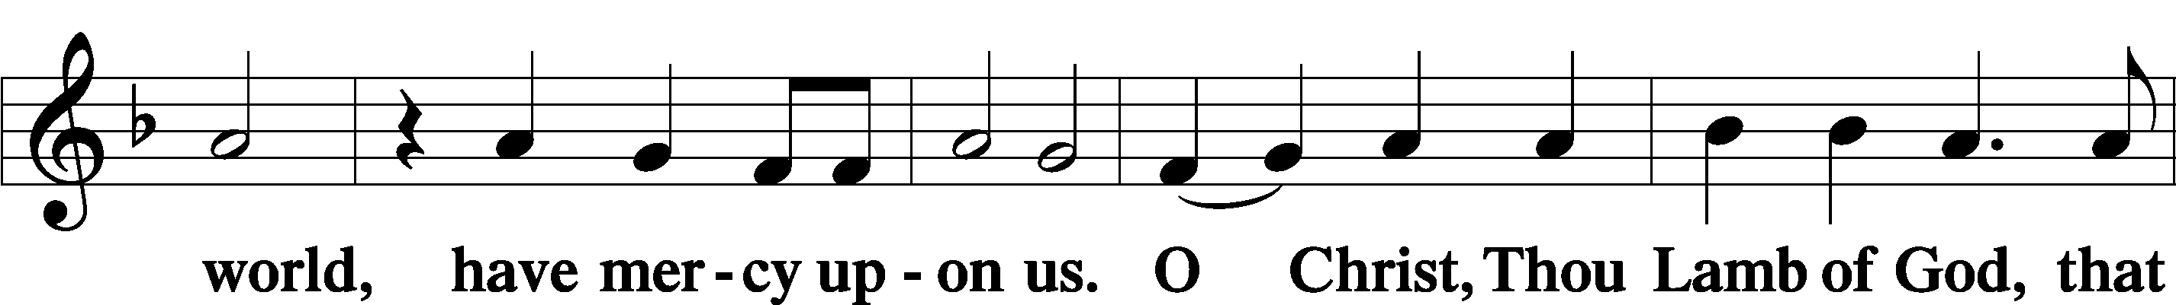
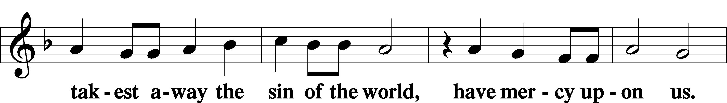
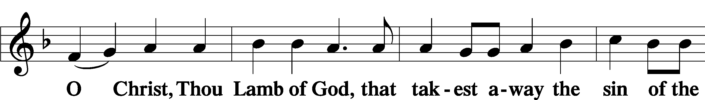
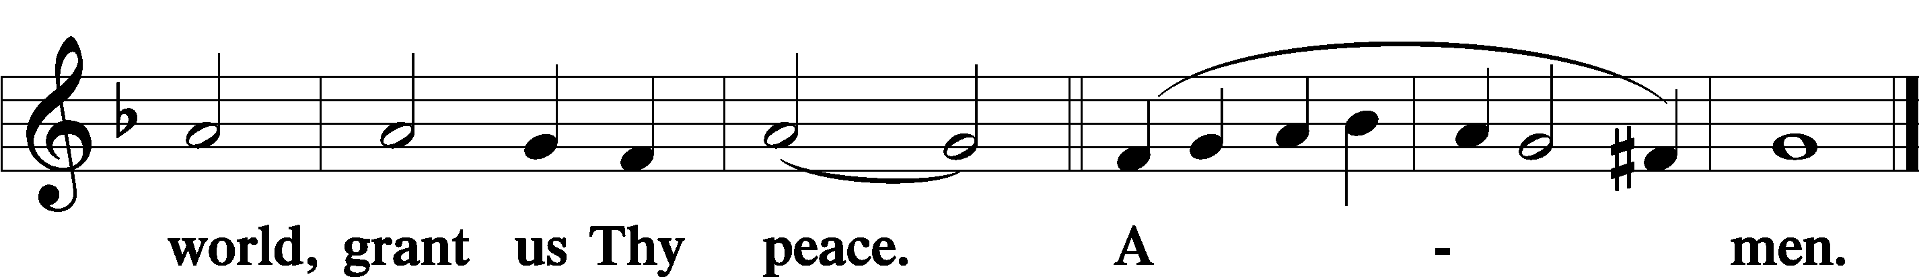
Sit

Distribution
The pastor and those who assist him receive the body and blood of Christ first and then distribute them to those who come to receive, saying:
Take, eat; this is the true body of our Lord and Savior Jesus Christ, given into death for your sins.
Amen.

Take, drink; this is the true blood of our Lord and Savior Jesus Christ, shed for the forgiveness of your sins.
Amen.

In dismissing the communicants, the following is said:
The Dismissal
P The body and blood of our Lord Jesus Christ strengthen and preserve you in body and soul to life everlasting. Depart T in peace.
C Amen.

Distribution Hymn: LSB #622 “Lord Jesus Christ, You Have Prepared”

Distribution Hymn: LSB #915 “Today Your Mercy Calls Us”

Distribution Hymn: LSB #497 “Come, Holy Ghost, God and Lord”

Stand

Nunc Dimittis Luke 2:29–32
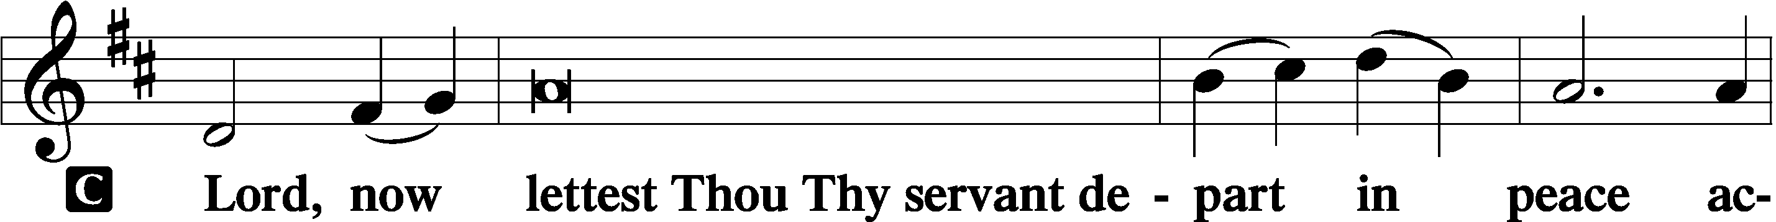
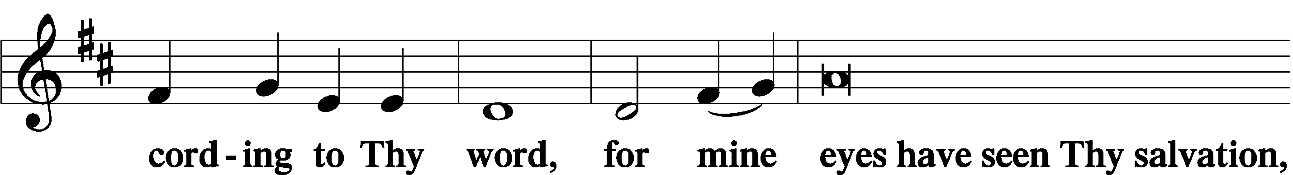
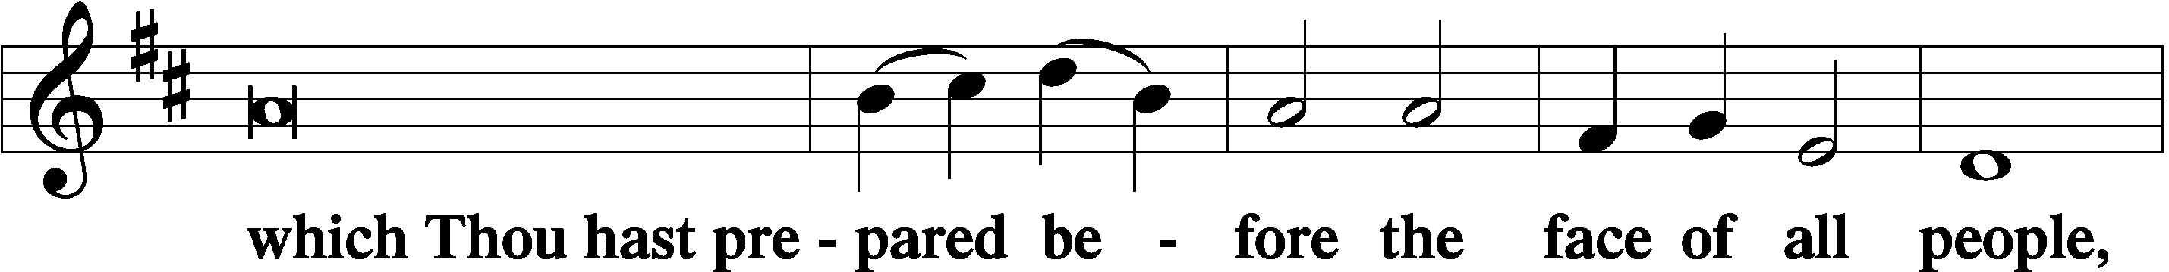
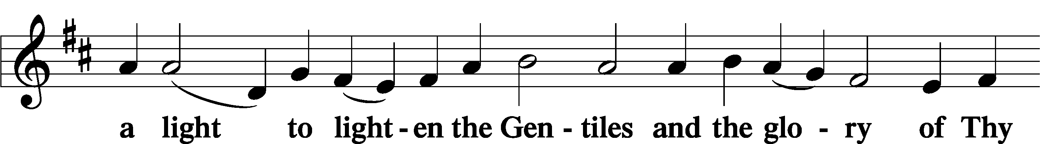
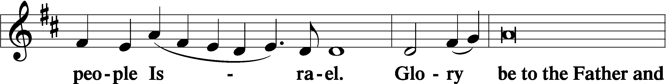
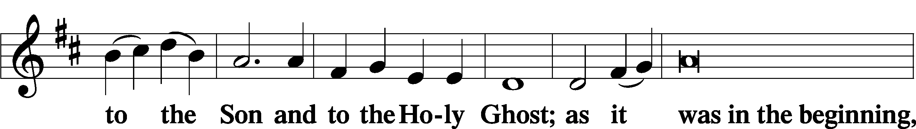
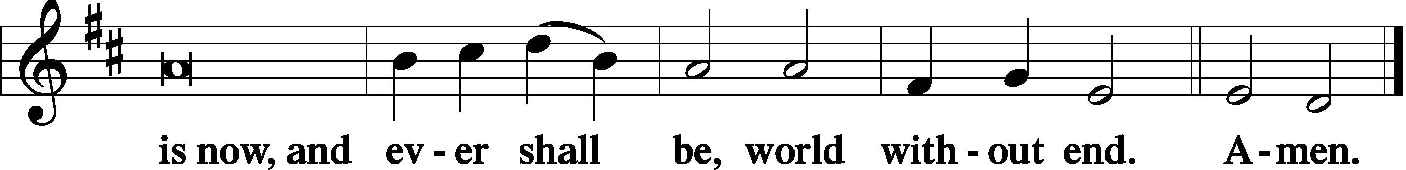

Thanksgiving Psalm 107:1
P O give thanks unto the Lord, for He is good,
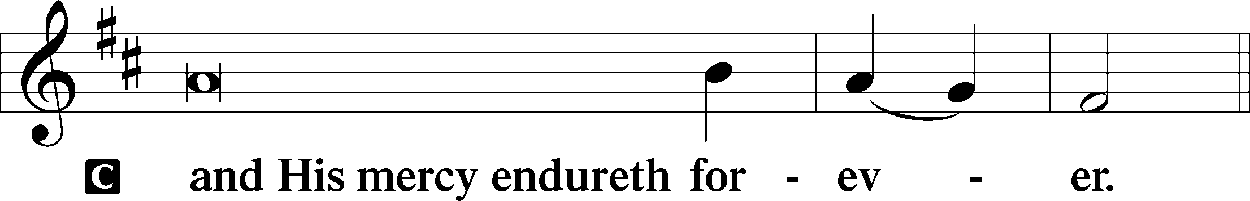

Post-Communion Collect
P Let us pray.
We give thanks to You, almighty God, that You have refreshed us through this salutary gift, and we implore You that of Your mercy You would strengthen us through the same in faith toward You and in fervent love toward one another; through Jesus Christ, Your Son, our Lord, who lives and reigns with You and the Holy Spirit, one God, now and forever.
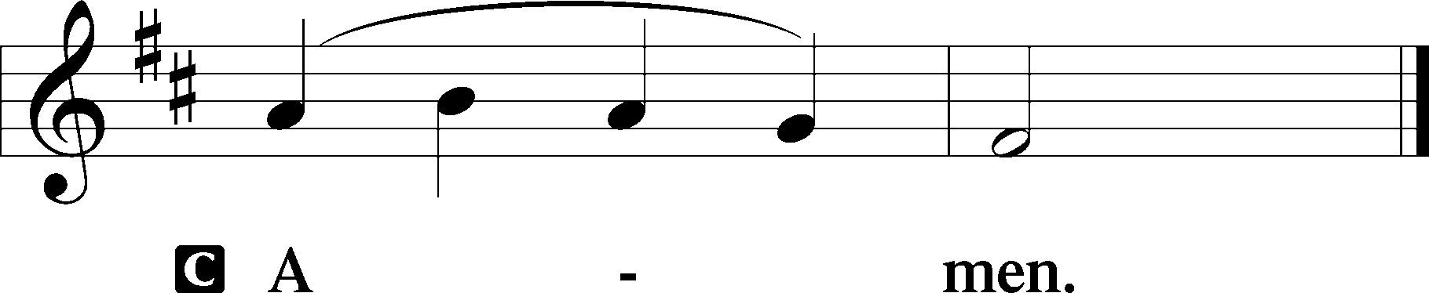

Salutation 2 Timothy 4:22
P The Lord be with you.
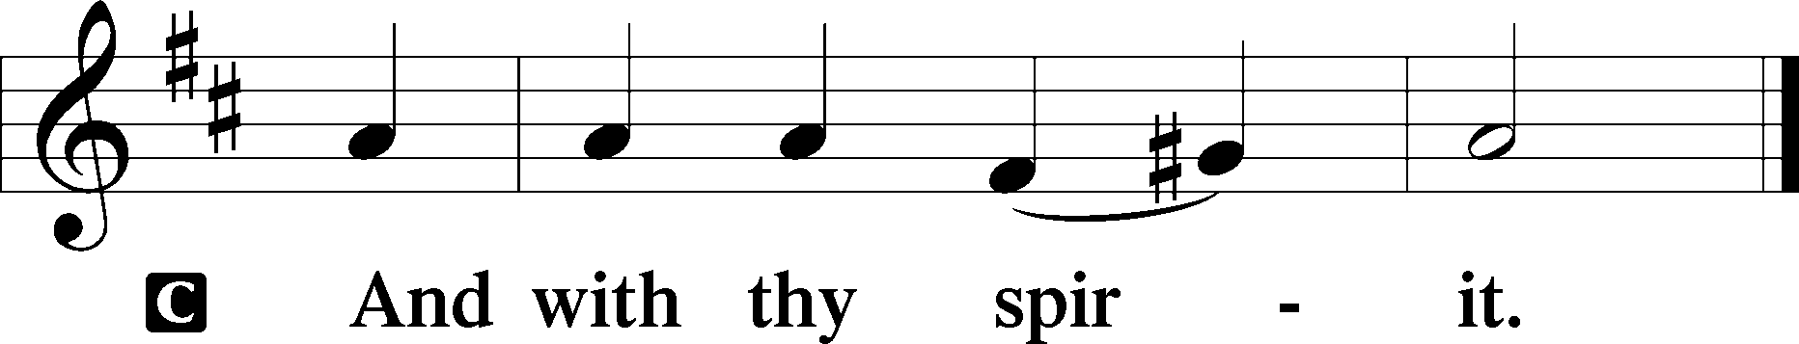

Benedicamus Psalm 103:1
P Bless we the Lord.
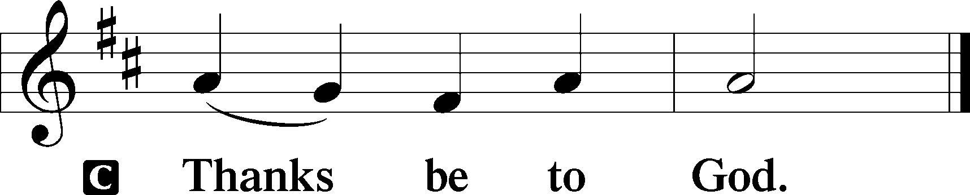

Benediction Numbers 6:24–26
P The Lord bless you and keep you.
The Lord make His face shine upon you and be gracious unto you.
The Lord lift up His countenance upon you and T give you peace.
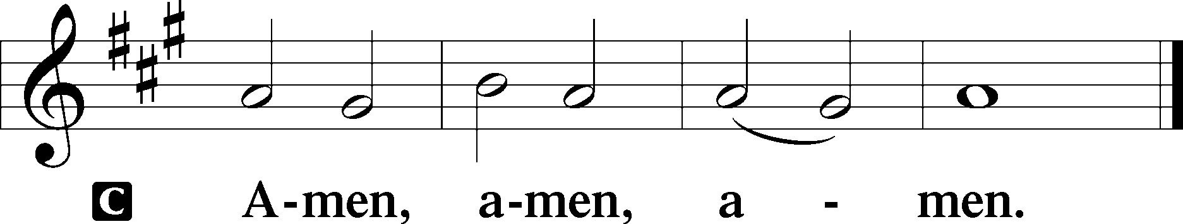

Closing Hymn: LSB #714 “Who Trusts in God a Strong Abode”

Silent prayer after worship: Dear Lord, give me faith to love You above anything else, and to love others as myself, so that, living in Your love, others might see Your love living in me. In Jesus’ name. Amen.
fffffffffffffffffffffffffffffffffff
Acknowledgments
Unless otherwise indicated, Scripture quotations are from the ESV® Bible (The Holy Bible, English Standard Version®), copyright © 2001 by Crossway, a publishing ministry of Good News Publishers. Used by permission. All rights reserved.
Created by Lutheran Service Builder © 2023 Concordia Publishing House.
fffffffffffffffffffffffffffffffffff
The Altar Flowers this day are given by Mike & Marie Flaugher in Celebration of their 46th Wedding Anniversary. We give sincere thanks for this gift.
fffffffffffffffffffffffffffffffffff
SCHEDULE THROUGH AUGUST 13, 2023:

:

Today, 7 pm, Fellowship Hall: AA Meeting
Tuesday, 7-9 pm, Fellowship Hall: Penn-Ohio Singers
Wednesday, 7 pm, Library: Trustees meeting
Wednesday, 7:30 pm, Fellowship Hall: NA Meeting
Thursday, 9 am, Downstairs: Food Pantry
Next Sunday, 9 am, Sanctuary: Divine Service
Following Worship, Fellowship Hall: Coffee Fellowship
7 pm, Fellowship Hall: AA Meeting
fffffffffffffffffffffffffffffffffff
Attendance: Sunday, July 30, 2023: 30
fffffffffffffffffffffffffffffffffff
Our prayer list has been updated. If you would like someone’s name added or deleted from our Prayer List, please put a note in the secretary’s mail slot or email the church office. Thank you!
Our Stewardship of Treasures for the Lord:
In order to do the Lord’s work, we need $2,553.63 each week to meet our 2023 budget for general purposes and $76.92 for the SELC.
Figures for Sunday, July 30, 2023
General Fund: $1,103.00 Behind for the week: -$1,450.63
SELC: $65.00 Behind for the week: -$11.92
Capital Campaign: $375.00
Quarterly Missions: $35.00

For online giving, check out https://www.saintspeterandpaul.net/online-giving.
fffffffffffffffffffffffffffffffffff
THANK YOU FOR SERVING IN AUGUST: Elder: Jonathan Baisch; Ushers: Cheryl Fedele, Mike Flaugher, & Jesse Riffle; Altarware: (prior) Diane Riefstahl & Marie Flaugher (08/13); (after) Hank Holcroft & Kati Laird.
fffffffffffffffffffffffffffffffffff
The next Voters’ Assembly will take place following worship August 20th.
fffffffffffffffffffffffffffffffffff
Available this morning in the narthex and on tables adjacent to the nursery.
- August issue of “The Rock and the Sword” newsletter.
- Minutes from the July 24th Church Council meeting.
- Information concerning how to donate to the Barry Nelson Charitable Foundation.
- SCRIP order forms. (Due to Matt Berent this morning along with payment.)
fffffffffffffffffffffffffffffffffff
Bible Memory Verses ~ Week of August 6th:
For Adults: He has delivered us from the domain of darkness and transferred us to the kingdom of his beloved Son, in whom we have redemption, the forgiveness of sins. Colossians 1:13-14
For Children: Look carefully then how you walk, not as unwise but as wise.
Ephesians. 5:15
fffffffffffffffffffffffffffffffffff

Remember the following in Prayer…
~The Hurting and Healing: Amy, Steve Antolovich, Ellen Baron^{CA}, Lois Bortner^{CA}, Dee Bullock, Bev & Joe Chlpka, Susan Davies, Loretta Deal, Tim Dudash, Judith & Eddy Furey, Griffin, Austin Hamilton, Pastor Charles Henrickson, Joan, Darla Krajci, Barbara Kreske, Pastor Ed Kucera, Jess Lavoie, Elizabeth Loughan, Paul Lucas^{CA}, Sandy Marshall, Gene Moore, Frank Niemeyer^{CA}, Juanita Rentschler, Richard Reuning^{CA}, Nancy Robertson^{CA}, Landon Sargent, Joel & Peggy Wasson, Angela Weser^{CA}, and Ruth Wolf.
~The Homebound: Anna Mae Daris, Millie Elavsky, Rudy & Jean Tomko, Betty Wolf, and Ed & Millie Zachar.
~Celebrating this Week: Birthdays: Anthony Bale (08.06), Brooke Psznick (08.06), Diane Riefstahl (08.06), and Mildred Elavsky (08.08). Anniversaries: Mike & Marie Flaugher (08.06), Jesse & Alyxis Riffle (08.07), and Rev. Jacob & Ana Deal (08.10).
~Serving in the Military: Alex (Sasha) Carr, Curtis Sinewe, and Joshua Solyan.
~Community & World Needs: Those suffering from or affected by the coronavirus; those suffering due to the conflict between Ukraine and Russia; those suffering from loss and dislocation because weather disasters; those suffering from addiction and their families; Local, State, and National Government Leaders; safety for all Police Officers, Firefighters, & First Responders; the unemployed; our Third Quarter Local Mission: Luther Classical College.
*CA represents cancer.
fffffffffffffffffffffffffffffffffff
NEW: Trustees will meet this Wednesday, August 9th at 7 pm in the library.
fffffffffffffffffffffffffffffffffff
Next Sunday is “Stock the Food Pantry” Sunday. Your financial donations will be greatly appreciated.
fffffffffffffffffffffffffffffffffff
Join us next Sunday following worship for Coffee Fellowship. August’s sponsors are Mike & Marie Flaugher.
fffffffffffffffffffffffffffffffffff

Here to Serve
Pastor………………………………………………...……………Rev. Jacob Deal
E-mail …………………………….……pastordeal@saintspeterandpaul.net
Phone Number……………………..…………………724-347-3620 (Option 2)
Church Office………………………..…………………724-347-3620 (Option 3)
Website …………………………………………www.saintspeterandpaul.net
Secretary…………………………………………………………Diane Riefstahl
E-mail ………………………………………church@saintspeterandpaul.net
Website …………………………………………www.saintspeterandpaul.net
Food Pantry (email): ……………foodpantry@saintspeterandpaul.net
Congregation President………………………………….…Jonathan Baisch
Church Elder …………………………………………...……. Jonathan Baisch
Organist………………………………………………..….…Rebecca Marquette
Choir Director…………………………………………………….…Chris Nelson
AA Contact: Steve………………………………………………...…724-813-2358
NA Contact: Larry……………………………………..…………..724-977-8733
fffffffffffffffffffffffffffffffffff
If needing to get into the church building during the week, please phone first to make certain someone is here to let you in.

