Sts. Peter & Paul Evangelical Lutheran Church LC-MS
Monthly Newsletter --- August 2021
699 Stambaugh Avenue, Sharon, PA 16146
Phone: 724.347.3620 (Opt. 2, Pastor Deal; Opt. 3, Office)
E-mail: church@saintspeterandpaul.net www.saintspeterandpaul.net

“THE ROCK and THE SWORD”
“Built upon the Rock of Christ and wielding the
Sword of the Spirit, the Word of God.”

Over the past several weeks, Pastor Deal has shared information concerning “Stewardship Under the Cross” in preparation for the beginning of our Capital Campaign. The following is the final article in this series.

From the Pastor:
Stewardship Under the Cross: Luther on Tithing and Stewardship

On Vowing to Support the Church with Tithes
Thus it is said (Prov. 3:9): “Honor the Lord with your substance.” This must be understood not only of words and of the worship of the mouth or genuflection but of the deed itself.... Gal. 6:6: “Let him who is taught in the Word share all good things with him who teaches.” Therefore when God wants to be honored, then He wants sacrifices to be offered, not only sacrifices of the mouth but also the reverence of the heart, yes, the deed itself. He wants us to help the ministry, and He wants everyone to contribute for the purpose of supporting the
studies of the pupils and of propagating the doctrine. Then God is truly praised and

glorified there. Make a vow there, and say: “I promise that I am willing to contribute something for the assistance of the churches.” That is St. Jacob’s vow. Therefore this example should be diligently inculcated, namely, that Jacob vows tithes, not in order that God Himself may eat or be enriched; but he gives them to the poor ministers and to those who are always the least of the brethren or disciples of Christ on earth. For all other arts are gainful and have their profits. This profession alone is in need of bountiful giving. We must live from the altar, as Paul says (1 Cor. 9:13). Accordingly, he who is godly and loves the Word of God contributes something. He who hates the doctrine along with those who teach and learn it robs and despoils.
Otherwise God has so ordained that we should live from the vows, sacrifices, and alms that are owed to us by divine right. When the godly see the poverty and need of the ministers of the church and the school, they make vows and obligate themselves to give tithes, as Jacob gave them. (LW v.5)

On Tithing to Support God's Work in the Church
Therefore this text shows that Jacob did not make such a foolish and godless vow, but that it was a vow of thanksgiving.
For he says: “If I come again, etc.” It is as though he were saying: “I shall now obligate myself to pay a debt, and I shall make satisfactory reparation when I return. What? I shall build a school and a church here, and I shall give a tithe of bulls and goats and fruits for its establishment and upkeep, likewise a tenth part of the milk and the butter.” Of course, God does not need these things. For He does not eat bread or drink wine, as He says in Ps. 50:13: “Do I eat the flesh of bulls?” What, then, are you doing? I answer that Jacob is already righteous. Accordingly, he does not make a vow to placate God by making it; but he wants to do this to give thanks, to glorify God, in order that He may conduct him and bring him back according to the promise. Who will receive these tithes? Not the angels, not the sun, not the moon. But he will perform that extraordinary and glorious work for the purpose of preserving the ministry and founding churches and schools. . . .This is how Moses should be understood when he says (Deut. 23:21): “When you make a vow to the Lord your God, you shall not be slack to pay it.” What does it mean to make a vow to God, or whom is Moses addressing when he says: “The Lord your God”? It means to give tithes to the disciples, sons, and wives of the prophets, to the poor and needy. These are the ones who are to be supported by the tithes offered to God, and through these tithes God is supported. For God says: “Whatever you give to the children of the priests and prophets through whom the doctrine is propagated you must regard as given to Me, not that I may justify you through this work, but it should be a thanksgiving and a sacrifice of praise because I have justified you and have also blessed you in temporal matters. In addition, I shall bless you even more if you give ear to, support, and cherish the poor sons of the prophets.” (Luther's Works, vol. 5)

On Abraham's Stewardship
This was not the first time that Abraham gave tithes of these to the priest Melchizedek; he did so every year. Even before that victory Abraham conducted himself humbly, acknowledged Shem as a priest of the Most High, and gave him tithes, as did Lot and the other fathers who lived at that time. (LW vol. 2)... To be sure, Abraham had property; but he did not love it, since he showed that he was a manager and knew that by God’s will he had been appointed a steward of his goods. (LW vol. 30).

Your servant in Christ,
Pastor Jacob Deal
llllllllllllllllllllllllllll
REMINDER: Please let the church office know of any changes to your address, phone, cell phone or your e-mail address!
llllllllllllllllllllllllllll
Thank You for Serving in August:
Head Elder: Barry Nelson
Assisting Elder: Bob Sulek
Ushers: To be determined.
Altarware: (Before service) Marie Flaugher & Diane Riefstahl; (After service) Diane Riefstahl & Viola Sakony
Finance Committee: Rev. & Evelyn Baisch
llllllllllllllllllllllllllll
TRUSTEES’ UPDATE
The trustees met July 7, 2021. We have a lot of projects before us and appreciate all the support we have been receiving from the congregation.
Our biggest project has been the replacement of the church roof, fascia, and gutters. WaterTight Roofing Systems began work July 6th. With several days of inclement weather, the roof was finally finished July 20th. Replacement of the fascia is to start July 21st with gutters to follow. The project is scheduled for completion July 30th.
Also completed in July was the trimming of shrubbery, with the exception of shrubs in the courtyard. Thank you, Cheryl Fedele for your work on this.
The trustees have scheduled work days to finish several projects and volunteers to help are needed. Projects include
- Change out lights in sanctuary
- Trim bushes in courtyard
- Finish putting down mulch
- Pick up trash, nails, and debris around church yard
- Clean up Sonshine Room
- Clean up Fellowship Hall
- Power wash front steps
- Paint front steps
- Complete edging along sidewalks
- Wipe down interior hand rails in stairways
- Wash steps leading down to the Fellowship Hall
- Sweep parking lot and pick up debris
If able to help with any of these projects, please contact Trustee chairman Mike Flaugher (724-301-8277) and let him know which task(s) you will undertake and when you plan to work.
All help is greatly appreciated.
PHOTOS OF THE ROOFING PROJECT

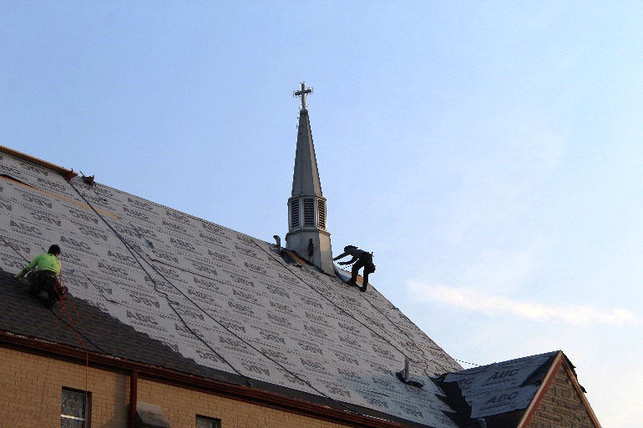

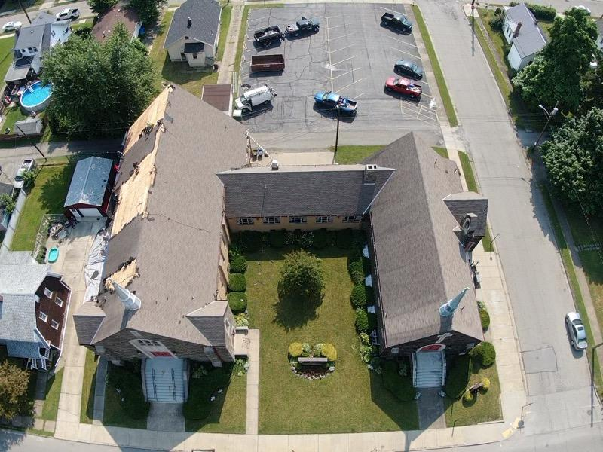

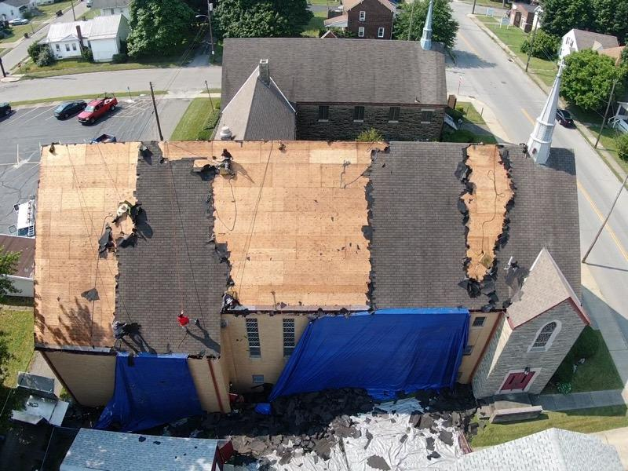
llllllllllllllllllllllllllll

STS. PETER & PAUL’S
FOOD PANTRY UPDATE
Gifts of Love Our Food Pantry was recently blessed with the skills of a volunteer who donated hand-knitted children’s sweaters of various sizes. These sweaters have been given to Food Pantry families with young children and have been graciously received.
The quality of these sweaters is incredible and they are truly a reflection of the time and effort, combined with love, that go into them.
If anyone has any skeins of yarn which they would like to donate to this ongoing effort, please leave them in the Food Pantry area or give them to a Food Pantry volunteer.
If you have questions about this project or would like to join the effort, please speak with Barry Nelson.
Food Warehouse Shows Appreciation The Community Food Warehouse of Mercer County is donating boxes of fresh produce to our Food Pantry clients in August, September, and October. To show their appreciation to our church for hosting a Food Pantry, they are allowing our congregation members to receive fresh produce as well!
Boxes of fresh produce will be available for pickup from 8:30 – 9:30 am August 12, September 9, and October 14. Past boxes have included apples, squash, cucumbers, cabbage, potatoes, and/or eggplant.
If interested in a monthly box, please let Barry Nelson or Bob Sulek know. You can pick them up on the scheduled Thursdays or the following Sundays after church. Please let them know your preference.
SUMMER TIME REMINDERS Sunday Bible Study is on hiatus until September. This Thursday, August 5th, will be the final session of our Summer Bible Study focusing on biblical parables.
A service of Evening Prayer will follow beginning at 6 pm.
Sunday morning worship services will begin at 9 am through the end of the month and will revert to the 10 am start time in September.
llllllllllllllllllllllllllll
CELEBRATING IN AUGUST!
Birthdays
Anthony Bale 8- 6
Brooke Psznick 8- 6
Diane Riefstahl 8- 6
Mildred Elavsky 8- 8
Anson Holcroft 8-20
Alex (Sasha) Carr 8-28
Elizabeth Loughan 8-30

Anniversaries:
Mike & Marie Flaugher 8- 6
Rev. Jacob & Ana Deal 8-10
Rev. Arthur & Evelyn Baisch 8-17
David & Debbie Zurawsky 8-18
Rudy & Jean Tomko 8-20

*If birthdays or anniversaries have been omitted, please let the church office know. Thank You!
llllllllllllllllllllllllllll
LIKE & FOLLOW our Church’s Facebook page (Saints Peter and Paul Evangelical Lutheran Church)!
Remember to like, comment, and share to help us reach as many people as possible.
llllllllllllllllllllllllllll
ATTENTION AUDITORS!
The next audit of deposits will be following worship Sunday, August 15th in the library.
If unable to attend, please phone Bev Chlpka at 724-962-4806.
FROM YOUR ALTAR GUILD:
-Marie Flaugher

CROSSES of The Lutheran Church
We come to church each week and, as we sit in our pews, the view is the same. We have three lovely, ornate stained-glass windows shining above our beautiful altar which is adorned in proper paraments, and a pulpit and lectern ready for use. We see the eternal candle on the left wall, the Paschal candle standing tall, and communion ware and baptismal font in their places.
But, look closer. Have you ever counted the crosses that each of these items bear as visual reminders of Christ’s sacrifice for us? Well, I have! There are 37 crosses which I have found, and maybe more that I cannot see from the pew.
What is the significance of these crosses? On the windows, most of the small crosses may appear to be decorative, but the
one that stands out is Jesus on the cross, with the banner stating INRI—Jesus of Nazareth, King of the Jews. We look upon this cross as a reminder of His death for our sins.
On the Eternal candle, the cross that looks like the letter X with a P on top, stands for Chi-Rho, or the first two letter of Christ in Greek.
The LC—MS cross on the centennial banner reminds us of who we are and what we believe. It is also the registered trademark of the LC—MS.
Crosses on the altar and paraments are beautiful adornments. The Communion cross represents what Jesus directed us to do in remembrance of Him, and the Baptismal cross invokes God’s protection and allows the body to enter the body of the Christian Church.
All crosses should be reminders of our faith that, as Christians, we look at a cross and understand the sacrifice God has made for us.
Work Day Scheduled
Members of the Altar Guild are asked to meet at 10 am Friday, August 20th for a work day. Members will tackle the cleaning of the parament storage room, survey the sanctuary for needed repairs, inventorying Pastor’s vestments, and begin sorting through / cleaning the Fellowship Hall kitchen. Additional dates will be scheduled as needed.
Please let Diane know if unable to help out that day.
The next meeting of the Altar Guild is scheduled for Sunday, September 19th following worship. New members are welcome! Officer elections for the next year will be held.

llllllllllllllllllllllllllll Homebound Member & Friend
Please keep the following in your prayers:
Marion Roberts
287 East 2nd St. Apt. #103
Hummelstown, PA 17036
724-893-4570
llllllllllllllllllllllllllll
SCRIP Program:
The next date for SCRIP orders and payments is Sunday, August 1st. Checks should be made out to Sts. Peter & Paul’s and are to be given to Matt Berent or placed in the offering plate. You should receive your gift cards the following week.
llllllllllllllllllllllllllll
BIBLE MEMORY VERSES FROM JULY
For Adults:
July 4: For the word of the cross is folly to those who are perishing, but to us who are being saved it is the power of God.
1 Corinthians 1:18

July 11: Heaven and earth will pass away, but my words will not pass away.
Mark 13:31

July 18: But he said to me, “My grace is sufficient for you, for my power is made perfect in weakness.” Therefore I will boast all the more gladly of my weaknesses, so that the power of Christ may rest upon me. For the sake of Christ, then, I am content with weaknesses, insults, hardships, persecutions, and calamities. For when I am weak, then I am strong. 2 Corinthians 12:9-10

July 25: For our sake he made him to be sin who knew no sin, so that in him we might become the righteousness of God. 2 Corinthians 5:21

For Children:
July 4: No one who puts his hand to the plow and looks back is fit for the kingdom of God. Luke 9:62

July 11: Fear not, for I have redeemed you; I have called you by name, you are mine.
Isaiah 43:1

July 18: Present your members as slaves to righteousness leading to sanctification.
Romans 6:19

July 25: Walk as children of light, for the fruit of light is found in all that is good and right and true. Ephesians 5:8-9
Remember the
following in Prayer…
~The Hurting and Healing: Ellen Baron^{CA}, Lois Bortner^{CA}, Richard Brandes, John Burdette, Kim, Susan Davies, Tim Dudash, Joseph Fleet, Judith Furey, Marie Haenftling, Neale & Melissa Huston, Michelle Kelly^{CA}, Donna Kennedy, George Klein, Jess Lavoie, Paul Lucas^{CA}, Sandy Marshall, Ernie Meszaros, David Nelson, Lisa Pfrenger, Juanita Rentschler, Richard Reuning^{CA}, Marty Scott, Angela Weser^{CA}, Betty Wolf, and Millie Zachar.
~The Homebound: Marion Roberts
~Serving in the Military: Curtis Sinewe and Joshua Solyan.
~Community & World Needs: Those suffering from or affected by the coronavirus; those suffering from loss and dislocation because weather disasters; those suffering from addiction and their families; Local, State, and National Government Leaders; safety for all Police Officers, Firefighters, & First Responders; the unemployed; our Third Quarter Local Mission: Meals on Wheels of the Shenango Valley
*CA represents cancer
llllllllllllllllllllllllllll
.REMINDER: If you would like someone’s name to be added to or deleted from our prayer list, please put a written note in the secretary’s mail slot by the office door.
llllllllllllllllllllllllllll
A note from Pastor Deal: Please let me know if you or a loved one are in the hospital or have a special need. Also, please ask the hospital or family members to phone me or the church office as I wish to visit those who may be hurting.
llllllllllllllllllllllllllll

Submissions for the September issue of “The Rock and the Sword” newsletter are due to the secretary’s office Monday, August 23rd at noon. This includes meeting dates and times for the church calendar.
llllllllllllllllllllllllllll
If you do not have an email account or do not receive emails from the church but wish to be notified of significant information concerning your fellow church members (such as births or deaths), please put a note in the Secretary’s mail slot asking to receive a phone call. Every attempt will be made to phone you within 24 hours of an email being sent out.
llllllllllllllllllllllllllll
Word of Hope: 1-888-217-8679
The only 24/7 CONFIDENTIAL Hotline that is distinctly Lutheran, bringing healing found in Christ, to those whose hearts have been broken by abortion.
llllllllllllllllllllllllllll
The next Voters’ Assembly
Meeting will be Sunday,
August 8th following
Worship.
The meeting will be held in the
Sanctuary. All are encouraged to attend!
llllllllllllllllllllllllllll
Please Note:
Pastor Deal will be on vacation August 8th – August 21st. If you should have need of pastoral care during this time, please phone Elders’ Chairman Barry Nelson at 724-866-7417.
We are grateful to Rev. Baisch who will be leading our worship August 8 and August 15 with Services of the Word (no Holy Communion).
Community Day 2021 was Saturday, July 17th. Despite torrential rains and windy weather, approximately 45 friends and neighbors joined us in the Fellowship Hall and Youth Room for movies, Bingo, crafts, games, and prizes.
Sincere thanks are extended to all those who assisted with the planning of the event, donated raffle baskets and/or food and beverages, and who attended. A lot of work goes into this annual project and it takes a cadre of volunteers to make it happen.
Pictures from the event are at the end of this newsletter.
llllllllllllllllllllllllllll
Shenango Valley Meals on Wheels has been selected as our Third Quarter Local Mission. Donations may be placed in a pew envelope labeled with your name and envelope number. Be sure to indicate “Local Mission” on the envelope.
Have you ever wondered as to how you could help this organization in ways other than financial? They are very appreciative of home-made, donated desserts (especially those which are sugar and/or gluten-free) which are packaged for their clients. These items may be dropped off at their location at 396 Buhl Blvd., Sharon by 9 am weekdays.
llllllllllllllllllllllllllll

To listen to Pastor Deal’s sermons, phone 724-347-3620 and press Option 6.

CAPITAL CAMPAIGN BEGINS
Every household should have received a booklet outlining our Capital Campaign along with a pledge card. If you have not received yours, extra copies are on the lower shelf of the table adjacent to Pastor Deal’s office.
Commitment Sunday was held July 25th. If you were not in attendance or forgot to bring your pledge card, you are encouraged to please bring it over the next couple of weeks. Pledges will help our Finance Committee determine when different planned projects can begin.
Sunday, September 5th has been designated as “Giving Sunday”. Members are encouraged to give 10% of their total commitment, if possible, on this date to kick-off our campaign.
Projects which will be addressed with funds garnered in the Capital Campaign are as follows:
(In Completion Order)
Project: Roof & Fascia
Watertight Roofing Systems
(50 yr single / 10 yr labor)
Cost: $64,500.00
Completion: Immediate
Project: Gutters
Watertight Roofing Systems
Cost: $7,950.00
Completion: Immediate
Project: Drainage Repair
Contractor to be determined
Anticipated Cost: $20,000.00
Completion: Immediate
Project: Mold Mitigation in Old Church Attic
Contractor to be determined
$10,000.00
Completion: Immediate
Project: Masonry Work
Contractor to be determined
Description: Repointing of chancel end of church, narthex end of church, north wall windows (right of entrance)
Estimated cost: $40,414.00
Completion: When campaign reaches $75,000.00 goal
Project: Replacement of Narthex Doors
Estimated cost: $3,500.00
Completion: When campaign reaches $95,000.00 goal
Nave Renovations
Project: Plaster Repair / Coverings in Chancel and other Locations
Estimated cost: $3,000.00
Completion: When campaign reaches $105,000.00 goal
Project: Flooring
Estimated cost: $8,000.00
Completion: When campaign reaches $145,000.00 goal
Project: Air Conditioning
Estimated cost: $25,000.00
Completion: When campaign reaches $165,000.00 goal
Project: Window Replacement
Anticipated contractor: Pella
Estimated cost: $68,500.00
Completion: When campaign reaches $200,000.00 goal
Sincere thanks are extended to the church leadership, Trustees, Financial Committee, and Pastor Deal for all their hard work in developing these Capital Campaign projects and goals. Countless hours have been spent meeting with contractors, securing quotes, and agonizing over details.
Please help us RECYCLE! A bin has been placed next to the parking lot doors for used bulletins. Please help us keep our sanctuary neat by either taking home your service bulletins or disposing of them here.
Additionally, there is a basket by the secretary’s office for donations of already-read Christian materials. They will be sorted and donated to ICLD periodically.
llllllllllllllllllllllllllll
If entering the church during the week, please let office staff know that you are in the building. Also, please make certain to turn off lights, lock doors, etc. upon leaving.
llllllllllllllllllllllllllll
There are many Sundays available to purchase or provide Flowers for the Altar. Check out the sign-up sheet in the narthex.
llllllllllllllllllllllllllll
TECHNOLOGY GRANT RECEIVED
At the recent Church Council meeting, Council President Jonathan Baisch announced that Sts. Peter & Paul’s has received a technology grant in the amount of $1,150.00 from the LC—MS. Plans are to use this grant in conjunction with other monies already budgeted for the replacement of speakers in the front of the nave and upgrading the church’s wireless internet.
llllllllllllllllllllllllllll

Sincere “Best Wishes” are extended to Alyxis Kimmel and Jesse Riffle on their upcoming marriage August 7th!
Community day photos….
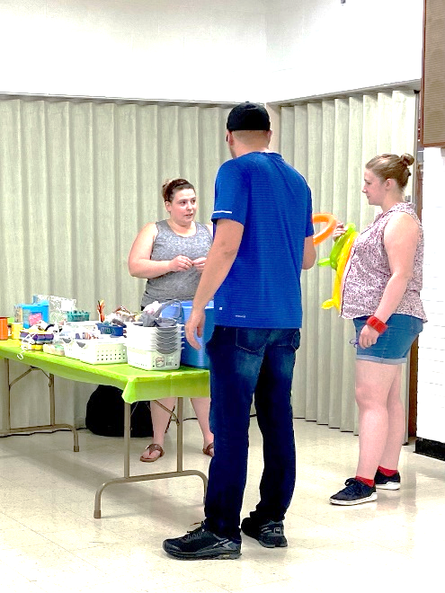
Pastor, Ana, and Alyxis check over the craft table.

Raffle baskets continue to be a popular draw.

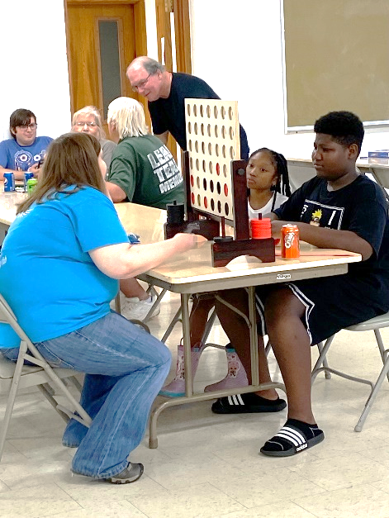
“Connect Four” was popular with adults and children alike.
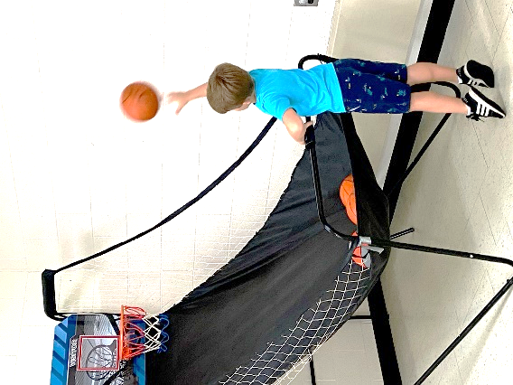
Guests of all ages enjoyed showing off their basketball skills.

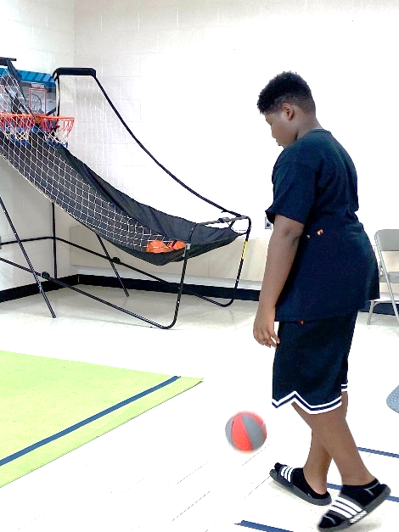
Several competitive games were offered with chances to earn great prizes.

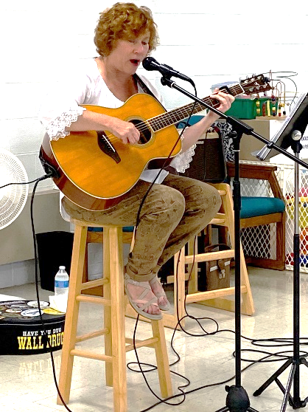
Diane Drapcho, an local musician, offered selections which appealed to all ages.
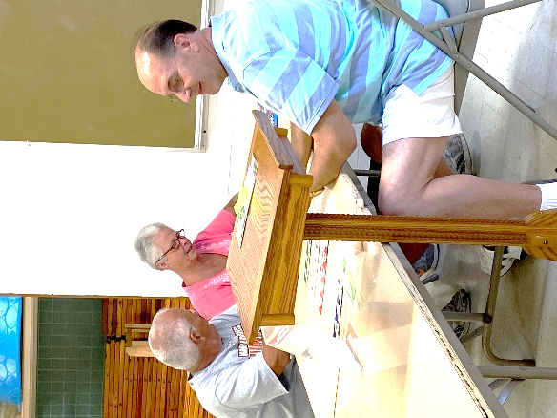
There were several competitive games of Bingo.

Crafts were popular with guests of all ages.

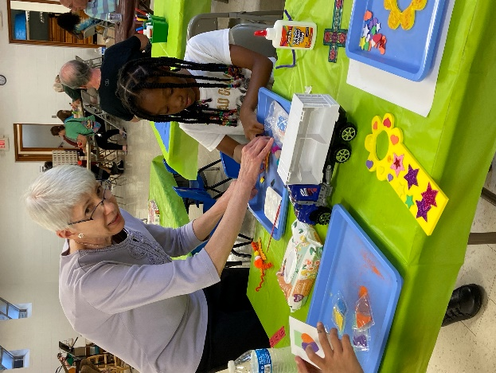
Nancy offers a hand in completing a special craft item.

