Sts. Peter & Paul
Evangelical Lutheran Church
Lutheran Church-Missouri Synod
Founded-1917

April 30, 2023

699 Stambaugh Ave.
Sharon, Pennsylvania 16146

“I was glad when they said to me,
Let us go to the house of the LORD!”
Psalm 122:1
Sts. Peter & Paul Evangelical Lutheran Church, LC-MS
JUBILATE
April 30, 2023

A special welcome to our guests this day! If you would like more information about The Lutheran Church - Missouri Synod, or this congregation, please speak with Pastor Deal or an Elder after the service.
Members & Guests: Don’t be embarrassed if your children make noise during the worship service, all children do. We encourage families to worship together but, if you feel the need, there are pews in the rear of the Church which are reserved for young families on both sides of the sanctuary. There is also a quiet room available to you during our service which is located down the hallway past the offices on the right side of the church as well as a children’s area in the Fellowship Hall where you are able to follow along with the service.

Today’s service includes the Sacrament of Holy Communion. If during this past year, you have not worshipped with us and been communed, we respectfully ask that you do not partake of this sacrament this day before first speaking with Pastor Deal.
If visiting from a sister congregation of the LC-MS and are in good standing, please inform Pastor Deal of your desire to commune prior to the service.
If wishing to receive a blessing during communion, please approach with your arms crossed.

CONTACT INFORMATION
Pastor Deal: pastordeal@saintspeterandpaul.net or 724-347-3620 (opt. 2)
Church Office: church@saintspeterandpaul.net or 724-347-3620 (opt. 3)
Secretary’s Office will be open Monday and Thursday of this week (8:30 am -4:30 pm)

Silent prayer before worship: Dear Heavenly Father, You sent Jesus to be my Good Shepherd. Yet, I am not always a faithful sheep. Cause me to focus on You today so I may find healing, strength and direction through Your Word. In Jesus’ name. Amen.
Confession and Absolution

Opening Hymn: LSB #737 “Rejoice, My Heart, Be Glad and Sing”

Stand

The sign of the cross may be made by all in remembrance of their Baptism.

Invocation
P In the name of the Father and of the T Son and of the Holy Spirit.
C Amen.

Exhortation Hebrews 10:22; Psalm 124:8; Psalm 32:5
P Beloved in the Lord! Let us draw near with a true heart and confess our sins unto God our Father, beseeching Him in the name of our Lord Jesus Christ to grant us forgiveness.

P Our help is in the name of the Lord,
C who made heaven and earth.
P I said, I will confess my transgressions unto the Lord,
C and You forgave the iniquity of my sin.

Silence for reflection on God’s Word and for self-examination.

Confession of Sins
P O almighty God, merciful Father,
C I, a poor, miserable sinner, confess unto You all my sins and iniquities with which I have ever offended You and justly deserved Your temporal and eternal punishment. But I am heartily sorry for them and sincerely repent of them, and I pray You of Your boundless mercy and for the sake of the holy, innocent, bitter sufferings and death of Your beloved Son, Jesus Christ, to be gracious and merciful to me, a poor, sinful being.

Absolution [John 20:19–23]
P Upon this your confession, I, by virtue of my office, as a called and ordained servant of the Word, announce the grace of God unto all of you, and in the stead and by the command of my Lord Jesus Christ I forgive you all your sins in the name of the Father and of the T Son and of the Holy Spirit.
C Amen.

Service of the Word

Introit Psalm 66:3, 5, 8–9; antiphon: vv. 1–2
Shout for joy to God, all the earth. Alle- | luia.*
Sing the glory of his name; give to him glorious praise! Alle- | luia.
Say to God, “How awesome | are your deeds!*
So great is your power that your enemies come cringing | to you.”
Come and see what | God has done:*
he is awesome in his deeds toward the chil- | dren of man.
Bless our God, O | peoples;*
let the sound of his | praise be heard,
who has kept our soul among the | living*
and has not let our | feet slip.
Shout for joy to God, all the earth. Alle- | luia.*
Sing the glory of his name; give to him glorious praise! Alle- | luia.

Gloria Patri
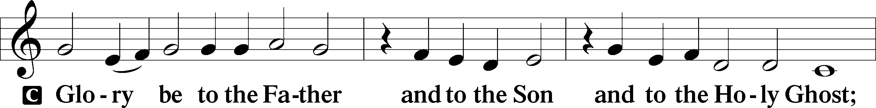
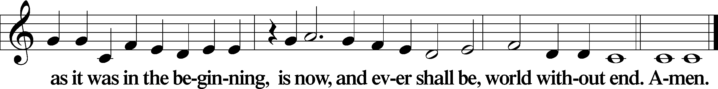
Kyrie Mark 10:47
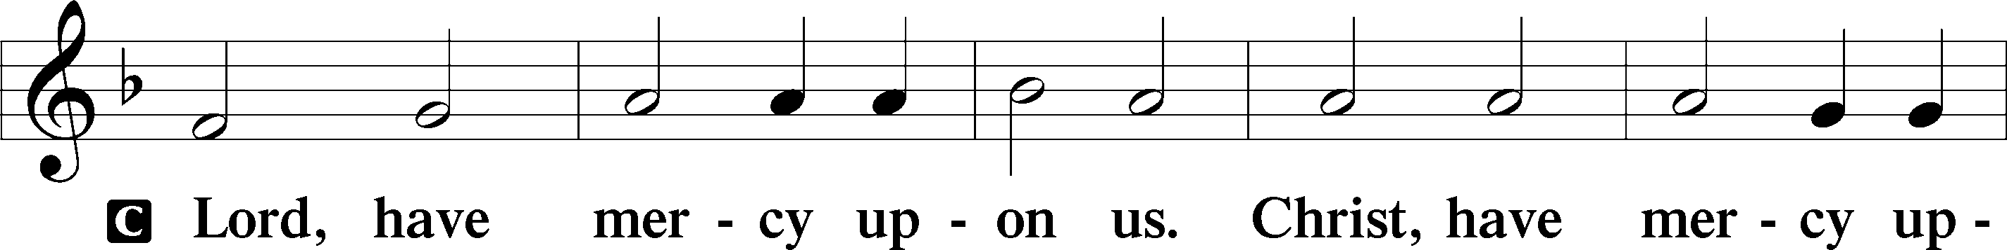
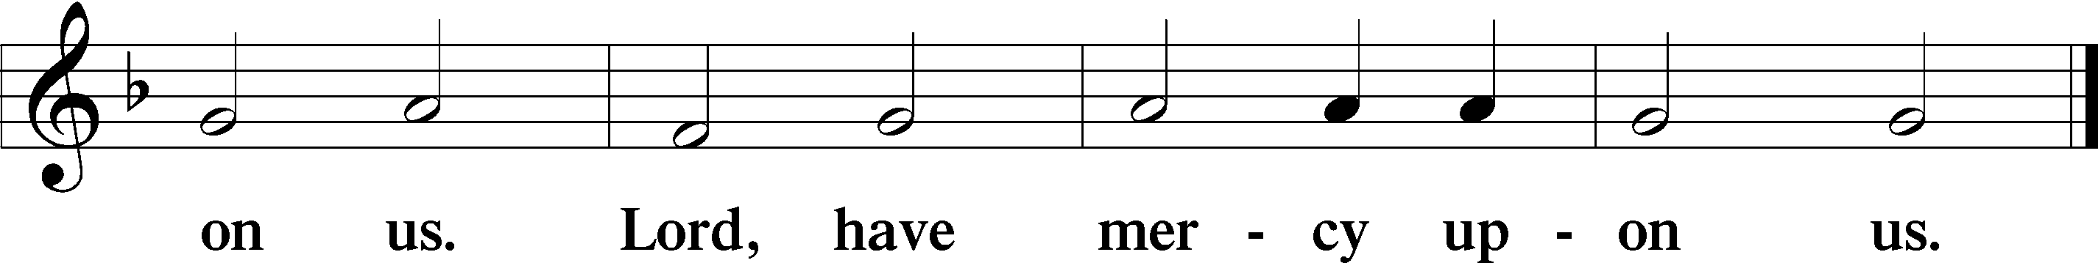

Gloria in Excelsis Luke 2:14; John 1:29
P Glory be to God on high:
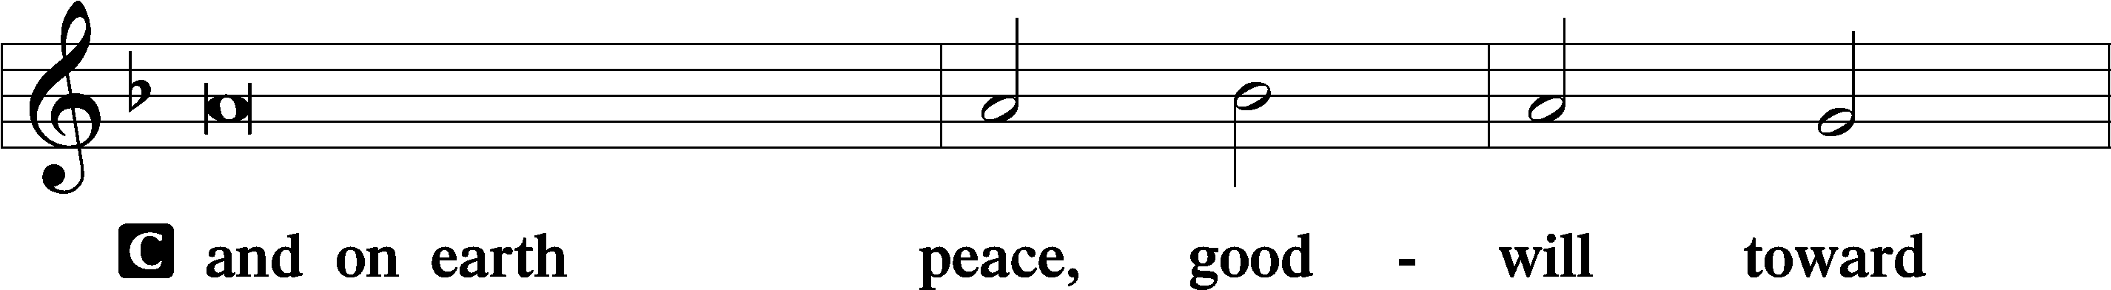
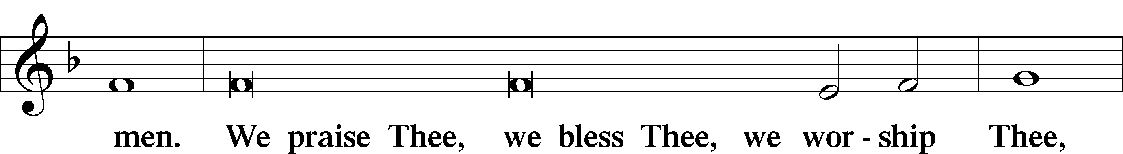
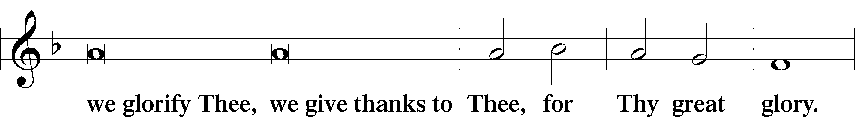
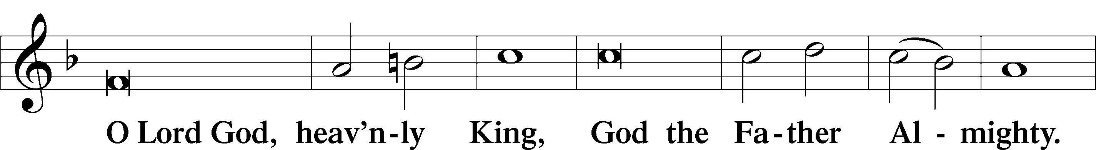
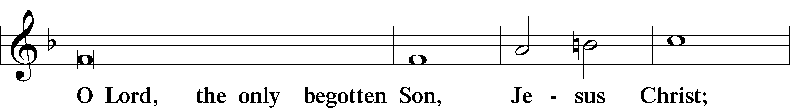
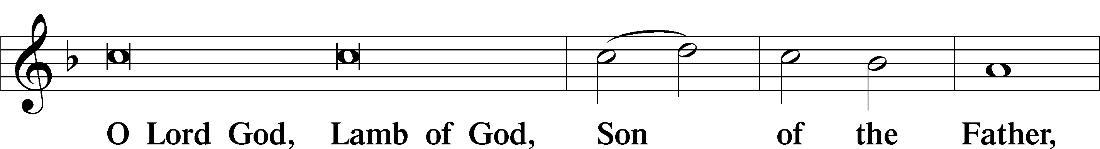
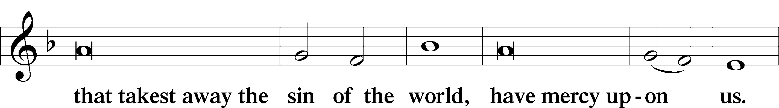
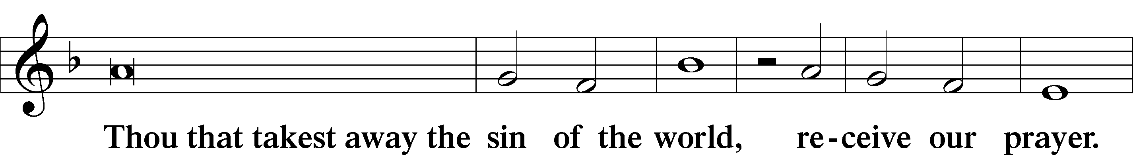
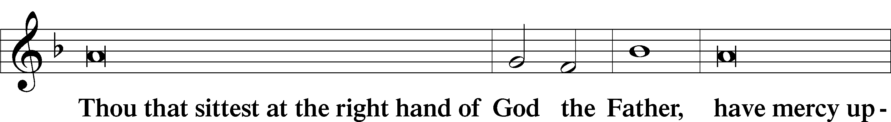
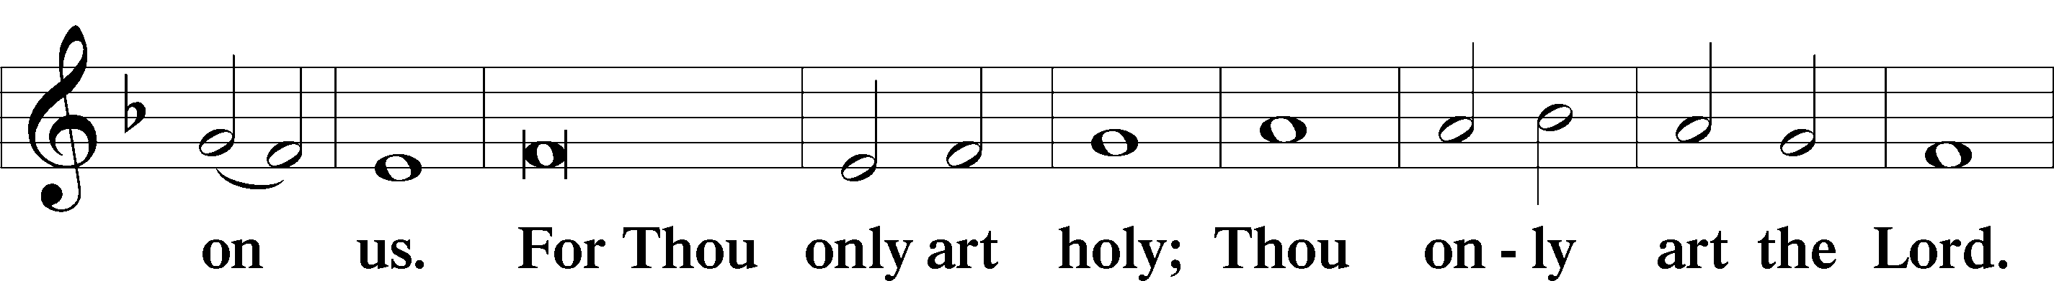
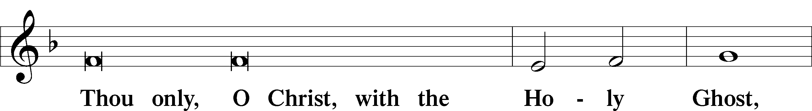
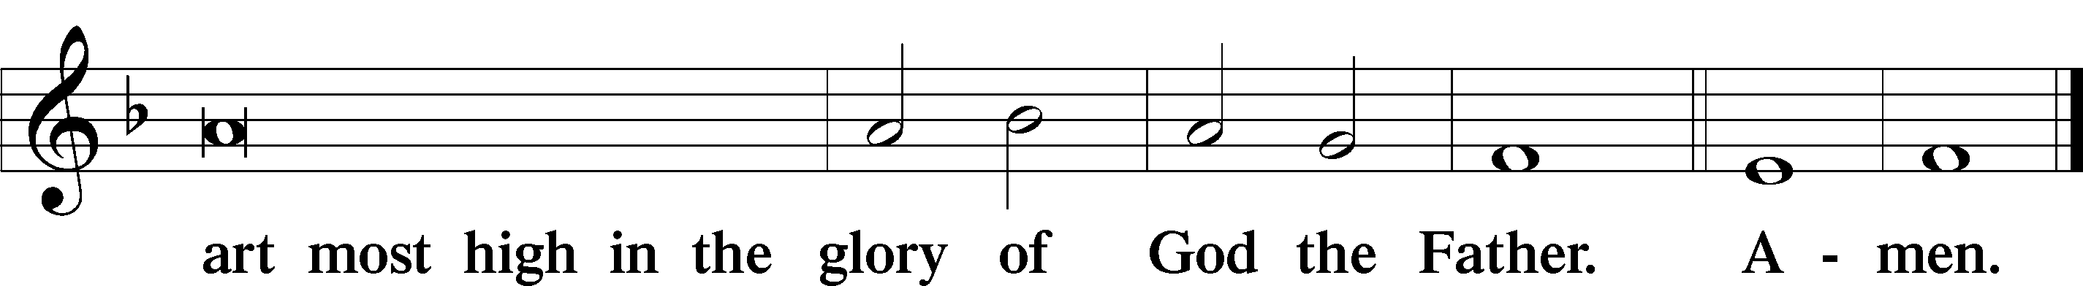

Salutation and Collect of the Day: Jubilate
P The Lord be with you.
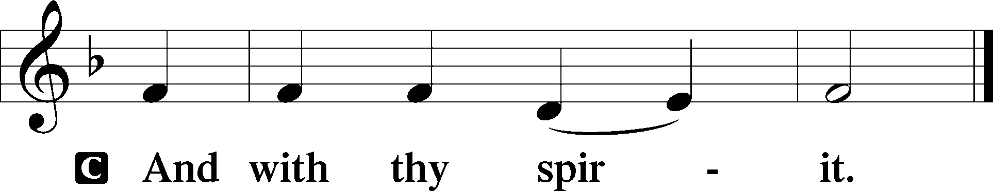

P Let us pray.
Almighty God, You show those in error the light of Your truth so that they may return to the way of righteousness. Grant faithfulness to all who are admitted into the fellowship of Christ’s Church that they may avoid whatever is contrary to their confession and follow all such things as are pleasing to You; through Jesus Christ, Your Son, our Lord, who lives and reigns with You and the Holy Spirit, one God, now and forever.
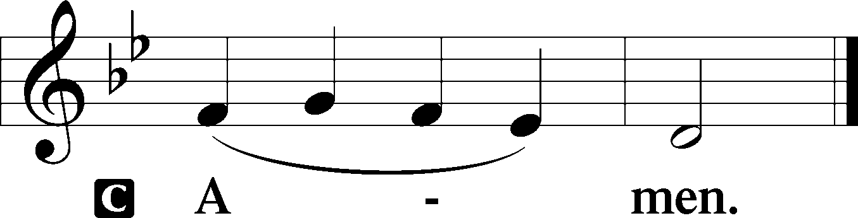
Sit

Prophecy: Isaiah 40:25–31 (NKJV)
Thus says the Lord God: “To whom will you liken Me, or to whom shall I be equal?” says the Holy One. Lift up your eyes on high, and see who has created these things, who brings out their host by number; He calls them all by name, by the greatness of His might and the strength of His power; not one is missing. Why do you say, O Jacob, and speak, O Israel: “My way is hidden from the Lord, and my just claim is passed over by my God”? Have you not known? Have you not heard? The everlasting God, the Lord, the Creator of the ends of the earth, neither faints nor is weary. His understanding is unsearchable. He gives power to the weak, and to those who have no might He increases strength. Even the youths shall faint and be weary, and the young men shall utterly fall, but those who wait on the Lord shall renew their strength; they shall mount up with wings like eagles, they shall run and not be weary, they shall walk and not faint.

P This is the Word of the Lord.
C Thanks be to God.

Psalm: Psalm 147:1–11
Praise the Lord!
For it is good to sing praises to our God;
for it is pleasant, and a song of praise is fitting.
The Lord builds up Jerusalem;
he gathers the outcasts of Israel.
He heals the brokenhearted
and binds up their wounds.
He determines the number of the stars;
he gives to all of them their names.
Great is our Lord, and abundant in power;
his understanding is beyond measure.
The Lord lifts up the humble;
he casts the wicked to the ground.
Sing to the Lord with thanksgiving;
make melody to our God on the lyre!
He covers the heavens with clouds;
he prepares rain for the earth;
he makes grass grow on the hills.
He gives to the beasts their food,
and to the young ravens that cry.
His delight is not in the strength of the horse,
nor his pleasure in the legs of a man,
but the Lord takes pleasure in those who fear him,
in those who hope in his steadfast love.

Epistle: 1 Peter 2:11–20 (NKJV)
Dearly Beloved: I beg you as sojourners and pilgrims, abstain from fleshly lusts which war against the soul, having your conduct honorable among the Gentiles, that when they speak against you as evildoers, they may, by your good works which they observe, glorify God in the day of visitation. Therefore submit yourselves to every ordinance of man for the Lord’s sake, whether to the king as supreme, or to governors, as to those who are sent by him for the punishment of evildoers and for the praise of those who do good. For this is the will of God, that by doing good you may put to silence the ignorance of foolish men—as free, yet not using liberty as a cloak for vice, but as bondservants of God. Honor all people. Love the brotherhood. Fear God. Honor the king. Servants, be submissive to your masters with all fear, not only to the good and gentle, but also to the harsh. For this is commendable, if because of conscience toward God one endures grief, suffering wrongfully. For what credit is it if, when you are beaten for your faults, you take it patiently? But when you do good and suffer, if you take it patiently, this is commendable before God.

P This is the Word of the Lord.
C Thanks be to God.

Stand

Verse Psalm 111:9a; Luke 24:26
Alleluia. He sent redemption to his people. Alleluia. Was it not necessary that the Christ should suffer these things and enter into his glory? Alleluia.

Alleluia
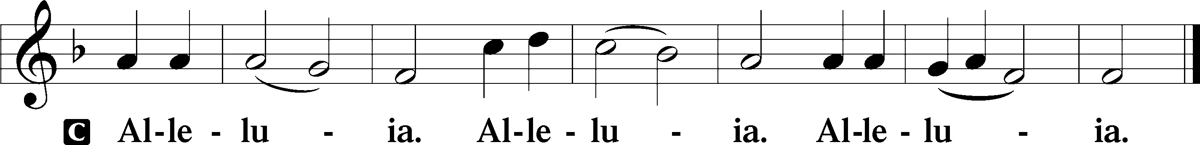

Holy Gospel: John 16:16–22 (NKJV)
P The Holy Gospel according to St. John, the sixteenth chapter.
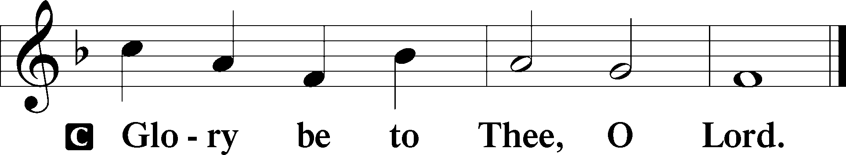

At that time Jesus said to His disciples: “A little while, and you will not see Me; and again a little while, and you will see Me, because I go to the Father.” Then some of His disciples said among themselves, “What is this that He says to us, ‘A little while, and you will not see Me; and again a little while, and you will see Me’; and, ‘because I go to the Father’?” They said therefore, “What is this that He says, ‘A little while’? We do not know what He is saying.” Now Jesus knew that they desired to ask Him, and He said to them, “Are you inquiring among yourselves about what I said, ‘A little while, and you will not see Me; and again a little while, and you will see Me’? Most assuredly, I say to you that you will weep and lament, but the world will rejoice; and you will be sorrowful, but your sorrow will be turned into joy. A woman, when she is in labor, has sorrow because her hour has come; but as soon as she has given birth to the child, she no longer remembers the anguish, for joy that a human being has been born into the world. Therefore you now have sorrow; but I will see you again and your heart will rejoice, and your joy no one will take from you.”

P This is the Gospel of the Lord.
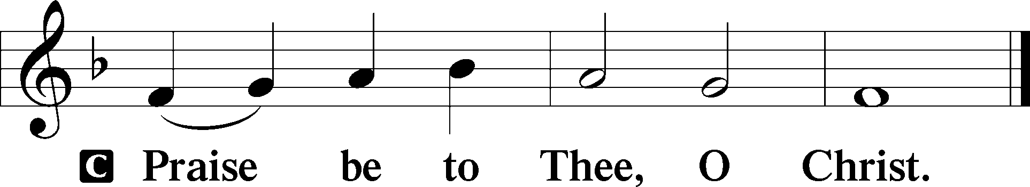

Nicene Creed
C I believe in one God,
the Father Almighty,
maker of heaven and earth
and of all things visible and invisible.

And in one Lord Jesus Christ,
the only-begotten Son of God,
begotten of His Father before all worlds,
God of God, Light of Light,
very God of very God,
begotten, not made,
being of one substance with the Father,
by whom all things were made;
who for us men and for our salvation came down from heaven
and was incarnate by the Holy Spirit of the virgin Mary
and was made man;
and was crucified also for us under Pontius Pilate.
He suffered and was buried.
And the third day He rose again according to the Scriptures
and ascended into heaven
and sits at the right hand of the Father.
And He will come again with glory to judge both the living and the dead,
whose kingdom will have no end.

And I believe in the Holy Spirit,
the Lord and giver of life,
who proceeds from the Father and the Son,
who with the Father and the Son together is worshiped and glorified,
who spoke by the prophets.
And I believe in one holy Christian and apostolic Church,
I acknowledge one Baptism for the remission of sins,
and I look for the resurrection of the dead
and the life T of the world to come. Amen.
Sit
Hymn of the Day: LSB #483 “With High Delight Let Us Unite”

Sermon

Stand

Prayer of the Church

Offertory Psalm 51:10–12
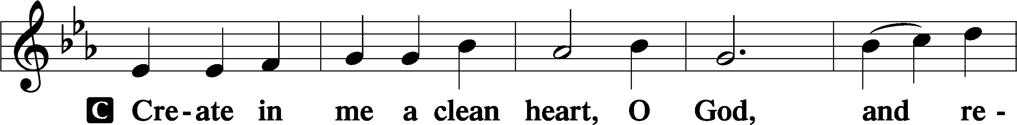
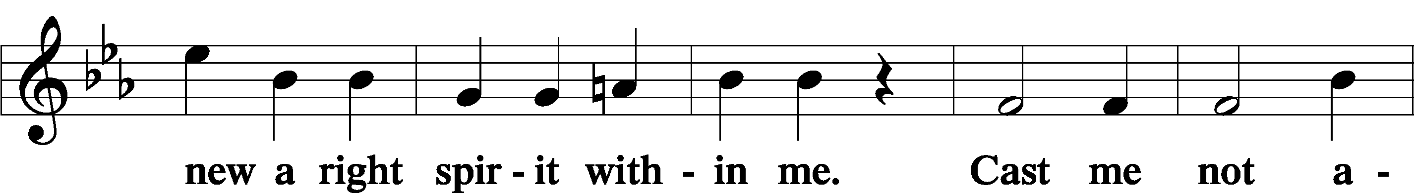
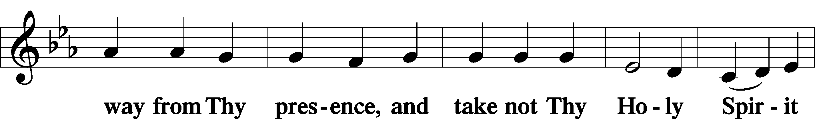
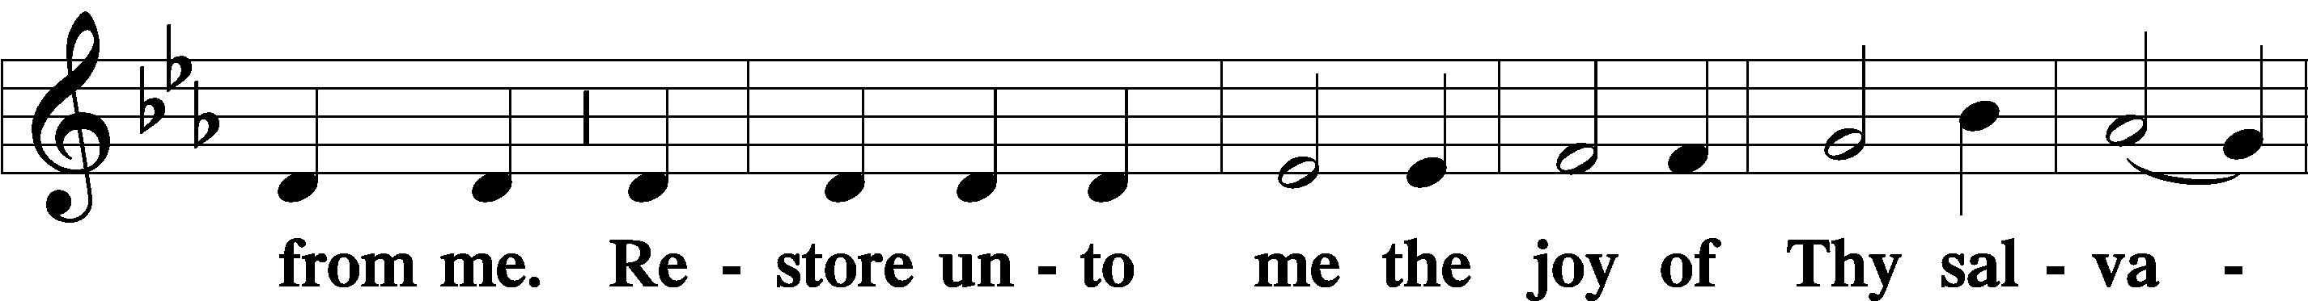
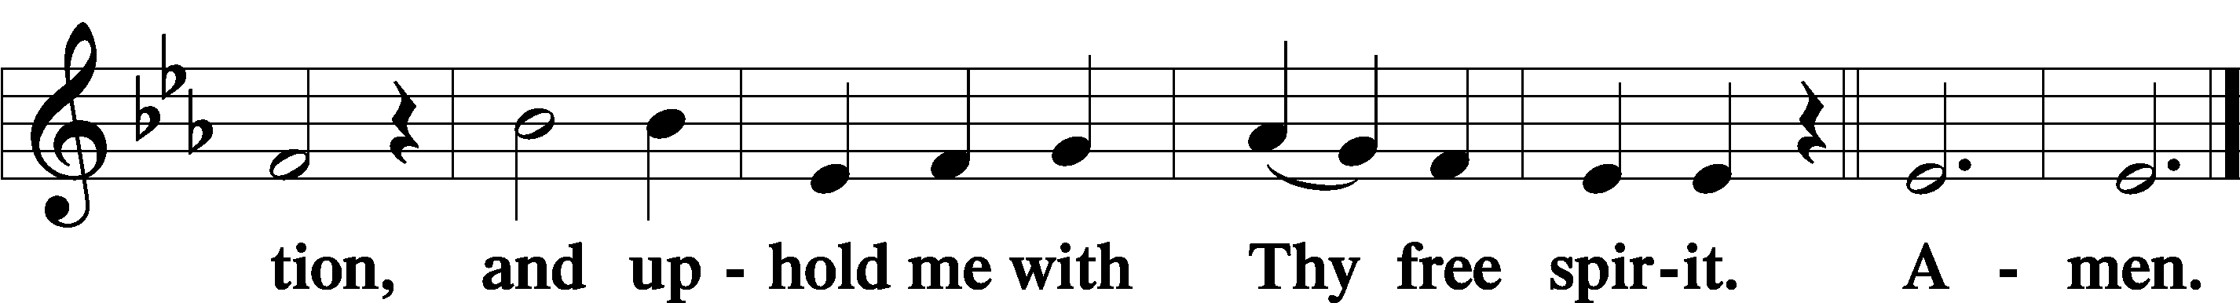
Sit

Preparatory Hymn: LSB #897 “O Rejoice, Ye Christians, Loudly”

Stand
Service of the Sacrament

Preface 2 Timothy 4:22; Colossians 3:1 Psalm 136
P The Lord be with you.
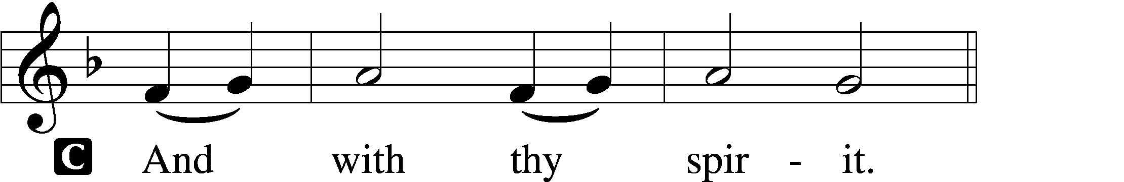
P Lift up your hearts.
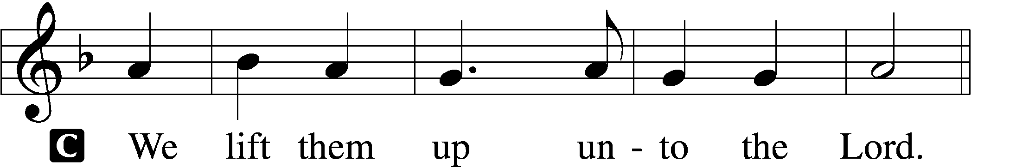

P Let us give thanks unto the Lord, our God.
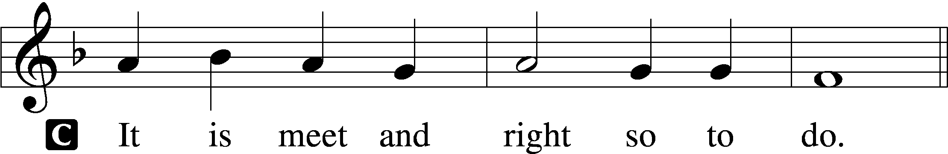

Proper Preface (Abbreviated) LSB 194
P It is truly meet, right, and salutary . . . evermore praising You and saying:

Sanctus Isaiah 6:3; Matthew 21:9
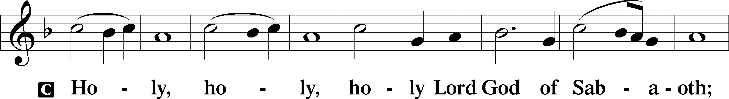
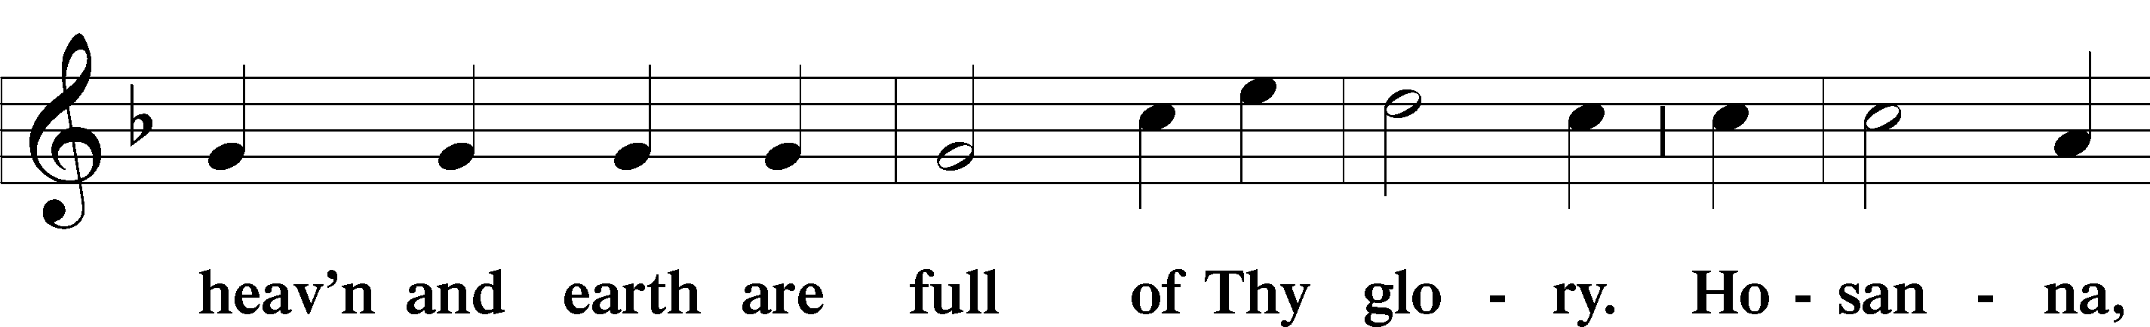
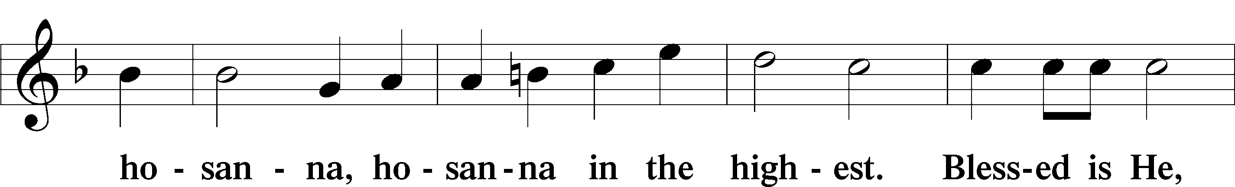
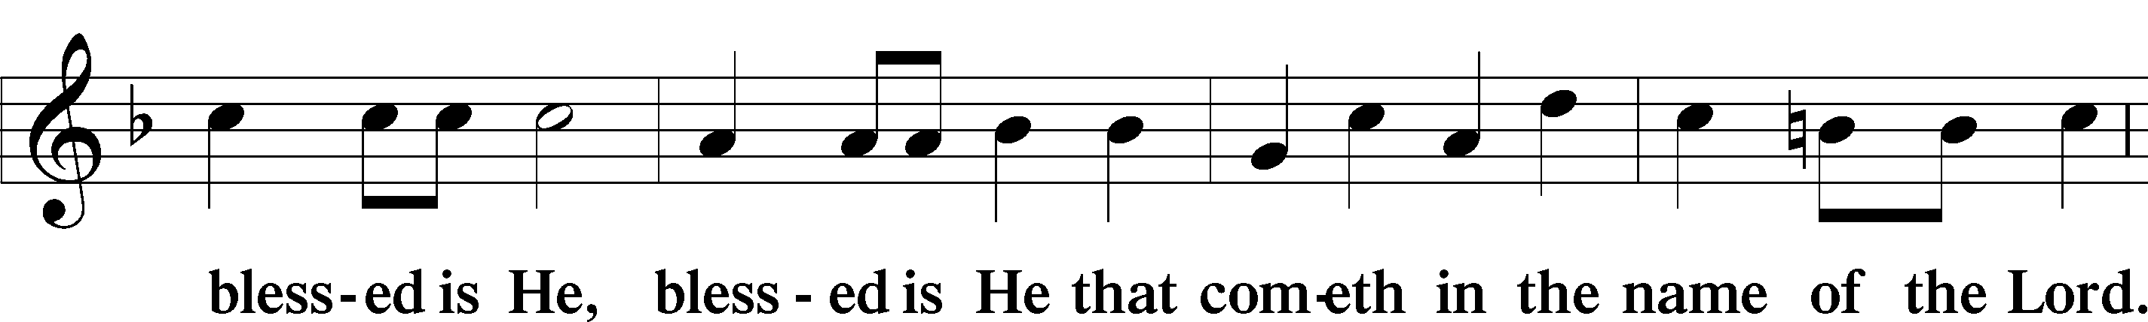
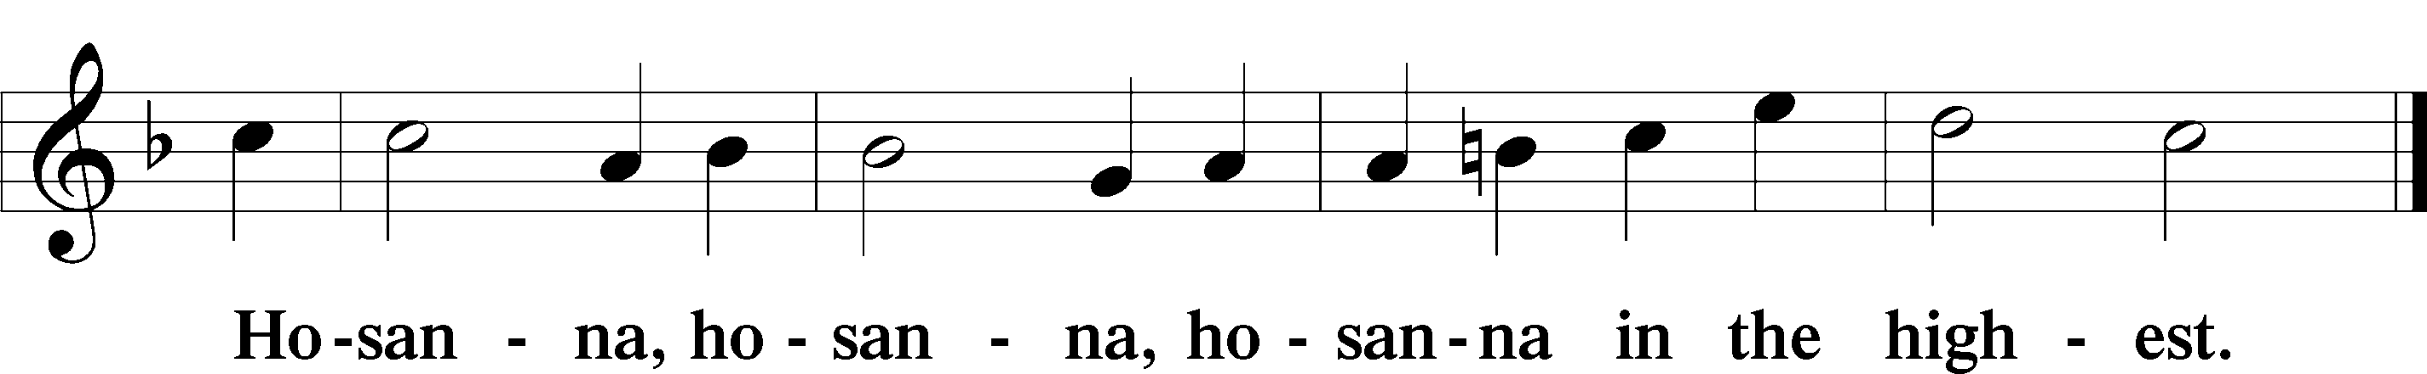

Lord’s Prayer Matthew 6:9–13
C Our Father who art in heaven,
hallowed be Thy name,
Thy kingdom come,
Thy will be done on earth as it is in heaven;
give us this day our daily bread;
and forgive us our trespasses as we forgive those who trespass against us;
and lead us not into temptation,
but deliver us from evil.
For Thine is the kingdom and the power and the glory forever and ever. Amen.

The Words of Our Lord Matthew 26:26–28; Mark 14:22–24; Luke 22:19–20; 1 Corinthians 11:23–25
P Our Lord Jesus Christ, on the night when He was betrayed, took bread, and when He had given thanks, He broke it and gave it to the disciples and said: “Take, eat; this is My T body, which is given for you. This do in remembrance of Me.”

In the same way also He took the cup after supper, and when He had given thanks, He gave it to them, saying: “Drink of it, all of you; this cup is the new testament in My T blood, which is shed for you for the forgiveness of sins. This do, as often as you drink it, in remembrance of Me.”

Pax Domini John 20:19
P The peace of the Lord be with you always.
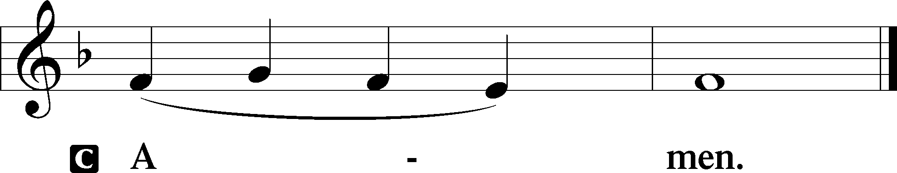

Agnus Dei John 1:29
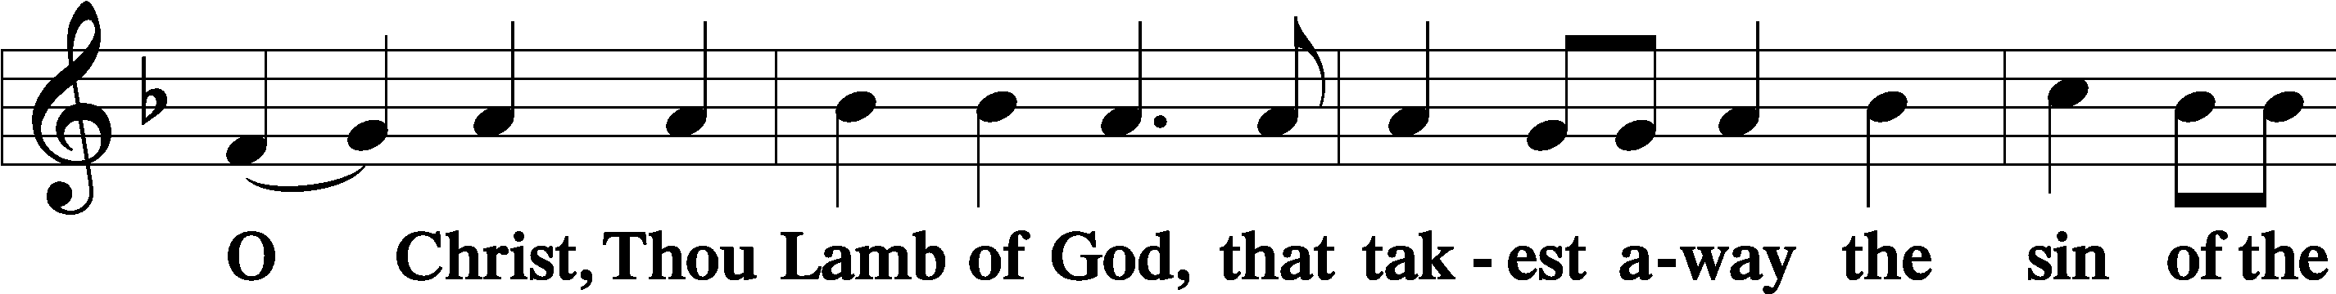
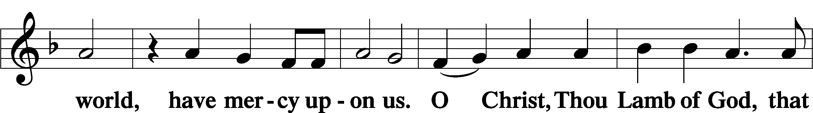
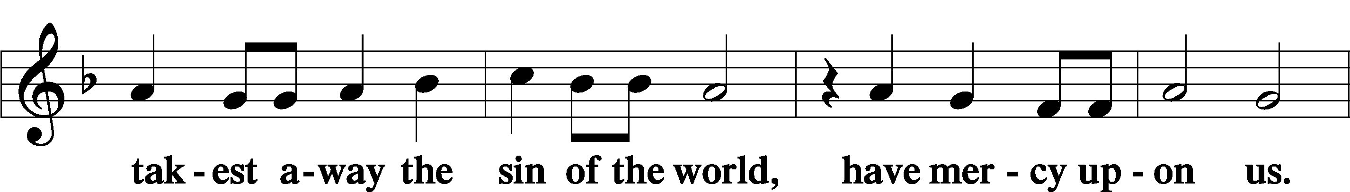
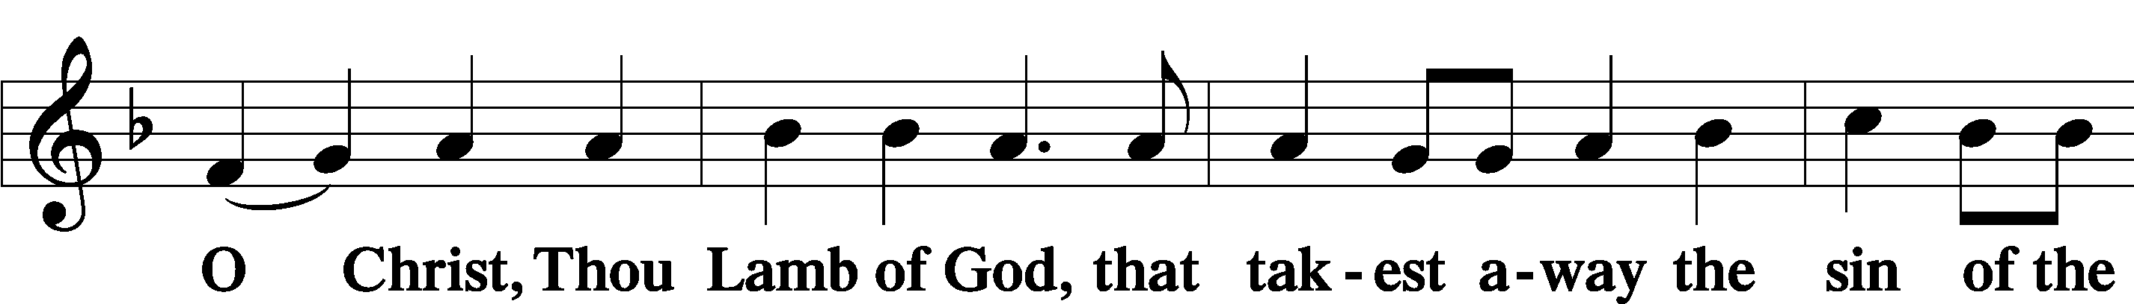
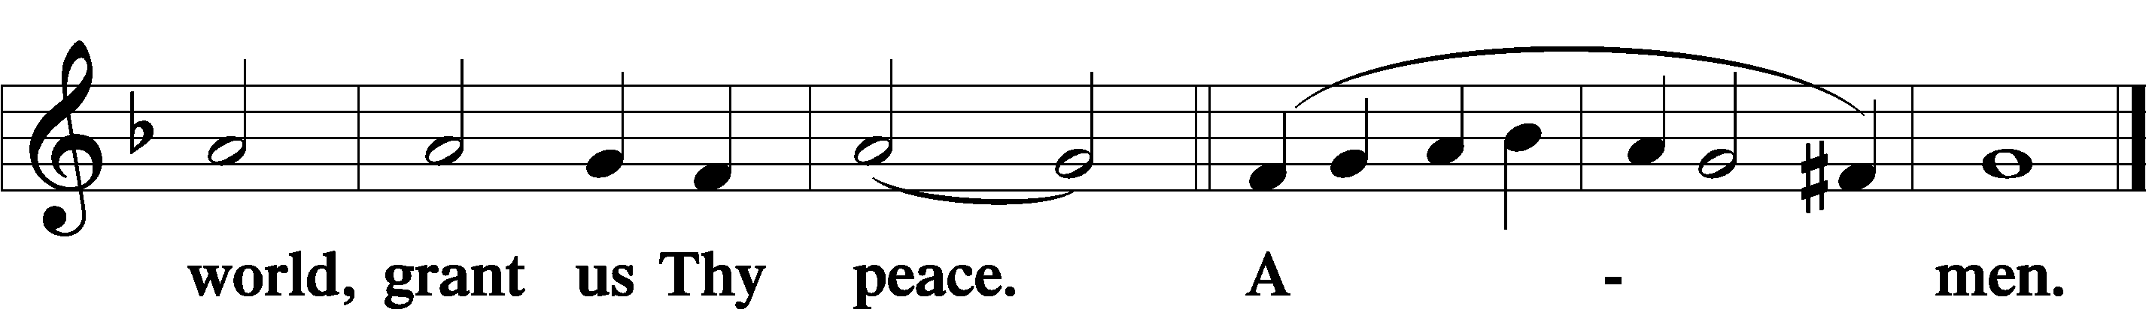
Sit

Distribution
The pastor and those who assist him receive the body and blood of Christ first and then distribute them to those who come to receive, saying:
Take, eat; this is the true body of our Lord and Savior Jesus Christ, given into death for your sins.
Amen.

Take, drink; this is the true blood of our Lord and Savior Jesus Christ, shed for the forgiveness of your sins.
Amen.

In dismissing the communicants, the following is said:
The Dismissal
P The body and blood of our Lord Jesus Christ strengthen and preserve you in body and soul to life everlasting. Depart T in peace.
C Amen.

Distribution Hymn: LSB #818 “In Thee Is Gladness”

Distribution Hymn: LSB #708 “Lord, Thee I Love with All My Heart”

Distribution Hymn: LSB #475 “Good Christian Friends, Rejoice and Sing”

Stand

Nunc Dimittis Luke 2:29–32
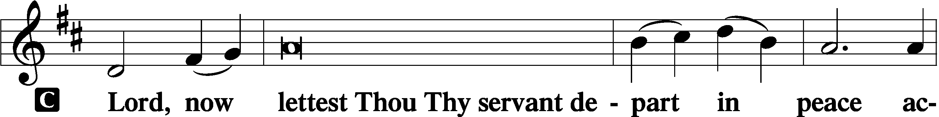
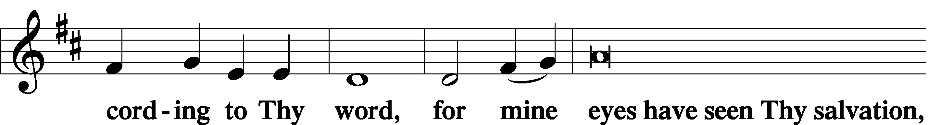
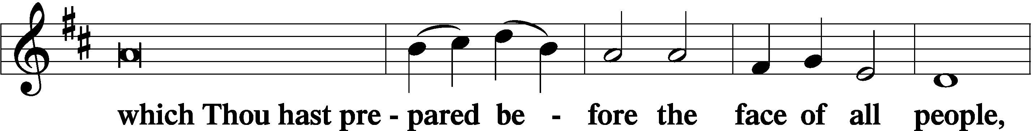
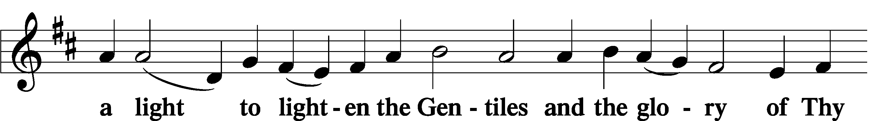
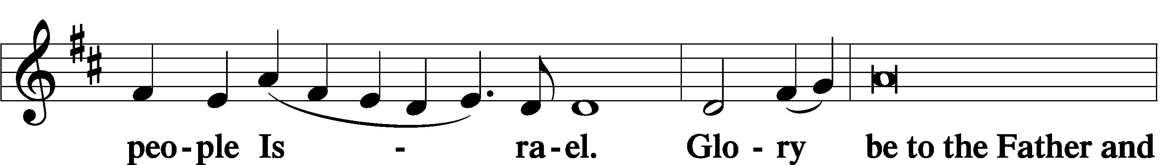
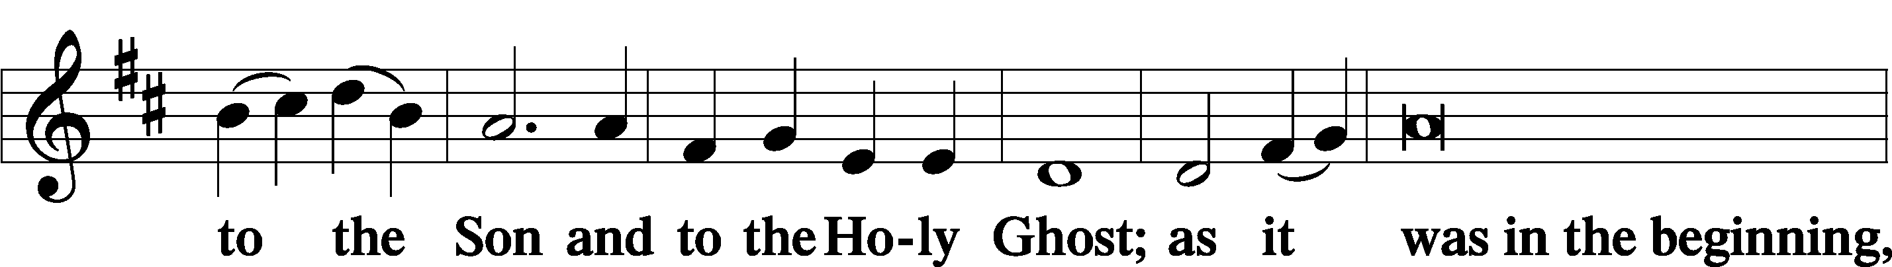
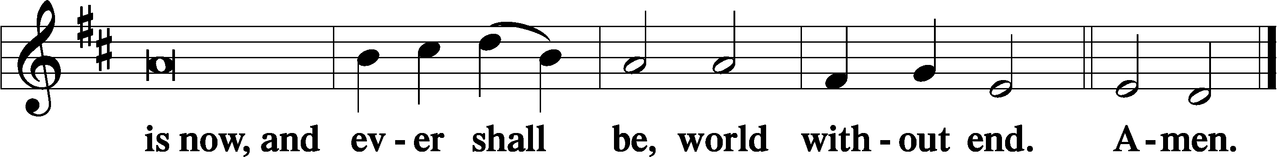

Thanksgiving Psalm 107:1
P O give thanks unto the Lord, for He is good,
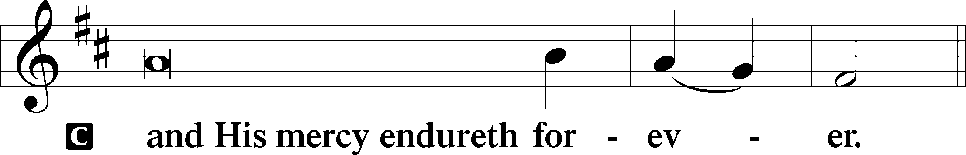

Post-Communion Collect
P Let us pray.
We give thanks to You, almighty God, that You have refreshed us through this salutary gift, and we implore You that of Your mercy You would strengthen us through the same in faith toward You and in fervent love toward one another; through Jesus Christ, Your Son, our Lord, who lives and reigns with You and the Holy Spirit, one God, now and forever.
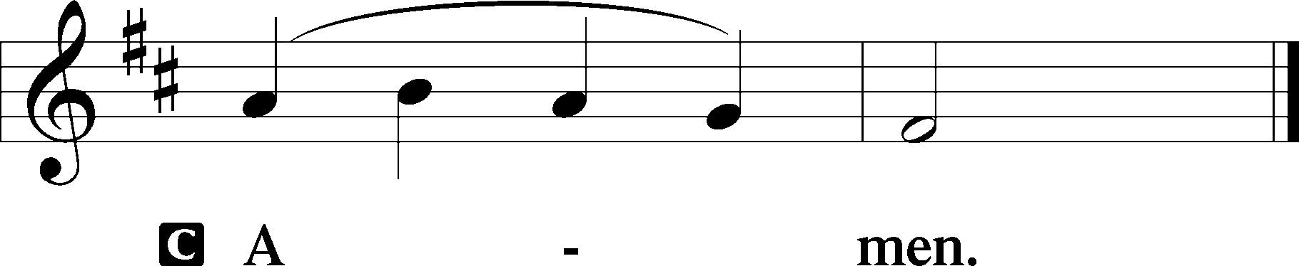

Salutation 2 Timothy 4:22
P The Lord be with you.
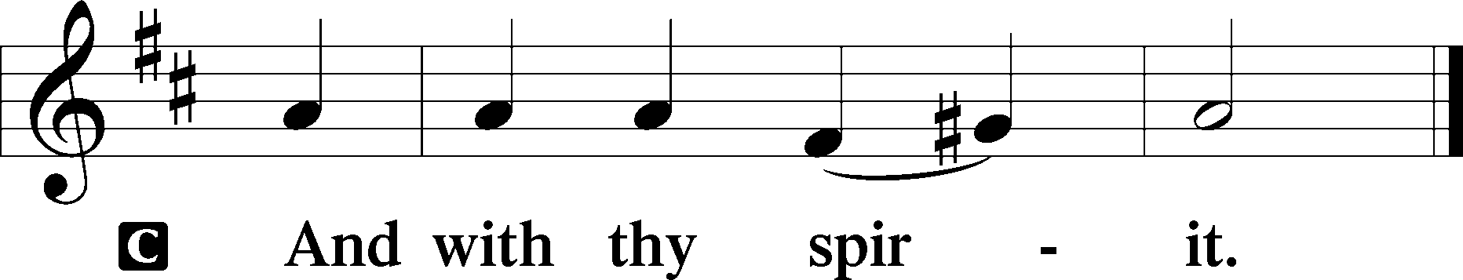

Benedicamus Psalm 103:1
P Bless we the Lord.
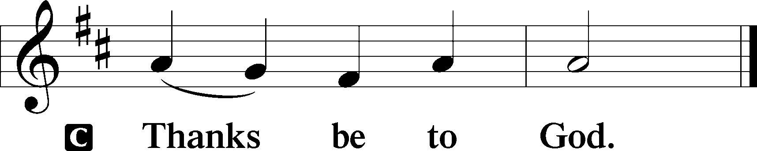

Benediction Numbers 6:24–26
P The Lord bless you and keep you.
The Lord make His face shine upon you and be gracious unto you.
The Lord lift up His countenance upon you and T give you peace.
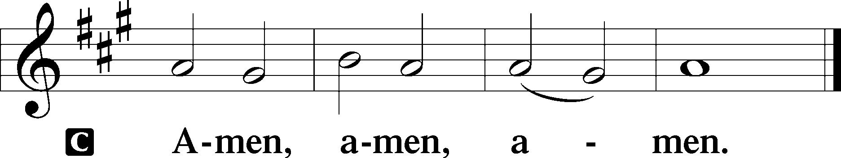

Closing Hymn: LSB #469 “Christ the Lord Is Risen Today”

Silent prayer after worship: Dear Jesus, grant me the assurance that I am never alone, but that You are always with me. Lead me to be in Your Word, in prayer, and in worship regularly so that through me You might bring others to Yourself. Amen.
fffffffffffffffffffffffffffffffffff
Acknowledgments: Unless otherwise indicated, Scripture quotations are from the ESV® Bible (The Holy Bible, English Standard Version®), copyright © 2001 by Crossway, a publishing ministry of Good News Publishers. Used by permission. All rights reserved. Created by Lutheran Service Builder © 2023 Concordia Publishing House.
fffffffffffffffffffffffffffffffffff
fffffffffffffffffffffffffffffffffff
In Loving Memory of my Aunt, Anne Zomparelli, and Uncle, Rev. Paul Grexa: Dolores Fee (Capital Campaign).
In Loving Memory of Don Riefstahl and Viola Sakony: Barry & Chris Nelson (Food Pantry).
fffffffffffffffffffffffffffffffffff
SCHEDULE THROUGH MAY 7, 2023:

:

Today, 7 pm, Fellowship Hall: AA Meeting
Tuesday, 7-9 pm, Fellowship Hall: Penn-Ohio Singers
Wednesday, 7:30 pm, Fellowship Hall: NA Meeting
Thursday, 10 am, Fellowship Hall: Women’s Bible Study
Saturday, 9:30 am, All Saints~Slippery Rock: Catechism Class
Next Sunday, 8 am, Fellowship Hall: Bible Study
9 am, Sanctuary: Divine Service
Following Worship: Coffee Fellowship
7 pm, Fellowship Hall: AA Meeting
fffffffffffffffffffffffffffffffffff
Our Stewardship of Treasures for the Lord:
In order to do the Lord’s work, we need $2,553.63 each week to meet our 2023 budget for general purposes and $76.92 for the SELC. Online Figure for Wednesday, April 19, 2023
General Fund: $250.00
Figures for Sunday, April 16, 2023
General Fund: $751.00 Behind for the week*: -$1,552.63
SELC: $0.00 Behind for the week*: -$76.92
Food Pantry: $50.00
Capital Campaign: $60.00
Other: $873.00 *Includes above figures.

For online giving, check out https://www.saintspeterandpaul.net/online-giving.
fffffffffffffffffffffffffffffffffff
Remember the following in Prayer…
~The Hurting and Healing: The family and friends of Barry Nelson, who passed away April 25, 2023; also, Amy, Gerald Arthur, Ellen Baron^{CA}, Lois Bortner^{CA}, John Burdette, Bev & Joe Chlpka, Kathleen Coughenour, Kim, Anna Mae Daris, Susan Davies, Tim Dudash, Millie Elavsky, Joseph Fleet, Judith & Eddy Furey, Tim Haenftling, Austin Hamilton, Joan, Darla Krajci, Barbara Kreske, Donna Kennedy, Jess Lavoie, Joanne Lozier, Paul Lucas^{CA}, Sandy Marshall, Frank Niemeyer^{CA}, Linda Parkany, Juanita Rentschler, Richard Reuning^{CA}, Nancy Robertson^{CA}, Marty Scott, Kara, Fred Tonty, Angela Weser^{CA}, and Ruth Wolf.
~The Homebound: Rudy & Jean Tomko, Betty Wolf, and Ed & Millie Zachar.
~Serving in the Military: Curtis Sinewe and Joshua Solyan.
~Community & World Needs: Those suffering from or affected by the coronavirus; those suffering due to the conflict between Ukraine and Russia; those suffering from loss and dislocation because weather disasters; those suffering from addiction and their families; Local, State, and National Government Leaders; safety for all Police Officers, Firefighters, & First Responders; the unemployed; our Second Quarter Local Mission: The Support of a Concordia, Fort Wayne Seminarian.
*CA represents cancer.
fffffffffffffffffffffffffffffffffff
THANK YOU FOR SERVING IN APRIL: Elder: Jonathan Baisch; Ushers: Jerry Krivosh & Jeff Sutton; Altarware: (prior) Diane Riefstahl & Marie Flaugher (04/09 & 04/30); (after) Elizabeth Haenftling (04/02 & 04/16) & Marie Flaugher (04/09, 04/23, & 04/30).
fffffffffffffffffffffffffffffffffff
THANK YOU FOR SERVING IN MAY: Elder: Jonathan Baisch; Ushers: Matt Berent, Mark Gabriel, Michael Laird, & Jerome Thomas; Altarware: (prior) Diane Riefstahl & Marie Flaugher (05/14); (after) Evelyn Baisch & Arlene Sutton.
fffffffffffffffffffffffffffffffffff
Bible Memory Verses ~ Week of April 30th:
For Adults: In the same way, let your light shine before others, so that they may see your good works and give glory to your Father who is in heaven. Matthew 5:16

For Children: If anyone is in Christ, he is a new creation. The old has passed away; behold, the new has come. 2 Corinthians 5:17
Sincere sympathy is expressed to the family and friends of Barry Nelson, who passed away suddenly April 25, 2023. Calling hours for Barry will be Monday, May 1st from 4-8 pm at the McGonigle Funeral Home and Crematory and May 2nd from 10-11am here at the church. The funeral service will begin at 11 am.
May all be comforted by the fervent faith Barry had and the knowledge that he now rests in the arms of our Lord.
fffffffffffffffffffffffffffffffffff
Church Council members are reminded of the May meeting date change. We will now be meeting Monday, May 15th at 7 pm in the Fellowship Hall. Please be certain to submit your Council reports to the secretary’s office by noon that day so that packets can be put together.
fffffffffffffffffffffffffffffffffff
Attention all Women! Beginning in May, Women’s Bible Study will be held the first and third Thursdays of each month from 10-11 am. Please join us this coming Thursday as we study the book of Philippians.
fffffffffffffffffffffffffffffffffff
Attendance: Sunday, April 23, 2023: 39
fffffffffffffffffffffffffffffffffff
Available in the narthex:
- May issue of “The Rock and the Sword” newsletter.
- Minutes from the March 18th Altar Guild meeting.
- Copies of the “Lutherans Engage” magazine.
fffffffffffffffffffffffffffffffffff
Join us next Sunday, May 7th, following worship for Coffee Fellowship. May’s sponsor is Linda Tomko.
If interested in sponsoring a Coffee Fellowship, please sign the sheet posted on the bulletin board in the narthex. Sponsors are asked to bring 2-1/2 to 3 dozen “treats” and 1 quart of juice to the Fellowship Hall kitchen prior to worship. All else, including set-up and clean-up, will be provided.
fffffffffffffffffffffffffffffffffff
Scrip orders and payments for May are due to Matt Berent next Sunday, May 7th. Order forms are available on the tables in the narthex and by the parking lot entrance.

Here to Serve
Pastor………………………………………………...……………Rev. Jacob Deal
E-mail …………………………….……pastordeal@saintspeterandpaul.net
Phone Number……………………..…………………724-347-3620 (Option 2)
Church Office………………………..…………………724-347-3620 (Option 3)
Website …………………………………………www.saintspeterandpaul.net
Secretary…………………………………………………………Diane Riefstahl
E-mail ………………………………………church@saintspeterandpaul.net
Website …………………………………………www.saintspeterandpaul.net
Food Pantry: Please leave message……………724-347-3620 (Option 3)
AA Contact: Steve………………………………………………..…724-813-2358
NA Contact: Larry………………………………………………..724-977-8733
Choir Director………………………………………………………Chris Nelson
Congregation President……………………………………Jonathan Baisch
Church Elder …………………………………………...…… Jonathan Baisch
fffffffffffffffffffffffffffffffffff
If needing to get into the church building during the week, please phone first to make certain someone is here to let you in.

