Sts. Peter & Paul Evangelical Lutheran Church, LC-MS
FEAST OF SAINT MARK, EVANGELIST
April 25, 2024

Stand

Common Versicles LSB 229
L O Lord, open my lips,
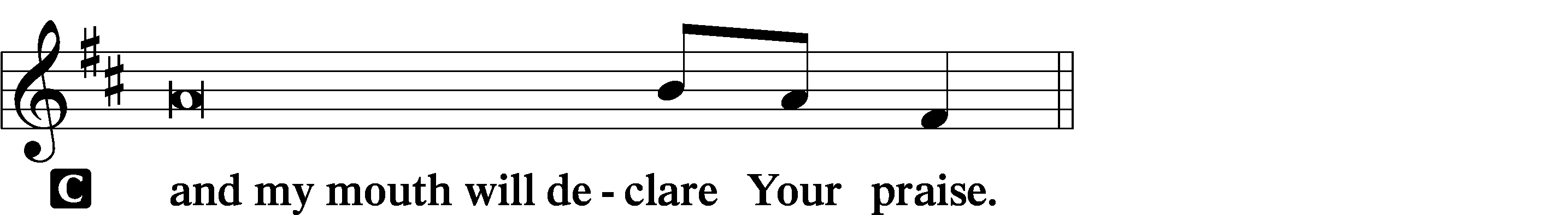

L Make haste, O God, to deliver me;
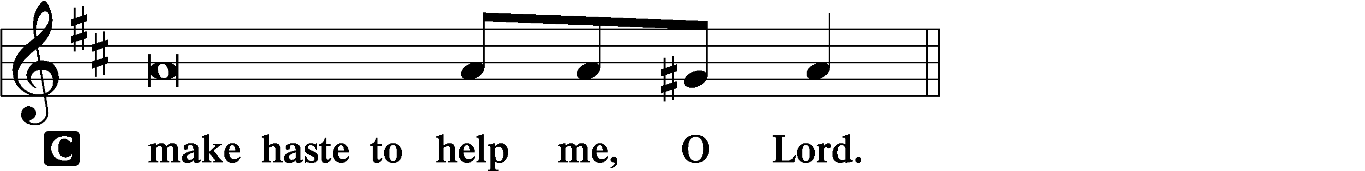

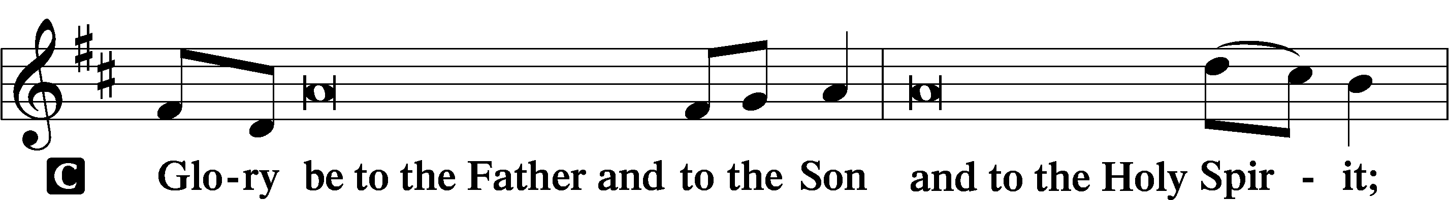
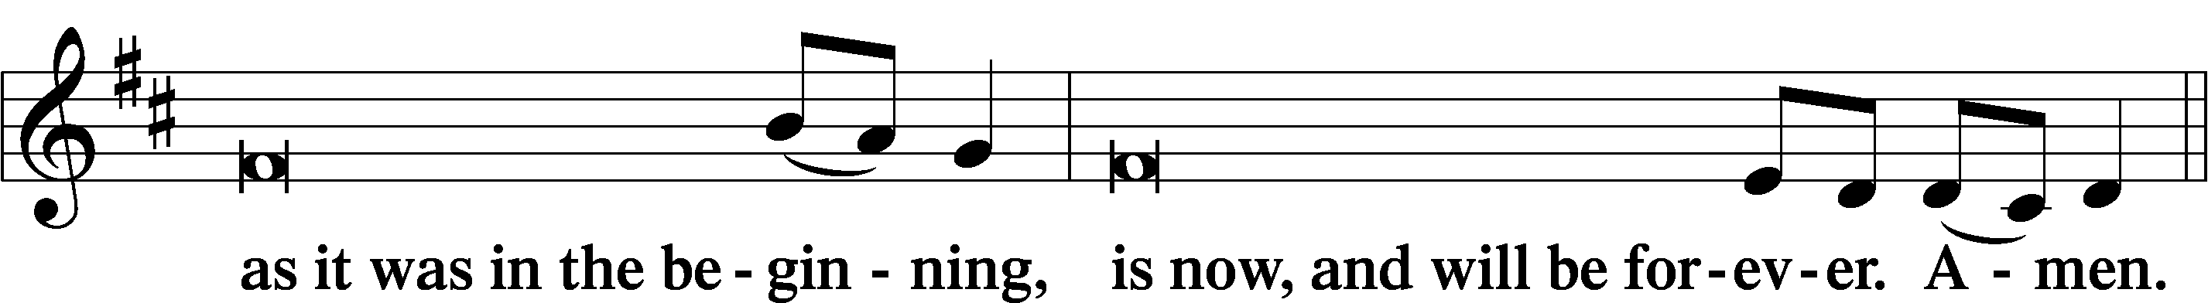
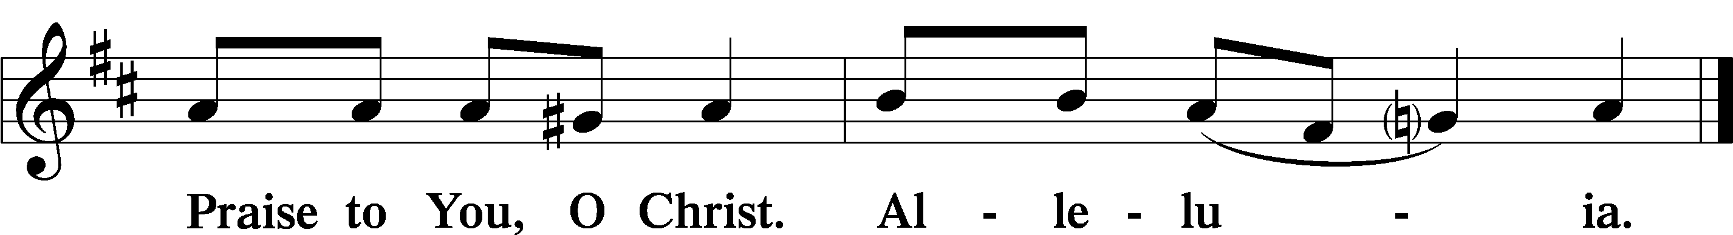
Psalmody
Psalm: Psalm 146
Praise the Lord!
Praise the Lord, O my soul!
I will praise the Lord as long as I live;
I will sing praises to my God while I have my being.
Put not your trust in princes,
in a son of man, in whom there is no salvation.
When his breath departs he returns to the earth;
on that very day his plans perish.
Blessèd is he whose help is the God of Jacob,
whose hope is in the Lord his God,
who made heaven and earth,
the sea, and all that is in them,
who keeps faith forever;
who executes justice for the oppressed,
who gives food to the hungry.
The Lord sets the prisoners free;
the Lord opens the eyes of the blind.
The Lord lifts up those who are bowed down;
the Lord loves the righteous.
The Lord watches over the sojourners;
he upholds the widow and the fatherless,
but the way of the wicked he brings to ruin.
The Lord will reign forever,
your God, O Zion, to all generations. Praise the Lord!
Sit

Office Hymn: LSB #836 “O God of Light” LSB 836
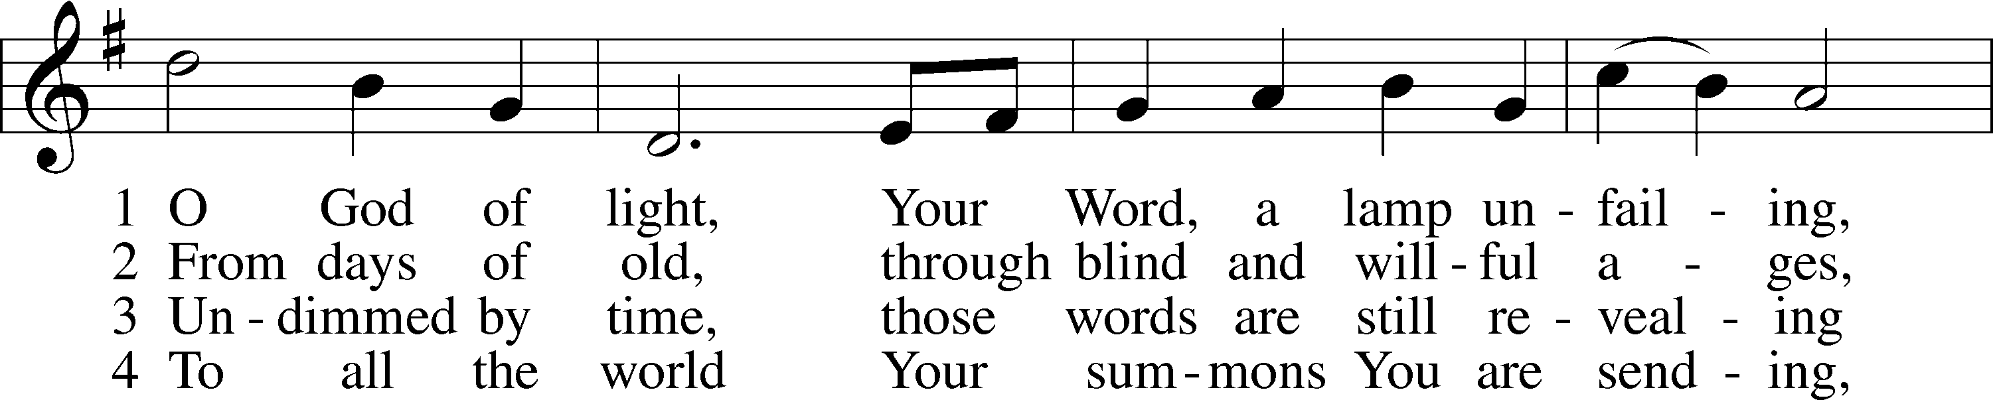
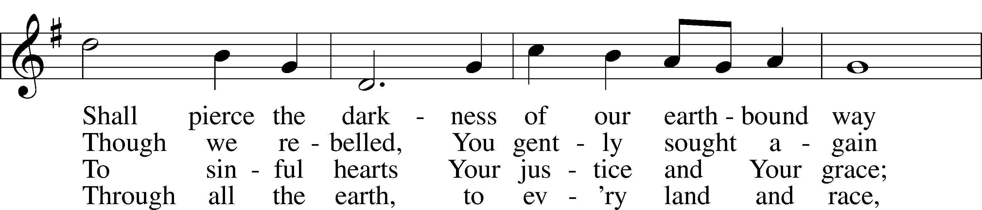
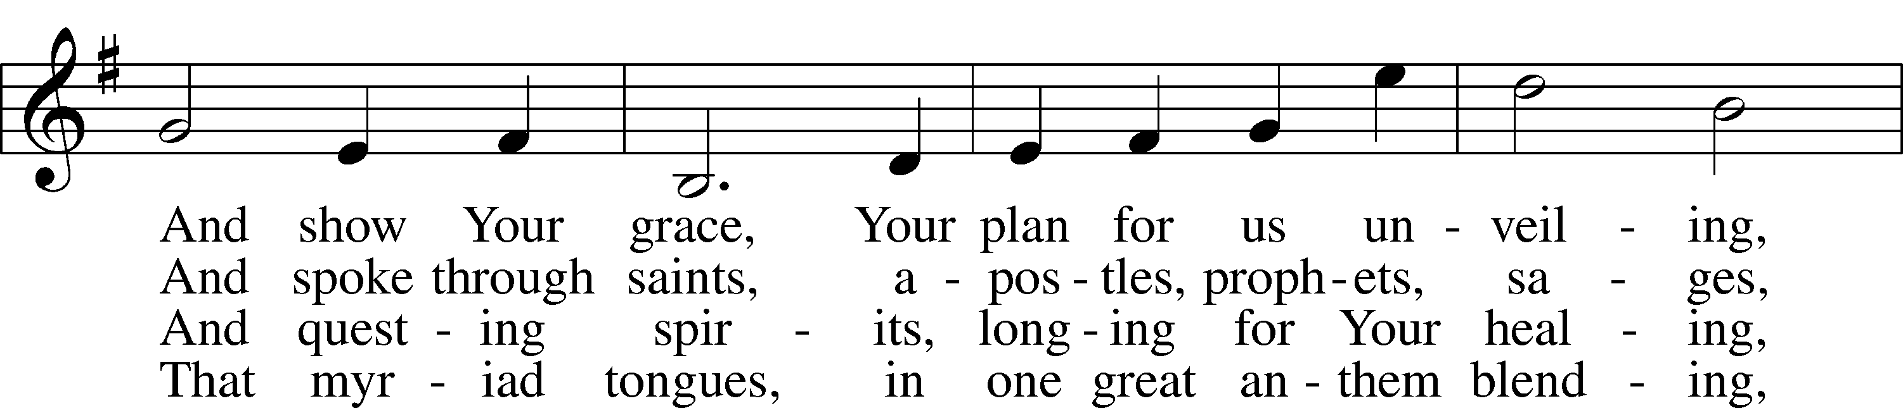
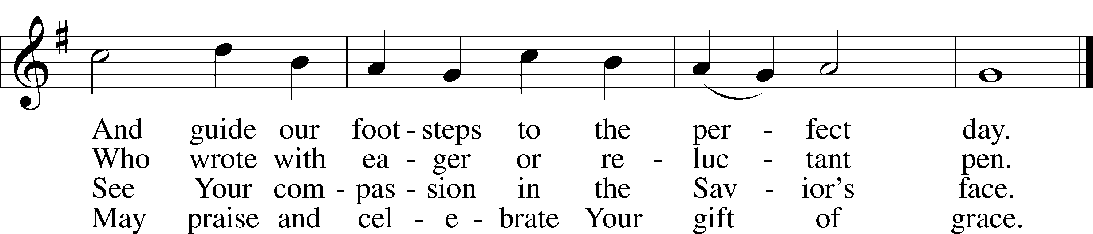

Text: Sarah E. Taylor, 1883–1954, alt. Tune: H. Barrie Cabena, 1933 Text: © 1952, renewed 1980 The Hymn Society, admin. Hope Publishing Co. Used by permission: LSB Hymn License no. 110004782 Tune: © 1978 Lutheran Book of Worship. Used by permission: LSB Hymn License no. 110004782

Readings

Prophecy: Wisdom 5:1-5 (NKJV)
The righteous man will stand with great confidence in the presence of those who have afflicted him and those who make light of his labors. When they see him, they will be shaken with dreadful fear, and they will be amazed at his unexpected salvation. They will speak to one another in repentance, and in anguish of spirit they will groan and say: “This is the man whom we once held in derision and made a byword of reproach—we fools! We thought that his life was madness and that his end was without honor. Why has he been numbered among the sons of God? And why is his lot among the saints?”

P O Lord, have mercy on us.
C Thanks be to God.

Epistle: Revelation 4:1-10a (NKJV)
In those days: I looked, and behold, a door standing open in heaven. And the first voice which I heard was like a trumpet speaking with me, saying, “Come up here, and I will show you things which must take place after this.” Immediately I was in the Spirit; and behold, a throne set in heaven, and One sat on the throne. And He who sat there was like a jasper and a sardius stone in appearance; and there was a rainbow around the throne, in appearance like an emerald. Around the throne were twenty-four thrones, and on the thrones I saw twenty-four elders sitting, clothed in white robes; and they had crowns of gold on their heads. And from the throne proceeded lightnings, thunderings, and voices. Seven lamps of fire were burning before the throne, which are the seven Spirits of God. Before the throne there was a sea of glass, like crystal. And in the midst of the throne, and around the throne, were four living creatures full of eyes in front and in back. The first living creature was like a lion, the second living creature like a calf, the third living creature had a face like a man, and the fourth living creature was like a flying eagle. The four living creatures, each having six wings, were full of eyes around and within. And they do not rest day or night, saying: “Holy, holy, holy, Lord God Almighty, who was and is and is to come!” Whenever the living creatures give glory and honor and thanks to Him who sits on the throne, who lives forever and ever, the twenty-four elders fall down before Him who sits on the throne and worship Him who lives forever and ever. Amen.

P O Lord, have mercy on us.
C Thanks be to God.

Gospel: John 15:1-7 (NKJV)
At that time Jesus said to His disciples: “I am the true vine, and My Father is the vinedresser. Every branch in Me that does not bear fruit He takes away; and every branch that bears fruit He prunes, that it may bear more fruit. You are already clean because of the word which I have spoken to you. Abide in Me, and I in you. As the branch cannot bear fruit of itself, unless it abides in the vine, neither can you, unless you abide in Me. “I am the vine, you are the branches. He who abides in Me, and I in him, bears much fruit; for without Me you can do nothing. If anyone does not abide in Me, he is cast out as a branch and is withered; and they gather them and throw them into the fire, and they are burned. If you abide in Me, and My words abide in you, you will ask what you desire, and it shall be done for you.

P O Lord, have mercy on us.
C Thanks be to God.
Sermon
Canticle
Stand
Antiphon (Common) 231
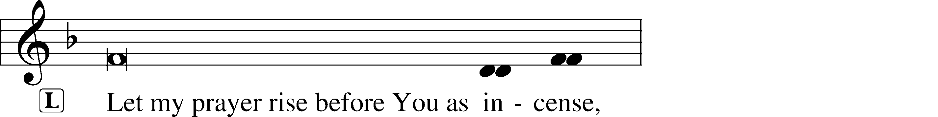
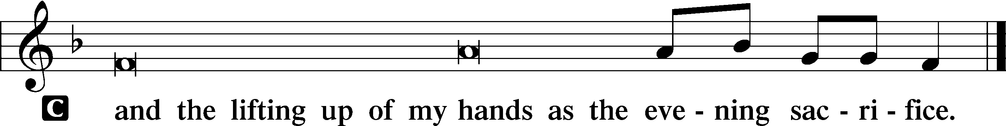

Magnificat 231
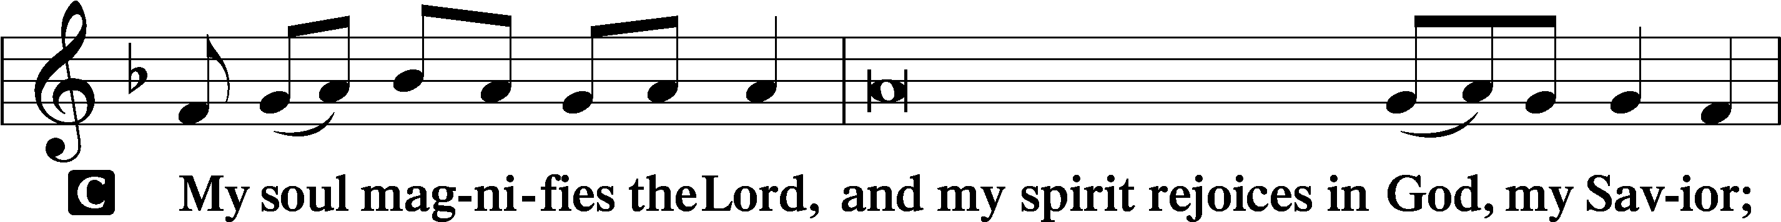
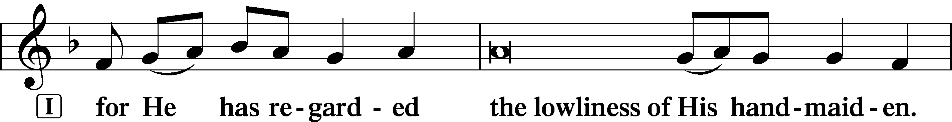
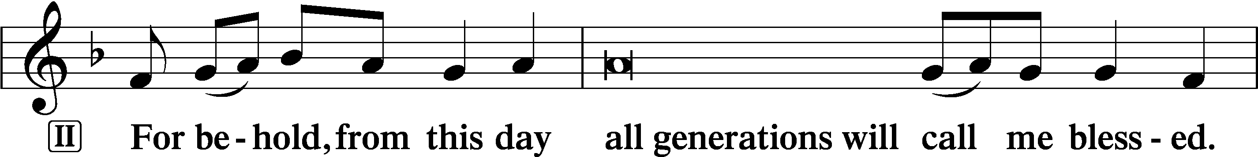
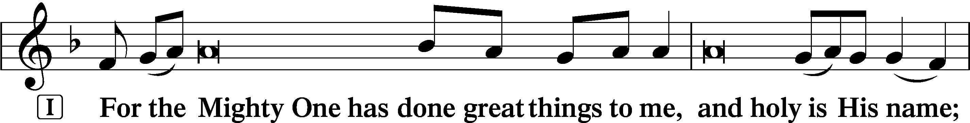
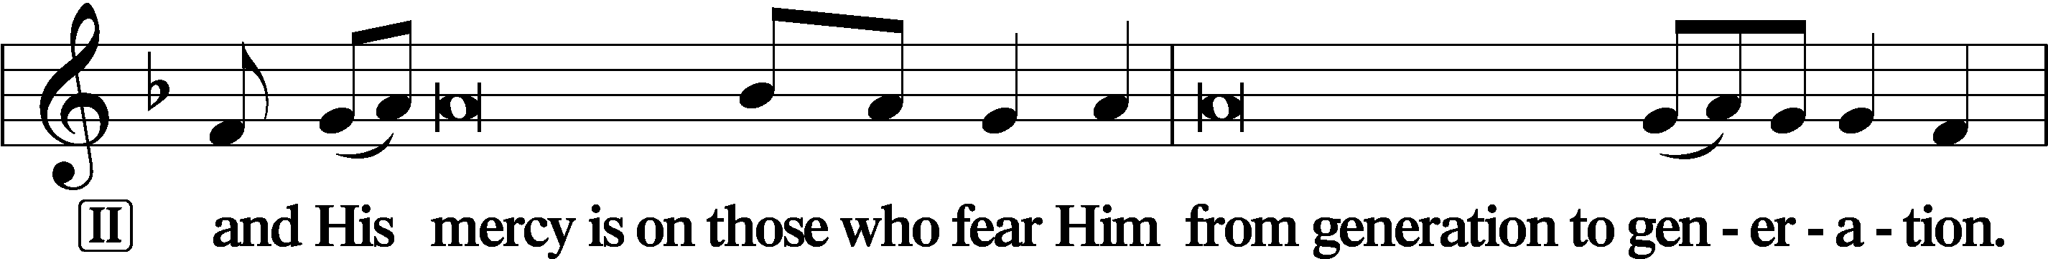
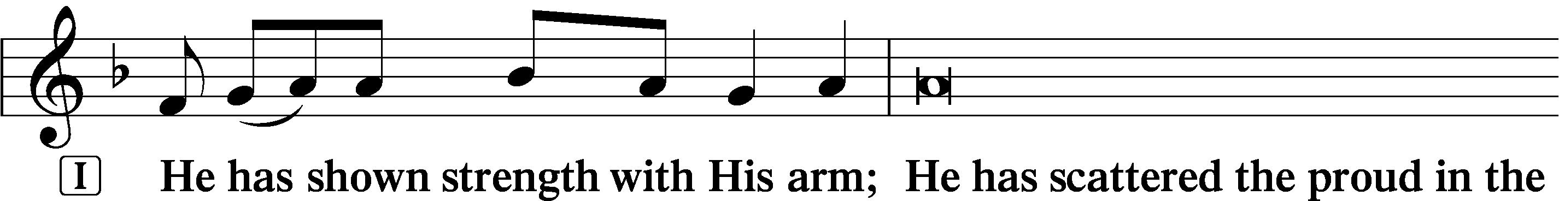
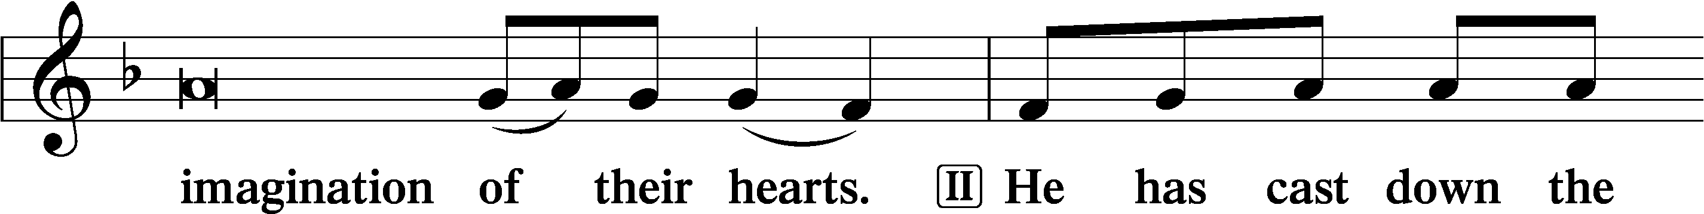
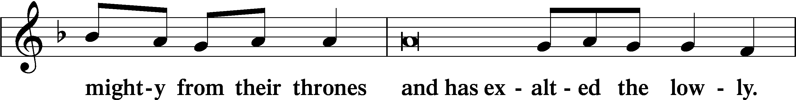
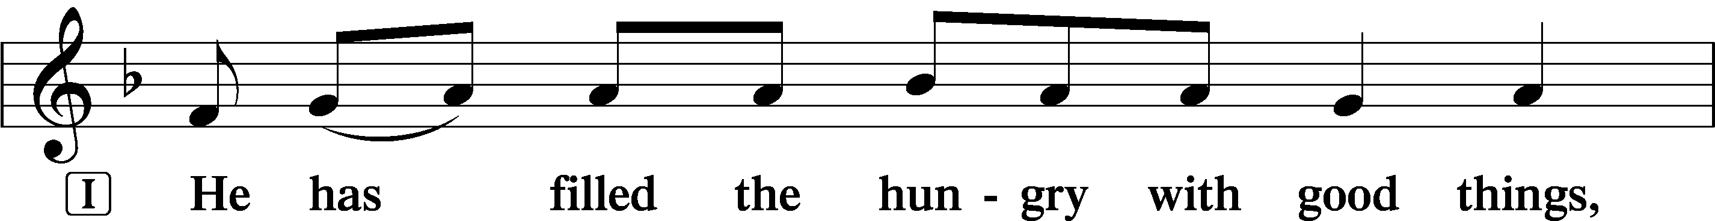
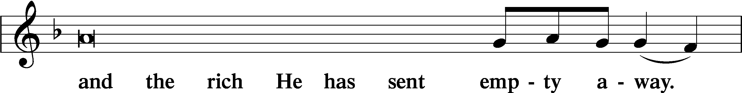
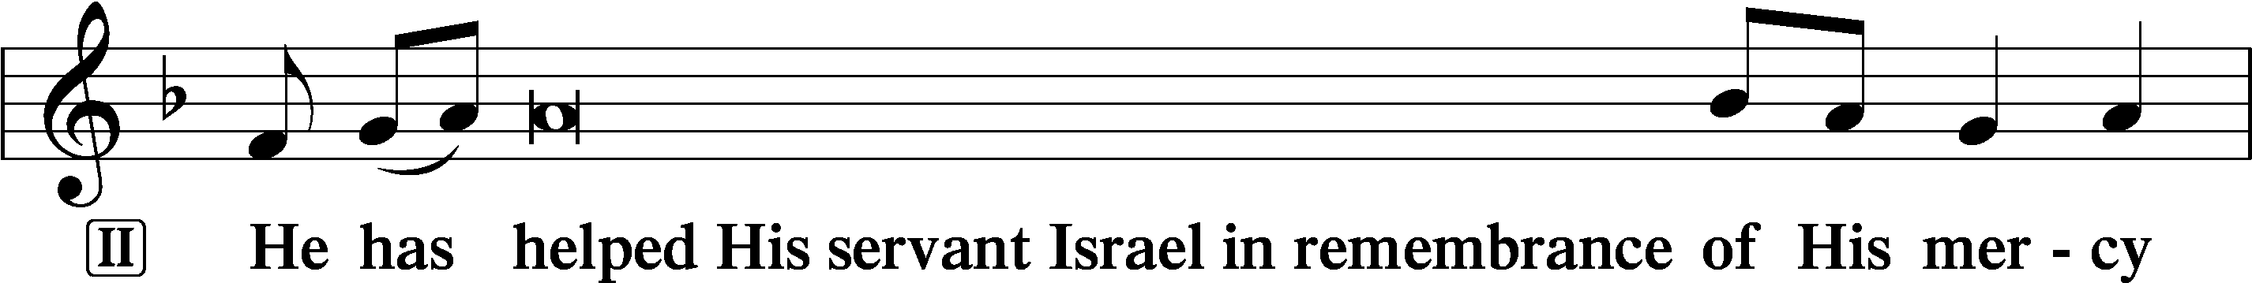
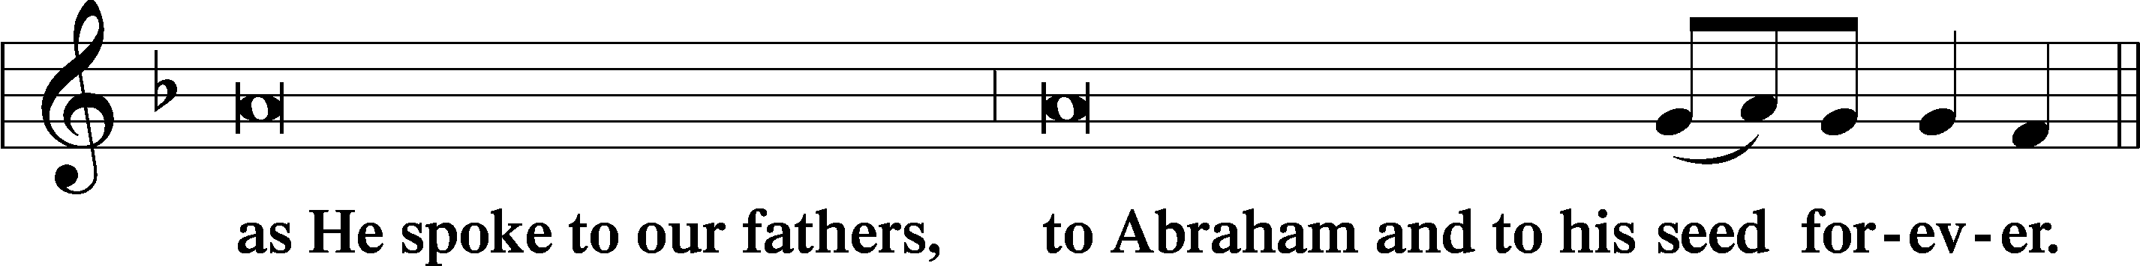
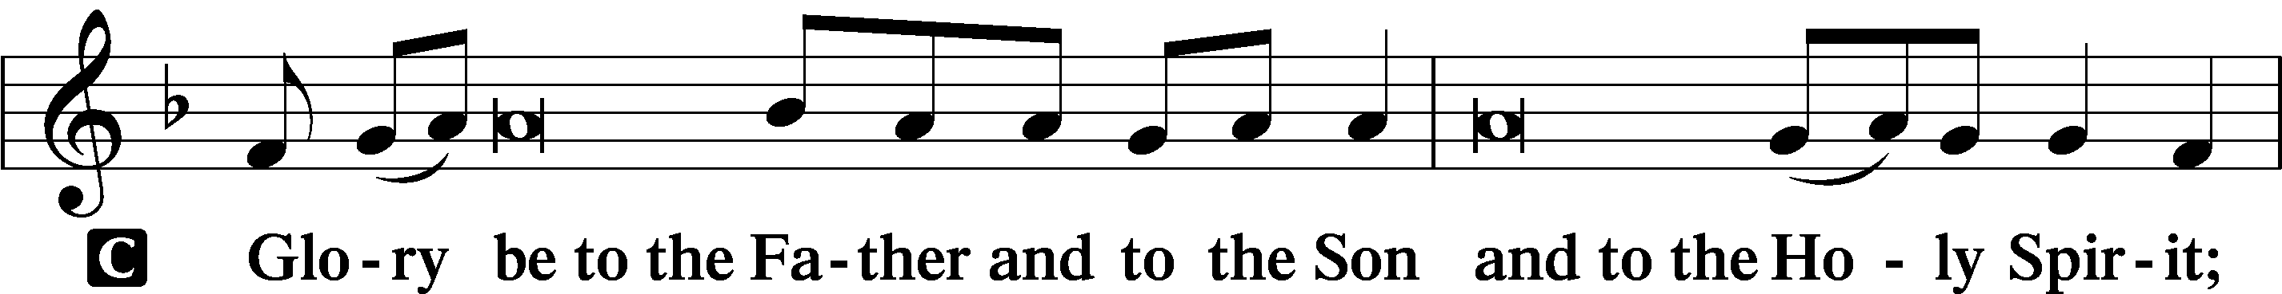
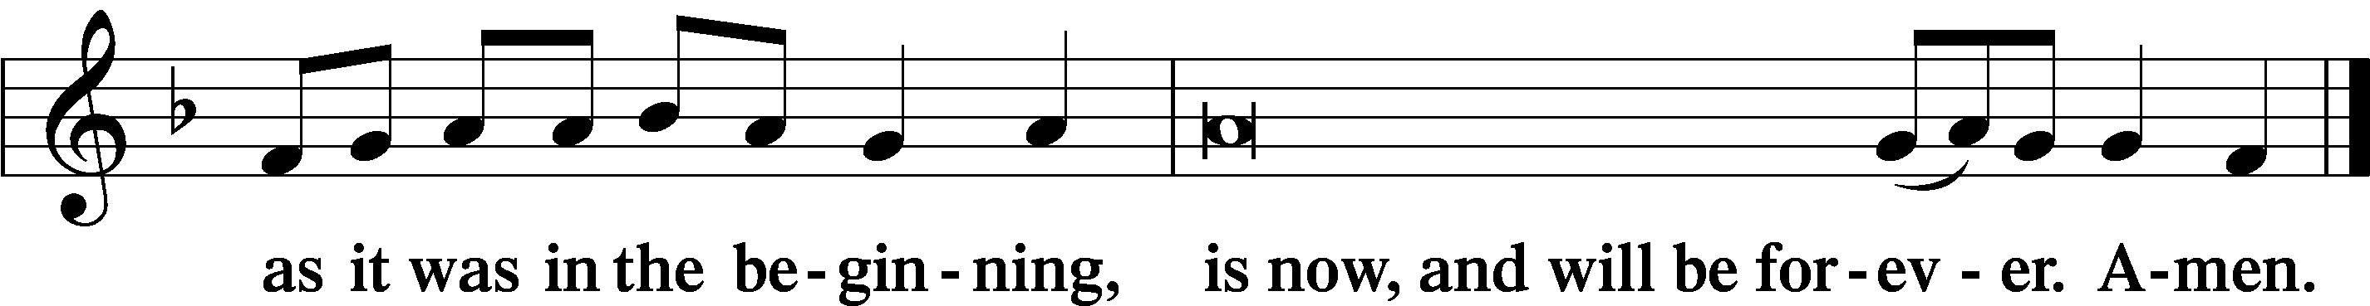
Prayer
Kyrie LSB 233
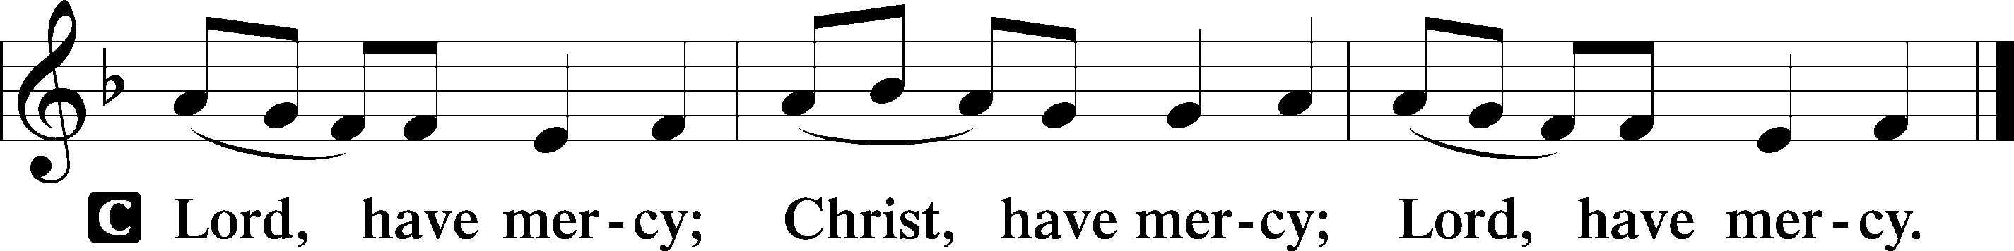

The Lord’s Prayer: LSB #957 “Our Father Who Art in Heaven” LSB 957
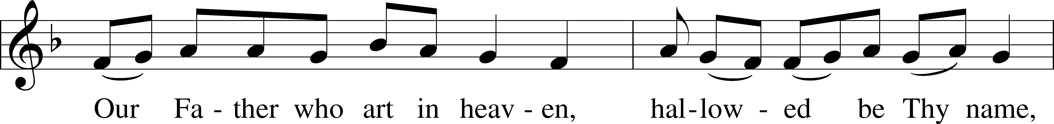
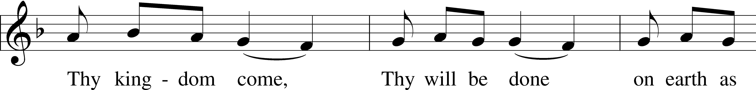
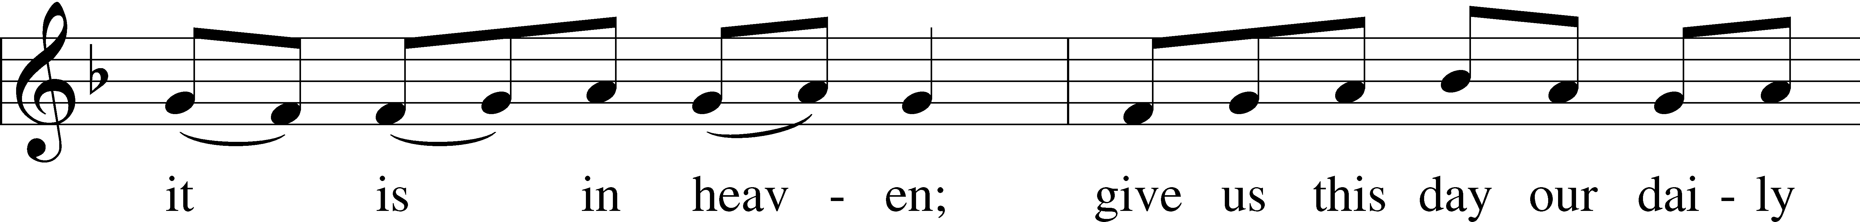
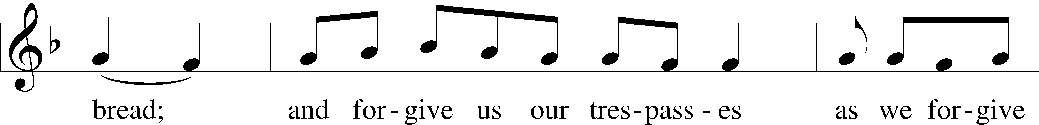
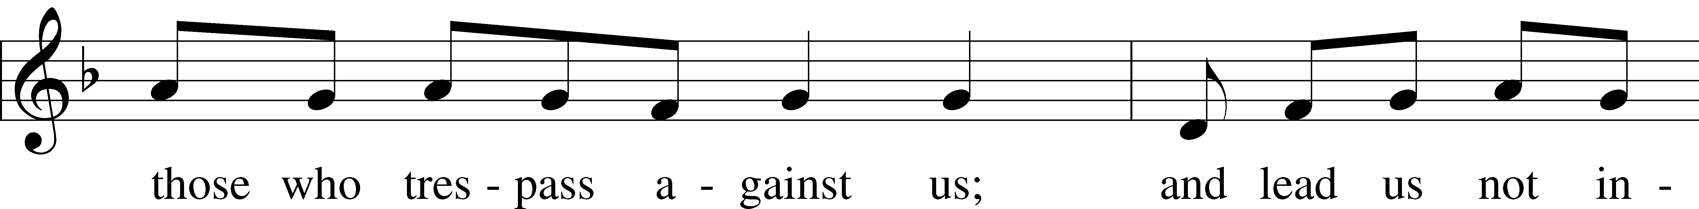
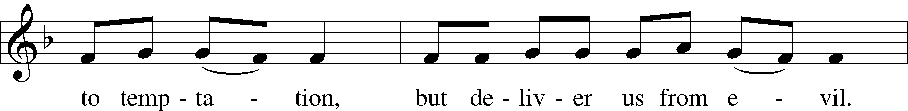
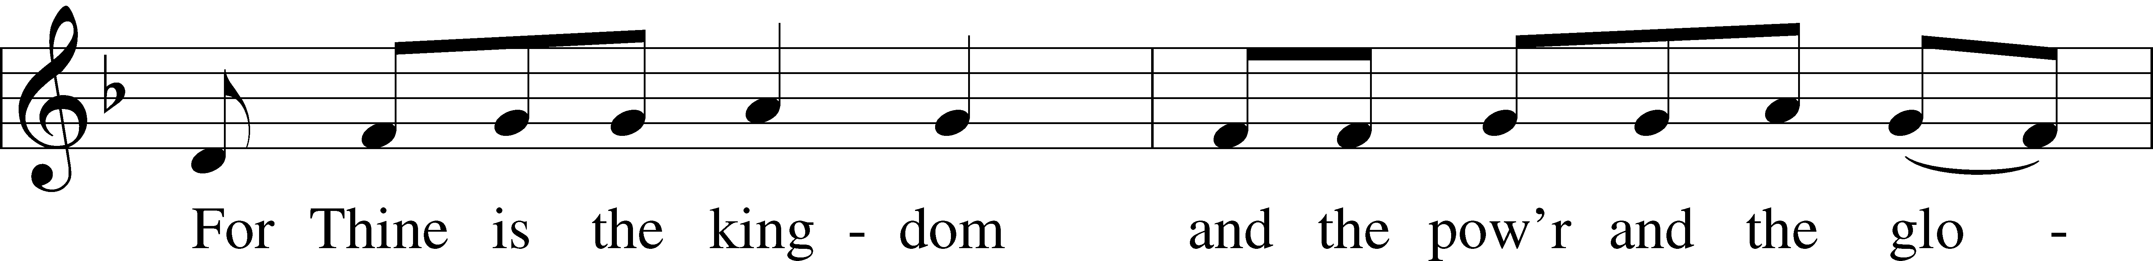
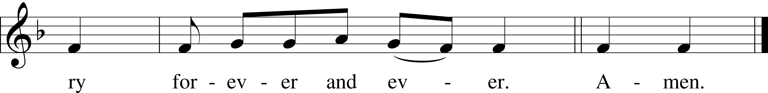

Text: Traditional Tune: Plainsong, mode VII Text and tune: Public domain

Introduction to Collects LSB 233
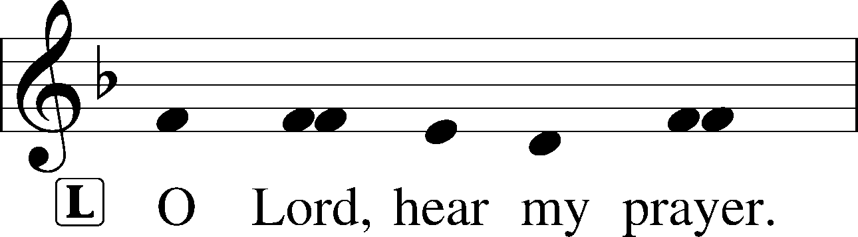
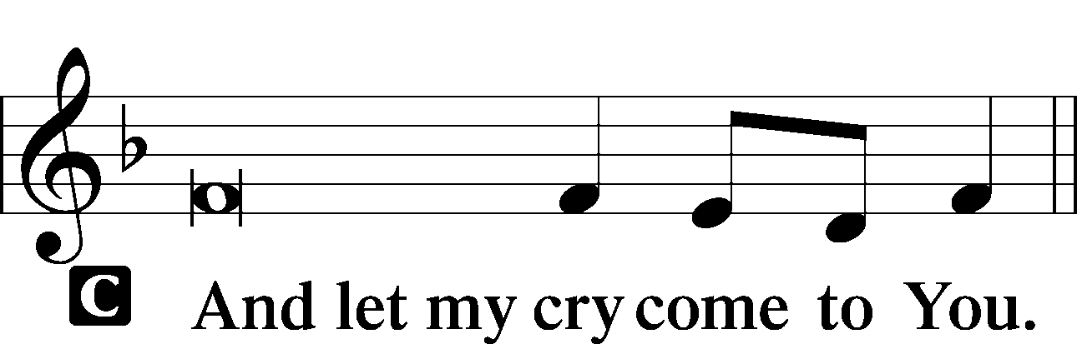

Collect of the Day: Saint Mark
P Almighty God, You have enriched Your Church with the proclamation of the Gospel through the evangelist Mark. Grant that we may firmly believe these glad tidings and daily walk according to Your Word; through Jesus Christ, our Lord, who lives and reigns with You and the Holy Spirit, one God, now and forever.
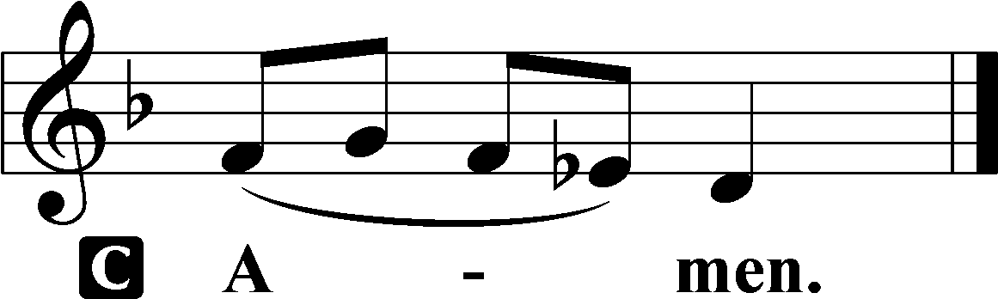

Collect for Peace
P O God, from whom come all holy desires, all good counsels, and all just works, give to us, Your servants, that peace which the world cannot give, that our hearts may be set to obey Your commandments and also that we, being defended from the fear of our enemies, may live in peace and quietness; through Jesus Christ, Your Son, our Lord, who lives and reigns with You and the Holy Spirit, one God, now and forever.

Benedicamus LSB 234
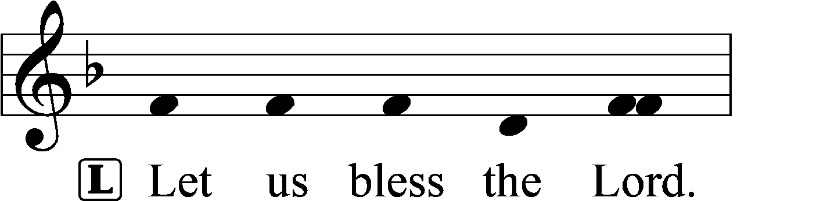
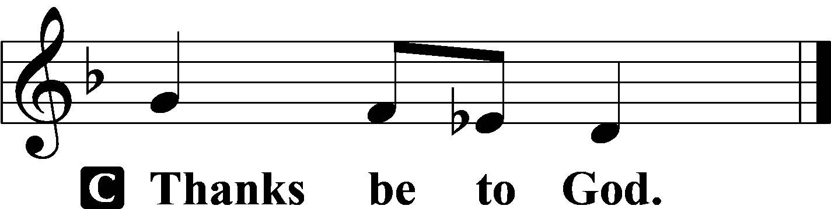

Benediction LSB 234
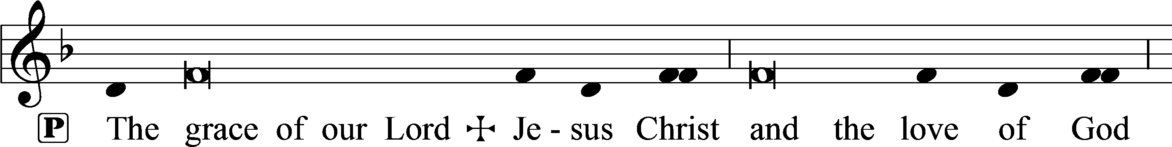
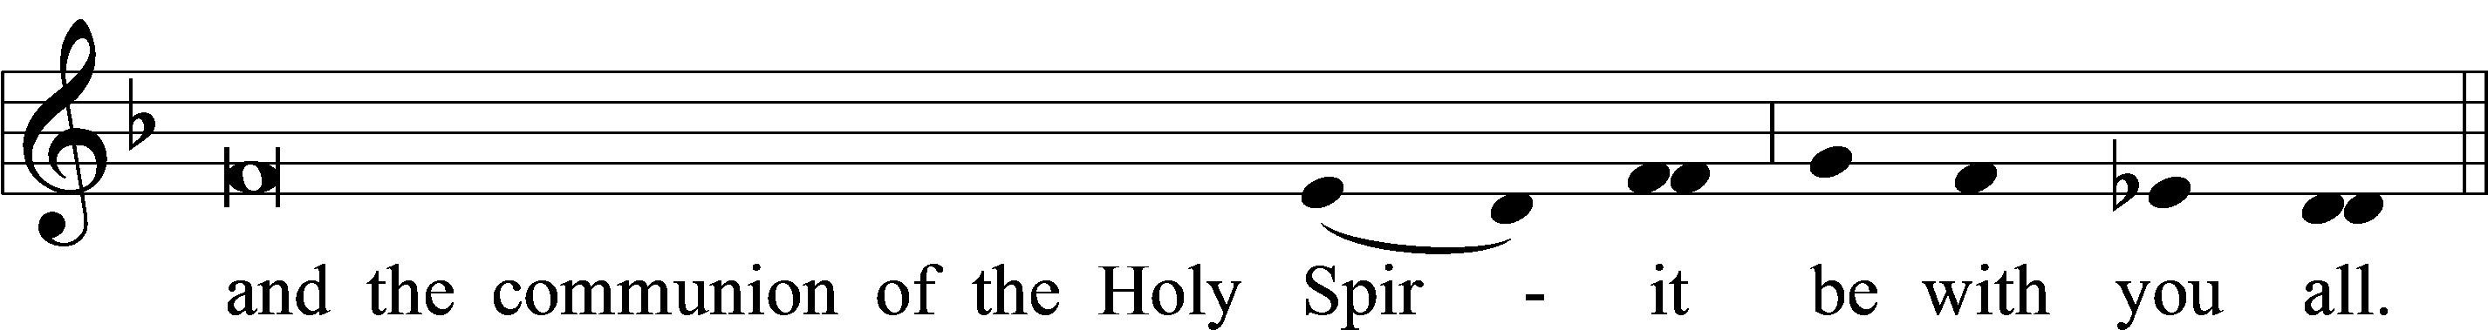

Acknowledgments: Unless otherwise indicated, Scripture quotations are from the ESV® Bible (The Holy Bible, English Standard Version®), copyright © 2001 by Crossway, a publishing ministry of Good News Publishers. Used by permission. All rights reserved. Created by Lutheran Service Builder © 2024 Concordia Publishing House.

