Sts. Peter & Paul
Evangelical Lutheran Church
Lutheran Church-Missouri Synod
Founded-1917

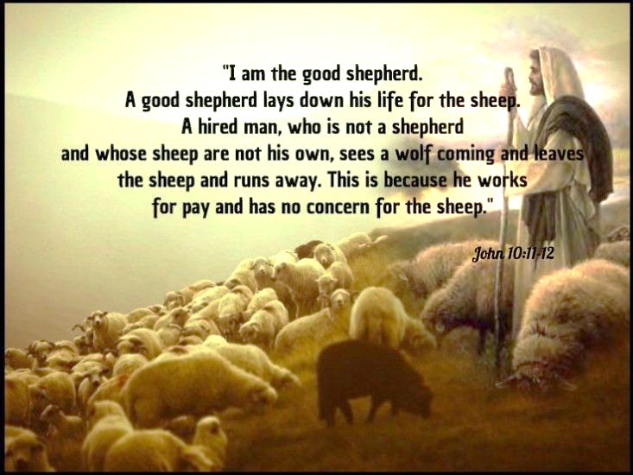

April 23, 2023

699 Stambaugh Ave.
Sharon, Pennsylvania 16146

“I was glad when they said to me,
Let us go to the house of the LORD!”
Psalm 122:1
Sts. Peter & Paul Evangelical Lutheran Church, LC-MS
MISERICORDIAS DOMINI
April 23, 2023

A special welcome to our guests this day! If you would like more information about The Lutheran Church - Missouri Synod, or this congregation, please speak with Pastor Deal or an Elder after the service.
Members & Guests: Don’t be embarrassed if your children make noise during the worship service, all children do. We encourage families to worship together but, if you feel the need, there are pews in the rear of the Church which are reserved for young families on both sides of the sanctuary. There is also a quiet room available to you during our service which is located down the hallway past the offices on the right side of the church as well as a children’s area in the Fellowship Hall where you are able to follow along with the service.

Today’s service includes the Sacrament of Holy Communion. If during this past year, you have not worshipped with us and been communed, we respectfully ask that you do not partake of this sacrament this day before first speaking with Pastor Deal.
If visiting from a sister congregation of the LC-MS and are in good standing, please inform Pastor Deal of your desire to commune prior to the service.
If wishing to receive a blessing during communion, please approach with your arms crossed.

CONTACT INFORMATION
Pastor Deal: pastordeal@saintspeterandpaul.net or 724-347-3620 (opt. 2)
Church Office: church@saintspeterandpaul.net or 724-347-3620 (opt. 3)
Secretary’s Office will be open Monday and Thursday of this week (8:30 am -4:30 pm)

Silent prayer before worship: Heavenly Father, You claimed me as Your child in Christ through Holy Baptism. Lead me to be in Your Word, in prayer, and in fellowship with my fellow believers so I can grow in my faith. In Jesus’ name. Amen.

Confession and Absolution

Opening Hymn: LSB #864 “Shepherd of Tender Youth”

Stand

The sign of the cross may be made by all in remembrance of their Baptism.

Invocation
P In the name of the Father and of the T Son and of the Holy Spirit.
C Amen.

Exhortation Hebrews 10:22; Psalm 124:8; Psalm 32:5
P Beloved in the Lord! Let us draw near with a true heart and confess our sins unto God our Father, beseeching Him in the name of our Lord Jesus Christ to grant us forgiveness.

P Our help is in the name of the Lord,
C who made heaven and earth.
P I said, I will confess my transgressions unto the Lord,
C and You forgave the iniquity of my sin.

Silence for reflection on God’s Word and for self-examination.

Confession of Sins
P O almighty God, merciful Father,
C I, a poor, miserable sinner, confess unto You all my sins and iniquities with which I have ever offended You and justly deserved Your temporal and eternal punishment. But I am heartily sorry for them and sincerely repent of them, and I pray You of Your boundless mercy and for the sake of the holy, innocent, bitter sufferings and death of Your beloved Son, Jesus Christ, to be gracious and merciful to me, a poor, sinful being.

Absolution [John 20:19–23]
P Upon this your confession, I, by virtue of my office, as a called and ordained servant of the Word, announce the grace of God unto all of you, and in the stead and by the command of my Lord Jesus Christ I forgive you all your sins in the name of the Father and of the T Son and of the Holy Spirit.
C Amen.
Service of the Word

Introit Psalm 33:1, 18–20; antiphon: vv. 5b, 6a
The earth is full of the steadfast love of the Lord. Alle- | luia.*
By the word of the Lord the heavens were made. Alle- | luia.
Shout for joy in the Lord, O you | righteous!*
Praise befits the | upright.
Behold, the eye of the Lord is on those who | fear him,*
on those who hope in his | steadfast love,
that he may deliver their | soul from death*
and keep them alive in | famine.
Our soul waits | for the Lord;*
he is our help | and our shield.
The earth is full of the steadfast love of the Lord. Alle- | luia.*
By the word of the Lord the heavens were made. Alle- | luia.

Gloria Patri
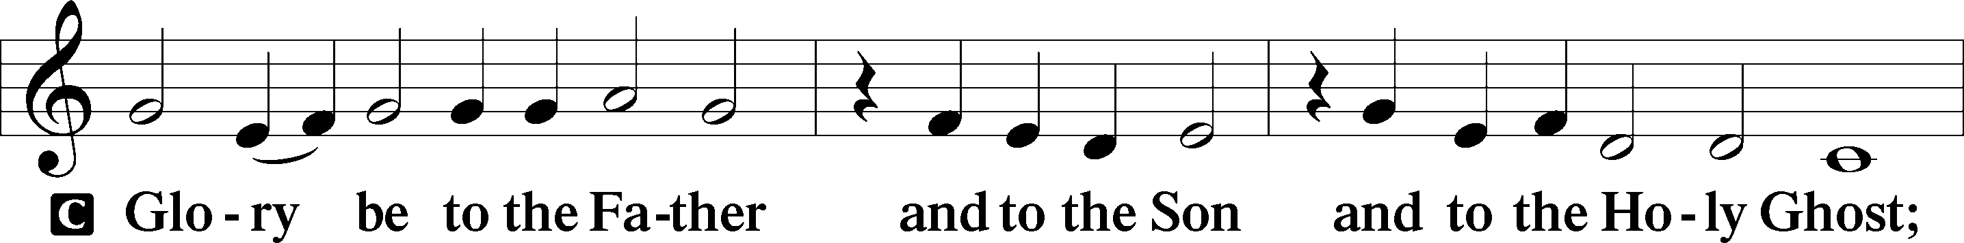
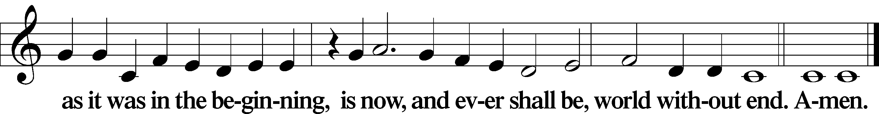

Kyrie Mark 10:47
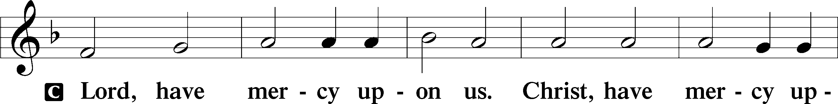
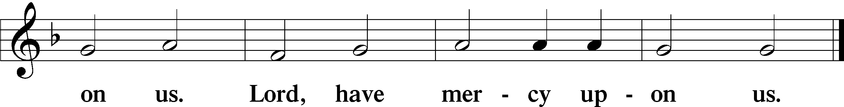

Gloria in Excelsis Luke 2:14; John 1:29
P Glory be to God on high:
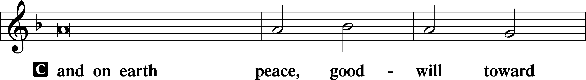
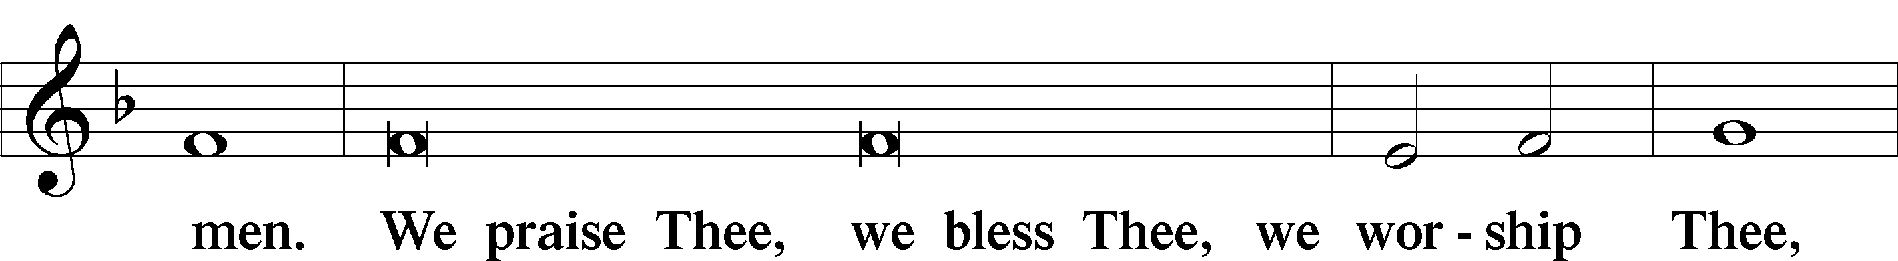
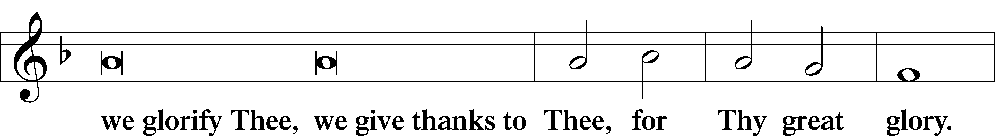
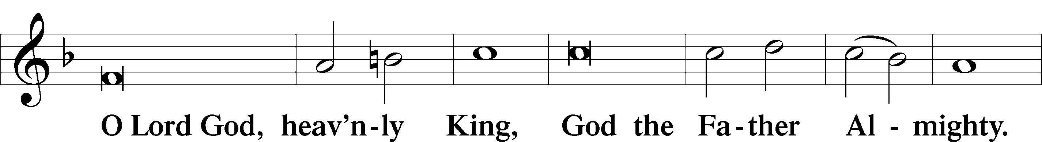
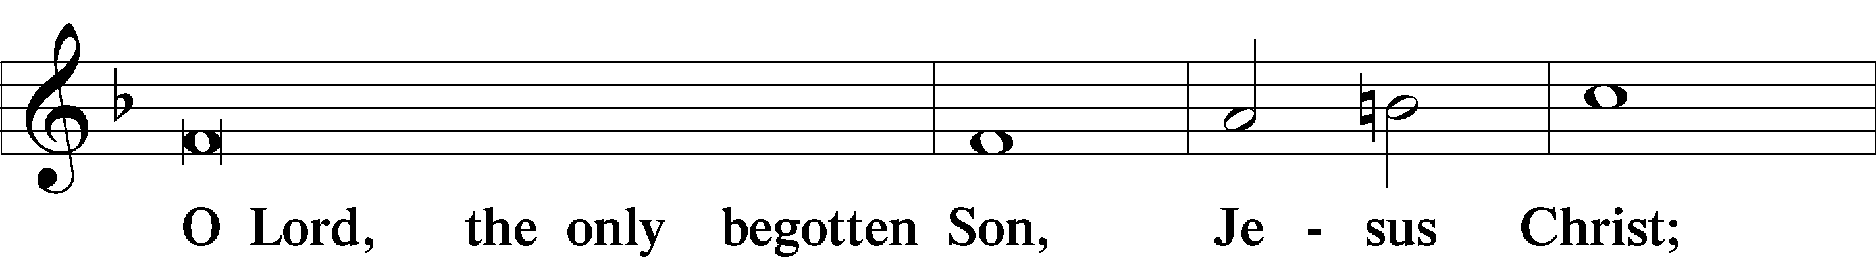
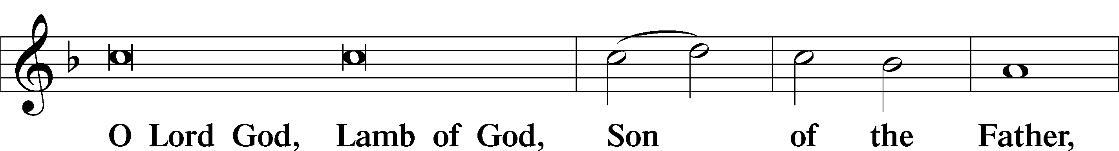
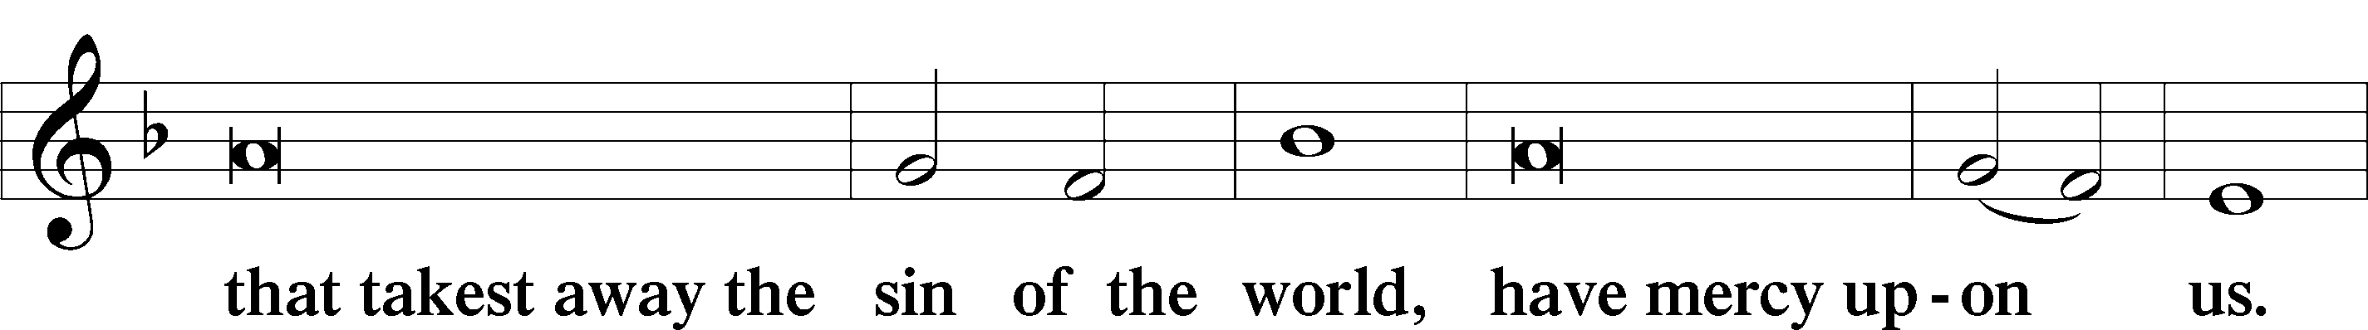
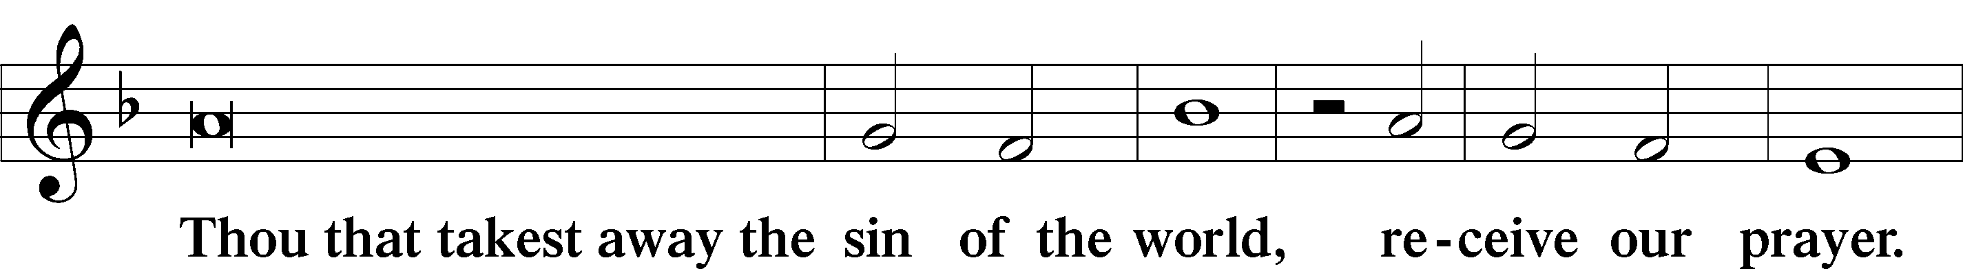
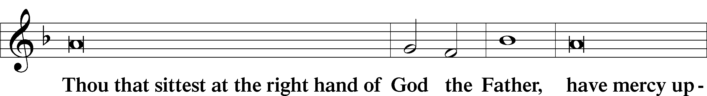
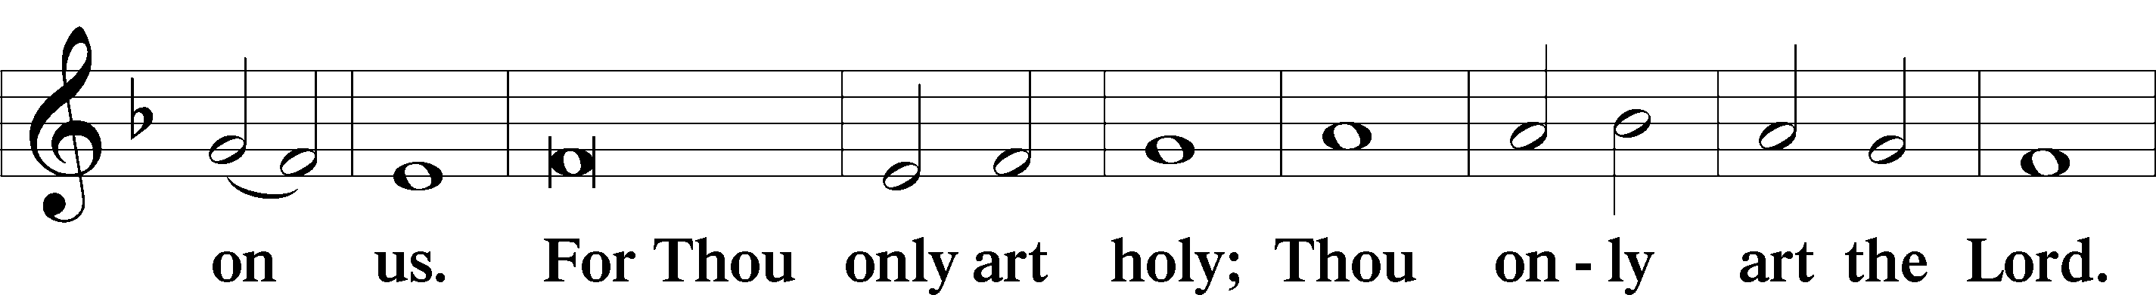
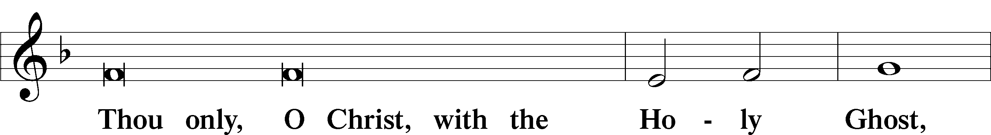
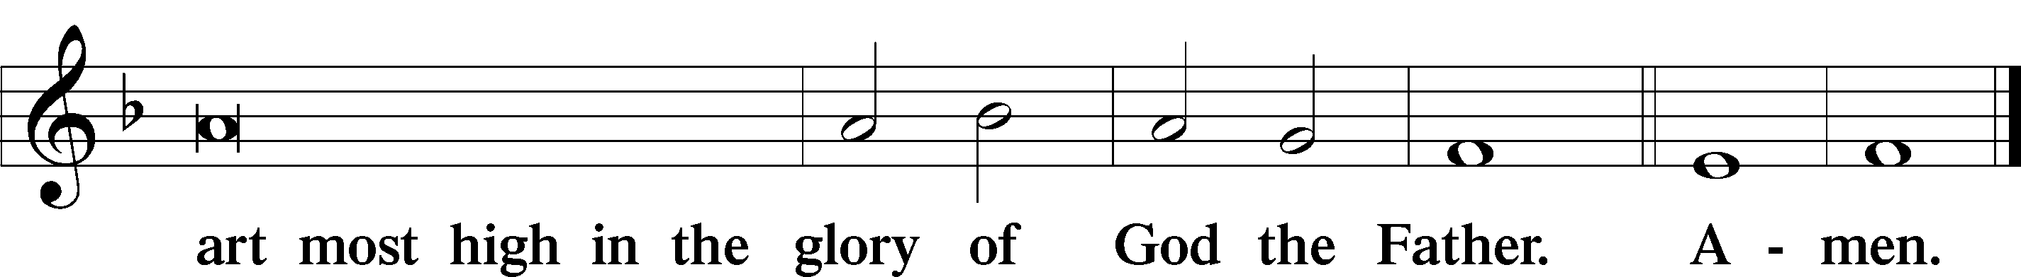

Salutation and Collect of the Day: Misericordias Domini
P The Lord be with you.
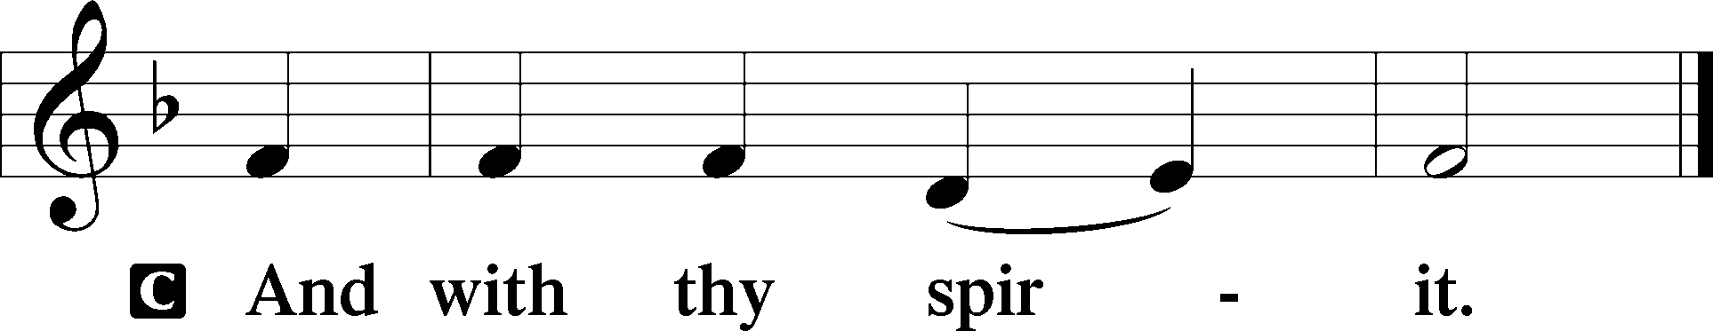

P Let us pray.
O God, through the humiliation of Your Son You raised up the fallen world. Grant to Your faithful people, rescued from the peril of everlasting death, perpetual gladness and eternal joys; through Jesus Christ, our Lord, who lives and reigns with You and the Holy Spirit, one God, now and forever.
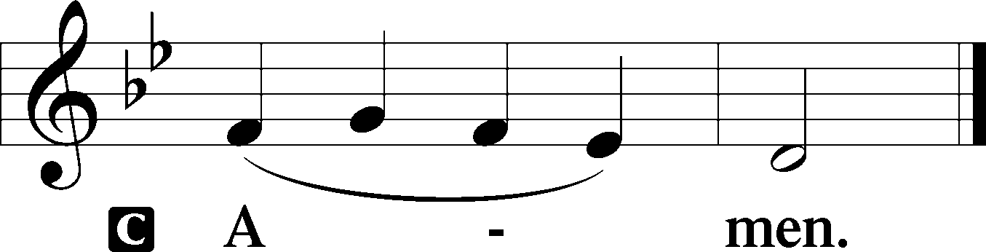
Sit

Prophecy: Ezekiel 34:11–16 (NKJV)
Thus says the Lord God: “Indeed I Myself will search for My sheep and seek them out. As a shepherd seeks out his flock on the day he is among his scattered sheep, so will I seek out My sheep and deliver them from all the places where they were scattered on a cloudy and dark day. And I will bring them out from the peoples and gather them from the countries, and will bring them to their own land; I will feed them on the mountains of Israel, in the valleys and in all the inhabited places of the country. I will feed them in good pasture, and their fold shall be on the high mountains of Israel. There they shall lie down in a good fold and feed in rich pasture on the mountains of Israel. I will feed My flock, and I will make them lie down,” says the Lord God. “I will seek what was lost and bring back what was driven away, bind up the broken and strengthen what was sick; but I will destroy the fat and the strong, and feed them in judgment,” says the Lord Almighty.

P This is the Word of the Lord.
C Thanks be to God.

Psalm 23 (NKJV)
The Lord is my shepherd; I shall not want.
He maketh me to lie down in green pastures: he leadeth me beside the still waters.
He restoreth my soul: he leadeth me in the paths of righteousness for his name's sake.
Yea, though I walk through the valley of the shadow of death, I will fear no evil: for thou art with me; thy rod and thy staff they comfort me.
Thou preparest a table before me in the presence of mine enemies: thou anointest my head with oil; my cup runneth over.
Surely goodness and mercy shall follow me all the days of my life: and I will dwell in the house of the Lord for ever.

Epistle: 1 Peter 2:21b–25 (NKJV)
Dearly Beloved: Christ suffered for us, leaving us an example, that you should follow His steps: “who committed no sin, nor was deceit found in His mouth”; who, when He was reviled, did not revile in return; when He suffered, He did not threaten, but committed Himself to Him who judges righteously; who Himself bore our sins in His own body on the tree, that we, having died to sins, might live for righteousness—by whose stripes you were healed. For you were like sheep going astray, but have now returned to the Shepherd and Overseer of your souls.

P This is the Word of the Lord.
C Thanks be to God.

Stand

Verse Luke 24:35b; John 10:14
Alleluia. [The Lord] was known to them in the breaking of the bread. Alleluia. I am the good shepherd. I know my own and my own know me. Alleluia.

Alleluia
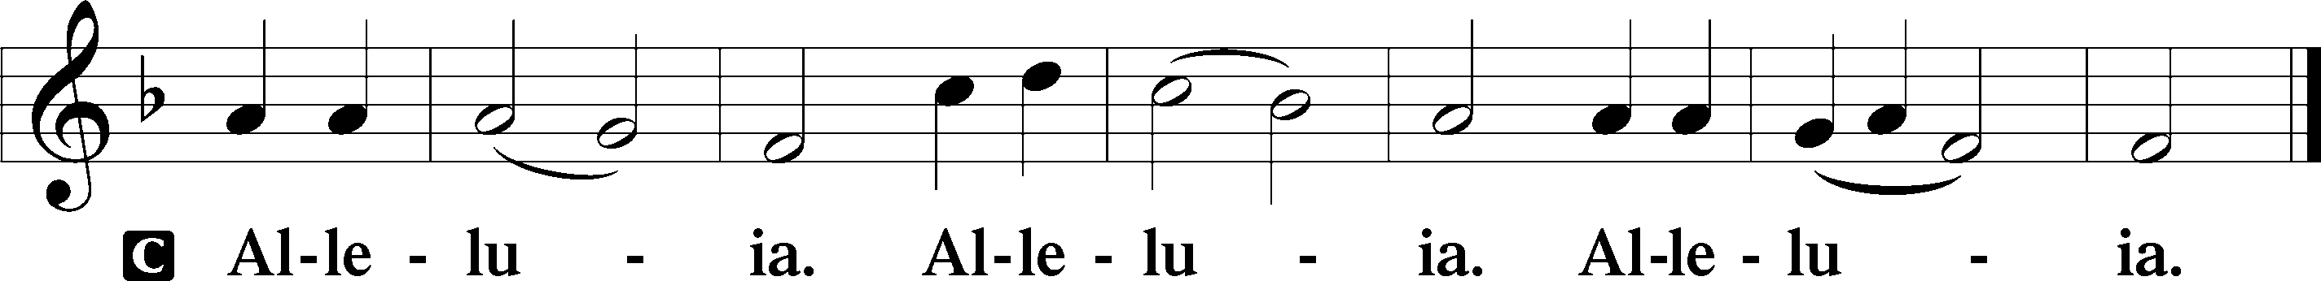

Holy Gospel: John 10:11–16 (NKJV)
P The Holy Gospel according to St. John, the tenth chapter.
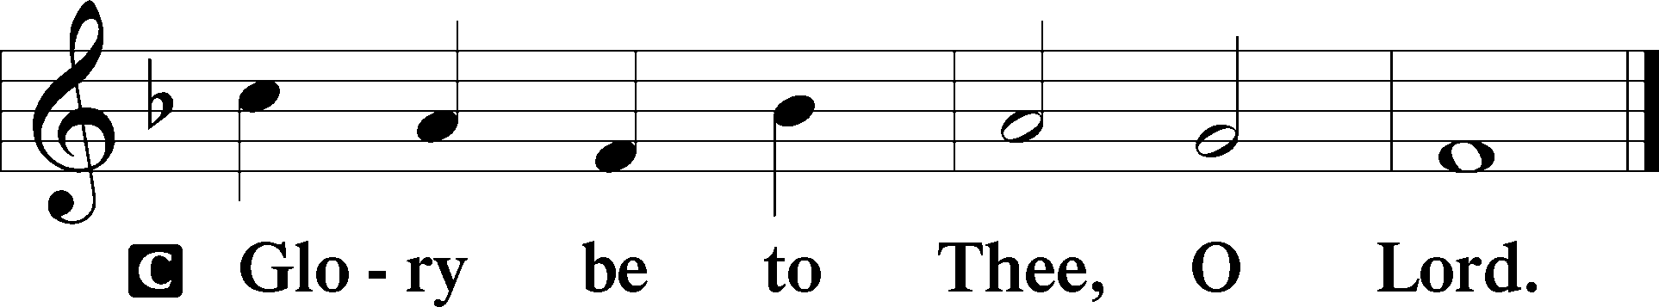

At that time Jesus said to His disciples: “I am the good shepherd. The good shepherd gives His life for the sheep. But a hireling, he who is not the shepherd, one who does not own the sheep, sees the wolf coming and leaves the sheep and flees; and the wolf catches the sheep and scatters them. The hireling flees because he is a hireling and does not care about the sheep. I am the good shepherd; and I know My sheep, and am known by My own. As the Father knows Me, even so I know the Father; and I lay down My life for the sheep. And other sheep I have which are not of this fold; them also I must bring, and they will hear My voice; and there will be one flock and one shepherd.”

P This is the Gospel of the Lord.
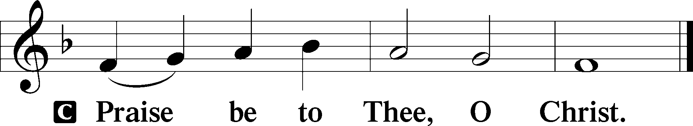

Nicene Creed
C I believe in one God,
the Father Almighty,
maker of heaven and earth
and of all things visible and invisible.

And in one Lord Jesus Christ,
the only-begotten Son of God,
begotten of His Father before all worlds,
God of God, Light of Light,
very God of very God,
begotten, not made,
being of one substance with the Father,
by whom all things were made;
who for us men and for our salvation came down from heaven
and was incarnate by the Holy Spirit of the virgin Mary
and was made man;
and was crucified also for us under Pontius Pilate.
He suffered and was buried.
And the third day He rose again according to the Scriptures
and ascended into heaven
and sits at the right hand of the Father.
And He will come again with glory to judge both the living and the dead,
whose kingdom will have no end.

And I believe in the Holy Spirit,
the Lord and giver of life,
who proceeds from the Father and the Son,
who with the Father and the Son together is worshiped and glorified,
who spoke by the prophets.
And I believe in one holy Christian and apostolic Church,
I acknowledge one Baptism for the remission of sins,
and I look for the resurrection of the dead
and the life T of the world to come. Amen.
Sit

Hymn of the Day: LSB #666 “O Little Flock, Fear Not the Foe”

Sermon

Stand

Prayer of the Church

Offertory Psalm 51:10–12
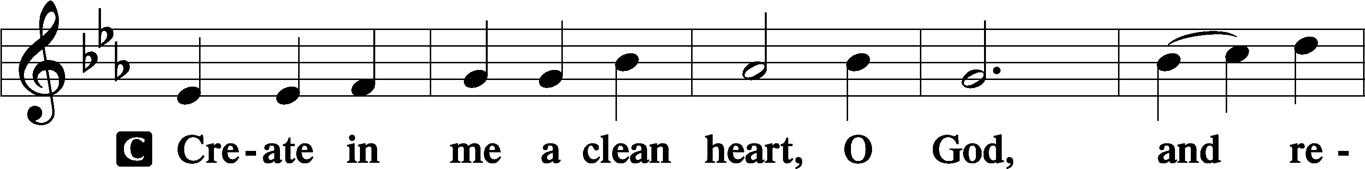
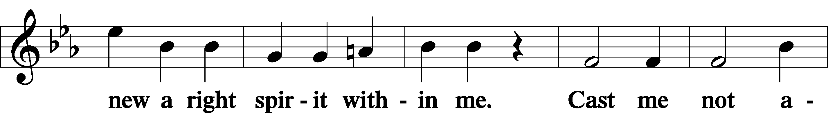
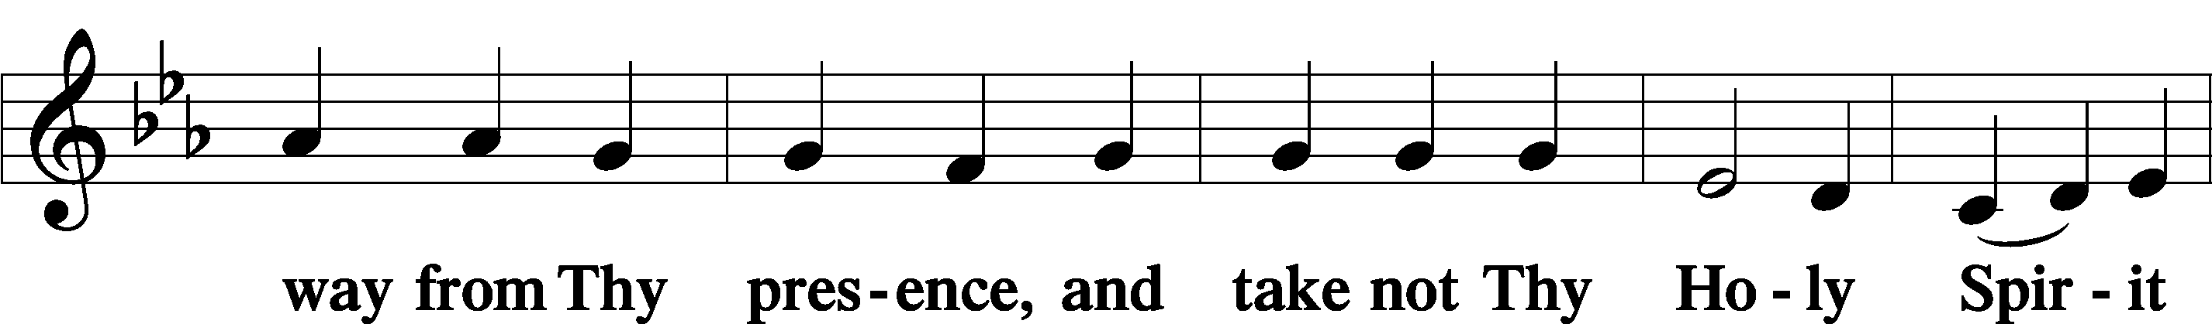
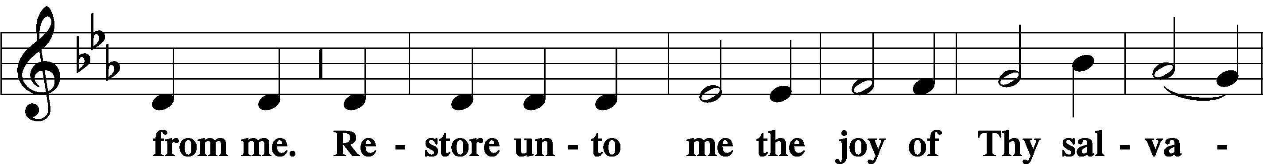
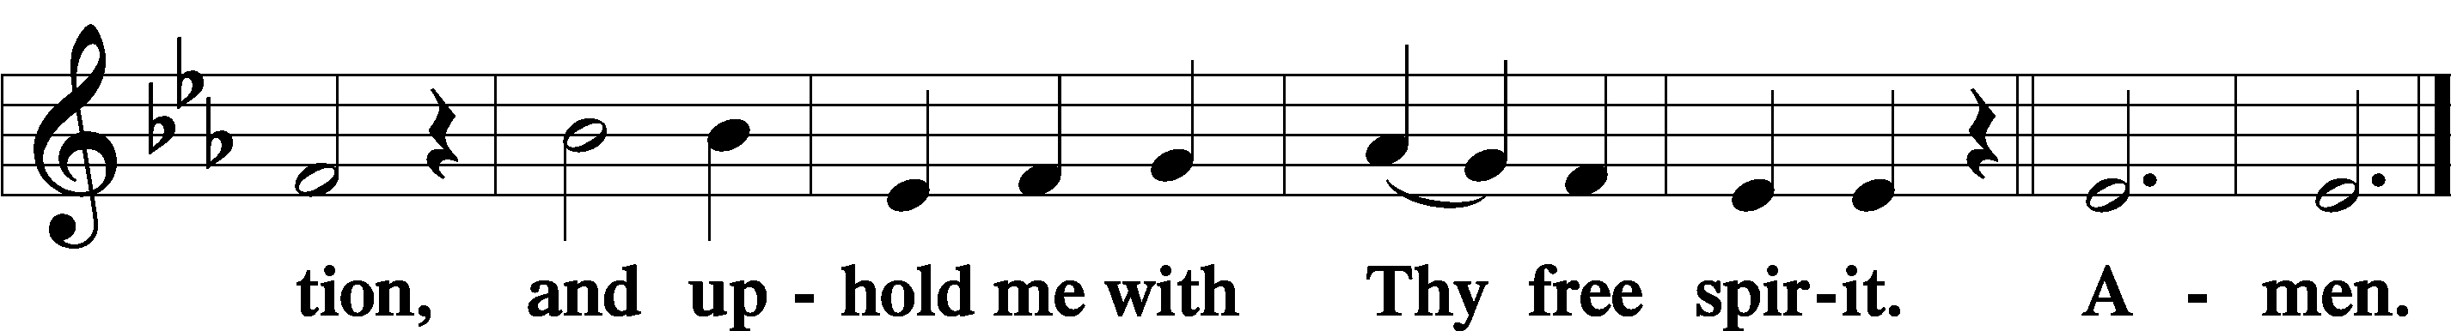
Sit

Preparatory Hymn: LSB #710 “The Lord’s My Shepherd, I’ll Not Want”

Stand

Service of the Sacrament

Preface 2 Timothy 4:22; Colossians 3:1 Psalm 136
P The Lord be with you.

P Lift up your hearts.
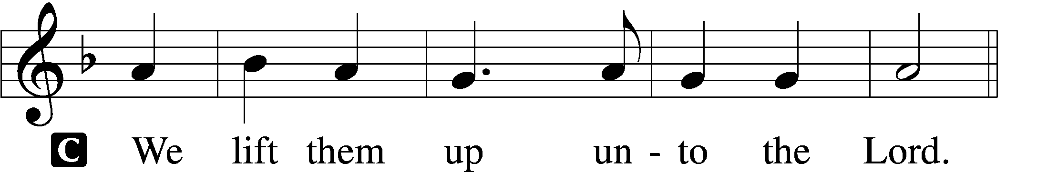

P Let us give thanks unto the Lord, our God.
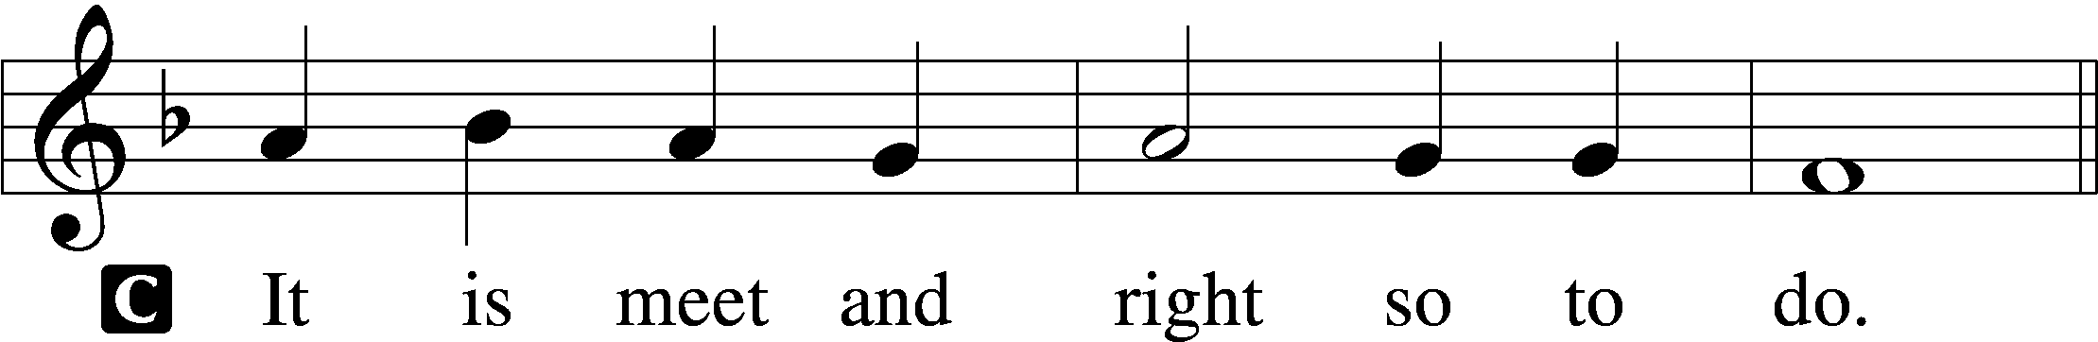

Proper Preface (Abbreviated) LSB 194
P It is truly meet, right, and salutary . . . evermore praising You and saying:

Sanctus Isaiah 6:3; Matthew 21:9
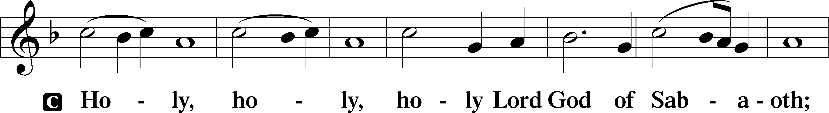
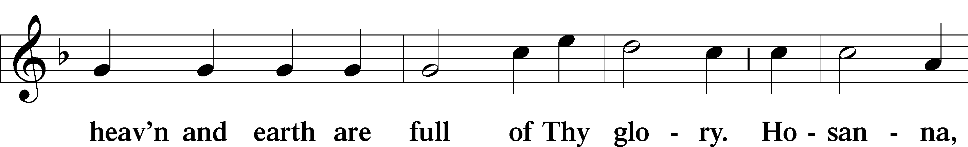
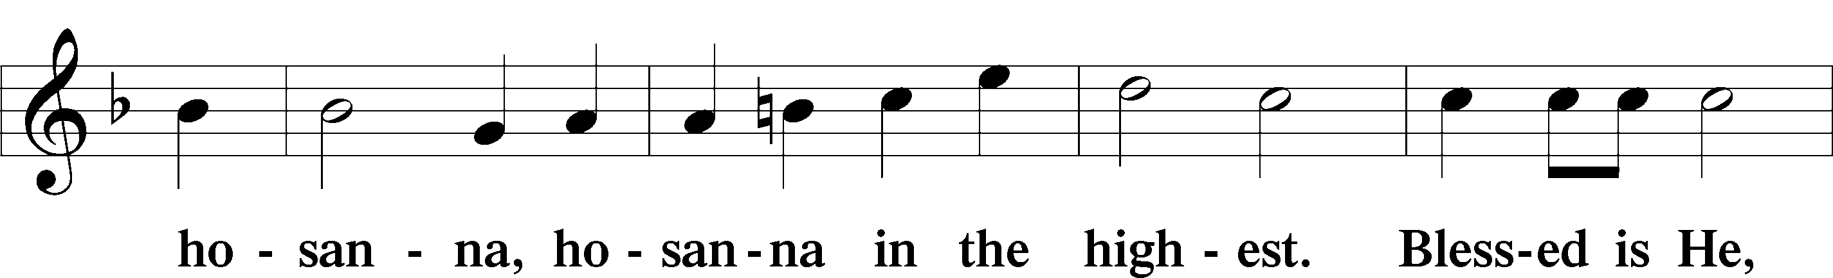
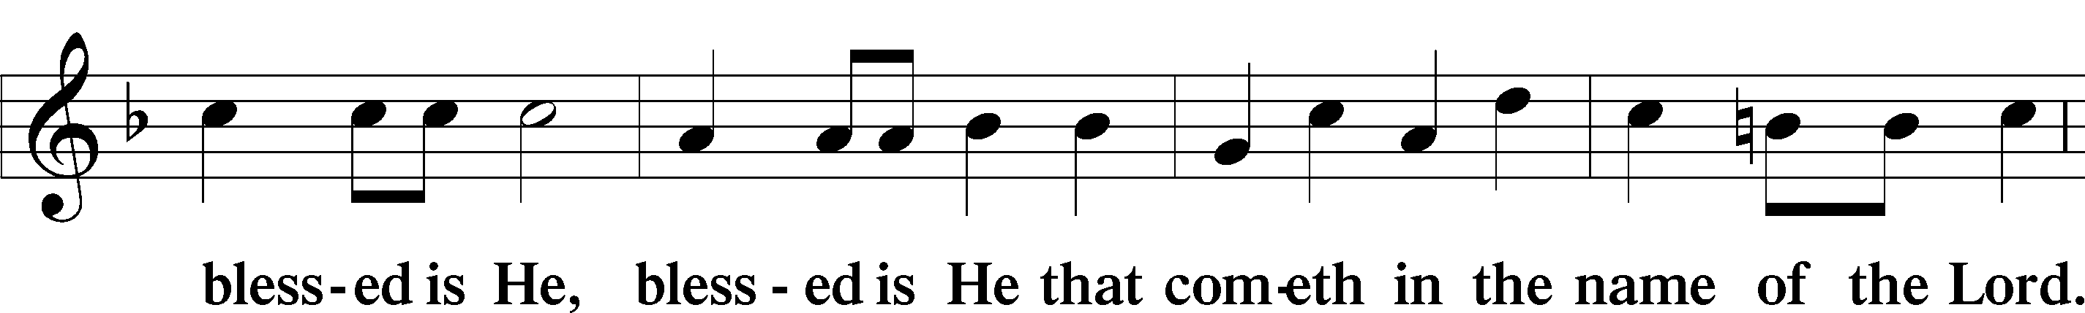
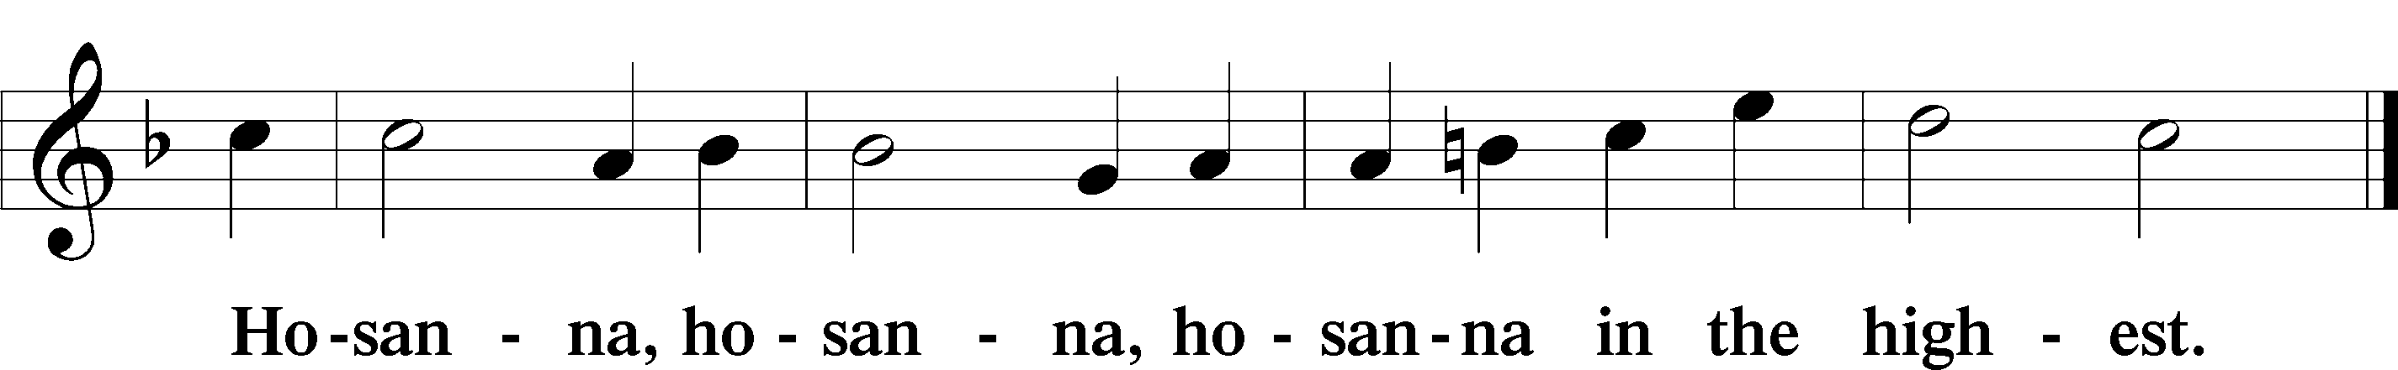

Lord’s Prayer Matthew 6:9–13
C Our Father who art in heaven,
hallowed be Thy name,
Thy kingdom come,
Thy will be done on earth as it is in heaven;
give us this day our daily bread;
and forgive us our trespasses as we forgive those who trespass against us;
and lead us not into temptation,
but deliver us from evil.
For Thine is the kingdom and the power and the glory forever and ever. Amen.

The Words of Our Lord Matthew 26:26–28; Mark 14:22–24; Luke 22:19–20; 1 Corinthians 11:23–25
P Our Lord Jesus Christ, on the night when He was betrayed, took bread, and when He had given thanks, He broke it and gave it to the disciples and said: “Take, eat; this is My T body, which is given for you. This do in remembrance of Me.”

In the same way also He took the cup after supper, and when He had given thanks, He gave it to them, saying: “Drink of it, all of you; this cup is the new testament in My T blood, which is shed for you for the forgiveness of sins. This do, as often as you drink it, in remembrance of Me.”

Pax Domini John 20:19
P The peace of the Lord be with you always.
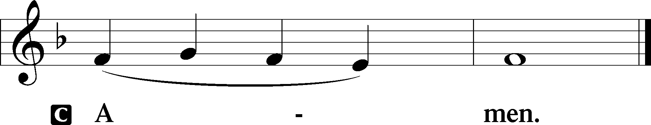

Agnus Dei John 1:29
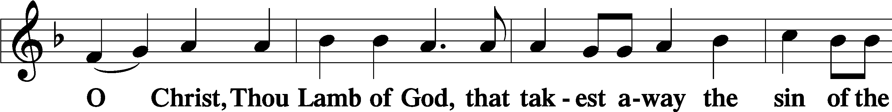
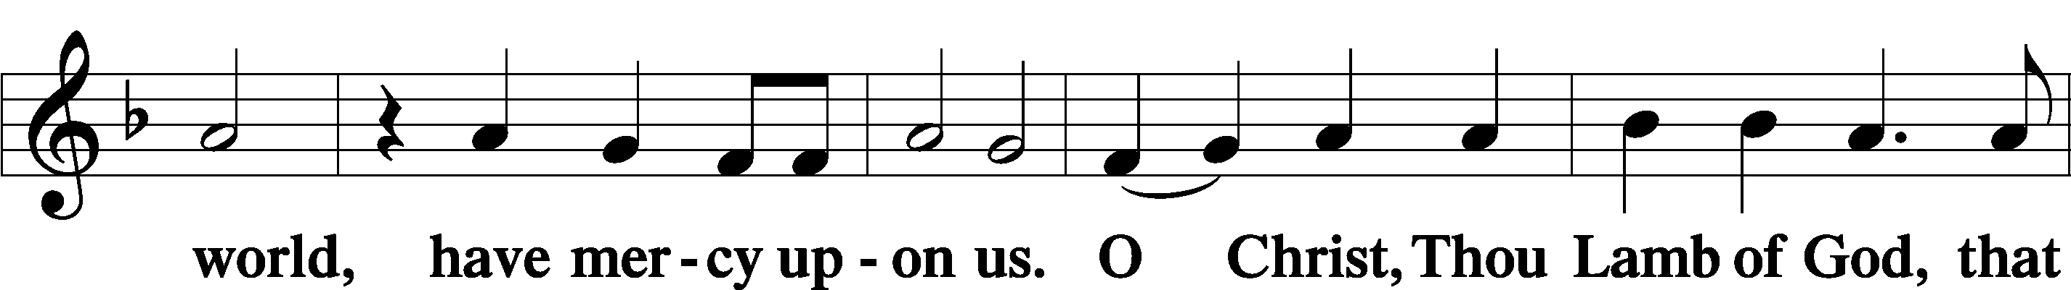
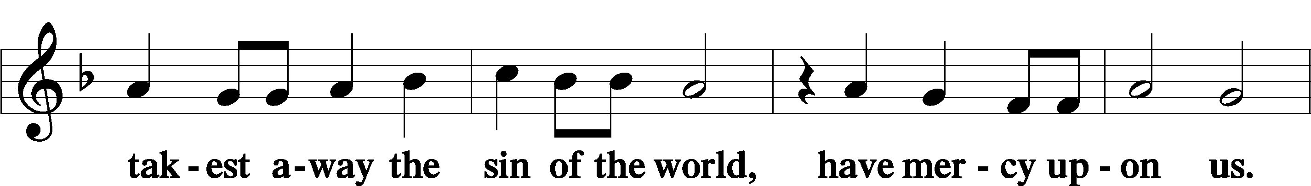
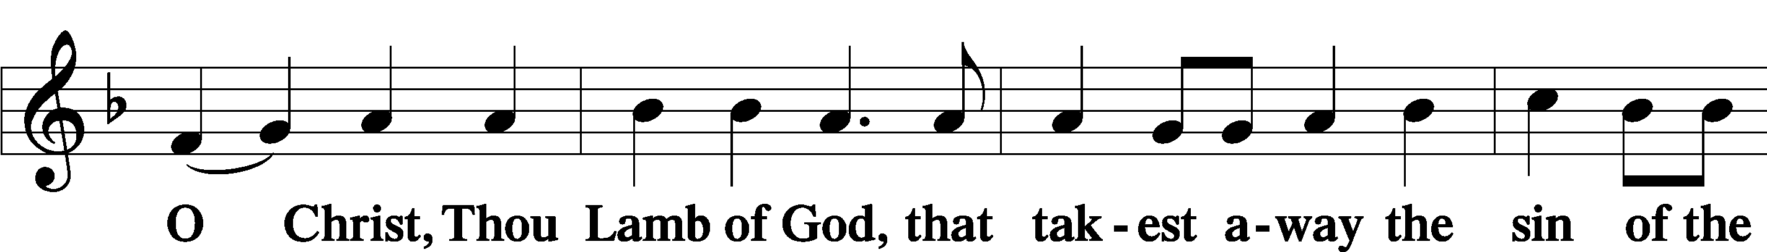
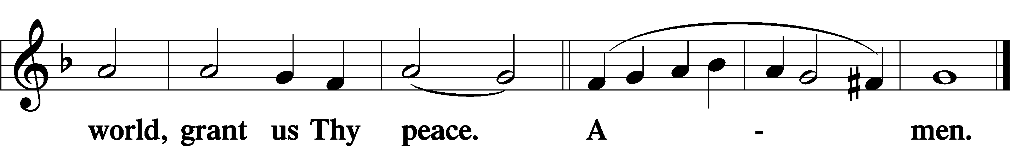
Sit

Distribution
The pastor and those who assist him receive the body and blood of Christ first and then distribute them to those who come to receive, saying:
Take, eat; this is the true body of our Lord and Savior Jesus Christ, given into death for your sins.
Amen.

Take, drink; this is the true blood of our Lord and Savior Jesus Christ, shed for the forgiveness of your sins.
Amen.

In dismissing the communicants, the following is said:
The Dismissal
P The body and blood of our Lord Jesus Christ strengthen and preserve you in body and soul to life everlasting. Depart T in peace.
C Amen.

Distribution Hymn: LSB #625” Lord Jesus Christ, Life-Giving Bread”

Distribution Hymn: LSB #685 “Let Us Ever Walk with Jesus”

Distribution Hymn: LSB #642 “O Living Bread from Heaven”

Stand

Nunc Dimittis Luke 2:29–32
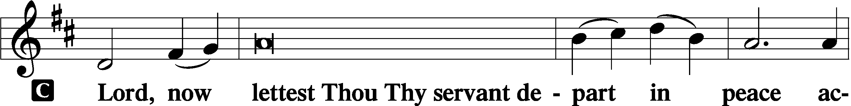
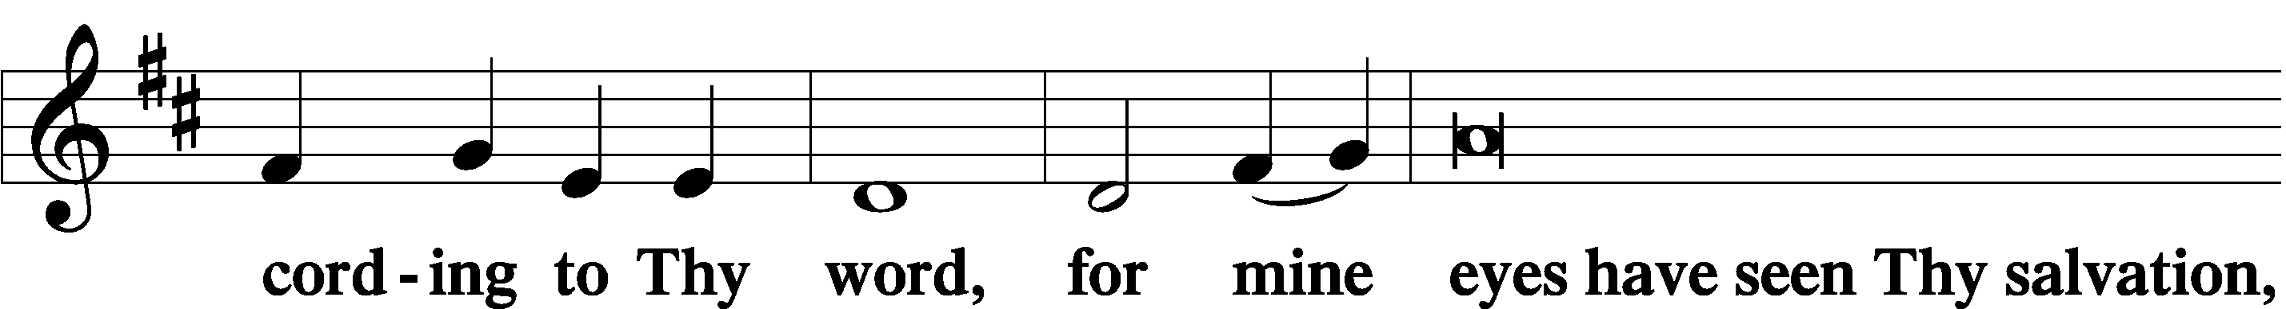
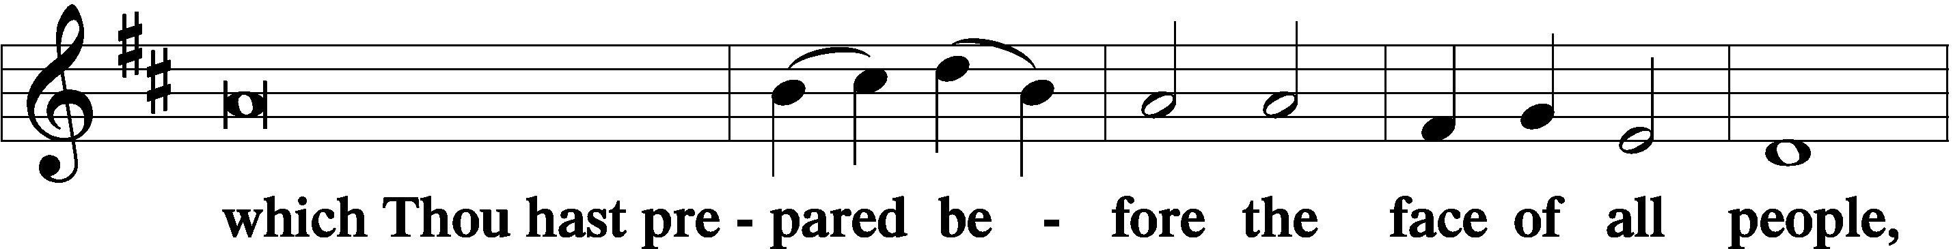
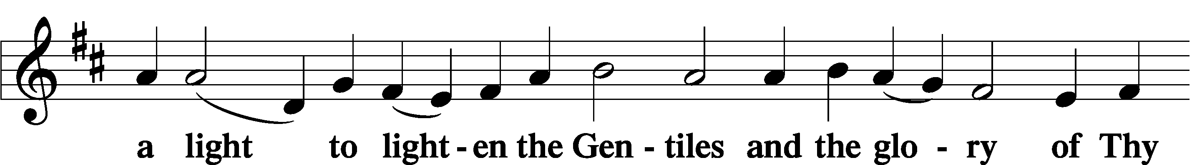
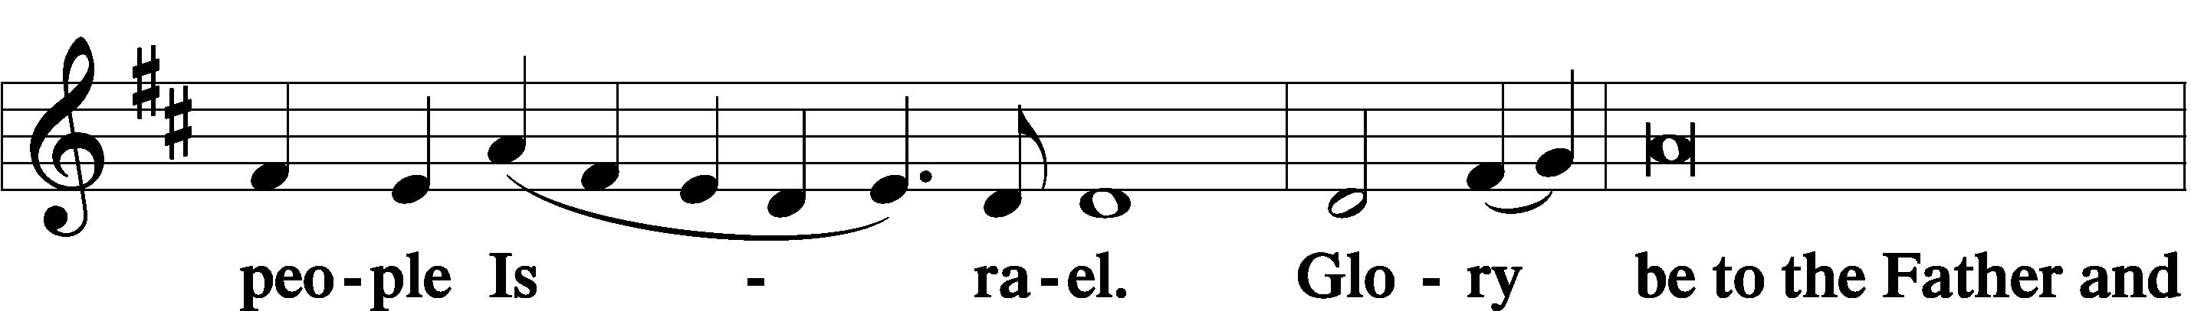
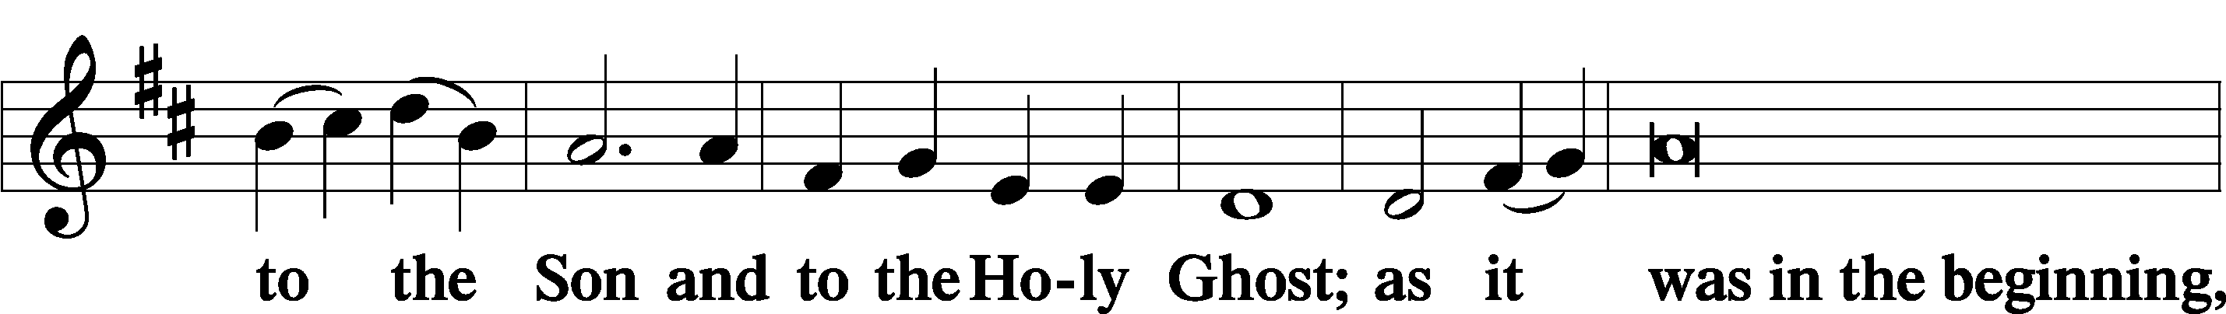
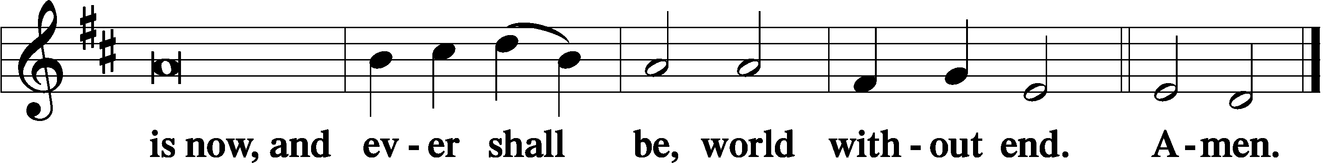

Thanksgiving Psalm 107:1
P O give thanks unto the Lord, for He is good,
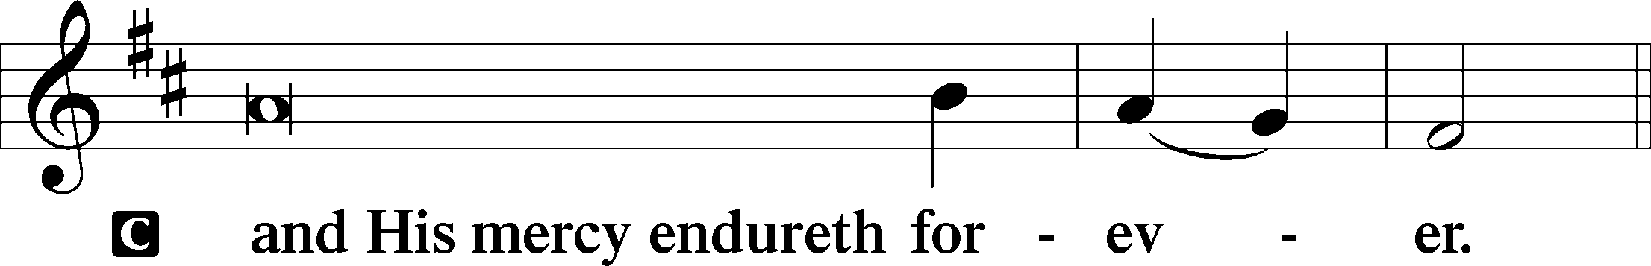

Post-Communion Collect
P Let us pray.
We give thanks to You, almighty God, that You have refreshed us through this salutary gift, and we implore You that of Your mercy You would strengthen us through the same in faith toward You and in fervent love toward one another; through Jesus Christ, Your Son, our Lord, who lives and reigns with You and the Holy Spirit, one God, now and forever.
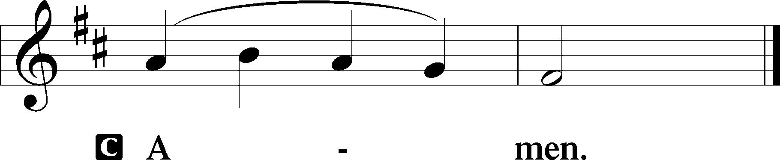

Salutation 2 Timothy 4:22
P The Lord be with you.
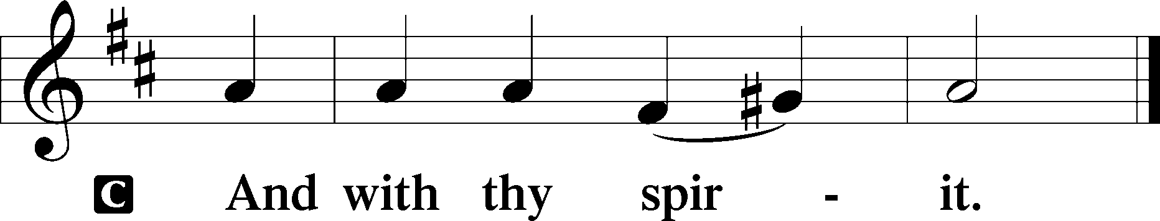

Benedicamus Psalm 103:1
P Bless we the Lord.
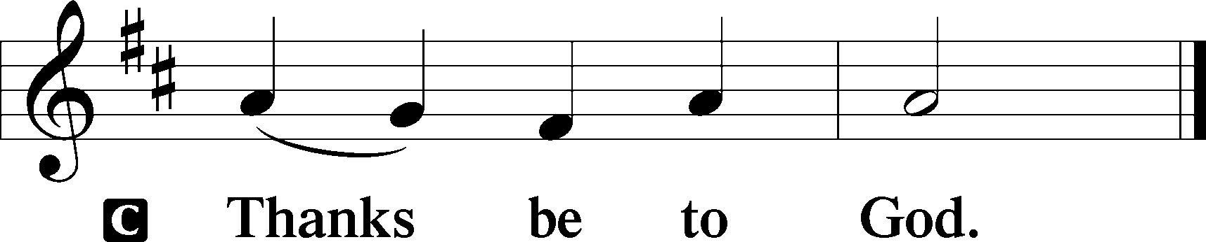

Benediction Numbers 6:24–26
P The Lord bless you and keep you.
The Lord make His face shine upon you and be gracious unto you.
The Lord lift up His countenance upon you and T give you peace.
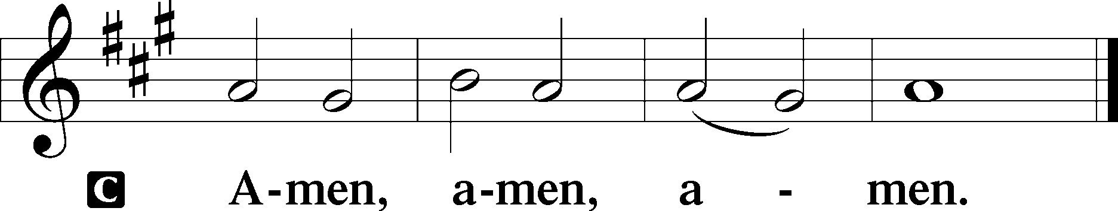

Closing Hymn: LSB #709 “The King of Love My Shepherd Is”

Silent prayer after worship: Dear Lord Jesus, by Your death and resurrection You have shown how deeply You love me. Help me to remember that You died for all people, so that I may share and show my faith so that others may know Your love through me. Amen.
fffffffffffffffffffffffffffffffffff
Acknowledgments: Unless otherwise indicated, Scripture quotations are from the ESV® Bible (The Holy Bible, English Standard Version®), copyright © 2001 by Crossway, a publishing ministry of Good News Publishers. Used by permission. All rights reserved. Created by Lutheran Service Builder © 2023 Concordia Publishing House.
fffffffffffffffffffffffffffffffffff
fffffffffffffffffffffffffffffffffff
In Loving Memory of my Father, Paul Tomko, on his April 16th Birthday: Linda Tomko.
In Loving Memory of Anson Holcroft: Cary Thomsen (Major Repair) and Richard & Sandra Wolfgang.
fffffffffffffffffffffffffffffffffff
SCHEDULE THROUGH APRIL 30, 2023:

:

Today, after Worship, Library: Quarterly/Monthly Audit
7 pm, Fellowship Hall: AA Meeting
Tuesday, 7-9 pm, Fellowship Hall: Penn-Ohio Singers
Wednesday, 7:15 pm, Library: Interior Committee Meeting
7:30 pm, Fellowship Hall: NA Meeting
Thursday, 9 am, Downstairs: Food Pantry
Saturday, 9:30 am, All Saints~Slippery Rock: Catechism Class
Next Sunday, 8 am, Fellowship Hall: Bible Study
9 am, Sanctuary: Divine Service
7 pm, Fellowship Hall: AA Meeting
fffffffffffffffffffffffffffffffffff
THANK YOU FOR SERVING IN APRIL: Elder: Jonathan Baisch; Ushers: Jerry Krivosh, Barry Nelson, & Jeff Sutton; Altarware: (prior) Diane Riefstahl & Marie Flaugher (04/09 & 04/30); (after) Elizabeth Haenftling (04/02 & 04/16) & Marie Flaugher (04/09, 04/23, & 04/30).
fffffffffffffffffffffffffffffffffff
Our Stewardship of Treasures for the Lord:
In order to do the Lord’s work, we need $2,553.63 each week to meet our 2023 budget for general purposes and $76.92 for the SELC. Online Figure for Thursday, March 2, 2023
Other: $50.00
Figure for Sunday, April 16, 2023
General Fund: $25.00
Figures for Sunday, April 16, 2023
General Fund: $1,757.00 Behind for the week*: -$771.63
SELC: $35.00 Behind for the week*: -$41.92
Capital Campaign: $571.00 *Includes above figures.

For online giving, check out https://www.saintspeterandpaul.net/online-giving.
fffffffffffffffffffffffffffffffffff
Attendance: Sunday, April 16, 2023: 43
fffffffffffffffffffffffffffffffffff
Remember the following in Prayer…
~The Hurting and Healing: Amy, Gerald Arthur, Evelyn Baisch, Ellen Baron^{CA}, Lois Bortner^{CA}, John Burdette, Bev & Joe Chlpka, Kathleen Coughenour, Kim, Anna Mae Daris, Susan Davies, Tim Dudash, Millie Elavsky, Joseph Fleet, Judith & Eddy Furey, Tim Haenftling, Austin Hamilton, Neil Huston, Joan, Darla Krajci, Barbara Kreske, Donna Kennedy, Jess Lavoie, Joanne Lozier, Paul Lucas^{CA}, Sandy Marshall, Frank Niemeyer^{CA}, Linda Parkany, Juanita Rentschler, Richard Reuning^{CA}, Nancy Robertson^{CA}, Marty Scott, Kara, Fred Tonty, Angela Weser^{CA}, and Ruth Wolf.
~The Homebound: Rudy & Jean Tomko, Betty Wolf, and Ed & Millie Zachar.
~Celebrating: Birthday~Henrietta (Hank) Holcroft (04.24).
~Serving in the Military: Curtis Sinewe and Joshua Solyan.
~Community & World Needs: Those suffering from or affected by the coronavirus; those suffering due to the conflict between Ukraine and Russia; those suffering from loss and dislocation because weather disasters; those suffering from addiction and their families; Local, State, and National Government Leaders; safety for all Police Officers, Firefighters, & First Responders; the unemployed; our Second Quarter Local Mission: The Support of a Concordia, Fort Wayne Seminarian.
*CA represents cancer.
Bible Memory Verses ~ Week of April 23rd:
For Adults: And there is salvation in no one else, for there is no other name under heaven given among men by which we must be saved. Acts 4:12

For Children: I am the Good Shepherd…My sheep hear my voice, and I know them, and they follow me. I give them eternal life. John 10:11, 27-28
fffffffffffffffffffffffffffffffffff
Please note that items for the May calendar and newsletter are due to the secretary’s office by noon, Monday, April 24, 2023.
fffffffffffffffffffffffffffffffffff
Church Council members are reminded of their up-coming meeting, Friday, May 5th at 7 pm. Reports should be sent to the secretary’s email no later than noon Thursday, May 3rd.
fffffffffffffffffffffffffffffffffff Attention all Women! Beginning in May, Women’s Bible Study will be held the first and third Thursdays of each month from 10-11 am. As a result, Altar Guild members are asked to contact Marie Flaugher concerning their preference of the starting time for future meetings (1 pm or 2 pm) beginning with the May 20th meeting. Members can email Marie at m-flaugher1@hotmail.com or text/phone 724-301-8278.
fffffffffffffffffffffffffffffffffff

Here to Serve
Pastor………………………………………………...……………Rev. Jacob Deal
E-mail …………………………….……pastordeal@saintspeterandpaul.net
Phone Number……………………..…………………724-347-3620 (Option 2)
Church Office………………………..…………………724-347-3620 (Option 3)
Website …………………………………………www.saintspeterandpaul.net
Secretary…………………………………………………………Diane Riefstahl
E-mail ………………………………………church@saintspeterandpaul.net
Website …………………………………………www.saintspeterandpaul.net
Food Pantry: Please leave message……………724-347-3620 (Option 3)
AA Contact: Steve………………………………………………..…724-813-2358
NA Contact: Larry………………………………………………..724-977-8733
Choir Director………………………………………………………Chris Nelson
Congregation President……………………………………Jonathan Baisch
Church Elder …………………………………………...…… Jonathan Baisch
fffffffffffffffffffffffffffffffffff
If needing to get into the church building during the week, please phone first to make certain someone is here to let you in.

